Software 6

5/02/18

Milestone 5Final Project

Principles of Software Engineering, Spring 2018

CEN 4010

Team Info

Team name: Software 6

Project: Access Control Device

Team name: Software 6

Team Number: Group 6

Team Members:

Timothy Duncan (Front/Back-end Developer) – [tdunca11@fau.edu](mailto:tdunca11@fau.edu)

Bentialy Saint Julien (Front-end Developer) – [bsaintju@fau.edu](mailto:bsaintju@fau.edu)

Jonathan Giger (Project Owner) – [jgiger2013@fau.edu](mailto:jgiger2013@fau.edu)

Jonathan Parreira (Back-end Developer) – [jparreir@fau.edu](mailto:jparreir@fau.edu)

Mihail Sandor (Scrum Master) [-msandor2014@fau.edu](mailto:-msandor2014@fau.edu)

Revision History Table:

|  |  |
| --- | --- |
| Project revised | 4/16/2018 |
| Project revised | 4/30/2018 |
|  |  |

**3.2 Project Summary**

1. Name of the product

**Access Control System**

1. Explicit list of ALL major committed functions.
2. The system is design to grant access to users that would be using lab equipment or workstation
3. The system is designed to keep track of all available workstations and lab equipment
4. The system shall grant a two-level access, students and administrators
5. The system shall grant access to users by using their credentials, student Z-number and password
6. The system shall only allow access to users who hold a valid student ID number (student Z-number)
7. The system shall allow the admin to add, delete or block a user from using the site
8. The system shall allow student users only to use the site for lab equipment or workstation.
9. The system shall assign randomly an available workstation to the user
10. The system shall keep track of the time allotted to each student using a workstation
11. The system shall support different type of workstations (drill press, soldering station, etc.)
12. The system will be accessed via an internet browser on a mobile device (smartphone, tablets, etc.)
13. The system shall keep track of multiple devices such as lab tools, soldering workstations, etc.
14. Unique Futures:

This site will provide the user a selection of two choices to choose from, one if bench is clean and operable and the other if is not. If the bench is not in good shape the user will be asked to take a picture of the workstation which will then be send to EE management team, while the student will be assigned a new available workstation.

Comments: This unique future listed above was to be implemented but unfortunately due to time constraints as well as lack of camera use from a desktop device this function was eliminated from the designed.

1. URL to your product accessible to instructors, on deployment server

http://lamp.cse.fau.edu/~CEN4010_S2018g06/

**3.3 Milestone documents**

* **Executive Summary**

Access Control Device

* + This project is designed simply to grant access, monitor and keep track of users that want to use a workstation or any lab equipment (devices) located in some of the lab rooms in the Engineering East and West buildings. The app will grant two level of access Student or Admin. The Admin user will be able to add delete or block a user from accessing the equipment. The Student user will only be able to access the site for lab equipment or bench use. This will be implemented through a friendly user mobile app, that will require the user’s Z-number for authentication to log into the site. The site will be accessed via an internet browser on a mobile device (smartphones, tablets, etc.). This will keep track of all workstations and lab equipment that are being used or available, by having an identifiable number assigned to it. The app will support different types of workstations (soldering station, drill press station, microscope station, etc.). The app will randomly assign an available workstation to the student and will show a sample picture of an operable clean workstation. The site will provide the user a selection of two choices to choose from, one if bench is clean and operable and the other if is not. If the bench is not in good shape the user will be asked to take a picture of the workstation which will then be send to EE management team, while the student will be assigned a new available workstation. Once the condition of the workstation is verified, the user will be allowed to use the workstation for the allotted time. Afterwards the user will be required to take a picture of the bench to verify the condition of it. The site will periodically remind the user of their remaining time and will be warned when the time is approaching 0 min. The site will also keep track of over 200 devices (tools, soldering workstations, etc.) that are located in the Engineering East and Engineering West buildings. The site will periodically ping these devices to keep status of their state so in case of an outage the service will remember the state of this devices before the outage. Only students that take a university course at FAU will be granted access to this workstations and lab equipment.
* **Competitive analysis**

Modify based on Milestone 1. Add or change as you see necessary.

|  |  |
| --- | --- |
| Our Features | Competitors Features |
| Mobile Browser Support | Requires App Download |
| Photo Upload Support | Text-only responses |
| Admin and Student Accounts | Only admin accounts stored in database |
| Supports different types of station | Only support 1 or 2 types of stations |
| Authentication via Z-number | Authentication via Username/Password |

While there are several competitors already on the market, they are not specifically tailored for the education use of several different types of physical devices. Most competitor’s software focuses either factories, which consist of mostly one type of station (for example there could be a soldering factory, or a drill press factory), or they focus on education station reservation, which is usually specific to desktop computers.

* **Data definition**

This should be reasonably consistent with Milestone 1 but should be expanded as needed and refined as per feedback.

* Station – Synonymous with “Work Bench” - One setup of equipment designed for the use of one person. For example, a soldering station, drill press station, or microscope station.
* Equipment – Any individual device, usually combined with other devices to make a station.
* WiFi Module – A device that connects to a wifi network and accepts commands via an API to turn a 110V AC relay on or off.
* Soldering Station – Consists of a soldering iron, roll of tin, bottle of flux, loop, and wire holder.
* Z-Number – A unique numerical identifier for each student.
* Smartphone – Cellular phone with the capabilities to display a web page.
* Website – Publicly accessible HTML page. Back end programming will be use to let verified users access for selective benches
* Tablet – Handheld device capable of displaying a web page.
* Engineering East/West – A building location on FAU campus.
* Picture – A photograph taken by a camera or phone. All formats accepted: a blob-65kb max and long blob- 4 GB max
* MySQL database- use to store Z-numbers for verification access as well as videos and photos stored by users/others
* User privileges- only users with a stored Z-number is allowed to use the benches
* **Overview, scenarios and use cases**

Modify based on Milestone 1. Add or change as you see necessary.

Product overview and its usage:

* Each workbench is assigned a number and when a user needs a bench the app will automatically search for ones that is available and assign it. The user will be shown a picture of a clean bench and will require to select if the bench is clean or not. If the bench is not clean then the user will be asked to take a pic of it and would also have the option of being reassigned.
* The site should also be mobile friendly since users will be accessing the site via an internet browser on their mobile device (smartphones, tablet, etc.) The user will be granted access to the bench or lab equipment only if they are enrolled in a University course. Users will be using their student Z-number to log into the site. Users will also be allowed access for a period of time only for a course session scheduled.
* All devices will have to be updated every few minutes in case of a power failures or other issues, so the device will resume its last state.
* This site will keep track of 200+ devices in Eng. West and East.
* **Initial list of High-level functional requirements**

1. Users will select their user type - 1
   1. Two total users
      1. Students: have limited access
      2. Admin: have access to more sensitive information
2. Users should be able to login to system with their FAU credentials -1
   1. Users will enter in Z-number and password into the site or scan their barcode with the barcode reader
3. Can scan the barcode on their owl card instead of entering Z-number and password - 3
4. The system will validate their credentials. -1
   1. The system will check the users FAU credentials to make sure they are a valid user.
   2. Valid users include Students, TA, and admin.
   3. This process will also pull any relevant additional information on the user such as the courses they are taking and the equipment that they can use.
5. Admin users can then select from various options -2
   1. Add User: Admins can add users who can use the equipment in the room
      1. Admin will fill out the user to be added information such as, their z-number and they type of bench they have access to.
   2. Remove User:
      1. Admin can remove user and deny them access to the lab. They must provide a reason why they are removing them. This will be reviewed by outside staff
   3. Block Access:
      1. Admin can choose from active users and control the types of benches that they can use
   4. Lab Settings:
      1. Admin can control the equipment allowed at certain benches and how long students can use the bench
6. Students will select the room number of the lab they are using - 1
7. Students will then be given a bench number -1
   1. The user will be asked if the workbench they have been assigned is clean. If it is, then they will be assigned that workbench. If not, then they will be asked to take a picture and be assigned a new workbench.
8. Once a valid work bench is assigned, users will have a set time limit for how long they can work for and limited access to the tools that they can use. - 1
   1. A timer will start once the user is assigned a valid workbench.
   2. They will only have access to equipment that they are qualified to use.
9. Once user is done with the bench, they are expected to clean up. -2
   1. Users are expected to clean the work area when they are done. This will be validated later when another user uses the same work area.
10. The system will then turn off any lights or devices after a certain amount of inactivity. - 2
    1. After the inactivity period, the system will turn of any active devices or equipment.

* **List of non-functional requirements**

Reference to your final high-level functional requirements, modify based on Milestone 1. Add or change as you see necessary.

Product requirements:

1.) The access control device needs to be simple to use and most users should be able to intuitively figure out how to operate it.

2.) The access control device should activate and deactivate the assigned equipment within 15 seconds of being requested.

3.) The access control device should resume its previous state when recovering from a power failure.

Organizational requirements:

4.) Users will be required to use their z number to access the system.

External requirements:

5.) The access control device should be able to operate across multiple browsers.

6.) Users should not have access to other users information except for staff for privacy concerns.

* **High-level system architecture and database organization**

Modify M1 accordingly, and add the following:

For this project we will be using HTML5 and JavaScript for the front end of the website. The backend will be a web socket server and a SQL database for the users who are allowed access to the system. The tools we will be using are node.js which has a MIT license and uWebsockets which has a zlib license. The sonoff switches that will be used in the labs have an API to control them which is given in the following link: <https://blog.ipsumdomus.com/sonoff-switch-complete-hack-without-firmware-upgrade-1b2d6632c01>. We will have 2 databases, one is for authorized users and the other is for the devices being controlled. In the user database we will have the users name, Z#, class crn, email, flag for unclean workbench, flags for what bench they are authorized to use, flag for admin, and password for admin. This DB will be sorted and searched by Z#. The device database will have station type, station number, flag for clean, status, time activated, room number, and picture of last state. This DB is going to be sort by room number, then station type for simplicity.

* **High-Level UML diagrams**

UML class diagram:

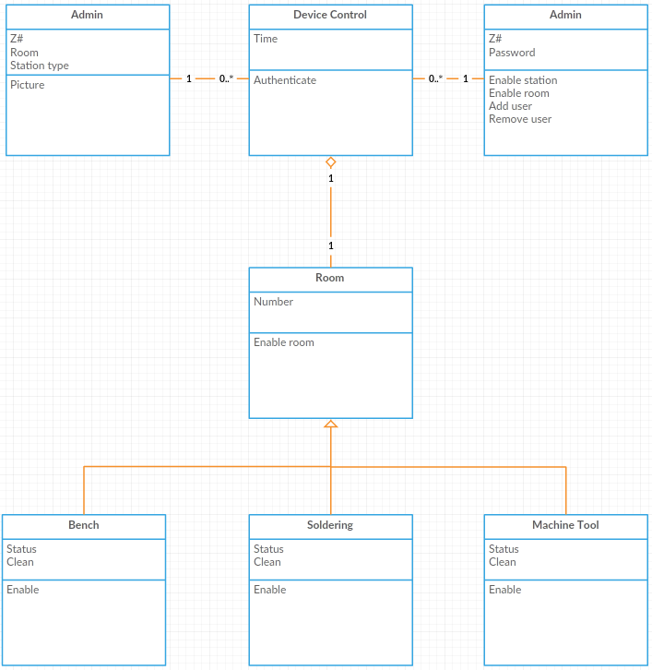

UML component and deployment diagram

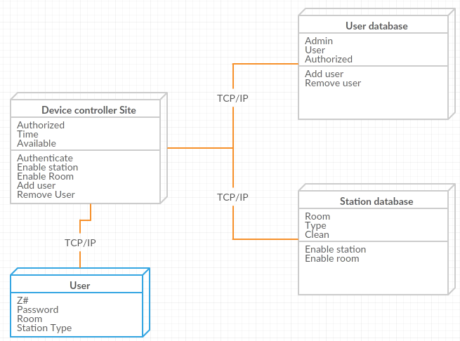

* **Identify actual key risks for your project at this time**

Identify only actual and specific risks in your current work such as (list those that apply:

1. Skills risks (do you have the right skills),

* Some of the risks involved are the use of HTML5, Java, node.js and SQL languages which will be required to implement this project. Some of us might not have enough knowledge and skills in using these languages.
* By communicating with team members and finding out who has more experience and who is more familiar with these types of languages and by assigning tasks to those individuals that are more proficient in certain languages listed above, will eliminate some if not all those risks listed.

1. Schedule risks (can you make it given what you committed and the resources),

* I believe the project can be implemented to some degree based on the information and resources we have (teacher, TA, teamwork).
* Since there is a short-limited time in completing this task, I believe this might contribute to not having it completely functional by the given deadline.
* Due to the time constraints, all team members will have to devote extra time and effort in completing this project.

1. Technical risks (any technical unknowns to solve),

* Other than the ones described above in section1, I cannot think of any technical unknowns to solve.

1. Teamwork risks (any issues related to teamwork);

* Lack of effort from certain team members can and will contribute to not completing the project successfully.
* This could be addressed by speaking directly to the individual involved or notifying the teacher that there is lack of effort from certain individual.

1. Legal/content risks (can you obtain content/SW you need legally with proper licensing, copyright).

* I would not think this would involve certain legal content, or proper licensing regarding the SW being used for our school project.

Tell us how do you plan to resolve risks? The key is to resolve risks as soon as possible. Categorizing risk as above helps a lot in managing them. Be brief: identify the risk and explain (2-3 lines), list how will you address these issues (2-3 lines)

1. **Vertical Demo**

Video Link: <https://www.youtube.com/watch?v=9VHOn4PmixU>

Website Link: http://lamp.cse.fau.edu/~CEN4010_S2018g06/demo

1. **History Table**

3/26/18

* Added the ability for users to scan their owl card via a barcode application
* Added an admin user
  + Can add users
  + Can remove users
  + Can restrict access for users
  + Can change lab settings

**Instructor feedback:**

The T.A. mentioned that we should prioritize each requirements/specifications with ordered numbers in part 6: List of non-functional requirements.

And we did take that into consideration and modify our next module accordingly. Module 4 has great feedback from the T.A.; such as the title page and ability to follow all the instructions. The only minute problem is that the T.A. mentioned that our demo page is not appealing enough so the team will include more CSS and bootstrap functionalities to our final product.

**3.4 Screenshots of actual final product as shown in the demo Section title** “Product Screenshots” contains ALL main functionalities of your final system as an illustration of your finished product.

Login Page:

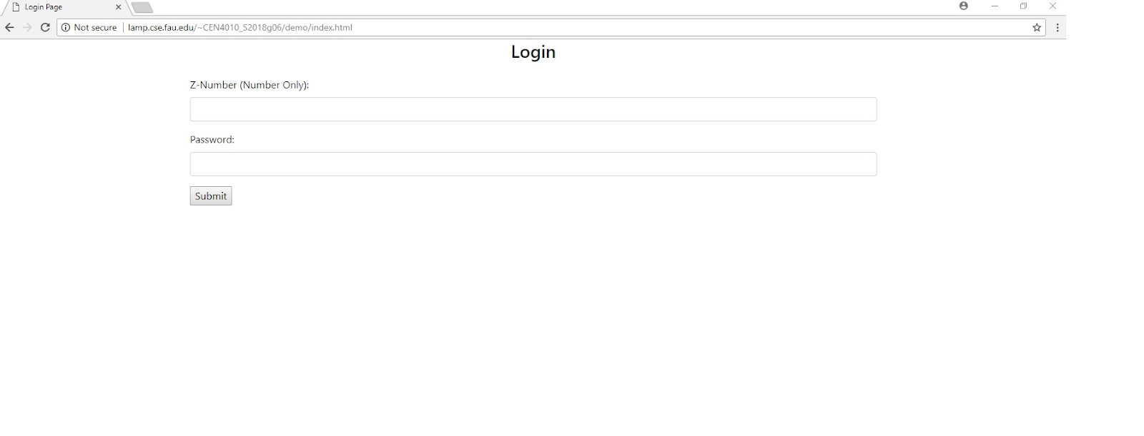

Admin Page:

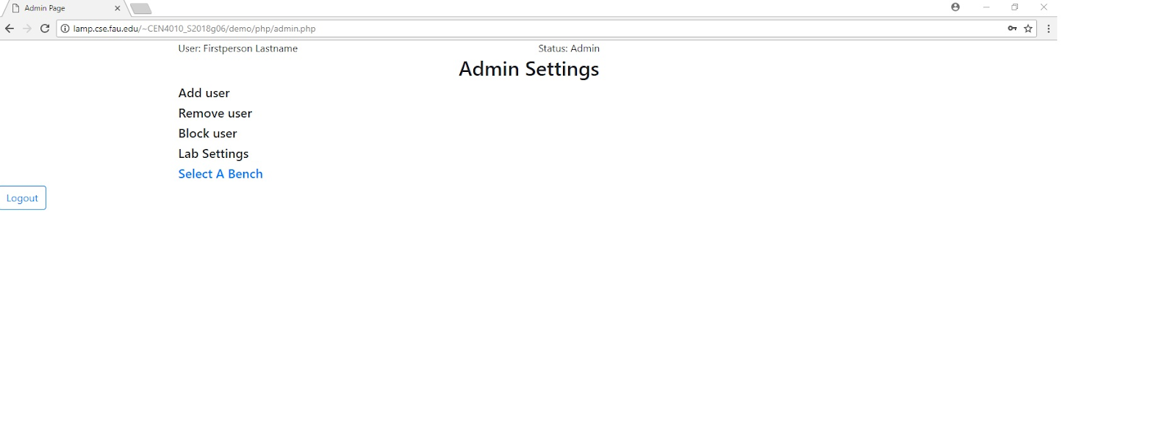

Add User:

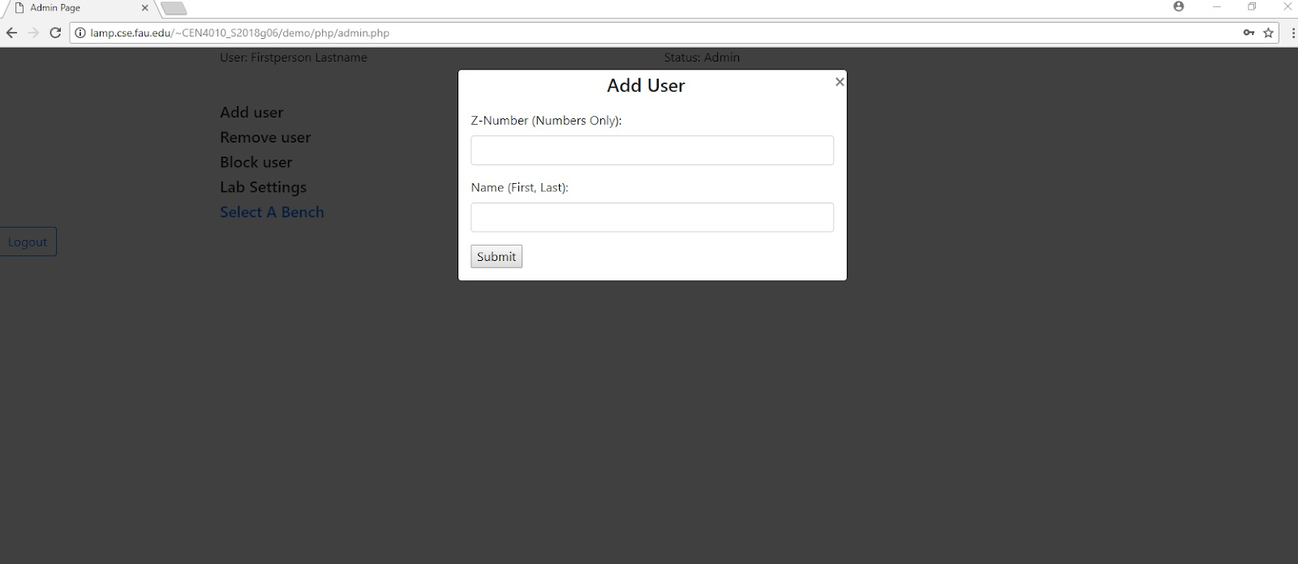

Remove User:

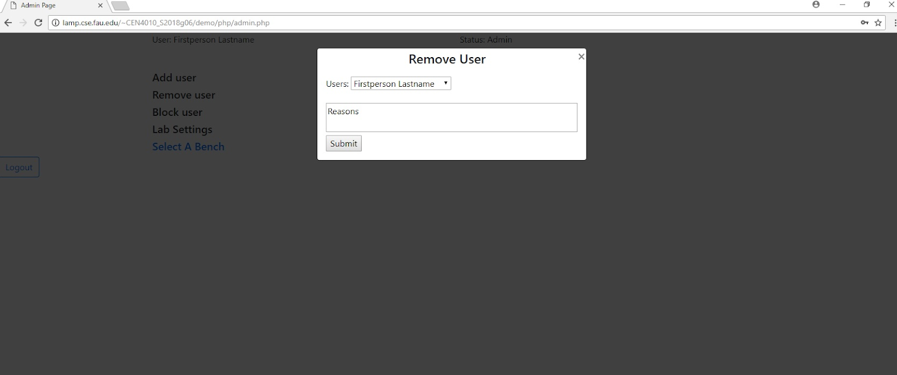

Select Bench:

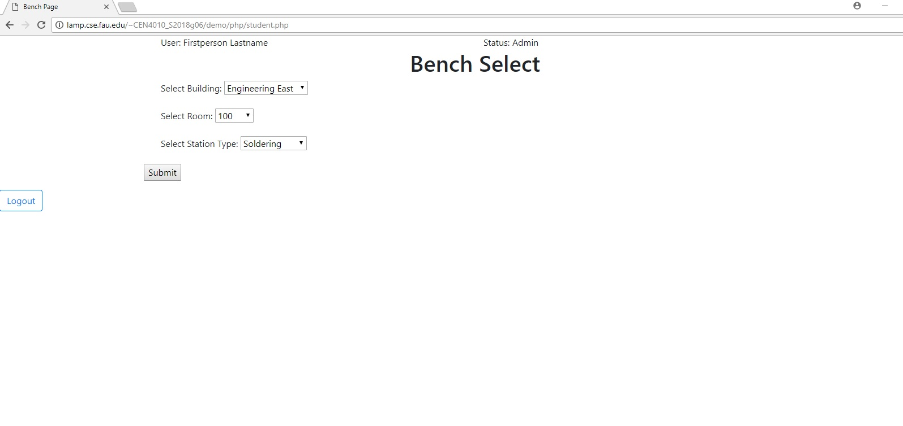

Assigned Bench:

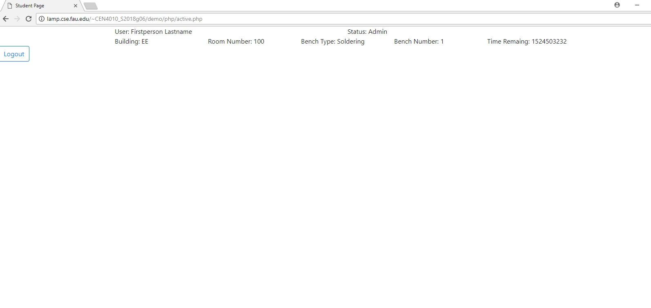

**3.5 Google analytics plot for your website**

(1 page) Use Google Analytics to analyze your website traffic <https://analytics.google.com/analytics/web/provision/?authuser=0#provision/SignUp/>

**3.6 Team members contribution**

Project Peer Evaluation

|  |  |
| --- | --- |
| **Members** | **Points** |
| Bentialy Saint Julien | 20 |
| Jonathan Giger | 20 |
| Jonathan Parreira | 20 |
| Mihail Sandor | 20 |
| Timothy Duncan | 20 |

*Members Contribution*

* Bentialy Saint Julien contributed to some aspects of the project design along with evaluating the overview and use cases scenarios of the project, none functional requirements and putting together a usability test plan. He was present and participated at most team meetings that were scheduled throughout the course.
* Jonathan Giger contributed to the design of the project, writing code for various functions and testing the functionality of the system. He was also in charge of developing the software prototype demo. He was also present and active at most group meeting that were scheduled throughout the course.
* Jonathan Parreira also contributed in designing the project and its functionality along with drawing high level UML diagrams. He was in charge with designing the high-level architecture of the system. He attended most group meetings that were scheduled throughout the course.
* Timothy Duncan also contributed to the design of the project and developing and implementing the system, reviewing code, debugging and testing the final product. He was also a driven force keeping the team members on task with each milestone. He attendee all meeting scheduled throughout the course.
* Mihail Sandor was also involved in designing the project, listing all system functionalities and the overview of the entire project. He was also in charge with assigning task for each team member on Trello, scheduling and attending in person meetings throughout the course.

The image below shows number of submissions each team member made to GitHub

GitHub Commits of each Member

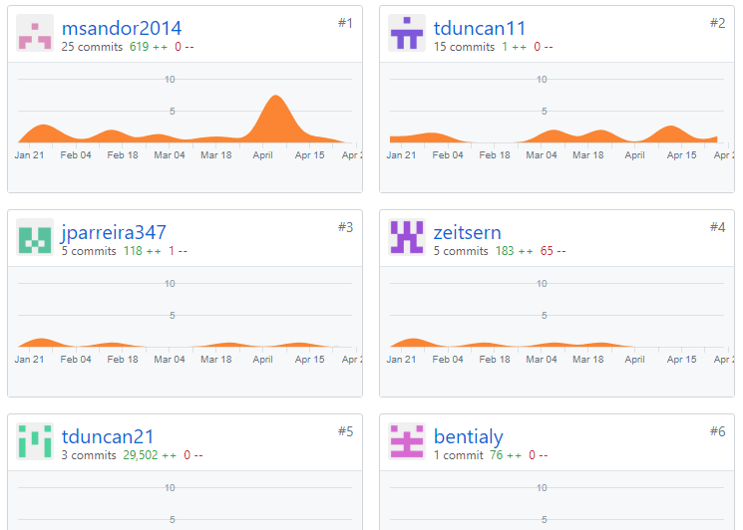

**3.7 Post-project analysis**

(one page or so) In many organizations, after the project is finished, people engage in analysis of the experience, issues, and lessons learned. In the classroom, one often learns more from mistakes. But for real learning to happen, one needs to be able to understand what mistakes were made and what would need to be done to avoid them in the future. BTW: this is also worthy of discussion in your job interviews – employers love those real stories about challenges and how there were dealt with. In about one page team lead should summarize: a) main challenges; and b) what would you do better next time to address those challenges. Team lead should consult with team 3 members before completing this task. Please be honest and identify issues and mistakes, this will help your learning. Also include:

1) Features you have finished and those you’d like to finish but couldn’t be able to, and the reasons

2) Knowledge gained and lessons learnt from your project and teamwork

4 Submission Submit the following to Canvas by due date:

a. Final project report, in word format,

b. Your presentation PPT 5 Grading criteria See “Project Grading Rubric” for details.