Software 6

5/02/18

Milestone 5Final Project

Principles of Software Engineering, Spring 2018

CEN 4010

Team Info

Team name: Software 6

Project: Access Control Device

Team name: Software 6

Team Number: Group 6

Team Members:

Timothy Duncan (Front/Back-end Developer) – [tdunca11@fau.edu](mailto:tdunca11@fau.edu)

Bentialy Saint Julien (Front-end Developer) – [bsaintju@fau.edu](mailto:bsaintju@fau.edu)

Jonathan Giger (Project Owner) – [jgiger2013@fau.edu](mailto:jgiger2013@fau.edu)

Jonathan Parreira (Back-end Developer) – [jparreir@fau.edu](mailto:jparreir@fau.edu)

Mihail Sandor (Scrum Master) [-msandor2014@fau.edu](mailto:-msandor2014@fau.edu)

Revision History Table:

|  |  |
| --- | --- |
| Project revised | 4/16/2018 |
| Project revised | 4/30/2018 |
|  |  |

**3.2 Project Summary**

1. Name of the product

**Access Control System**

1. Explicit list of ALL major committed functions.
2. The system is design to grant access to users that would be using lab equipment or workstation
3. The system is designed to keep track of all available workstations and lab equipment
4. The system shall grant a two-level access, students and administrators
5. The system shall grant access to users by using their credentials, student Z-number and password
6. The system shall only allow access to users who hold a valid student ID number (student Z-number)
7. The system shall allow the admin to add, delete or block a user from using the site
8. The system shall allow student users only to use the site for lab equipment or workstation.
9. The system shall assign randomly an available workstation to the user
10. The system shall keep track of the time allotted to each student using a workstation
11. The system shall support different type of workstations (drill press, soldering station, etc.)
12. The system will be accessed via an internet browser on a mobile device (smartphone, tablets, etc.)
13. The system shall keep track of multiple devices such as lab tools, soldering workstations, etc.
14. Unique Futures:

This site will provide the user a selection of two choices to choose from, one if bench is clean and operable and the other if is not. If the bench is not in good shape the user will be asked to take a picture of the workstation which will then be send to EE management team, while the student will be assigned a new available workstation.

Comments: This unique future listed above was to be implemented but unfortunately due to time constraints as well as lack of camera use from a desktop device this function was eliminated from the designed.

1. URL to your product accessible to instructors, on deployment server

http://lamp.cse.fau.edu/~CEN4010_S2018g06/

**3.3 Milestone documents**

1) Put your modified Milestone 3 here after incorporating feedback.

2) summarize instructor’s feedback of Milestone 3 and 4

**3.4 Screenshots of actual final product as shown in the demo Section title** “Product Screenshots” contains ALL main functionalities of your final system as an illustration of your finished product.

Login Page:

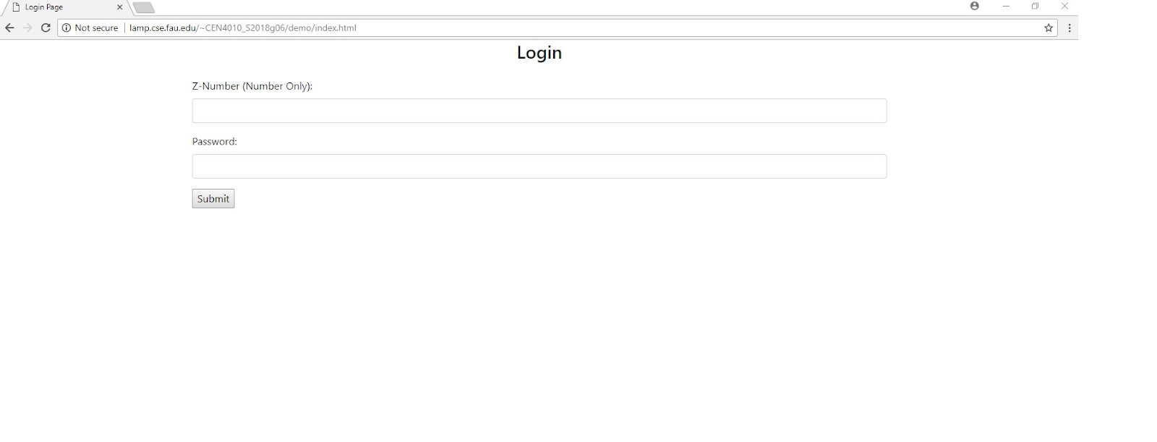

Admin Page:

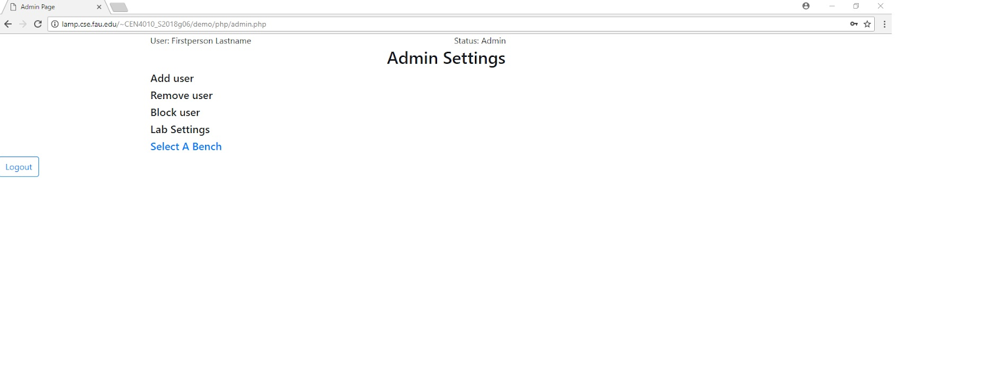

Add User:

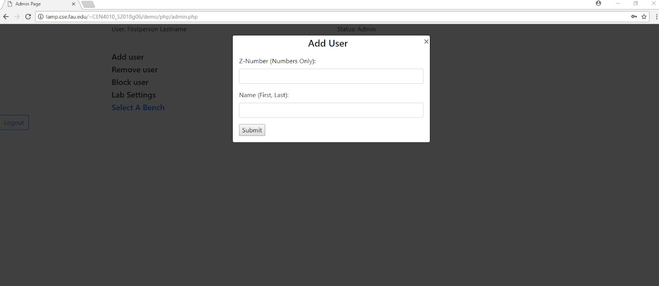

Remove User:

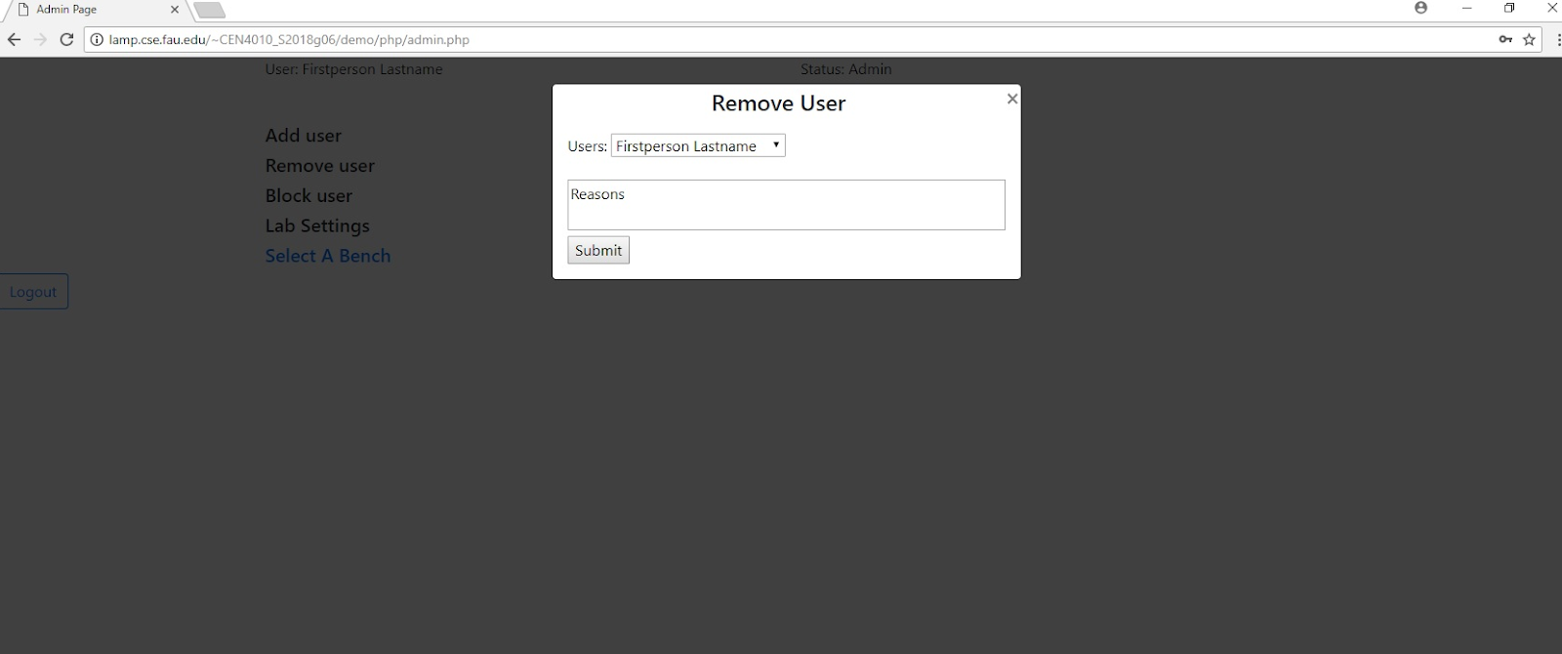

Select Bench:

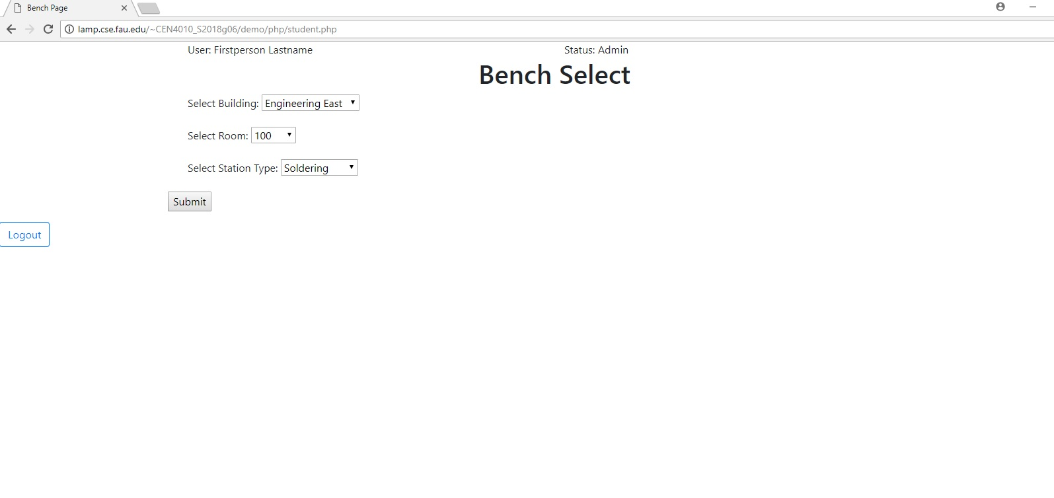

Assigned Bench:

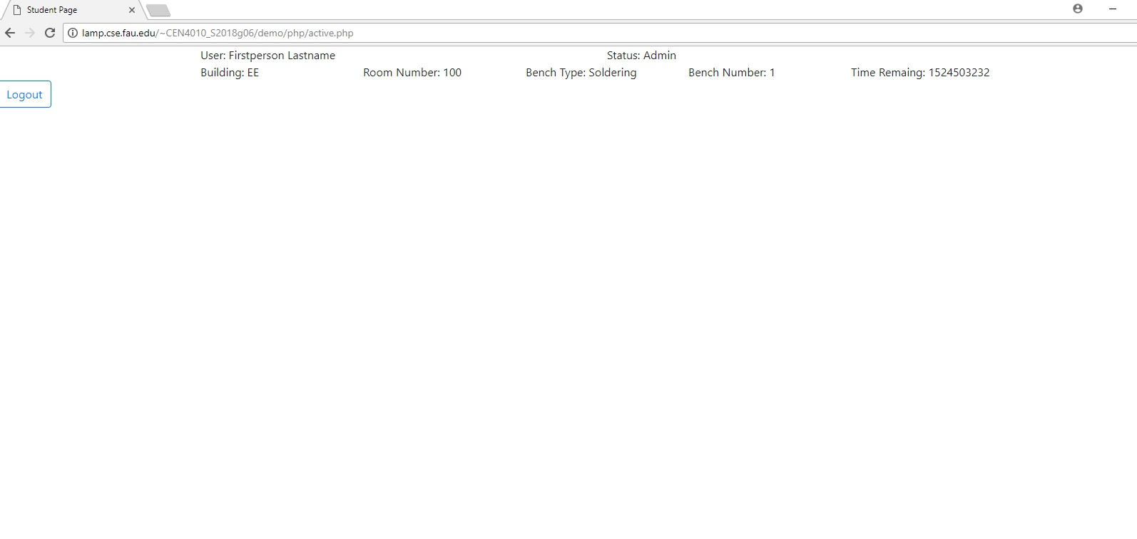

**3.5 Google analytics plot for your website**

(1 page) Use Google Analytics to analyze your website traffic <https://analytics.google.com/analytics/web/provision/?authuser=0#provision/SignUp/>

**3.6 Team members contribution**

Project Peer Evaluation

|  |  |
| --- | --- |
| **Members** | **Points** |
| Bentialy Saint Julien | 20 |
| Jonathan Giger | 20 |
| Jonathan Parreira | 20 |
| Mihail Sandor | 20 |
| Timothy Duncan | 20 |

*Members Contribution*

* Bentialy Saint Julien contributed to some aspects of the project design along with evaluating the overview and use cases scenarios of the project, none functional requirements and putting together a usability test plan. He was present and participated at most team meetings that were scheduled throughout the course.
* Jonathan Giger contributed to the design of the project, writing code for various functions and testing the functionality of the system. He was also in charge of developing the software prototype demo. He was also present and active at most group meeting that were scheduled throughout the course.
* Jonathan Parreira also contributed in designing the project and its functionality along with drawing high level UML diagrams. He was in charge with designing the high-level architecture of the system. He attended most group meetings that were scheduled throughout the course.
* Timothy Duncan also contributed to the design of the project and developing and implementing the system, reviewing code, debugging and testing the final product. He was also a driven force keeping the team members on task with each milestone. He attendee all meeting scheduled throughout the course.
* Mihail Sandor was also involved in designing the project, listing all system functionalities and the overview of the entire project. He was also in charge with assigning task for each team member on Trello, scheduling and attending in person meetings throughout the course.

The image below shows number of submissions each team member made to GitHub

GitHub Commits of each Member

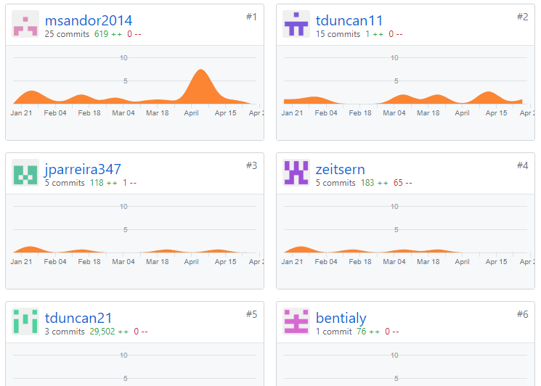

**3.7 Post-project analysis**

(one page or so) In many organizations, after the project is finished, people engage in analysis of the experience, issues, and lessons learned. In the classroom, one often learns more from mistakes. But for real learning to happen, one needs to be able to understand what mistakes were made and what would need to be done to avoid them in the future. BTW: this is also worthy of discussion in your job interviews – employers love those real stories about challenges and how there were dealt with. In about one page team lead should summarize: a) main challenges; and b) what would you do better next time to address those challenges. Team lead should consult with team 3 members before completing this task. Please be honest and identify issues and mistakes, this will help your learning. Also include:

1) Features you have finished and those you’d like to finish but couldn’t be able to, and the reasons

2) Knowledge gained and lessons learnt from your project and teamwork

4 Submission Submit the following to Canvas by due date:

a. Final project report, in word format,

b. Your presentation PPT 5 Grading criteria See “Project Grading Rubric” for details.