**Conferences**

TedX Fargo 2014

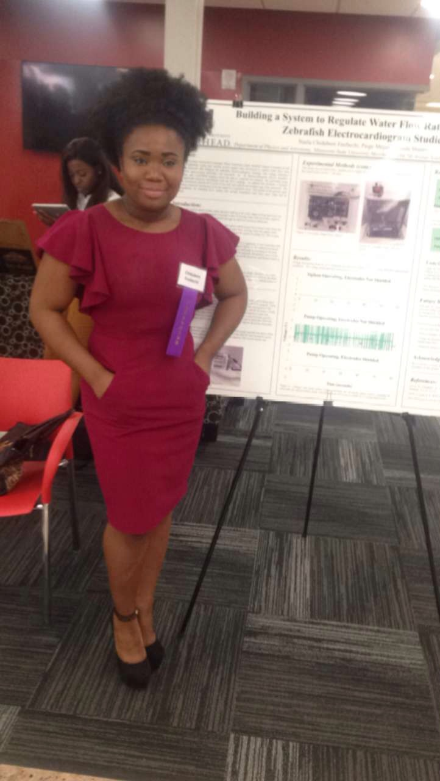

Student Academic Conference MSUM 2016

NEW Women Leadership Development Institute conference 2016

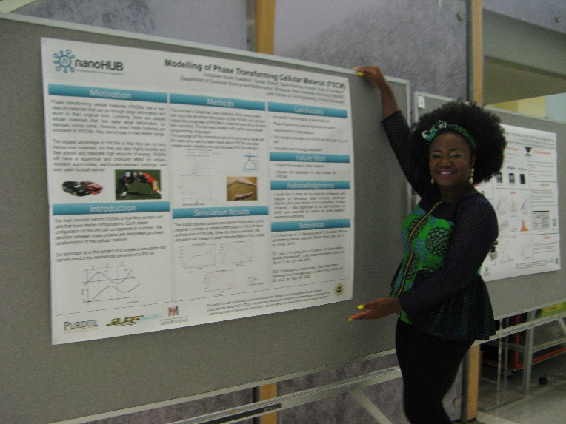

Summer Undergraduate Research Fellowship 2017

NEW Women Leadership Development Institute conference 2018

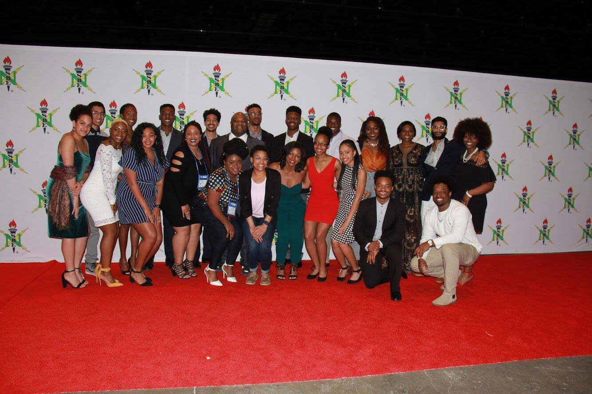

National Society of Black Engineers National convention March 2019

Indiana STEM Education Conference.

American Society of Engineering Education June 2020

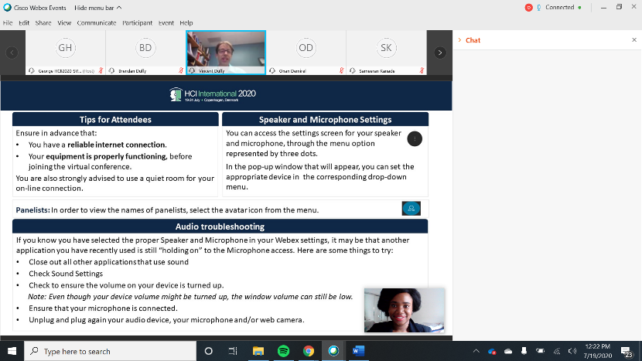

Human Computer Interaction July 2020

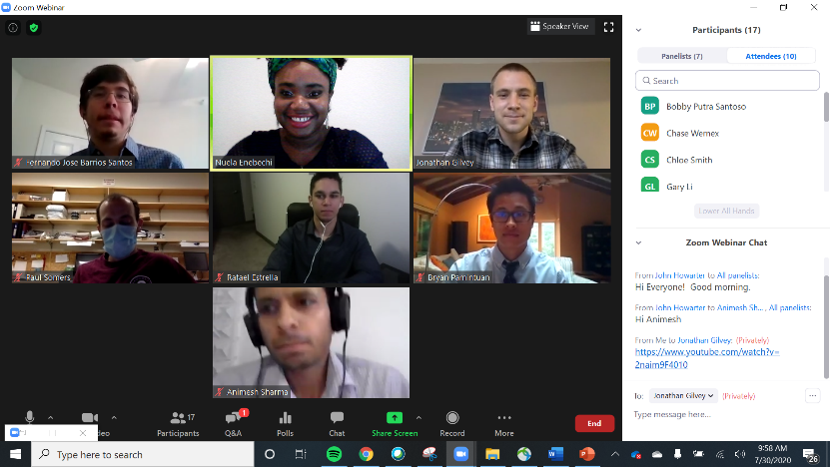

Summer Undergraduate Fellowship Symposium 2020

**Publications:**

* Modelling of Phase Transforming Cellular Materials (PXCM) Purdue University, Published on nanoHUB

<https://nanohub.org/resources/26939>

* Relationship Between Student’s Demographics and Manufacturing Career perceptions. American Society of Engineering Education.

<https://www.youtube.com/watch?v=cdQmkG3VUAs>

* Virtual Reality and Artificial Intelligence in mobile Computing and Applied Ergonomics:

A Bibliometric and Content Analysis. Human Computer Interaction <https://link.springer.com/chapter/10.1007/978-3-030-49907-5_24>