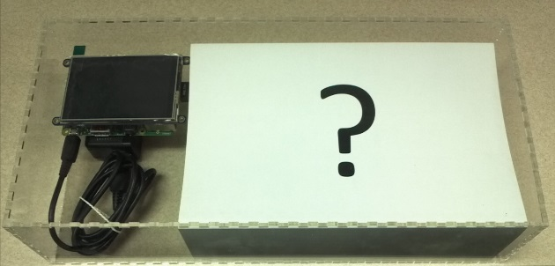 Date: ___________________________________

Name: __________________________________  
*Computer Engineering Technology Student*

**Pieces of Tech in the box:**

1. ______________________________________________________________________________
2. ______________________________________________________________________________
3. ______________________________________________________________________________
4. ______________________________________________________________________________
5. ______________________________________________________________________________
6. ______________________________________________________________________________
7. ______________________________________________________________________________
8. ______________________________________________________________________________
9. ______________________________________________________________________________
10. ______________________________________________________________________________
11. ______________________________________________________________________________
12. ______________________________________________________________________________
13. ______________________________________________________________________________