Crowdfunding Report

Analysis of Provided Dataset

# Conclusions

Given the provided data, the following three conclusions can be drawn about crowdfunding campaigns:

1. Regardless of the industry category or sub-category of the campaign, there’s at least about a 50% chance that the campaign will be successful.
2. Campaigns started in June or July will likely have the best chance of being successful as compared with campaigns started in the other months of the year.
3. Campaigns started in August will likely have the worst chance of being successful as compared with campaigns started in any other month of the year.

# Limitations

One major limitation of the data is that it does not provide a global picture of the success rates of crowdfunding campaigns; countries from Latin America, Eastern Europe, Africa, and Asia aren’t represented in the data at all.

Another major limitation of the data is that they are from the decade or so prior to the global Covid-19 pandemic; because of the pandemic’s impact on global economies, this dataset might not provide a clear picture of current success rates, even in the countries that are represented by the set.

# Other Tables and/or Graphs to Consider

One potentially predictive table/graph is generated by first calculating the average donation as a percentage of the total goal for each campaign (to normalize/account for currency differences), then calculating and plotting the mean and median of those based on the campaigns’ outcomes. There is a clear difference between successful and canceled/failed campaigns (more than double in either case) which is easy to visualize with a bar graph.

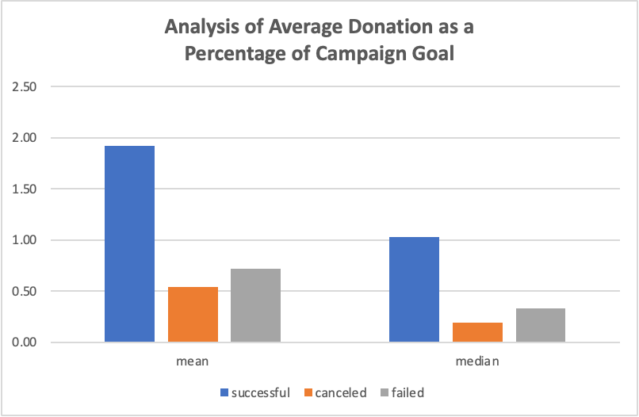

This could be used to predict the outcome of ongoing campaigns with at least some donations. Please see “OtherTables&Graphs_CE.xlsx” for reference.

Another potentially useful table/graph investigates the relationship between staff_pick/spotlight and campaign outcome. Although these two columns are not described to reflect their meaning, their relationship to campaign outcome can still be explored.

If staff_pick and spotlight are both true, there’s a slightly increased chance for success, compared to whether one is or both are false (which are all relatively similar). This likely doesn’t have too much predictive power for ongoing or future campaigns. Please see “OtherTables&Graphs_CE.xlsx” for reference.