1. 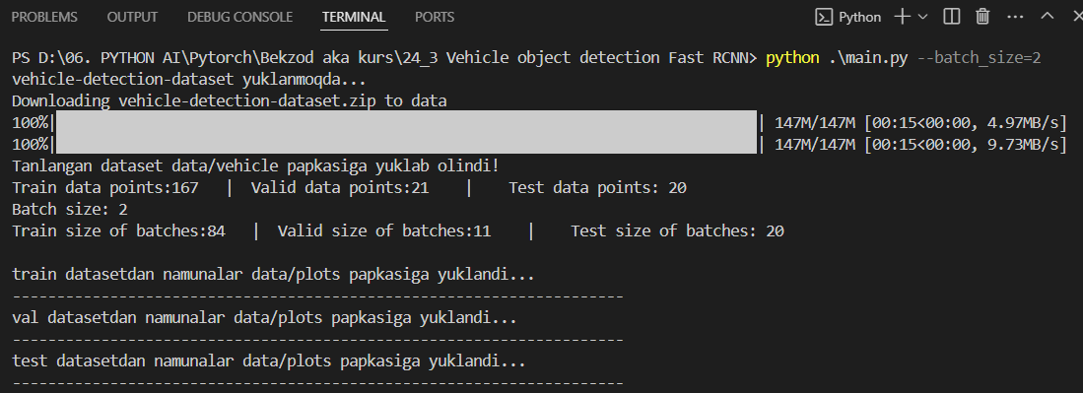First download dataset, if it is not available on the root folder. Then, transformations are committed to the dataset and splitted up batches.
2. Vizualizations examples will be download specific folder shown on command line print

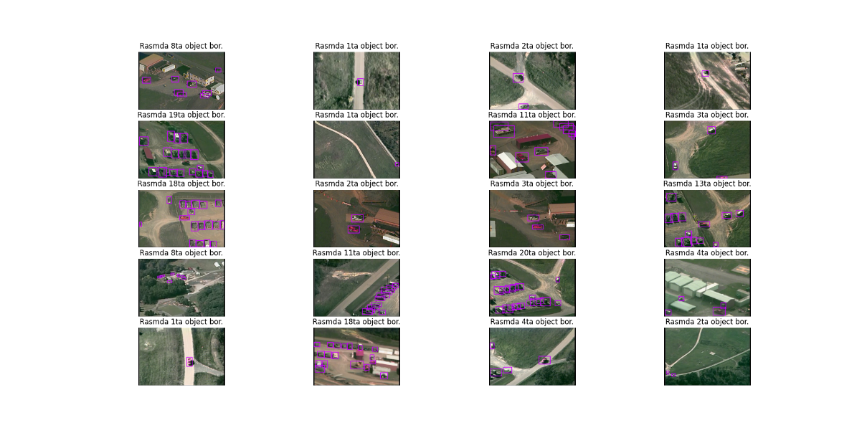

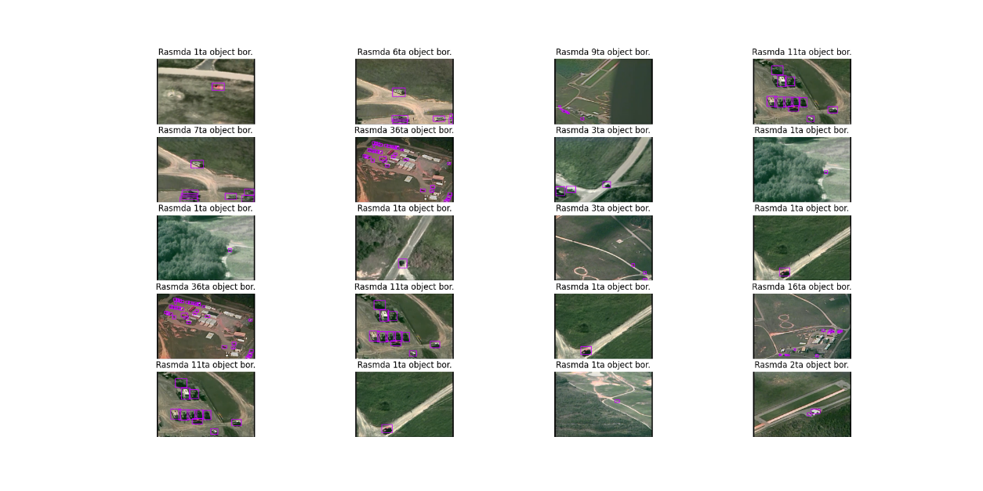

1. Train process started……….

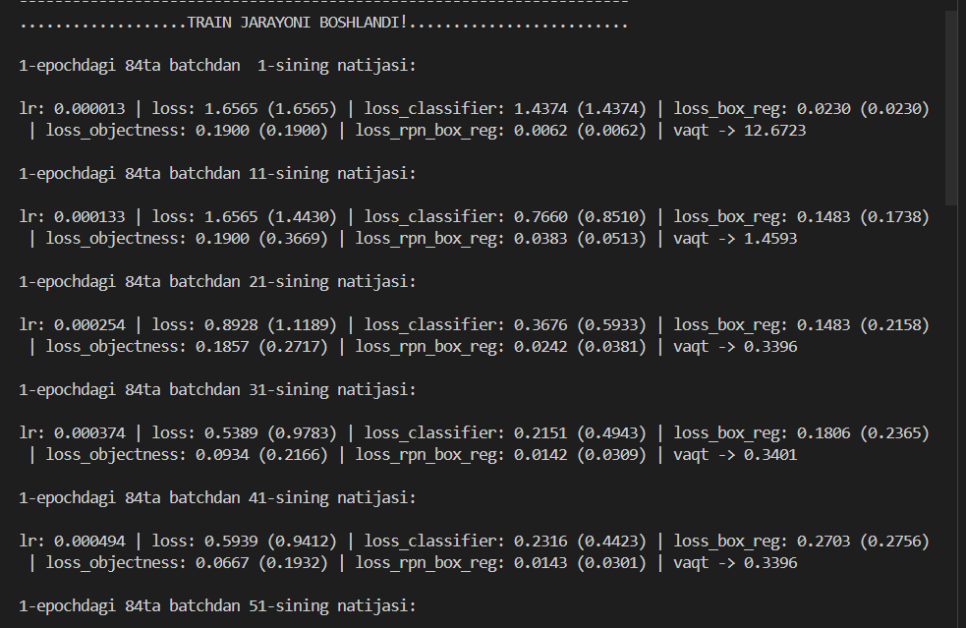

1. 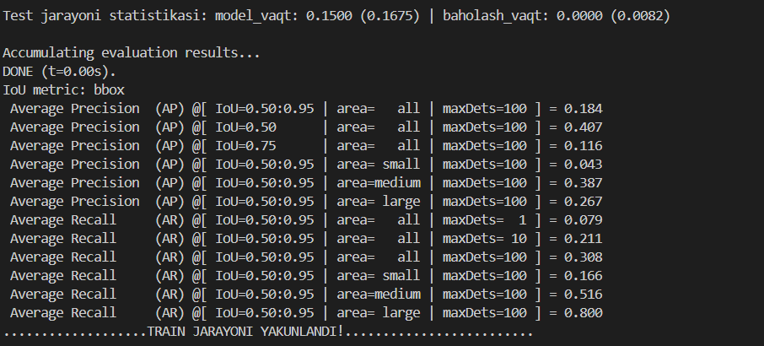It is the result after the training and validation process.
2. 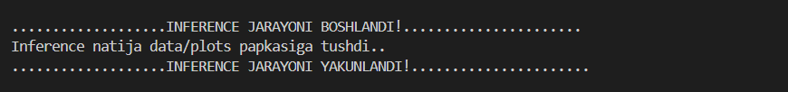Last step is inference. After being procced inference, the visualization results will being download to specific folder which we inputted.
3. 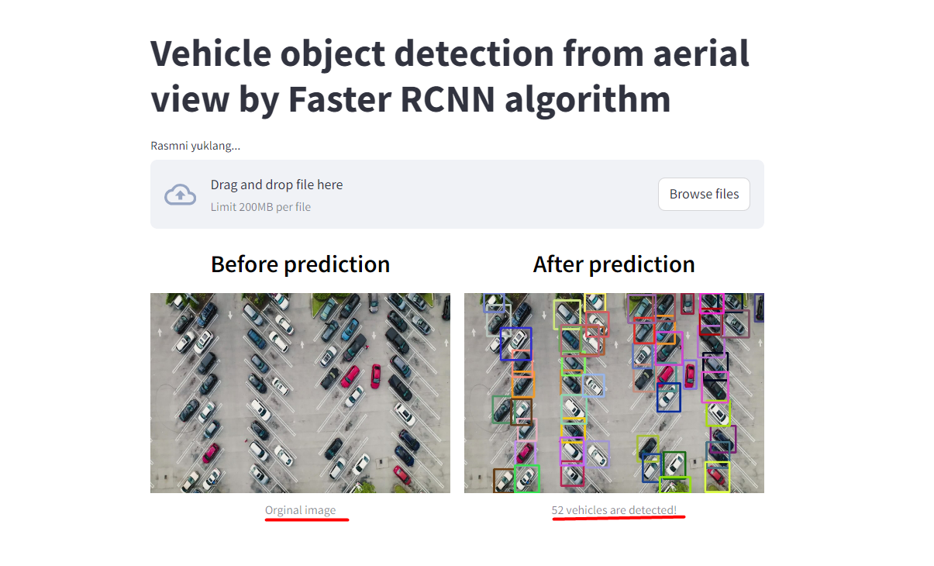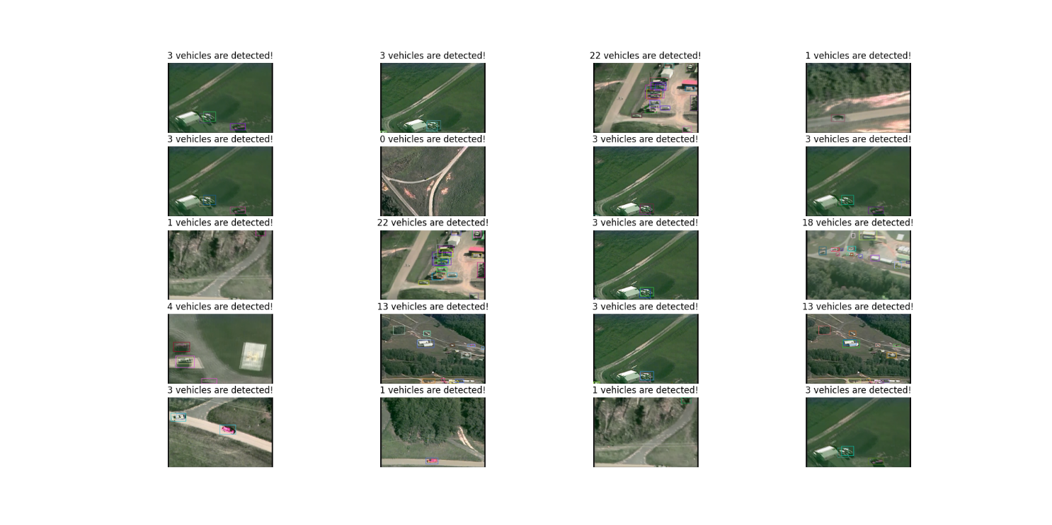Deployment. We utilized streamlit user interface web application to demonstrate how is working our model. Among .py files demo.py file need to be run by as ***streamlit run demo.py*** and here we go:
4. 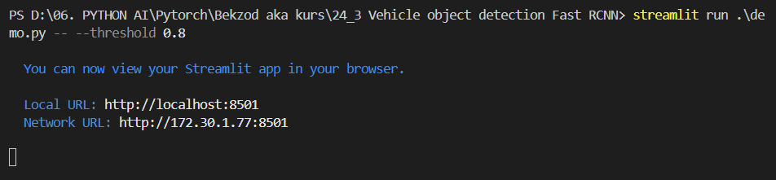By the way we can control the **threshold** valuewhich services to get rid of lower score object detection namely bounding boxes. In *data/test-images*folder we can testify our model it is being evaluated by few test never seen before data.

