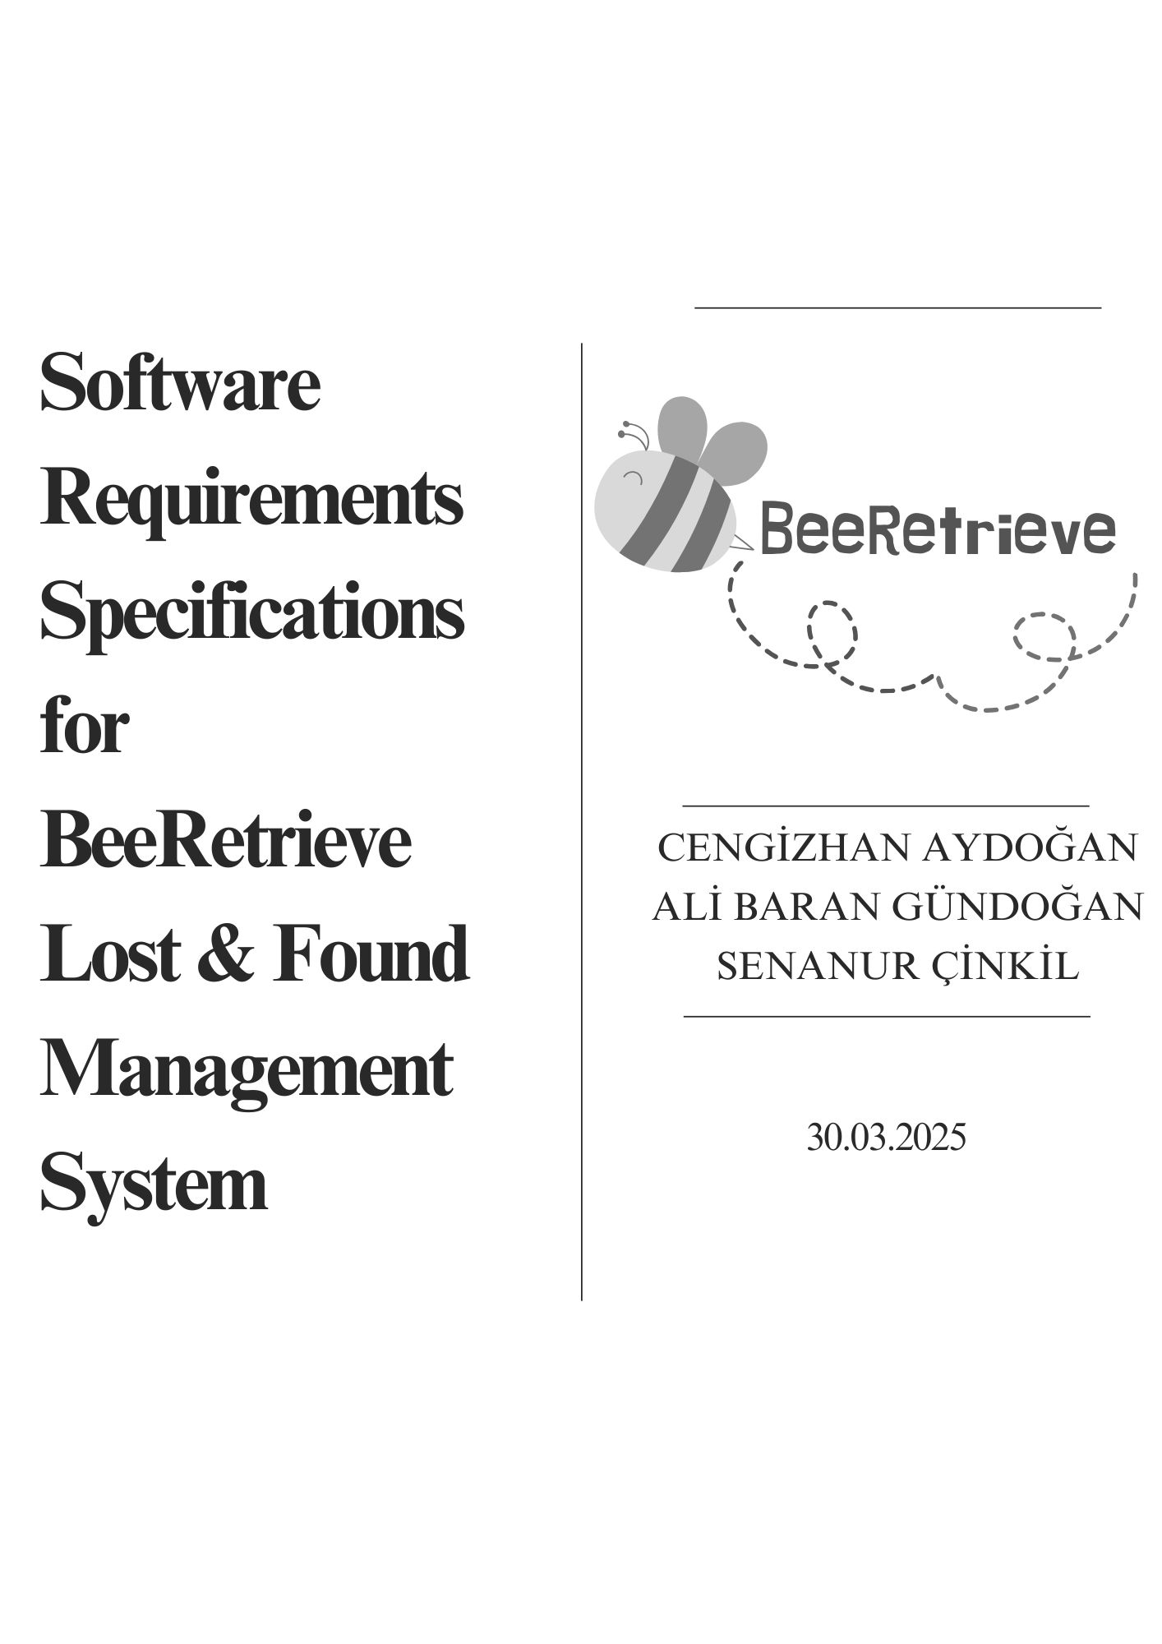
TABLE OF CONTENTS
1. IntroductIon 2
1.1 Purpose 2
1.2 Scope 2
1.3 DefInItIons, Acronyms, and AbbrevIatIons 2
1.4 References 3
2. Overall DescrIptIon 3
2.1 Product PerspectIve 3
2.2 Product FunctIons 3
2.2.1 User Registration and Login Function 3
2.2.2 Forget Password - Function 3
2.2.3 Automatic Data Retrieval from an External Database - Function 3
2.2.4 Found Item Reporting - Function 4
2.2.5 Searching Lost Item - Function 4
2.2.6 Link to Your Lost Item - Function 4
2.2.7 Report the Suspicious Activities - Function 4
2.2.8 After the Linking - Function 4
2.3 User CharacterIstIcs 4
3. SpecIfIc RequIrements 5
3.1 FunctIonal RequIrements 5
3.1.1 User Registration and Login Function 5
3.1.2 Forget Password - Function 5
3.1.3 Automatic Data Retrieval from an External Database - Function 6
3.1.4 Found Item Reporting – Function 6
3.1.5 Searching Lost Item - Function 7
3.1.6 Link to Your Lost Item - Function 7
3.1.7 Report the Suspicious Activities - Function 8
3.1.8 After the Linking - Function 9
3.1.9 Admin Management of Submitted Complaint Reports – Function 9
3.2 Database Models 10
3.2.1 Conceptual Model 10
3.2.2 Logical Model 11
4. AppendIces 12
4.1 User GuIde 12
4.2 PhysIcal ImplementatIon MaterIals 13
4.2.1 Tables 13
4.2.2 Data Loading 14
4.2.3 Queries 14

Revision History
Name | Date | Reason For Changes | Version
SRS for BeeRetrieve LFMS | 30.03.2025 | First version created. | 1.0
SRS for BeeRetrieve LFMS | 31.03.2025 | Certain spelling, punctuation, and grammar errors have been corrected. Requirements have been numbered for traceability. The project name has been changed. The user guide has been updated. The conceptual model has been added. | 1.1

Introduction

Purpose
This project aims to create a database system for lost and found properties at Çankaya University. With this project, members of the Çankaya University community can retrieve their lost belongings easily and without unnecessary delays.
The purpose of this document is to define the functional and non-functional requirements for the Lost and Found Item Management System at Çankaya University. This project seeks to facilitate the process of reporting and recovering lost items within the university premises by providing a secure and efficient platform for students, faculty, and staff.
This document serves as a reference for developers, testers, and stakeholders to ensure the successful implementation of the system while adhering to the specified requirements.

Scope
BeeRetrieve is a mobile application that provides a user-friendly and secure platform for managing lost and found items within the university, operating based on the mutual trust of its users.
BeeRetrieve aims to facilitate the process of reporting and recovering lost items within the university premises by providing a secure and efficient platform for students, faculty, and staff. Users can register and authenticate using their Turkish Citizenship Number, report found items with relevant details and images, search for lost items based on various attributes, initiate communication between the finder and the owner, and ensure a safe and accountable exchange process.

Definitions, Acronyms, and Abbreviations
BeeRetrieve LFMS | Abbreviation of BeeRetrieve Lost and Found Management System. Name of the product.
TCN | Turkish Citizenship Number
SMS | Short Message Service

References
IEEE Std 830-1998, "IEEE Recommended Practice for Software Requirements Specifications," IEEE, 1998.

Overall Description

Product Perspective
BeeRetrieve is a standalone mobile application designed to operate within the university’s existing infrastructure. It integrates with the university’s database to authenticate users and retrieve necessary user details.
Key characteristics of the system include:
- Standalone System: The application operates independently but requires integration with the university’s authentication system.
- User Authentication: Utilizes a Turkish Citizenship Number (TCN), phone number, and password for secure login.
- Database Integration: Retrieves essential user information and securely stores lost-and-found item records.
- Secure Messaging: Includes a built-in messaging system that enables finders and owners to communicate about lost items.
- Accountability Mechanism: Requires users to confirm item exchanges, ensuring a transparent and trustworthy process.
The system serves as an organized and reliable platform to enhance the efficiency of lost-and-found operations within the university.

Product Functions

User Registration and Login Function
Users can register in the system using their Turkish Citizenship Number (TCN), phone number, and a password. After registration, users can log in to the system using their credentials.

Forget Password - Function
Users can retrieve a new password by clicking the "I forgot my password" button, entering their phone number, and receiving a password reset link via SMS. They must confirm the new password in two matching fields. If they don’t match, an error message will be displayed.

Automatic Data Retrieval from an External Database - Function
Upon successful registration, the system retrieves the user's necessary data (name, surname, department, student number, etc.) from Çankaya University’s database and stores it in the BeeRetrieve system with a unique user ID.

Found Item Reporting - Function
Users can report found items by filling in mandatory and optional fields like category, color, location, condition, and image. The system generates a unique ID for the report and assigns a discovery date and a pending delivery status.

Searching Lost Item - Function
Users can search for lost items by filling out mandatory and optional fields. The system will send details of the lost item to users who have found items in the same category.

Link to Your Lost Item - Function
Users can check if the found item matches their lost item by comparing details. If the item is correctly identified, users can unlock the messaging system to communicate freely.

Report the Suspicious Activities - Function
Users can report suspicious activity related to lost and found items (e.g., false ownership claims, fraud, threats). They can choose from predefined situations or describe their issue and submit it.

After the Linking - Function
After the item is physically handed over, users must confirm successful delivery on the system. The system updates the delivery status and saves the details of both users and the item.

User Characteristics
User characteristics of this project are:
- Çankaya University Students
- Çankaya University Academic Staff
- Çankaya University Administrative and Support Staff:
  - Cleaning Staff
  - Drivers
  - Security Staff
  - Cafeteria & Kitchen Staff
  - Dormitory Staff
  - Sports Center Staff
  - Department Officers
  - Student Affairs Staff
  - IT Staff
  - Health Center Staff
  - Psychological Counseling Staff
  - Private Business Employees on Campus
  - Career & Alumni Relations Staff
  - Library Staff
  - International Office Staff

Specific Requirements

Functional Requirements

User Registration and Login Function
REQ-1: Users should be able to register in the system using their Turkish Citizenship Number, phone number, and password.
REQ-2: The system should provide input fields for:
- Turkish Citizenship Number (mandatory)
- Phone Number (mandatory)
- Password (mandatory)
REQ-3: The system should validate all inputs:
- If any field is left empty, the system should display an error message indicating the missing field.
- If the Turkish Citizenship Number or phone number format is incorrect, the system should highlight the incorrect part and prompt the user to enter a valid format.
- If the password does not meet security requirements, the system should display an appropriate error message.
REQ-4: After entering the phone number, the system should send a verification code via SMS. Users should be required to enter this code to complete their registration. If the code is incorrect or expired, the system should display an error message and allow the user to request a new code.
REQ-5: The password should meet the following security criteria:
- Minimum 8 characters
- At least one uppercase letter
- At least one lowercase letter
- At least one digit
- At least one special character (@, #, $, etc.)
- If the password does not meet these criteria, the system should inform the user and suggest a stronger password.
REQ-6: The system should check if the Turkish Citizenship Number or phone number is already registered. If an existing account is found, the system should display an error message and prevent duplicate registration. If the user has forgotten their password, they should be prompted to recover it.

Forget Password - Function
REQ-1: Users should be able to reset their passwords using their registered phone numbers.
REQ-2: Users should be able to click on the “I forgot my password” button.
REQ-3: Users should be able to enter their registered phone numbers.
REQ-4: The system should send a password reset link via SMS to the provided phone number.
REQ-5: Users should be able to open the password reset link from their phones.
REQ-6: When users click on the reset link, the system should direct them to the password reset page.
REQ-7: Users should be able to enter a new password and confirm it by re-entering the same password.
REQ-8: The system should verify that both password entries match.
REQ-9: If the passwords match, the system should update the user's password accordingly.
REQ-10: If the passwords do not match, the system should display an error message and highlight the incorrect fields.

Automatic Data Retrieval from an External Database - Function
REQ-1: When a user successfully completes their registration, the system should retrieve necessary user data from the Çankaya University Database System.
REQ-2: The system should retrieve the following data:
- Name
- Surname
- Associated department
- Associated faculty (if applicable)
- Picture (if available)
- Student number (if applicable)
- Address
REQ-3: The system should then enter the retrieved data into the BeeRetrieve Database System.
REQ-4: The system should assign a unique user identification number to the user.

Found Item Reporting – Function
REQ-1: Users should be able to report found items to the system at any time.
REQ-2: Users should be required to fill in both obligatory and optional fields when reporting a found item.
REQ-3: The system should require users to:
- Choose a category from the list. (obligatory)
- Select a color from the list. (obligatory)
- The system should display a circular shape with the corresponding color next to the color name.
- Enter the location where the item was found. (obligatory)
- Provide details about the condition of the item. (obligatory)
- Upload an image of the item. (obligatory)
REQ-4: Users should also be able to add a note with additional information if desired (optional).
REQ-5: If the obligatory fields are filled correctly, the system should:
- Create a found item record and assign it a unique found item identification number.
- Automatically assign a discovery date without requiring the user to provide it.
- Assign a default "pending" delivery status.
- Assign the finder's unique user identification number to the report.
REQ-6: If the obligatory fields are not filled correctly, the system should:
- Display an error message to the user.
- Highlight the incorrect fields.

Searching Lost Item - Function
REQ-1: Users should be able to search for lost items in the system at any time.
REQ-2: Users should be required to fill in both obligatory and optional fields when searching for lost items.
REQ-3: To search for lost items, users should:
- Click the search button.
- Choose a category from the list on the pop-up screen. (obligatory).
- Select a color from the list. (obligatory).
- The system should display a circular shape with the corresponding color next to the color name.
- Enter the lost item’s location. (obligatory).
- Provide details about the condition of the item. (obligatory).
- Optionally upload an image of the lost item.
- Optionally add a note with additional information.
- Optionally enter the date when the item was lost.
REQ-4: If the obligatory fields are filled correctly, the system should:
- Create a lost item record and assign it a unique lost item identification number.
- Assign the loser's unique user identification number to the report.
- Send all the filled details to all found items that match the same category as the lost item.
REQ-5: If the obligatory fields are not filled correctly, the system should:
- Display an error message to the user.
- Highlight the incorrect fields.

Link to Your Lost Item - Function
REQ-1: Users should be able to click the “Possible Lost Item Owners” button.
REQ-2: If the categories match, all users who found an item should receive the details of the lost item as a message.
REQ-3: The system should lock the messaging feature until the user clicks the “I found the true owner” button.
REQ-4: Users should be able to click on one of the received messages.
REQ-5: The system should display a screen that compares the relevant lost item details with the found item details.
REQ-6: If users believe they have found the correct owner, they should be able to click the “I found the true owner!” button.
REQ-7: Upon clicking, users will see a pop-up with “Five key points to pay attention to.” After reviewing the warning, users should be able to select either “Yes, this is the right person” or “Allow me to reconsider.”.
REQ-8: If users click on “Yes, this is the right person,” the system should unlock the messaging system, allowing both users to communicate freely.
REQ-9: Once the messaging system is unlocked, users who found the item should be able to send a picture of the relevant lost item by clicking the “Send the image of the lost item” button.
REQ-10: The system should display a warning message, “Things to consider when sending a photo of the lost item.”
REQ-11: After reviewing the warning, users should be able to click either the “Confirm” or “Decline” button to send or decline sending the image.
REQ-12: If users believe they have found the wrong person, they should be able to click the “This is not the true owner” button.
REQ-13: After clicking this button, the system should delete the relevant lost item request and its associated details.

Report the Suspicious Activities - Function
REQ-1: Users should be able to report a lost item request by clicking the “Report the User” button in suspicious situations such as:
- False Ownership Claim – A user attempts to claim an item that does not belong to them.
- Incomplete or Incorrect Information – A user provides missing, false, or contradictory details about an item.
- Fraud or Deception – A user tries to take, sell, or misuse someone else's lost item for personal gain.
- Misleading or Offensive Messages – A user sends fraudulent, threatening, or inappropriate messages within the system.
- Issues During Handover – The lost item is not delivered at the agreed location, or the other party exhibits unsafe or suspicious behavior.
- Spam or False Reports – A user misuses the system by submitting unnecessary or fake reports.
- Blackmail or Threats – The finder demands money or other benefits in exchange for returning the item.
- Fake User Information – A user registers with false or stolen credentials.
- Misuse of the System – The platform is used for purposes other than lost and found services (e.g., advertisements, scams, etc.).
- Other – Any other suspicious activity not listed above.
REQ-2: The system should display all the situations above on the user's screen. Additionally, a text box should be available where users can freely describe the issue they experienced. Users should be able to:
- Select one or multiple situations from the list above.
- Enter additional details about the issue in the text box.
- Click on the “Confirm” or “Back” button.
REQ-3: If the user clicks the “Back” button, the system should redirect them to the lost item request page.
REQ-4: If the user clicks the “Confirm” button:
- The system should save the selected options and the user's description in the database.
- The system should generate a unique report identification number.
- A success message should be displayed to the user.

After the Linking - Function
REQ-1: After the physical handover of the item, users must return to the lost item request screen in the application and confirm that the delivery was successfully completed.
REQ-2: Users should be able to click on the "Approve the Delivery" button.
REQ-3: Once both users click on the "Approve the Delivery" button, the system should:
  - Assign the finder's user identification number.
  - Assign the loser's user identification number.
  - Assign the lost and found identification number.
  - Update the delivery status based on both the receiver’s and the finder’s approval.
  - Record the date of delivery.
  - If available, assign the finder’s report identification number.
  - If available, assign the loser's report identification number.
REQ-4: After both users approve the delivery, the system should display a success message to confirm the process.

Admin Management of Submitted Complaint Reports – Function
REQ-1: The system should be able to forward user-created complaint reports to the admin user.
REQ-2: The admin user should have the privilege to review complaint reports and suspend users from the system if necessary.
REQ-3: Each complaint report should be assigned a unique report ID, along with:
- The unique ID of the reporting user.
- The report message.
- The report category.

Database Models

Conceptual Model

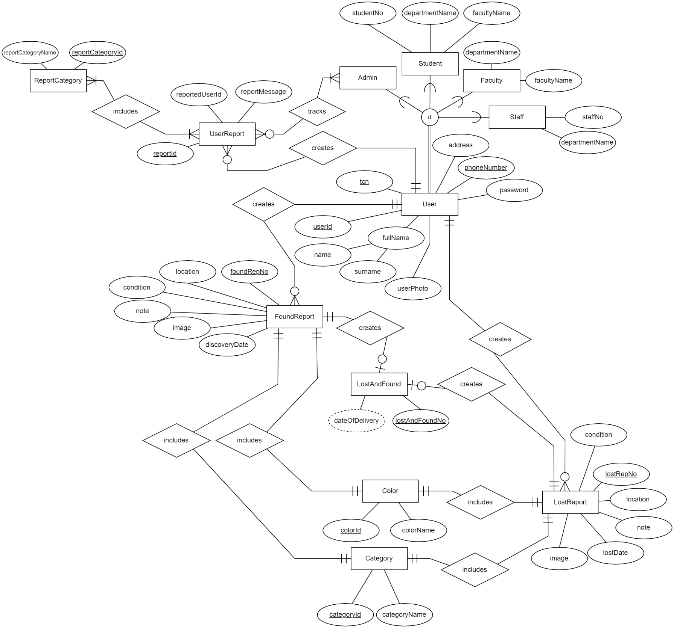

Logical Model

User (PK: userID)
- userID (PK)
- tcn
- name
- surname
- userPhoto
- address
- phoneNumber
- password

Student
- studentNo
- userID (FK → User)
- departmentName
- facultyName

Staff
- staffNo
- userID (FK → User)
- departmentName

Admin
- userID (FK → User)

Category
- categoryID (PK)
- categoryName

Color
- colorID (PK)
- colorName

FoundReport
- foundRepNo (PK)
- userID (FK → User)
- categoryID (FK → Category)
- colorID (FK → Color)
- condition
- location
- note
- image
- discoveryDate

LostReport
- lostRepNo (PK)
- userID (FK → User)
- categoryID (FK → Category)
- colorID (FK → Color)
- condition
- location
- note
- image
- lostDate

LostAndFound
- lostAndFoundNo (PK)
- foundRepNo (FK → FoundReport)
- lostRepNo (FK → LostReport)
- dateOfDelivery

UserReport
- reportID (PK)
- reportedUserID
- userID (FK → User)
- reportCategoryID (FK → ReportCategory)
- reportMessage

ReportCategory
- reportCategoryID (PK)
- reportCategoryName

Appendices

User Guide
  - Register to the system with your Turkish Identity Number, your phone number and a password that is at least 8 characters long (containing at least one uppercase letter, one lowercase letter, one digit, and one special character).
  - If you are not a Çankaya University student, academic, or administrative staff, your registration to the system will not be completed.
  - Approve the "Things You Need to Know" and KVKK (Personal Data Protection Law) texts; otherwise, your registration to the system will not be processed.
  - After registering to the system, fill in the required mandatory information for your security.
  - For your name, surname, student number, and photo information, your Çankaya University information will be valid.
  - Log in to the system.
  - If you found a lost item open an ad for the item you found and fill in the required fields.
  - If you lost an item click the "Find Lost Item" button.
  - Enter the type of your lost item.
  - Choose the category of your item from the list.
  - The system sends the details entered by the person who lost the item and an information message to all ads in the category of the lost item.
  - Users who found lost items of that type have received an information message. It is the responsibility of those who found lost items to check the messages they receive.
  - The user who found the lost item compares the details in the messages they receive with the details of the item they found earlier and decides whether the lost item belongs to the person in the message.
  - If the person who found the lost item verifies the incoming details, the messaging system opens. And the two users can freely message each other.
  - Users are responsible for the messages they write. It is recommended to pay attention to the "Things You Need to Know" text while messaging. The system cannot intervene in the event in any way.
  - If a situation contrary to the " Things You Need to Know " section occurs, both parties can report each other with the report button. If the system finds a message that violates the "Things You Need to Know" text, penal action may be taken.
  - Upon the smooth agreement of both parties, a meeting is held at the specified address. After the item delivery is completed smoothly, users are responsible for updating the delivery status by selecting the item in question from the system. Regardless of what happens during the delivery, users must fill in the delivery details below when updating the delivery status. For example:
- I received my item smoothly.
- I received my item, but it was a little dirty.
- I think the person who found my item broke the end of it.

Physical Implementation Materials
The SQL source code prepared for table creation, data loading, and query design can be accessed via the links provided below.

Tables
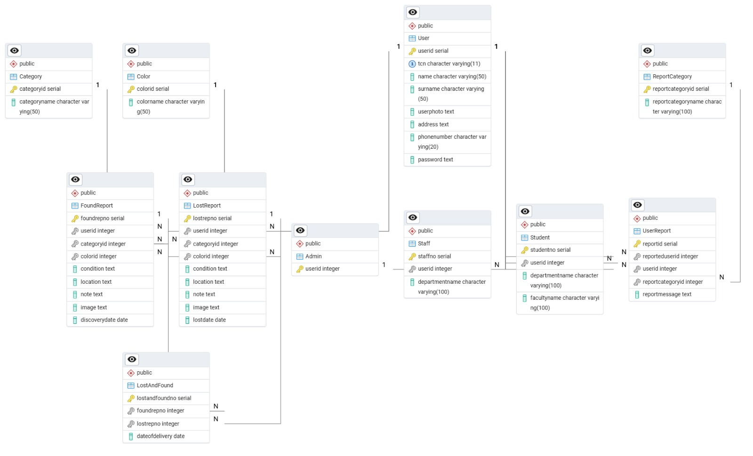
The SQL source code for creating the tables is available in the referenced external repository [1].

Data Loading
The SQL source code for data loading is available in the referenced external repository [2].

Queries
The SQL source code for queries is available in the referenced external repository [3].

[1] http://bit.ly/3FgMLbW, [2] https://bit.ly/4jUzOnc, [3] https://bit.ly/4j7wfZG

