Temperature and Heat Transfer Measurements in Aerospace Engineering

1. Introduction
2. Resistive temperature transducers
2.1 Metallic resistive temperature sensors
2.2 Resistance temperature sensor (RTD) bridge circuits
2.3 Thermistors
3. Thermocouples
3.1 Principle of operation for thermocouples (VKI)
3.2 Spurious EMF related problems (VKI)
3.2.1 Galvanically induced spurious EMF generation
3.2.2 Strain induced spurious EMF generation
3.2.3 Material inhomogeneity induced spurious EMF generation
3.3 Laws of thermoelectricity for thermocouples (VKI)
3.4 Thermocouple compensation
3.5 Multiple thermocouple arrangements

4. Bi-metallic temperature sensors
5. Semiconductor diode temperature sensors
6. Liquid crystal temperature sensors
6.1 Using Liquid crystals in the rotating frame of reference
7. Infrared thermometry and pyrometry
7.1 Infrared Scanning radiometer (VKI 167)
7.2 Gas turbine pyrometer/solar Turbines
8. Gas temperature measurements in aerospace engineering (VKI)
9. Heat transfer measurements
9.1 Time accurate thermopile based HF sensors
9.2 Short duration wind tunnel measurements
9.3 Steady state wind tunnel measurements
9.4 Transient HT measurements using liquid crystals
9.5 Steady state HT measurements using liquid crystals
9.6 Gardon gauge
9.7 Mass-heat transfer analogy based HT measurements

References

1. Introduction

Temperature is an important parameter for aerospace engineering system design. There are a great number of aerospace systems that fail simply because of thermal reasons. Satellite thermal management systems, hot sections of propulsion systems, combustors, aerodynamic heating of supersonic/hypersonic vehicle surfaces, turbomachinery flow simulators, jet engine demonstrators, composite manufacturing facilities, rocket engines, all require large number of sensors that can measure temperature and heat flux with good accuracy. As physical quantity, temperature is difficult to define accurately and simply. In general local temperature in an engineering system is something to do with the concept of heat that is usually interpreted with the help from the first law of thermodynamics. The temperature of a body may be considered as its thermal state with reference to its ability of communicating heat to other bodies in the environment.
All materials in aerospace engineering systems consist of atoms and/or molecules which exist in a more or less agitated thermodynamic state. Whether materials are in a solid, liquid or gaseous phase is related to the level of agitation. The cohesive forces binding the particles together are usually balanced by the kinetic energy of the individual particles. Temperature in a material can be regarded as the degree of activity attained by the particles in the system. Thus the concept of temperature in empty space is not meaningful since there are no agitated particles in empty space. When a body in which “thermal agitation” is totally absent is said to have an absolute temperature of zero.
The temperature of any system is proportional with its internal thermodynamic energy level. For a system in thermal equilibrium with its surroundings, the mean kinetic energy per degree of freedom of the particles making up the material system is κT/2 where κ is Boltzmann's constant and T is the absolute temperature in ^{O} K. This equation also represents the Brownian motion in mechanical systems, Johnson noise in electronic systems, and radiation noise in thermal systems.
The most direct realization of a scale of temperature using this approach is based on the ideal gas equation, which can itself be derived directly from the Kinetic Theory of Gases [1]. The gas equation p =ρRT gives the static pressure p of a gas at a density ρ and static temperature T, with a constant of proportionality R which is equal to the number of molecules in the specific volume divided by Boltzmann's constant κ . R is also called a gas constant. The constant volume gas thermometer, in which the pressure of a fixed mass of an inert ideal gas is measured as a function of temperature, uses this approach. It forms the basis of most temperature measurement schemes.
Establishing a proper “temperature scale” in engineering systems is important. An “International Temperature Scale” based on the zeroth law of thermodynamics is used by the international scientific community. According to the zeroth law, that “two systems in thermal equilibrium with a third system are in thermal equilibrium with each other”. The operational temperature scale is defined using a series of fixed reference points (boiling and freezing). The fixed reference points defined on the Celcius scale presented in Table 3-3 are easily reproducible in the laboratory. The triple point of water which is “melting ice” is usually taken as 0.01 º C. The melting points of sulfur, antimony, silver and gold are also frequently used as reference points.

FIXED REFERENCE POINT | TEMPERATURE  ^{O} C
MELTING ICE (TRIPLE POINT OF WATER) | 0.01
STEAM (BOILING WATER) | 100.0
OXYGEN (BOILING) | -182.97
SILVER MELTING) | 960.8
GOLD (MELTING) | 1063.0
SULFUR (MELTING) | 444.6
ANTIMONY (MELTING) | 630.5

Table 1 The fixed reference points on the Celcius scale

The interpolations between different fixed points in Table 1 are performed using precision measurement standards such as platinum resistance temperatures or calibrated mercury thermometers. Other temperature scales including Fahrenheit scale are commonly used in different environments. A comparison of the four most frequently used temperature scales in engineering applications is presented in Figure 1.

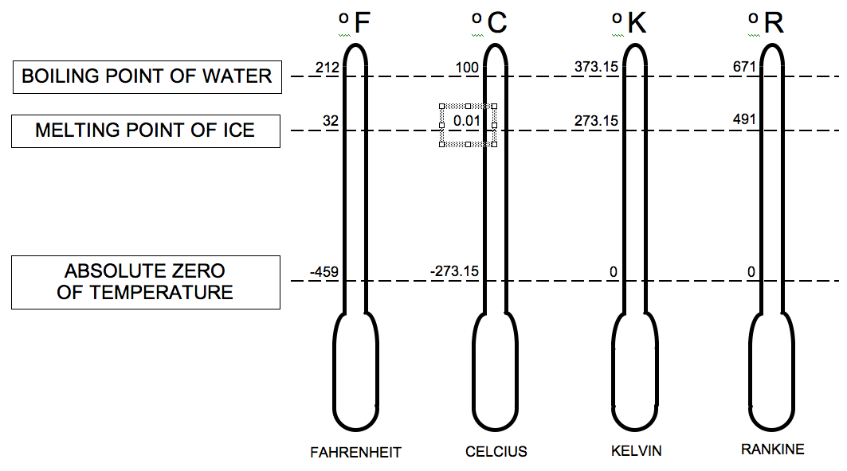

Figure 1 Four most frequently used temperature scales

The concept of temperature is usually accepted as hard to comprehend since it is less easy to define a meaningful scale of temperature than it is for, say, length. This is mainly because it is more difficult to relate temperature to the fundamental dimensions of mass, length and time than it is for most other common measurements, such as pressure, flow rate, strain, etc. Temperature cannot be measured directly, but has to be quantified by observing the effect it produces, such as the expansion of a liquid, the electrical current it induces in a bi-metallic junction, the color change it results in a liquid crystal coating, the local oxygen concentration it defines in a thin layer of thermographic phosphor, etc. In general, assumptions need to be made about the linearity of the effect observed.
Most electronic temperature sensors used in engineering fall into one of two classes: resistive or thermoelectric [2]. Resistive sensors may be either metallic or semiconductor and require some form of bridge completion circuit or signal conditioning device since they are modulating transducers. Thermoelectric sensors or thermocouples are self-generating, but their very low output at μV level means that an amplifier is always needed in the measurement chain. The thermal expansion of a solid or a bi-metallic system can also be used as a temperature transducer, for example to control thermostat opening in water-cooled rocket engine nozzle or internal combustion engines. Infrared emission or pyrometry can also be used in temperature sensing, and is particularly useful non-intrusively monitoring inaccessible or rotating components. A more general classification of temperature sensors thermocouples, resistive sensors, bi-metallic sensors, infrared sensors, pyrometry based sensors, semiconductor sensors

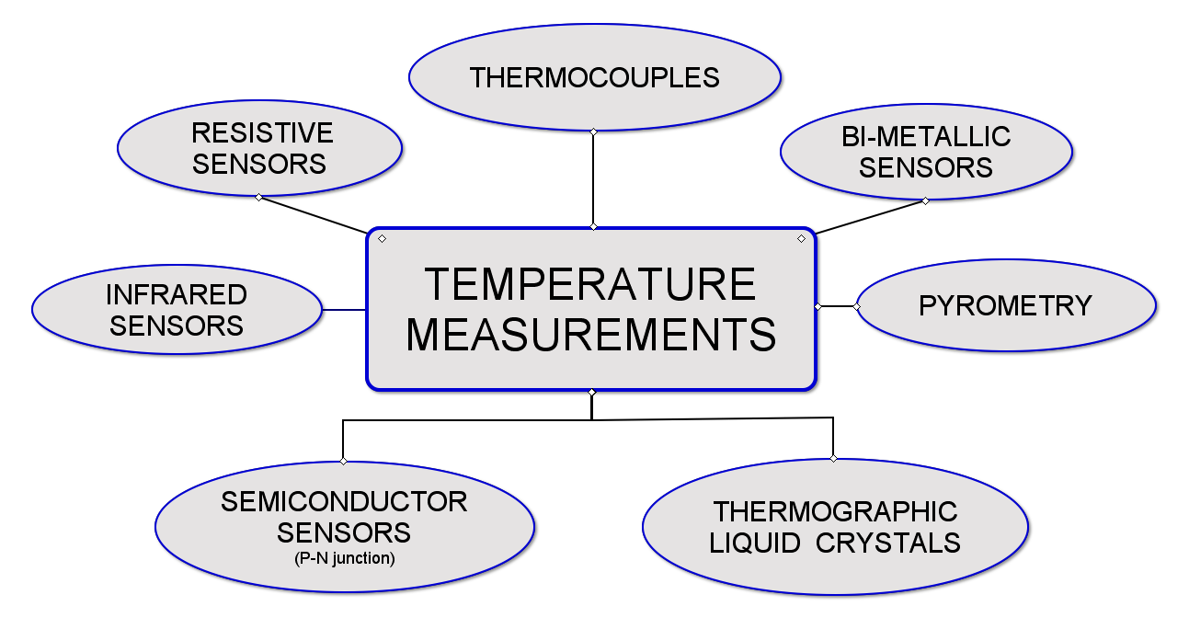

Figure 2 A general classification of the most frequently used temperature sensors in Aerospace Engineering

and thermographic liquid crystals. Thermographic phosphors are also effective thermally sensitive paints used in aerospace engineering research however this topic will be covered individually in a separate chapter of this encyclopedia. The last section of this chapter also deals with the sensors and systems that are used for heat transfer measurements in aerospace engineering. These systems deal with the rate of energy transferred from one point to another in a domain filled with a gas, solid or liquid material rather than a discrete point measurement of the temperature of the system. However accurate temperature measurements are essential parts of most heat transfer measurement systems.

2. Resistive temperature transducers
Resistive temperature sensors are probably the most common type in use. They may be based on metals or semiconductors. The semiconductor versions are also frequently used and probably the cheapest. They are sometimes known as resistance temperature detectors or RTD’s. Metallic resistive temperature sensors offer better performance than semiconductor RTD’s and may be installed if high accuracy is required.
2.1 Metallic resistive temperature sensors: These transducers are similar in appearance to wire-wound resistors. Metallic resistive sensors often take the form of a non-inductively wound coil of a metal wire such as platinum, copper, or nickel. The wound metallic coils may be encapsulated within a sealed glass tube to form a temperature probe which can be miniature in size. An alternative form is shown in Fig. 3, in which a rectangular matrix of platinum is deposited on a quartz or ceramic substrate. Thin or thick films of metals are also deposited on flexible Mylar substrates or quartz/ceramic substrates as shown in Fig. 3. Connections within the matrix are laser-trimmed to give a precise value of nominal resistance. In general, the resistance of the RTD can be adjusted by controlling the length to width ratio of the active resistive films. The variation of resistance R with respect to temperature T of most metallic materials can be represented by equation 1 :

(1)



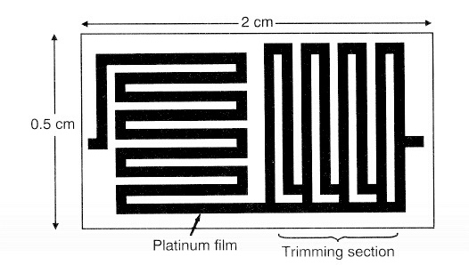
where R_{o} is the resistance at a user selected reference temperature T_{o} . The number of terms used in equation 1 depends on the material, the temperature range to be covered and the accuracy required. Platinum, nickel, and copper are the most commonly used metals, and they generally require a summation containing at least α₁ and/or α₂ for accurate temperature measurements.
PLATINUM FILM
Trimming area

Figure 3 Metallic resistance transducers of various forms

Tungsten and nickel alloys are also frequently used. In most aerospace engineering applications it is often possible to model a metallic RTD using only one coefficient α₁. In a typical engineering application using only α₁, the resulting nonlinearity is only around 0.5% over the temperature range 233.15 º K to 413.15 º K (-40 º C to + 140 º C). The nominal resistance R_{o} of a metallic RTD can vary from a few ohms to several kilohms. However, l00 Ω is a fairly standard value. The resistance change of a metallic RTD can be quite large and is typically up to 20% of the nominal resistance over the design temperature range, [2]. A comprehensive treatment of metallic resistive temperature sensors is also given in [3].
2.2 Resistance temperature sensor (RTD) bridge circuits: Thermistors are modulating transducers that are normally used in a Wheatstone bridge circuit. A typical bridge balancing arrangement is shown in Fig. 4. While the resistance changes exhibited by a metallic RTD are reasonably linear, those shown by semi- conductor thermistors are markedly nonlinear, [2]. In both cases the resistance changes are large enough to record accurately.
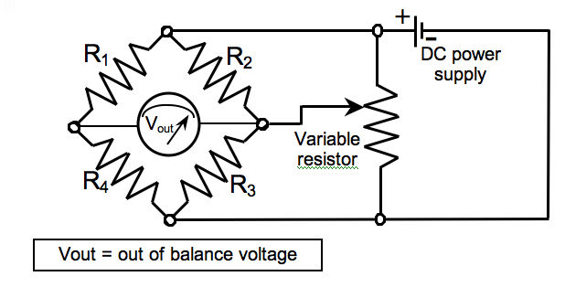
Fixed
resistor
Fixed
resistor

Figure 4 A typical bridge balancing arrangement for resistance temperature sensors, [2]

Even if the sensor output is linear, the out-of-balance voltage measured using a bridge circuit is not necessarily linear when the sensor resistance varies significantly. The case of a 500 Ω platinum-resistance-thermometer which exhibits a 100 Ω resistance change over its design temperature range is a good example of this feature. If the sensor is included in a bridge with four equal arms, the out-of-balance voltage will be very nonlinear as a function of temperature. However, the fixed resistors R₁ and R₂ in Fig. 4 are of considerably higher resistance (about x 10 is normal) than the platinum sensing resistors R₃ and R₄, and if care is taken to balance the bridge at the middle of its design temperature range rather than at one end, reasonable linearity may be achieved, [2].
The bridge circuits for resistance thermometers may be excited with either AC or DC voltages. The current through the sensor is usually in the range from 1 to 25 mA. This current results in Joule heating (I²R heating) to take place in the sensor. This internal heat generation raises the temperature of the sensor above that of its surroundings and causes a “self-heating” error to occur. The level of this uncertainty depends on conduction and convection heat transfer characteristics of the substrate to which the sensor is attached

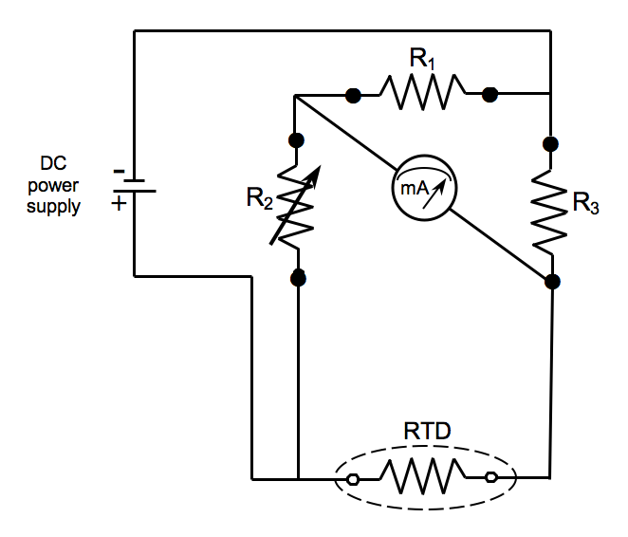

Figure 5 Four wire circuit for resistance thermometry, [2]

The four-wire 'ohmmeter' technique shown in Fig. 5 is an alternative to the classical bridge techniques for conditioning RTD sensors. This specific bridge circuitry is widely used with data acquisition systems using accurate A/D converter systems. Any sensor non- linearity is corrected in the computer software after collecting data using either 12 bit or 16 bit A/D converters.

2.3 Thermistors: Thermistors are semiconductor based transducers, manufactured in the shape of flat disc, beads, or rods. They are manufactured by combining two or more metal oxides. When oxides of copper, cobalt, iron, manganese, nickel, magnesium, vanadium, tin, titanium or zinc are used, the resulting semi-conductor is said to have a negative temperature coefficient (NTC) of resistance. This means that as the temperature goes up, the electrical resistance of the NTC thermistor falls. Most of the thermistors used in engineering are of type NTC, and they can exhibit large resistance variations. Typical values are 10 kΩ at 0 º C and 200 Ω at l00 º C. This very high sensitivity allows very small temperature changes to be detected. However, the accuracy of a thermistor is not as good as that of a metallic RTD, due to possible variations in the composition of the semiconductor which occur during manufacturing [2]. Most thermistors are manufactured and sold with tolerances in a range from 10 % to 20%. Any engineering system using semiconductor thermistors must therefore include provisions for adjusting out errors. Thermistors are known to be nonlinear unlike metallic RTD’s. The resistance versus temperature relation is usually of the form:

, (2)

where R is the resistance (in Ω) at temperature K (in K), R_{o} is the nominal resistance at temperature T_{o}, and β is a constant which is thermistor material dependent. The reference temperature T_{o} is usually taken to be 298 K (25 º C), and β is of the order of 4000. If equation 2 is differentiated and the temperature coefficient of resistance α at temperature T_{o} can be found:

. (3)

The units of the temperature coefficient of resistance α are (Ω/K). If β is taken as 4000, a typical value α for a thermistor at 298 K (25 ^{O} C) is -0.045 (Ω/K). Thermistors can be used within the temperature range from – 60 º C to + 150 º C. The accuracy can be as high as ±0.1%. An important problem area associated with thermistors is their nonlinearity as expressed by equation 2. Figure 6 compares the voltage output versus temperature characteristic of a thermistor, an RTD sensor and a thermocouple. While thermocouples and RTD sensors provide a highly linear signal in a selected temperature interval, thermistors exhibit a strong non-linearity in their voltage output. The voltage versus temperature curve for a thermistor is not only highly non-linear but also have a very steep voltage response to varying temperature in a relatively narrow temperature interval. However, thermistors can be effectively used for accurate temperature measurements in a well-defined temperature interval using computer data acquisition techniques and linearization.
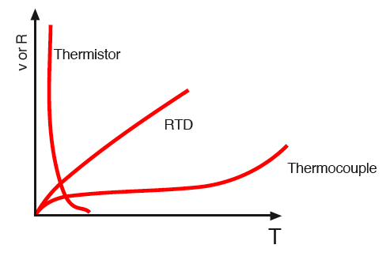
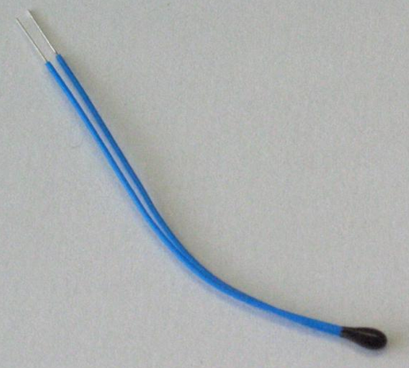
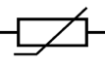

Figure 6 Voltage output versus temperature characteristic of a thermistor, RTD and a thermocouple

Positive temperature coefficient (PTC) thermistors can also be obtained by using materials such as barium, lead, or strontium. PTC thermistors are usually used to provide thermal protection for wound equipment such as electric motors and transformers. PTC thermistors are frequently embedded in the windings of the equipment to be protected, and are connected in series with the power supply. When the temperature exceeds the maximum allowable level, the PTC resistance rises and power is effectively disconnected from the load. PTC thermistors are highly effective than NTC types for thermal protection purposes since they are fail-safe: if a connection to a PTC sensor fails, the resulting high impedance will disconnect the power, [2]. Conventional thermistors are manufactured as discrete components. However, it is also possible to print thermistors on to a substrate using thick film fabrication methods. Thick film thermistors can be very low-cost and physically small, and have the further advantage of being more intimately bonded to the substrate than a discrete component. It has been shown [4] that thick film thermistors can have as good, if not better, performance than a comparable discrete component.

3. Thermocouples
When two dissimilar metals are in contact with each other, a thermal load existing over the junction of the metallic couple induces a measurable electrical potential. A thermocouple is a self-generating transducer made up of two or more junctions between dissimilar metals. The most frequently used thermocouples are designated by type letters as shown in Table 2. The conventional thermocouple temperature measurement arrangement is shown in Figure 7.a and it will be noted that one junction (the cold junction) has to be maintained at a known reference temperature, for instance by surrounding it with melting ice. The other junction is attached to the object to be measured. A more practical circuit is shown in Figure 7.b with the two wires directly
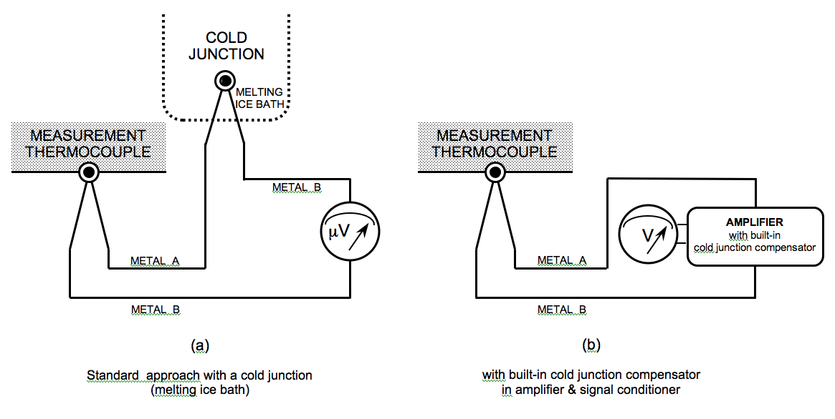

Figure 7 Conventional thermocouple arrangement

connected to a measuring circuit containing a built-in cold junction compensator. The junctions between the two wires and the voltmeter do not cause any error signal to appear as long as they are at the same temperature. Since there is no proper reference junction with this approach, the system is liable to give an erroneous output if the temperature of the surrounding environment changes. This small error may be avoided by using a cold junction compensation system in which the characteristics of the signal conditioning circuitry are modified by including another temperature sensor such as a thermistor in the circuitry. The arrangement shown in Figure 7.b is usually applied whenever thermocouples are used. The main advantages of thermocouples are their wide temperature range, (nominally from - l80 to + 1200 ^{O} C for a Chromel/Alumel couple), and their linearity [2]. Table 2 gives the uncertainty levels, temperature range and output level of some of the most common commercially-available thermocouples of seven different types.
Type | METALLIC COUPLE | UNCERTAINTY | TEMPERATURE  RANGE ^{O}C | Output level  mV
K | Nickel: chromium (Chromel)  Nickel: aluminium (Alumel) | 0 to 400 ^{O}C: ±3 ^{O}C  400 to 1100 ^{O}C: ± 1 ^{O}C | -200 to 1100 | 4.10 mV at 100 ^{O}C
T | Copper/constantan | 0 to 100 ^{O}C: ± 1 ^{O}C  100 to 400 ^{O}C: ± 1 ^{O}C | -250 to 400 | 4.28 mV at 100 ^{O}C
B | Platinum: 30% Rhodium alloy  Platinum: 6% Rhodium alloy | 0 to 1100 ^{O}C: ± 3 ^{O}C  1100 to 1550 ^{O}C: ± 4 ^{O}C | 0 to 1500 | 1.24 mV at 500 ^{O}C
E | Nickel:Chromium/Constantan | 0 to 400 ^{O}C: ±3 ^{O}C | -200 to 850 | 6.32 mV at 100 ^{O}C
J | Iron/Constantan | 0 to 300 ^{O}C: ±3 ^{O}C | -200 to 850 | 5.27 mV at 100 ^{O}C
R | Platinum:13% Rhodium/Platinum | 0 to 1100 ^{O}C: ±1 ^{O}C  1100 to 1400 ^{O}C: ±2 ^{O}C  1400 to 1500 ^{O}C: ±3 ^{O}C | 0 to 1500 | 4.47 mV at 500 ^{O}C
S | Platinum:10% Rhodium/Platinum | The same as R type | 0 to 1500 | 4.23 mV at 500 ^{O}C

Table 2 Common thermocouple types, uncertainties, range and output level

One of the most frequently used devices for temperature measurements in aerospace system applications, is the thermocouple. Thermocouples can be very small, cost effective and remarkably accurate when used with a proper understanding of their characteristics, [5]. The operational range of thermocouple based measurements in aerospace systems is quite wide. While measurements in a liquid Helium bath at a level of -270 ^{O} C are possible, temperatures in gas turbine combustors at about 1500 ^{O} C are commonly encountered. It is possible to extend this measurement range up to 2200 ^{O} C for the case of high temperature furnaces. A large number of metallic couples are available for different temperature measurement ranges. Table 3 shows the maximum measurement range and sensitivity of a number of popular metallic couples used in thermocouple construction. Most metallic couples generate a linearly changing electrical output with varying temperature in a selected range. Table 3 provides maximum temperature range and sensitivity information for only five of popular thermocouples used in a wide temperature range.

METALLIC COMBINATION | Maximum Temperature  (^{O}C) | Sensitivity  (μV/^{O} C)
0.6 Rhodiuml+0.4 Iridium-Tridium | 2100 | 5
Copper-Constantan (type T) | 370 | 40
Chromel-Alumel (type K ) | 1250 | 40
Iron-Constantan (type J) | 750 | 50
Chromel-Constantan (type E) | 870 | 60

Table 3. Five thermocouples and max temperature their sensitivity

The operating characteristics of thermocouples were first observed by Seebeck in 1821 in an experiment where he measured a net electrical potential change when the junction of a bi-metallic couple is heated to a controlled temperature level. Peltier later showed that this effect was reversible. A bi-metallic couple showed a measurable temperature increase when a small electrical current is externally imposed on the junction. Figure 8 shows induced electro motor force (EMF) voltage (mV) versus temperature ( ^{O} C) for commonly used thermocouples
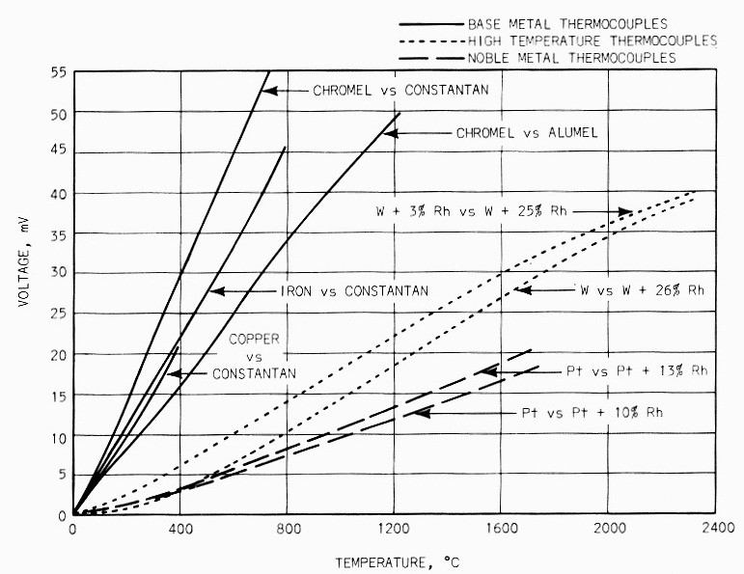
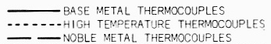

Figure 8 Induced electro motor force versus temperature for various thermocouples

including base metal thermocouples, high temperature thermocouples and noble metal thermocouples.
3.1 Principle of operation for thermocouples: A summary of thermocouple measurement principles, possibility of spurious signal generation, basic laws of thermoelectricity, thermocouple compensation, thermopiles and multiple thermocouple measurements will be discussed in the next few paragraphs. A comprehensive treatment of this topic can also be found in a lecture series monograph from the von Karman Institute for Fluid Dynamics, [5].
Materials used in thermocouple manufacturing can be classified in terms of thermoelectric polarity which indicates the slope of the EMF versus junction temperature curve. A “positive'' material produces an increase in measured EMF along its length in response to elevated temperature as shown in Figure 9. The slopes for materials in Figure 9 are relative to pure Platinum.
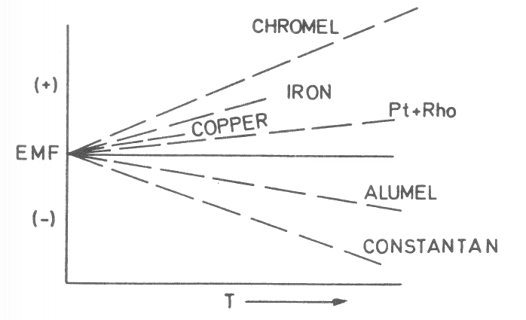
PURE PLATINUM

Figure 9 Induced electro motor force versus temperature for various thermocouple materials
© COURTESY OF THE VON KARMAN INSTITUTE, [5]

A graphical description of a basic thermocouple circuit is presented in Figure 10. This is the simplest possible measurement setup for an Iron and Constantan thermocouple. The circuit measures the temperature T_{HOT} relative to the ambient temperature T_{AMB} existing at the instrument terminals. The electrical potential V₁₋₃ measured between the junctions 1 and 3 indicates the value of (T_{HOT} - T_{AMB}). If a measurement of “T_{HOT} “ alone is desired, then the junction temperature at T_{AMB} must also be measured. The thermocouple system shown in Figure 10 provides a temperature measurement accuracy which is not better than ± 1^{O}C.
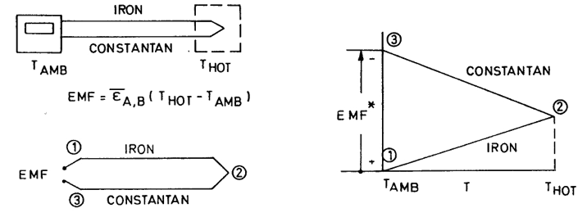

Figure 10 Thermocouple measurements with no reference zone box
© COURTESY OF THE VON KARMAN INSTITUTE, [5]

When an accurate measure of T_{HOT} is needed, a reference box is added to the measurement system as shown in Figure 11. A reference box may contain an ice bath, a triple point or an isothermal plate with precise temperature control in time. The temperature of the reference zone T_{REF} needs to be known precisely. For example, the average temperature of an ice bath containing melting ice in water maintains a temperature at about 0.01 º C. Another approach
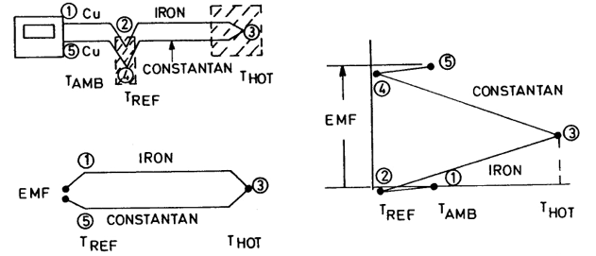

Figure 11 - Measurements with a reference zone box – using Copper connectors
© COURTESY OF THE VON KARMAN INSTITUTE, [5]
may be to electronically control the temperature of a reference slab precisely, at a carefully selected T_{REF}. Two different measurement circuits with a reference junction are possible. In Figure 11 Iron and Constantan wires form junctions 2 and 4 when they are coupled with Copper wires. The junctions 2 and 4 are both immersed in the reference box which is precisely kept at
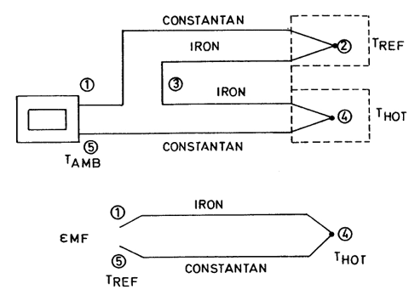
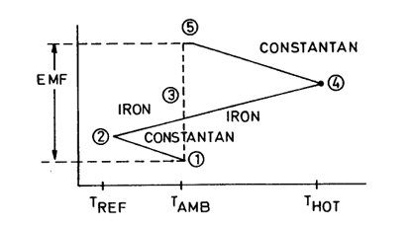

Figure 12 Measurements with a reference zone box – without Copper connectors
© COURTESY OF THE VON KARMAN INSTITUTE, [5]

T_{REF}. The small magnitude EMF values generated between 1-2 and 4-5 do not contribute to the the actual EMF measurement sampled at the ends of the Copper wires V ₁₋₅. The electrical voltage drop occurring between 1-2 and the voltage gain between 4-5 automatically cancel each other. The Copper leads do not influence the overall measurement of V₁₋₅ which is now directly proportional to (T_{HOT}- T_{REF}) . If the reference junction is a melting ice bath at T_{REF} = 0.01 º C then V₁₋₅ is directly proportional with T_{HOT}.
The second thermocouple circuit approach with a reference junction is shown in Figure 12. This approach utilizes a second identical thermocouple without any Copper connection wires in contrast to the first approach. The second thermocouple is usually kept at a known reference temperature T_{REF}. In general, T_{REF} is kept at a temperature lower than the ambient temperature, T_{AMB}. Either the ice point or the triple point for water is used for this purpose. It should be noted that measured V₁₋₂ and V₄₋₅ are two different measured voltage changes as shown in Figure 12.
3.2 Spurious signal generation in thermocouples: A thermocouple may always provide a signal unless the wires are not broken. Thermocouples are known to generate spurious signals if proper attention is not paid to a few of their important properties. Spurious EMF’s are usually generated because of excessive AC electrical noise. Electrical ground loops may also result in erroneous signals. Other significant spurious EMF problems unique to thermocouples are galvanic EMF generation, strain induced EMF's and material inhomogeneities in a thermocouple circuit and in the junction areas.

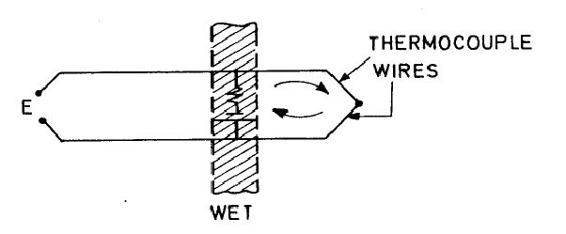
ELECTROLYTE

Figure 13 Source of spurious EMF's as a result of galvanic EMF generation form electrolytes
© COURTESY OF THE VON KARMAN INSTITUTE, [5]

3.2.1 Galvanically induced spurious EMF generation: Thermocouples involve pairs of dissimilar materials and hence are liable to galvanic EMF generation when electrolytes are in presence. Iron and Constantan wires may produce a signal as large as 250 mV when they are immersed in an electrolyte. Copper-constantan and Chromel-alumel thermocouple wires are highly sensitive to galvanically induced spurious EMF’s. When such a problem exists, the output from a thermocouple circuit will be the thermocouple EMF corresponding to (T_{HOT}-T_{REF}) plus the potential drop shown in the equivalent circuit presented in Figure 13. An active EMF source and a resistance wired in parallel with the thermocouple represents the spurious EMF generated. Generally, distilled water does not show the properties of an electrolyte. However, it is useful to know that the dye that is used to color code thermocouple wires may form an electrolyte when dissolved.
3.2.2 Strain induced spurious EMF generation: Thermocouple wires tend to generate EMF when they are subject to mechanical strain. The spurious EMF's result from changes in the slope of the EMF versus temperature curves. Strain related thermocouple problems are frequently encountered when the mechanical vibration of the sensor is at a significant level. While K type thermocouples are severely affected by strain, Copper-constantan and Iron-constantan based thermocouples show less severe strain dependency.
3.2.3 Material inhomogeneity induced spurious EMF generation: Material inhomogeneities can easily modify the EMF temperature curves of thermocouple materials resulting in spurious EMF generation. Typical inhomogeneities may include defects resulting from manufacturing, plastic deformation of the thermocouple wires, change in material composition due to oxidation, or a change in chemical composition due to gradient on the wire while keeping the rest of the wire environmental contaminants. lnhomogeneities can be detected by imposing a sharp temperature undisturbed as shown in Figure 14. If a non-uniformity exists in the region of the sharp gradient, a measurable EMF will be produced. An inhomogeneous material will measurably alter the EMF versus temperature response of thermocouple wire material.
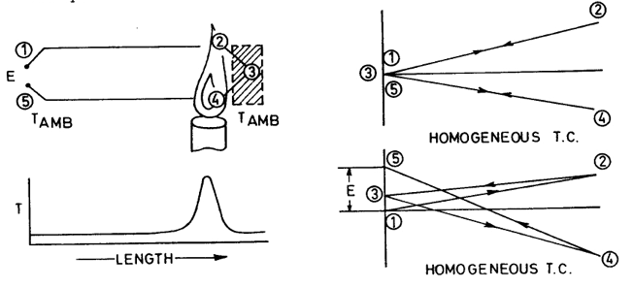
© COURTESY OF THE VON KARMAN INSTITUTE, [5]

Figure 14 Effect of wire inhomogeneities on thermocouple measurements

3.3 Laws of thermoelectricity for thermocouples: An understanding of thermocouples may be obtained by referring to a set of “laws'' given by various authors, [5]. These laws can be understood by referring to EMF versus temperature sketches.

(1)
EFFECT OF INTERMEDIATE TEMPERATURE VARIATION:
The thermal EMF of a thermocouple with junctions at T₁ and T₃ is totally unaffected by any temperature elsewhere in the circuit (i.e., T₂ ) if the two metals used are each homogeneous, Figure 15.a.
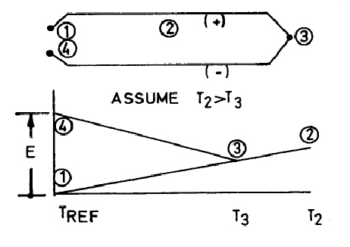

© COURTESY OF THE VON KARMAN INSTITUTE, [5]

Figure 15.a Effect of intermediate temperature variation

(2)
EFFECT OF A THIRD HOMOGENEOUS MATERIAL IN A THERMOCOUPLE CIRCUIT:
lf a third homogeneous metal, C, is inserted into either wire A or B as long as the two new thermo junctions are at equal temperatures, the net EMF of the circuit is unchanged irrespective of the temperature of C away from the junctions, Figure 15.b.
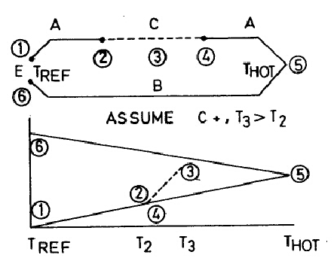

© COURTESY OF THE VON KARMAN INSTITUTE, [5]

Figure 15.b Effect of a third homogeneous material in a thermocouple circuit

(3)
EFFECT OF THIRD HOMOGENEOUS MATERIAL AT JUNCTION:
If metal C is inserted between A and B at one of the junctions, the temperature of C at any point away from the AC and BC junctions is immaterial. So long as the junctions AC and BC are both at temperature T₂ , the net EMF is the same as if C were not there Figure 15.c.
© COURTESY OF THE VON KARMAN INSTITUTE, [5]

Figure 15.c Effect of third homogeneous material at junction

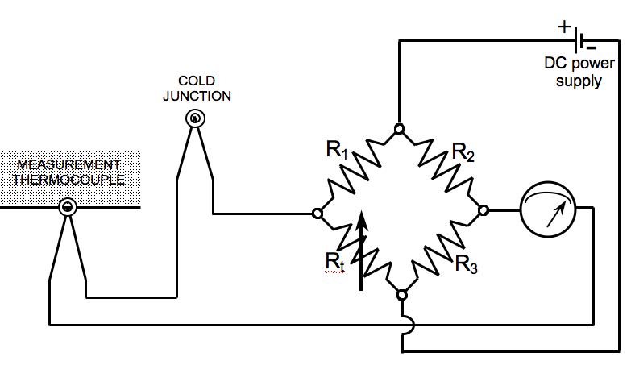
3.4 Thermocouple compensation: As noted earlier, it is not practical to have thermocouple cold junctions maintained at a controlled reference temperature. However assuming that the cold junction will not change its temperature is not realistic. It is desirable to have a compensation
Figure 16 Cold junction compensation of a thermocouple

t
a
C
D
THERMISTOR

mechanism for slight variations of the cold junction temperature around ambient temperature level. Consider the arrangement shown in Figure 16 which shows a thermocouple with its measuring junction at t ^{O} C and its cold junction at ambient temperature. The thermocouple output is E_{(a-t)}, but what is more useful is the output that would be obtained if the cold junction were at 0 ^{O}C, i.e. E_{(o-t)}. Thus, a voltage E_{(0-a)} must be added to E_{(a-t)} to compensate the output signal:

E_{(o-t)}= E_{(a-t)}+ E_{(o-a)} . (4)

The voltage E_{(o-a)} is called the “cold junction compensation voltage”, and it is generated automatically by the circuit of Figure 16 which includes a thermistor R_{t}. R₁, R₂ and R₃ are temperature-stable resistors. The bridge is first balanced when all of the components are at 0 ^{O} C. As the ambient temperature is changed away from 0 ^{O} C an unbalance voltage will be generated across CD. This voltage is scaled by selecting R_{t} such that the unbalance voltage across CD equals E_{(o-a)} in equation (4).
3.5 Multiple thermocouple arrangements: A number of thermocouples may be connected in series or parallel as shown in Figure 17 to achieve a thermopile or an averaging system. The series arrangement is used mainly as a means of enhancing sensitivity. This arrangement is usually termed as a “thermopile” as shown in Figure 17.a . All of the measuring junctions are held at one temperature T₁, and all of the reference junctions are exposed to another temperature T₂ . Since n thermocouples are connected in a series arrangement a thermopile gives an output n
times as great as that which can be obtained from a single couple. A typical commercially
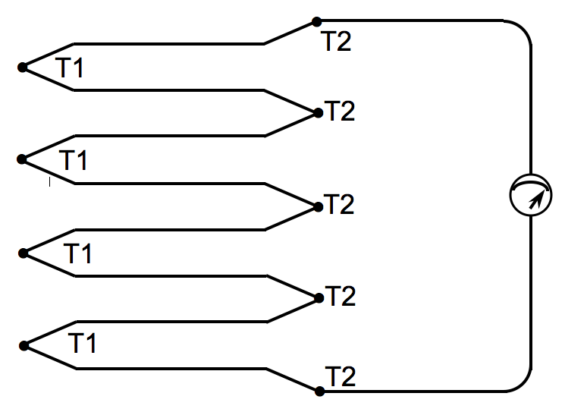
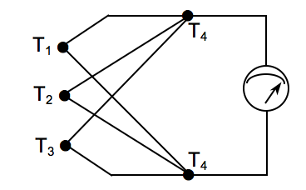
AVERAGING THERMOCOUPLES
THERMOPILE OF
FOUR THERMOCOUPLES
(a)
(b)

Figure 17 Thermopile and averaging

available Chromel/constantan thermopile has 25 junctions and produces about 0.5 mV/^{O}C.The parallel arrangement presented in Figure 17.b does not generate a voltage output as strong as the
thermopile as shown in Figure 17.a. The circuit in Figure 17.b generates about the same voltage level of a single thermocouple if all of the measuring and reference junctions are kept at a common temperature. When the measuring junctions T₁, T₂, T₃ are at different temperatures and
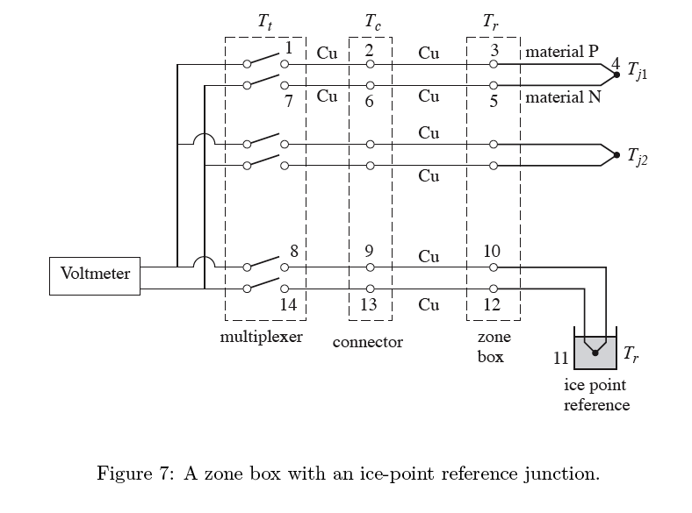
Figure 18 Arrangement for multiple thermocouple measurements at different locations

the thermocouples all have the same resistance, the output voltage is the average of the voltages generated by T₁, T₂, T₃.
Figure 18 presents a measurement system for thermocouple measurements at many different locations using the same reference junction plane. The system includes an ice point reference for the precise determination of the reference junction plate, and a multiplexer for a sequential measurement of the voltage proportional with (T_{jn}-T_{r})
3.6 Thermocouple calibration using an ice bath as a reference junction:
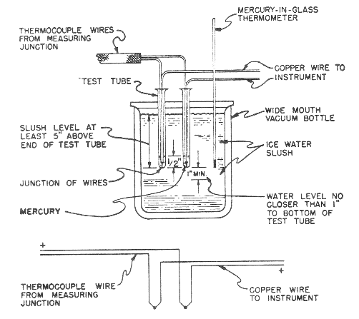

4. Bimetallic temperature sensors

Bimetallic strips are made by bonding together two metals with different coefficients of thermal expansion. Typical materials used are brass and Invar. As the temperature of the bimetallic component changes the brass side expands or contracts more than the Invar, resulting in a change of curvature.

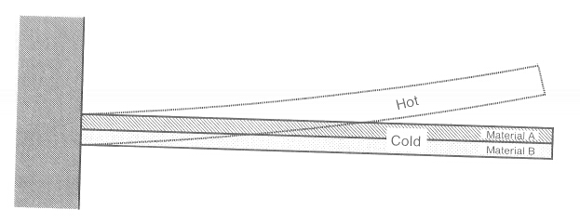

Figure 2.8 Bimetallic strip

If two metal strips A and B with coefficients of thermal expansion α_{A} and α_{B} are bonded together as shown in Fig. 2.8, a temperature change will cause differential thermal expansion to occur. If it is unrestrained the strip will deflect to form a uniform circular arc. Analysis [3] gives the radius of curvature ρ as:

(2.7)

where ρ is the radius of curvature, m is the thickness ratio, t_{B}/t_{A}, t_{B}, t_{A} are the thicknesses of strips A and B, t is the total strip thickness, n is the ratio of elastic moduli, E_{B}/E_{A} and T₂-T₁ is the temperature rise. In most practical cases t_{B}/t_{A}=∼1 and (n+1)/n=∼2 , giving

(2.8)

Equations (2.7) or (2.8) can be combined with the appropriate mechanics of solids expressions to calculate the deflections of most shapes of bimetal component, or of the forces developed by partially or completely restrained structures.

Bimetallic devices are used for low-cost, low-accuracy temperature Sensing, and as 'on-off' elements in temperature control systems. They are often used as overload cutout switches for electric motors.

5. Semiconductor diode temperature sensors
PN junctions in silicon have become popular as temperature sensors due to their very low cost. Figure 2.9 shows the forward bias characteristic of a silicon diode. It is well-known that a voltage V_{f} has to be applied across the junction before a current will flow. For silicon V_{f} (which

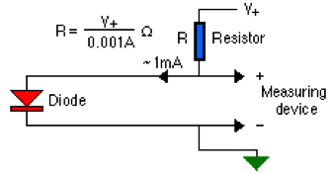
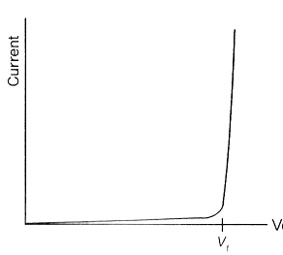
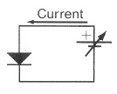

Fgure 2.9 Diode temperature transducer

is often termed the diode voltage drop) is of the order of 600-700 mV. V_{f} is temperature dependent, and is very nearly linear over the temperature range from – 50 to + 150 ^{O}C. The voltage V_{f} has a temperature characteristic which is essentially the same for all silicon devices of about - 2 mV/^{O}C.

A typical circuit is shown in Fig. 2.10. Bipolar transistors are often used instead of diodes, with the base and collector terminals connected together. For the best performance a constant current should flow through the diodes, but in practice the error incurred by driving the circuit from a constant voltage is small. There is one major disadvantage to using diodes as temperature sensors in control applications, which is that they are not fail-safe. If a diode temperature sensor is used to control, say, a heater, any breakage of the diode wires will be interpreted by the controller as 1ow temperature. More power will then be applied to the heater, resulting in an uncontrolled runaway.

6. Liquid crystal temperature sensors

A number of liquids (mainly organic) than be made to exhibit an orderly structure, in which most or a1l of the molecules are aligned in a common direction. The structure can be altered by electric or magnetic fields. Most people are familiar with the liquid crystal displays used in watches and calculators which use compounds sensitive to electric fiends. Less well- known, however, is the fact that some liquid crystal materials are temperature sensitive [3]. One application which may be familiar is the use of cholesterol compounds as medical thermometers, in the form of a flexible plastic strip which is pressed against the skin to measure its surface
temperature. The compounds involved have molecular structures similar to cholesterol, and or this reason are called 'cholesteric'. Cholesteric liquids form a helical structure, and this gives them their optical properties. The plane of polarization of light passing through the compound
may be rotated by three or more times per millimetre of path length. The structure can be enhanced by confining the cholesterol liquid between two parallel sheets of a suitable plastic. The choice of polymer or the plastic is based on two requirements. These are first, that it must
be optically transparent, and second, that it is sufficiently chemically active to bond to the liquid crystal molecules adjacent to the polymer and maintain their axes in the correct orientation. When used for temperature measurement the liquid crystal is confined between two polymer sheets as described above, a few tens of micrometers apart. The surface of one plastic sheet is given a reflective coating as shown in Fig. 2.11. In (a) a light ray enters the sandwich and is reflected back. Since the liquid crystal is in its ordered state the reflected ray interferes destructively with the incident light, and the sensor appears opaque. In Fig. 2.l1(b) the liquid crystal has been raised to a temperature at which its ordered structure has broken down due to thermal agitation.

The temperature at which this occurs depends on the exact molecular structure. It is possible to create compounds tailored to specific tempera- ture changes. If a ray of light enters the sandwich in this condition it is reflected back in the usual way, and the sensor appears to be transparent
(the colour of the backing material is usually visible). If polarized light is used this technique can detect temperature changes as small as 10 ⁻³ ^{O}C. If ordinary white light is used the resolution is of the order of 0.1 ^{O}C. The advantages of liquid crystal temperature sensors are that they are relatively cheap, and immune to electromagnetic interference. This last characteristic may make them suitable for applications where RFI problems are too severe or a conventional electronic sensor to be used. It is possible to interrogate a liquid crystal temperature sensor remotely, by means of a fiber optic link.

6.1 Using Liquid crystals in the rotating frame of reference:

7. Infra-red thermometry and pyrometery

Most people are familiar with the fact that the amount and the wave- length of radiation emitted by a body are functions of its temperature. This dependence on temperature of the characteristics of radiation is used as the basis of a non-contact temperature measurement technique in which
the sensors used are known as radiation thermometers. The total power of radiant flux of a11 the wavelengths R emitted by a black body of area A is proportional to the fourth power of the tempera- ture of the body in kelvin:

(2.9)

where σ is the Stefan-Boltzmann constant, which has the value 5.67032 x 10 ⁻⁸ W/m2 K⁴. Most radiation thermometers are based on this law, since if a sensing element of area A at a temperature T1 receives radiation from an object at temperature T2, it will receive heat at a rate σA(T₂⁴) and
will emit heat at a rate σA(T₁⁴). The net rate of heat gain is therefore σA(T₂⁴- T₁⁴) If the temperature of the sensor is small compared with that of the source T₁⁴ may be neglected in comparison with T₂⁴. The above discussion applies to perfectly black bodies with an emissivity ε of unity. 'Real' objects have non-unity emissivities, and a correction must be made for this. The total radiant flux emitted by an object of area A and emissivity ε is:

(2.10)

The flux R is equal to that emitted by a perfect black body at a tempera- ture T_{a}, the apparent temperature of the body:

(2.11)

an
Equating 2.10 and 2.11 gives:
-------
------
---
--

Radiation thermometers generally consist of a cylindrical body made from aluminium alloy or plastic. One end of the body carries a lens, which focuses energy from the target on to a detector within the tube. The lens may be made from glass, germanium, zinc sulphide, sapphire, or quartz, depending on the wavelength. The heat detectors within the instrument are generally thermocouples, thermistors or PN junctions.

8. Gas temperature measurements

9. Heat transfer measurements

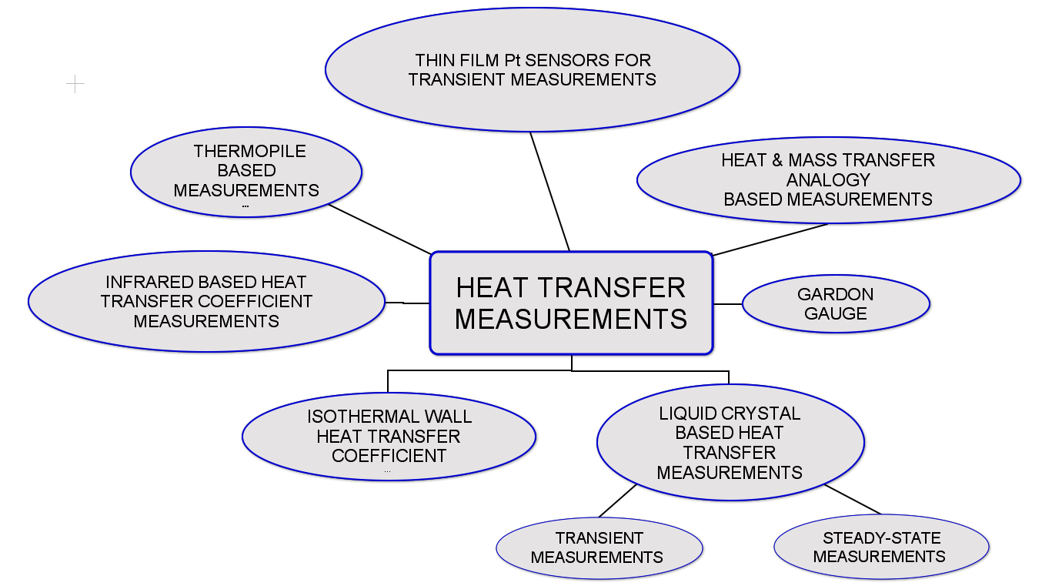

It is sometimes necessary to make local measurements of convective, radiative, or total heat transfer rates. This requirement has 1ed to the development of a class of sensors known as heat flux gauges.
One common type of heat flux gauge has the general form shown in Fig. 2.12. Two temperature measuring elements (usually thermocouples) are physically separated by a thermal insulator with known characteris- tics. When heat energy begins to pass through surface A, thermocouple
J1 generates a small voltage. Since the heat has to pass through the thickness of insulating material I to reach the second thermocouple on surface B, a different voltage is generated by J2. The differential voltage

Fig. 2.12 Heat flux gauge.

developed across Jl and J2 is proportional to their temperature difference. If the characteristics of the insulator I are known, the heat transfer rate may be obtained as a function of voltage. Heat flux gauges of this type are fabricated as a string of thermocouples on a flexible backing. Up to 30 thermocouple junctions (i.e. a thermopile) are placed on each side of the insulator to increase the sensitivity of the device. Heat flux gauges somewhat resemble strain gauges, and are bonded to the surface at which the heat flux is to be measured in a similar fashion. However, strain gauges are usually considered to be disposable, since they are relatively cheap. Heat flux gauges are expensive, and it is usual to try and remove them for re-use. A number of successful removal
techniques have been reported [4].

9.1 Time accurate thermopile based HF sensors:

9.2 Short duration wind tunnel measurements:

9.3 Steady state wind tunnel measurements:

9.4 Transient HT measurements using liquid crystals:

9.5 Steady state HT measurements using liquid crystals:

9.6 Gardon gauge:

9.7 Mass-heat transfer analogy based HT measurements:

References

[1] Engineering Thermodynamics Work and Heat Transfer. Rogers and Mayhew.
3rd edition. Longman, 1983.

[2] Instrumentation for Engineers and Scientist. Turner and Hill. Oxford Science Publications, 1999.

[3] Temperature Measurement Instruments and Apparatus. ASME PTC 19.3, Library of Congress Catalog No. 74-76612, 1974.

[4] Investigation of the Properties of the Thick Film Thermistor Pastes. P.N. Dargie. USITT Report No. U104-2. Available from USITT, University of Southampton, Southampton SO5 9NH, UK.

[5] TEMPERATURE MEASUREMENTS Profs. T. Arts & J-M. Charbonnier VKI

[6] Measurement Systems Application and Design. E.O. Doebelin. 4th Edition. McGraw Hill,1990.

[7] The use of thin-foil heat flux gauges to determine plug closure in cryogenic pipe freezing. M.J. Burton and R.J. Bowen, In Proceedings of the 12th International Cryogenic Engineering Conference (ICEC12), Southampton, 1988.

THE LAW OF INTERMEDIATE METALS : nserting the copper lead between the iron and constantan leads will not change the output voltage V, :regardless of the temperature of the copper lead. The voltage V is that of an Fe-C thermocouple at
temperature T1.

THE LAW OF INTERIOR TEMPERATURES: The output voltage V will be that of an Fe-C couple at Temperature T, regardless of the external heat source applied to either measurement lead.

THE LAW OF INSERTED METALS: The voltage V will be that of an Fe-C thermocouple at temperature T, provided both ends of the platinum wire
are at the same temperature. The two thermocouples created by the platinum wire (FePt and Pt -Fe) act in
opposition. All of the above examples assume the measurement wires are homogeneous; that is, free of defects and impurities.

