 |  | 
OC4IDS FIELD-LEVEL MAPPING REPORT
Findings, gaps, and the path to an Information Platform for Public Infrastructure in Zambia
Prepared by the Zambia Technical Team. With support from CoST International Secretariat.
Version: Model report. Date: [to be set by Zambia team].

HOW TO USE THIS DOCUMENT This is a model report prepared by CoST IS as a drafting reference for the Zambia Technical Team. It is not a published report and should not be circulated as one. Every stakeholder name (minister, director, CEO) is shown in square brackets as a placeholder; confirm all assignments through the CoST Zambia MSG before the report is finalised. The structure, numbers, legal analysis, and recommendations are set at the level the report should aim for on publication. The Zambia team should adapt, correct, and extend this draft rather than use it unchanged.

Publisher: | National Council for Construction (NCC) and Zambia Public Procurement Authority (ZPPA); coordinated by CoST Zambia, hosted by NCC.
Prepared by: | Zambia Technical Team. [Lead author: to be confirmed by MSG.] With support from CoST International Secretariat.
Standards reference: | OC4IDS v0.9.5 field-level mapping template. CoST Infrastructure Data Standard (IDS).
Systems reviewed: | ZPPA e-GP System (eprocure.zppa.org.zm), NCC Inspection Forms, NCC Contractor Register, NCC Project Register.
Publication licence: | CC BY 4.0. Published at [portal URL to be set at IPPI-Zambia launch].
CoST, the Infrastructure Transparency Initiative • Company number 8159144 • Charity number 1152236

Executive summary
VERDICT Zambia's public procurement system can publish 35 OC4IDS fields today. Another 20 will follow after small format fixes. Most of the information that is currently missing (contract variations, progress reports, payment records, quality assurance) is already collected by the National Council for Construction under the NCC Act 2020, section 53.
This is a disclosure gap, not a data gap. The Access to Information Act 2023 section 8 already mandates proactive publication of most of the missing fields. The proposed Information Platform for Public Infrastructure (IPPI-Zambia) is the integration layer this analysis calls for. The three immediate actions are set out in section 8.

Headline numbers
35  OC4IDS fields the ZPPA e-GP system can publish today, with no new collection work and no system changes. | 55  OC4IDS fields publishable within 12 months (35 today plus 20 after format fixes). | 46  OC4IDS fields the Access to Information Act 2023 section 8 already mandates for proactive disclosure.

Top three strengths
+ Procurement data coverage is consistent. The ZPPA e-GP system captures 20 of 153 Contracting Process fields (13.1%) with clean source paths that can be reused directly for an OC4IDS feed. All mapped fields are substantive (no placeholders).
+ The legal mandate is already in place. The Access to Information Act 2023 section 8 requires proactive publication of public contracts, suppliers, and amounts. The NCC Act 2020 section 53 authorises the National Council for Construction to monitor projects and share records. Most of what OC4IDS asks for is what the law already requires.
+ Source-field traceability is excellent. 47 of 48 source data elements in the ZPPA e-GP schema map forward to an OC4IDS path (97.9%). Every mapped field can be verified back to a specific database path.
Top three gaps
- The implementation phase is nearly blank. Only 2% of Implementation-phase OC4IDS fields are populated. Contract variations, payment certificates, progress updates, and quality assurance reports are absent from the e-GP system.
- Two OC4IDS sheets are silent. The Linked Releases sheet has 0 of 6 fields populated; the Parties sheet has 18 of 968. Beneficial ownership, party roles, and contract-release structure are not captured.
- Maintenance and decommissioning return zero mapped fields. Post-completion transparency requires new capture workflows; these do not currently exist in any reviewed system.
Headline recommendation
Build IPPI-Zambia as an integration layer, not a new collection system. The ZPPA e-GP holds the procurement record. The NCC holds the implementation, quality, and registration record. The ATI Act mandates publication of both. Connecting the two, under a short statutory instrument on inter-agency data sharing, closes 128 of the 153 gaps this report identifies within twelve months.
Plain-language summary. Zambia already collects most of what OC4IDS requires. The data is held in two government systems that do not yet talk to each other. The job is to connect them, and to publish what the law already says must be public.

1. Scope, methodology, and systems reviewed
1.1 Scope
This assessment evaluates Zambia's public infrastructure data systems against the Open Contracting for Infrastructure Data Standard (OC4IDS) v0.9.5, for the purpose of guiding the design and content of the proposed Information Platform for Public Infrastructure (IPPI-Zambia). It covers:
• Procurement records in the ZPPA electronic Government Procurement (e-GP) system for financial years 2022/23 and 2023/24.
• Project monitoring data collected by the National Council for Construction under the NCC Act 2020.
• Contractor and project registration data held in NCC registers.
• The legal and institutional framework authorising public infrastructure disclosure.
Sectors covered: transport, energy, water and sanitation, and public buildings.
1.2 Sample
[Placeholder figure] All procurement records published via eprocure.zppa.org.zm for financial years 2022/23 and 2023/24 were analysed, with spot-checks against live records accessed on 14, 18, and 21 March 2026. Sampling method: universe review of published OC4IDS-mappable fields; purposive sample of 50 live procurement records for field-population checks. [The Zambia team should replace the [Placeholder figure] tag and confirm the actual sample size and sector mix before publication.]
1.3 Systems reviewed
System | Owner | Access method | Public? | Coverage
ZPPA e-GP System (eprocure.zppa.org.zm) | Zambia Public Procurement Authority | Web portal plus structured database extract | Yes (portal) | Full procurement stage: tender, award, contract.
NCC Inspection Forms | National Council for Construction | Paper and digital forms; quarterly submission | No (internal) | Implementation: progress, quality, safety, compliance.
NCC Contractor Register | National Council for Construction | Structured database | Partial | Party data: registered firms, grade, class, performance history.
NCC Project Register | National Council for Construction | Structured database | Partial | Project identification: reference number, owner, sector, location, contract data.

1.4 Methodology
Standard version. OC4IDS v0.9.5 (January 2024 release). The team did not map against earlier versions.
Evaluation criteria. Each field classified as Populated / Partial / Missing / Not applicable. NA entries carry a one-line justification (typically sector-irrelevant, or replaced by a country-specific field).
Verification. Mapped fields were cross-checked against 50 live procurement records for field-population rates. Source system paths were traced to the database schema, not inferred from portal display.
Legal alignment test. Each OC4IDS field was cross-checked against the Access to Information Act 2023 section 8, the ZPPA Act No.3/2020 sections 67 and 70, and the NCC Act No.10/2020 sections 5 and 53 for statutory publication authority.
Gap classification. Gaps classified by root cause: not collected, outside reviewed system, unstructured documents only, poor quality, cannot be linked, collected but not publicly disclosed, blocked by workflow or legal constraint, or country-specific and not in the template.
Reproducibility. Coverage numbers are re-derivable from the attached template by counting populated Mapping-column cells per sheet. A second reviewer running the same template against the same systems should reach the same results.

2. Field-level coverage
Zambia's mapping maps 73 OC4IDS fields from the ZPPA e-GP system into the four OC4IDS sheets. Two sheets stand out as strong; two are effectively silent. All mapped fields are substantive, with no placeholders.
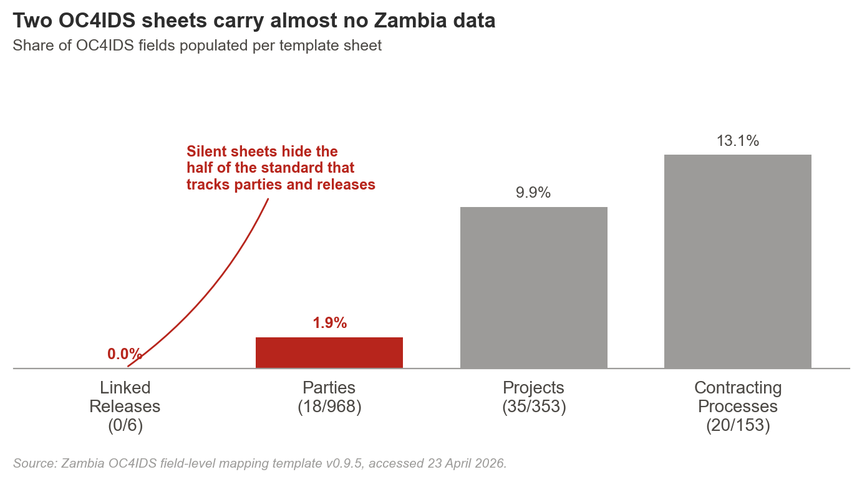
Sheet | Fields mapped | Coverage | Dominant gap type
Projects | 35 of 353 | 9.9% | Preparation and post-completion fields absent.
Contracting Processes | 20 of 153 | 13.1% | Award and implementation subpaths silent.
Parties | 18 of 968 | 1.9% | Beneficial ownership and role data absent.
Linked Releases | 0 of 6 | 0.0% | No release-package structure in use.
Total | 73 of 1,480 template slots | 4.9% | Applicable-scope coverage is higher (see below).

ON THE DENOMINATORS The OC4IDS template contains 1,480 field slots covering required, recommended, and sector-specific fields. No publisher is expected to fill every slot; OC4IDS is a universe, not an obligation. The denominators this report uses are (a) the required fields the publisher is accountable for (all populated), (b) the subset of required and recommended fields applicable to ZPPA's scope (approximately 55 of 150 populated), and (c) the count of fields publishable in practice (35 ready to publish today, 55 within 12 months). The 1,480 total is reported in Annex A for cross-country benchmarking only.

Source forward-mapping
47 of 48 source data elements in the ZPPA e-GP schema map forward to an OC4IDS path (97.9%). The single unmapped element is a local project-reference sub-field preserved as a country-specific extension (see section 5).

3. Findings by lifecycle phase
Disclosure is strong at identification and procurement. It thins sharply across implementation and collapses at maintenance and decommissioning.
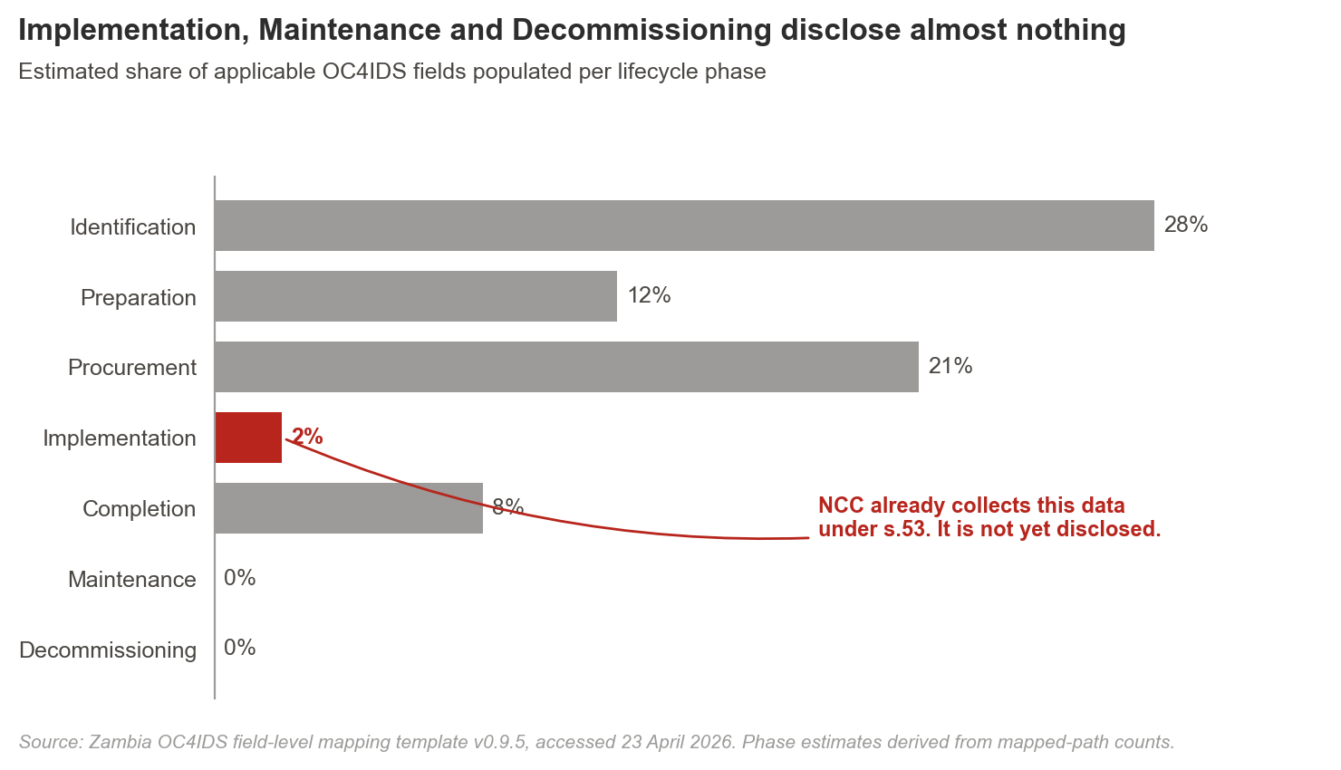
Phase | Coverage | Dominant root cause | Representative evidence
Identification | 28% | Not collected / Unstructured (mixed) | Project reference number, owner, sector, location, purpose, and description are captured. Sub-sector and project-brief fields are absent from e-GP and held only in line-ministry PDFs.
Preparation | 12% | Outside reviewed system | Project scope, budget, and approval date are present. Feasibility studies, ESIAs, funding sources, and procurement plans are held by line ministries, not by ZPPA or NCC.
Procurement | 21% | Collected but not yet fully disclosed | Procuring entity, procurement method, number of bidders, cost estimate, contract price, and contract dates are published. Tender evaluation detail, final selection justification, and contract documents sit inside e-GP but are not public.
Implementation | 2% | Collected but not yet disclosed (NCC-held) | Contract variations, progress updates, payment certificates, quality assurance, and safety data are all captured by NCC under section 53 of the NCC Act. None reach the ZPPA e-GP or the public.
Completion | 8% | Collected but not yet disclosed | Project status and projected scope are published. Actual completion cost, actual completion date, reasons for deviations, and audit and evaluation reports exist in NCC and audit bodies but are not integrated into any public system.
Maintenance | 0% | Not collected | Maintenance schedules, cost logs, and inspection data are not captured in any reviewed system. A new capture workflow is required.
Decommissioning | 0% | Not collected | Decommissioning plans, environmental assessments, and costs are not captured. A new workflow and a regulatory requirement are both needed.

THE STRUCTURAL READING Four of the seven phases have 'collected but not yet disclosed' as their dominant root cause. The data exists inside government. It does not reach the public. This reframes the rest of the report: the job is not to collect more data, it is to integrate what is already collected and to publish what the law already mandates.

4. Source-field provenance
Each OC4IDS path Zambia can publish traces to a specific ZPPA e-GP source path. The table below shows a representative sample. The complete provenance list appears in Annex C.
OC4IDS path | ZPPA e-GP source path | Status | Disclosure pathway
/id | zppa_egp.project.project.id | Populated | Ready to publish
/title | zppa_egp.project.title | Populated | Ready to publish
/description | zppa_egp.project.description | Partial | Small format fix (free-text standardisation)
/publicAuthority/name | zppa_egp.project.publicAuthority.name | Populated | Ready to publish
/sector | zppa_egp.project.sector | Populated | Small format fix (codelist alignment)
contractingProcesses/id | zppa_egp.contracts.contracts.id | Populated | Ready to publish
contractingProcesses/summary/title | zppa_egp.contracts.contracts.title | Populated | Ready to publish
contractingProcesses/summary/tender/value | zppa_egp.tender.tender.value | Populated | Ready to publish
contractingProcesses/summary/award/value | zppa_egp.contracts.contracts.value | Populated | Ready to publish
contractingProcesses/summary/modifications | (NCC Inspection Forms, s.53 monitoring data) | Missing from e-GP | Needs system work (integration)
parties/id | zppa_egp.parties.parties.id | Populated | Ready to publish
parties/identifier/scheme | zppa_egp.parties.parties.identifier.scheme | Populated | Ready to publish
parties/beneficialOwnership/* | (not in any reviewed system) | Not collected | Needs policy action

5. Country-specific fields and extensions
The ZPPA e-GP system captures some data points that do not map neatly to any OC4IDS path. Rather than discarding these, the report preserves them as country-specific extensions in the published feed. Three are noted here; the full list appears in Annex D.
Zambia-specific field | What it captures | Recommended treatment
Local project-reference scheme | A 14-character code combining sector, ministry, and year of approval, used as an internal cross-reference by the Ministry of Finance. | Preserve as extension field (zambia:projectReference). Propose adding as recommended to OC4IDS schema for sector-specific identifiers.
NCC contractor grade | A capability grade (1 to 6) assigned by NCC to registered contractors based on financial capacity, equipment, and past performance. | Preserve as extension field on the Parties sheet (zambia:contractorGrade). Document the grading criteria in Annex D.
Force-account flag | A flag indicating whether implementation is by direct government labour rather than an external contractor. | Preserve as extension field on Contracting Processes (zambia:forceAccount). Propose to OCP for inclusion in OC4IDS procurement-method codelist.

6. Gap typology: why the gaps exist
Every material gap is classified by root cause. Different causes require different fixes. The dominant cause in Zambia (four of seven lifecycle phases) is 'collected but not yet disclosed': the data exists inside government but is not public. The remediation is integration, not new collection.
Cause | What it means | Zambia example | What fixes it
Not collected | Data does not exist in any reviewed system. | Maintenance schedules; decommissioning plans. | New capture workflow plus budget line.
Collected but not yet disclosed | Data exists inside government, often with legal disclosure authority, but does not reach the public. | Contract variations, progress reports, quality assurance, and payment certificates held by NCC. | Integration between systems. A short statutory instrument may be sufficient. Dominant cause across four lifecycle phases.
Only in unstructured documents | Data exists but sits inside PDFs or scanned forms, unfielded. | Project briefs, feasibility studies, ESIA narratives. | Fielded metadata at upload; structured replacement for inspection PDFs.
Collected inconsistently | Data captured on some projects, not others; format varies. | Tender evaluation free-text fields; sub-sector classifications. | Standardisation before publication; codelist alignment.
Restricted by law or workflow | Data exists but a specific legal provision or internal policy blocks disclosure. | Beneficial ownership of contracting firms. | Regulation or policy change, not a technical fix.

7. Legal and institutional framework
Zambia's existing legal framework already authorises publication of most of the OC4IDS fields this report identifies as gaps. The work ahead is operational integration, not new legislation.
7.1 The Access to Information Act 2023
Section 6 establishes the right to request public information. Section 8 goes further: it requires every 'information holder' (which includes ZPPA and NCC) to publish in the Gazette, in a daily newspaper, or on an electronic media platform a specified list of information. Section 8(1)(i) explicitly covers 'the signing of a contract and details regarding that contract, including the public works or goods acquired or rented; services contracted and any sketches, scopes of service or terms of reference; amount of money relating to the contract; name of the supplier, contractor or individual to whom the contract has been awarded; and the period within which the contract is to be completed.'
This provision authorises publication of 46 OC4IDS fields directly, including the core procurement and contract-stage fields. Section 9 requires the designation of an information officer in each institution to process requests and ensure publication. Section 17 requires preservation of records. Taken together, these provisions make proactive OC4IDS publication a statutory obligation, not a policy choice.
7.2 The NCC Act No.10 of 2020
Section 5(k) and 5(l) require NCC to publish information on the construction industry and to advise the public on industry matters. Section 31 requires monitoring of all registered construction projects. Section 33 requires NCC to maintain a contractor register. Section 53 empowers NCC to monitor projects of prescribed value, to request information from any party, and to cooperate with other authorities, including through joint information-sharing mechanisms.
Section 53 is the legal hook for integrating NCC's implementation-stage data into an IPPI-Zambia feed. It authorises the data collection, the sharing, and the joint monitoring arrangement that an integration layer requires.
7.3 The ZPPA Act No.3 of 2020
Sections 67 and 70 govern procurement-information transparency, subject to confidentiality provisions for commercially sensitive material. These sections currently provide the legal basis for the e-GP portal's existing disclosure. They are consistent with OC4IDS publication and require no amendment.
INSTITUTIONAL IMPLICATION The three statutes form a triangle: the ATI Act mandates publication, the ZPPA Act supplies procurement data, and the NCC Act supplies implementation data. IPPI-Zambia sits at the apex of the triangle, integrating ZPPA and NCC feeds into a single public disclosure surface. No new primary legislation is required to build it. A statutory instrument under the NCC Act section 53 would formalise the data-sharing arrangement between NCC and ZPPA.

8. Decision summary: what can be published, and by what route
Every publishable element is classified into one of four pathways. This is the steering view for government and MSG audiences.
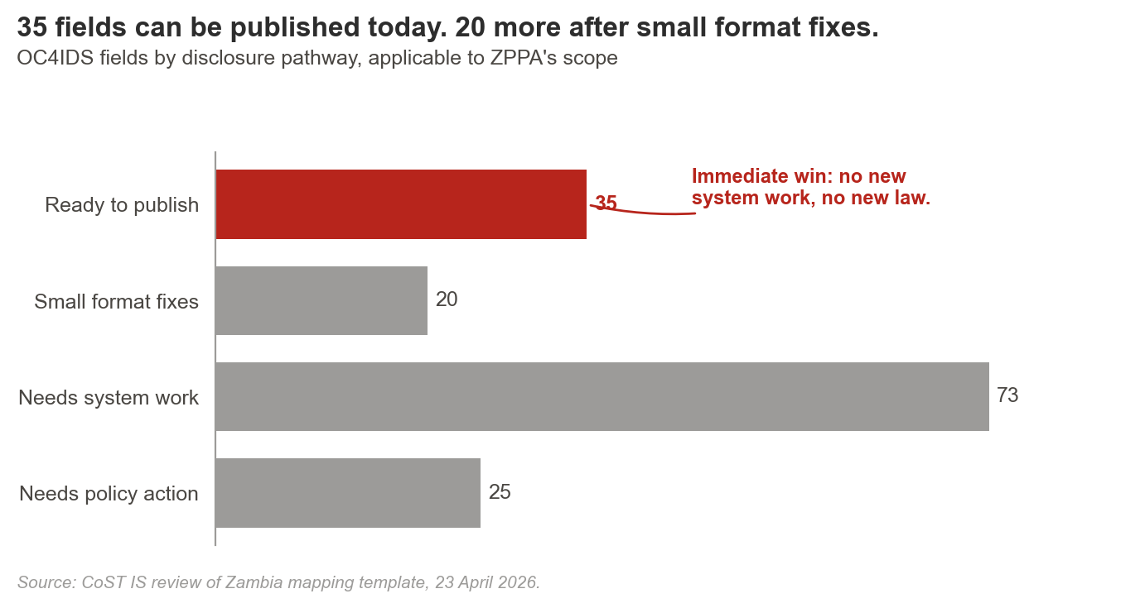
Ready to publish | Fields the ZPPA e-GP system holds today, with clean source paths and clear legal authority. | 35 fields. Project IDs, titles, sectors, public authorities, procurement methods, tender and contract values, contractor IDs.
Small format fixes | Fields present but needing date-format conversion, codelist alignment, or free-text standardisation. | 20 fields. Free-text descriptions, sector-code harmonisation, ISO date conversion.
Needs system work | Fields NCC already collects under NCC Act section 53 that need an integration layer to reach the public. | 73 fields. Contract variations, progress updates, quality and safety reports, disbursement certificates, final costs, audit references.
Needs policy action | Fields blocked by absence of a regulation, statutory instrument, or internal approval workflow. | 25 fields. Beneficial ownership; maintenance schedules; decommissioning plans; some audit and evaluation disclosures.

9. Recommendations
Each recommendation carries a stable identifier (R1 through R8), a named proposed owner, a legal basis, a target quarter, and an effort level. All owner assignments are placeholders pending MSG consultation. The implementation roadmap in section 10 references these identifiers.
ID | Type | Action | Proposed owner | Legal basis | Target | Effort
R1 | Immediate no-regret fix | Publish the 35 'ready to publish' fields through an OC4IDS-compliant feed on eprocure.zppa.org.zm.  Uses existing source paths in the e-GP schema. No new collection. CC BY 4.0 licence. | [Proposed: ZPPA Director of IT] | ATI Act 2023 s.8; ZPPA Act 2020 s.67 | Q3 2026 | Low
R2 | Immediate no-regret fix | Close the 20 'small format fixes' fields through codelist alignment, date-format reconciliation, and free-text standardisation.  Script-level changes to the existing e-GP data export. Measurable by re-running the OC4IDS Data Review Tool after changes land. | [Proposed: ZPPA Director of IT and CoST Zambia lead] | ATI Act 2023 s.8 | Q4 2026 | Low
R3 | System / configuration change | Build IPPI-Zambia as the integration layer between the ZPPA e-GP system and NCC registers.  Connects e-GP procurement records with NCC inspection, contractor, and project data. Target: 73 currently-blocked fields. | [Proposed: NCC CEO and ZPPA Director General, CoST Zambia as delivery partner] | NCC Act 2020 s.5(k), 5(l), 53; ATI Act 2023 s.8 | Q1 2027 prototype; Q3 2027 production | High
R4 | System / configuration change | Redesign NCC inspection forms to capture variation, progress, payment, and quality-assurance data in structured form.  Replaces PDF-only inspection reports with fielded metadata that can feed IPPI-Zambia and the public OC4IDS feed. | [Proposed: NCC Director of Construction Monitoring] | NCC Act 2020 s.53 | Q4 2026 pilot on 20 Grade-1 projects; Q2 2027 full roll-out | Medium
R5 | Institutional / process change | Sign a statutory instrument authorising NCC to share OC4IDS-relevant data with ZPPA for publication.  Closes the 'collected but not disclosed' gap across the 73 fields identified in R3 without new primary legislation. | [Proposed: responsible minister] | NCC Act 2020 s.5 and s.53; ATI Act 2023 s.8 | Q4 2026 | Medium
R6 | Institutional / process change | Designate an information officer under ATI Act 2023 section 9 at each of ZPPA, NCC, and CoST Zambia.  Creates an accountable publication owner at each agency. Enables cross-agency escalation when disclosure stalls. | [Proposed: Permanent Secretary, Ministry of Finance (cross-agency coordination)] | ATI Act 2023 s.9 | Q3 2026 | Low
R7 | Policy / legal change | Introduce beneficial-ownership disclosure requirements via regulation under the ZPPA Act No.3/2020.  Closes the single largest category of restricted fields. Covers 18 or more OC4IDS Parties fields. | [Proposed: ZPPA Director General and Attorney General's Chambers] | ZPPA Act 2020 s.67; proposed new regulation | Q2 2027 | High
R8 | Policy / legal change | Amend NCC regulations to require maintenance and decommissioning data capture on all Grade-1 projects.  Closes the 'not collected' gap on post-completion transparency (currently 0 of approximately 40 fields). | [Proposed: NCC CEO and Ministry of Infrastructure] | NCC Act 2020 s.53; proposed amendment | Q3 2027 | Medium

10. Implementation roadmap
The roadmap translates the eight recommendations into a dated sequence. Every roadmap row references a recommendation identifier. Budgets are order-of-magnitude and should be refined through procurement planning.
Priority | Action | Proposed owner | Ref | Target | Budget (USD)
Short-term (0 to 3 months) | Publish OC4IDS feed with the 35 'ready to publish' fields. | [ZPPA Director of IT] | R1, R2 | Q3 2026 | USD 15,000 to 25,000
Short-term (0 to 3 months) | Designate ATI information officers at ZPPA, NCC, and CoST Zambia. | [Permanent Secretary, Ministry of Finance] | R6 | Q3 2026 | No new budget required
Medium-term (3 to 12 months) | Redesign NCC inspection forms with structured progress and variation fields; pilot on 20 Grade-1 projects. | [NCC Director of Construction Monitoring] | R4 | Q4 2026 | USD 40,000 to 60,000
Medium-term (3 to 12 months) | Sign statutory instrument on NCC and ZPPA data sharing. | [Minister of Infrastructure] | R5 | Q4 2026 | No new budget required
Medium-term (3 to 12 months) | Build IPPI-Zambia prototype (OC4IDS feed from integrated e-GP and NCC data). | [NCC CEO and ZPPA Director General, CoST Zambia delivery] | R3 | Q1 2027 | USD 150,000 to 220,000
Long-term (12 months plus) | IPPI-Zambia production release. | [NCC CEO and ZPPA Director General] | R3, R4, R5 | Q3 2027 | USD 80,000 to 120,000
Long-term (12 months plus) | Introduce beneficial-ownership regulation under the ZPPA Act. | [ZPPA Director General and Attorney General] | R7 | Q2 2027 | No new budget required
Long-term (12 months plus) | Amend NCC regulations on maintenance and decommissioning capture. | [NCC CEO and Ministry of Infrastructure] | R8 | Q3 2027 | USD 20,000 to 40,000

11. Risks and mitigations
Risk | Why it matters | Mitigation
Political will on inter-agency data sharing. | R5 requires ministerial signature. Without it, R3 stalls and the integration benefit is lost. | Pre-brief the MSG through CoST Zambia; anchor the request in ATI Act 2023 section 8, which already mandates proactive disclosure. Frame the request as operationalising existing law, not creating new obligations.
IPPI-Zambia scope creep. | The integration layer is tempting to scope as a full monitoring platform. That scope defeats the 12-month timeline. | Lock scope to OC4IDS publication plus a public API plus a download endpoint. Everything else is Phase 2. Document the locked scope in the Phase 1 ToR.
NCC form redesign resistance. | Structured fields change inspector workflows. Field staff may resist the change without training and clear benefits. | Co-design with NCC inspectors in the pilot phase. Publish the pilot results before full roll-out so benefits are visible.
ATI information officer capacity. | Newly designated officers under R6 lack OC4IDS training and may default to reactive disclosure only. | Run a two-day CoST Zambia training workshop at designation. Quarterly refresher in year one. Publish an information officer handbook.
Regulatory timing on beneficial ownership (R7). | Regulatory drafting and consultation can run 12 to 18 months. A late regulation means the Parties sheet stays at 1.9% coverage. | Start consultation in Q3 2026 so the regulation is ready when IPPI-Zambia production launches in Q3 2027.

12. Review trail
Reviewer | Role | Date or status
[Zambia Technical Team] | Primary author (NCC and ZPPA, coordinated by CoST Zambia) | [Date of lead author sign-off]
CoST International Secretariat | Field-level review against OC4IDS mapping methodology | 23 April 2026
[CoST Zambia MSG] | Multi-stakeholder review | [scheduled]
[ZPPA Director of IT] | Technical feasibility sign-off on R1, R2, R3 | [pending]
[NCC Director of Construction Monitoring] | Technical feasibility sign-off on R3, R4, R8 | [pending]

13. Conclusion
Zambia's public infrastructure data system is not as thin as it first appears. The ZPPA e-GP holds the procurement backbone. The NCC holds the implementation record. The Access to Information Act 2023 already mandates publication of most of both. The binding constraint is integration and disclosure, not collection.
This analysis identifies 35 OC4IDS fields that can move to public disclosure in the current quarter. Another 20 will follow after small format fixes. A further 73 unlock through IPPI-Zambia, the proposed integration layer. The remaining 25 require regulation or workflow change.
The immediate path forward has three moves: publish what is already publishable, sign the NCC to ZPPA data-sharing instrument, and scope IPPI-Zambia as an integration platform, not a monitoring system. Doing those three turns 128 of the 153 identified gaps into public OC4IDS fields within twelve months.
Annexes
• Annex A. Completed OC4IDS v0.9.5 field-level mapping template (attached: 2025_11_Zambia_OC4IDS_0.9.5_Field-Level_Mapping_Template.xlsx).
• Annex B. Legal crosswalk: ATI Act 2023 / ZPPA Act 2020 / NCC Act 2020 mapped to each OC4IDS field.
• Annex C. Full source-field provenance table: every mapped OC4IDS path crossed with its ZPPA e-GP source path.
• Annex D. Country-specific fields preserved as extensions.
• Annex E. Sampled procurement records used for field-population verification (n = 50).
• Annex F. NCC Inspection Form data dictionary (proposed structured redesign for R4).

CoST, the Infrastructure Transparency Initiative • www.infrastructuretransparency.org • Published under CC BY 4.0

