­Distinct elevation patterns in snow algae communities revealed by rbcL high-throughput sequencing

Casey B. Engstrom1, Kurt M. Yakimovich1, and Lynne M. Quarmby1

2019-10-11 13:18:35

*Abstract*: Snow algae grow in melting summer snow across polar and alpine regions, reducing snow surface albedo, increasing melt rates. Despite over a century of study we still do not know what species are present in these microbiomes, nor how species composition varies from patch to patch. We used high-throughput sequencing of the plastid *rbc*L gene and 18S rDNA amplicons, and light microscopy to survey snow algae in the Coast Range of British Columbia, Canada. We found snow algae species composition varied greatly from bloom to bloom, with distinct communities above treeline and below treeline. Our findings highlight the need to consider the species composition of snow algae blooms in future research of this poorly understood microbiome.

1 Dept. Molecular Biology and Biochemistry, Simon Fraser University, 8888 University Drive, Burnaby, BC, V5A 1S6, Canada

### *Keywords*: snow algae rbcL 18S amplicon microbiome alpine community

### *Run title*: Elevation patterns in snow algae communities

### *To be submitted to*: 1) Nat Comm 2) Comm Biol 3) Frontiers in Micb 4) Env Micb

##### pagebreak

# Introduction

Snow algae are cold-adapted microalgae that bloom in melting snow (Leya 2013). Some species of snow algae produce red or orange pigments, which can color vast areas of polar and alpine snowfields. This decreases snow surface albedo, by one estimate enough to significantly increase snow melt (Ganey et al. 2017), potentially impacting drought (Staudinger, Stahl, and Seibert 2014; Barnhart et al. 2016) and snow-albedo feedback (Déry and Brown 2007). Thus, this microbiome could play an important role in the cryosphere, yet little is known about what species are present in snow algae blooms, and how communities vary from patch to patch.

Efforts to characterize snow algae communities have been hindered by incomplete taxonomy, which is currently in a state of revision. Many species names are holdovers from the days of morphology-based identification, which may not reflect genetic differences. Microalgae can look completely different from one life stage to the next (Shah et al. 2016; Salomé and Merchant 2019), but life cycle studies are lacking for most species of snow algae, as many have not been cultured. For instance, no one has observed the recently named species *Sanguina nivaloides* cells dividing in the lab or field. Whether red snow algae divide as green cells or red cells remains a topic of speculation with ambiguous microscopic evidence (Procházková et al. 2018; Novis et al. 2008).

Recent molecular work shows that strains formerly lumped together as *Chloromonas. cf. nivalis* contain four genetically-distinct lineages (Matsuzaki et al. 2019), while cells described as *Chloromonas cf. brevispina* contain at least two genetically distinct clades (Matsuzaki et al. 2015). *Sanguina* is a newly defined genera of snow algae containing two species, but due to how new this genus is further sampling could reveal more species. *Chlainomonas* is another genus of snow algae genus, originally described by morphology, but one genetic marker places this within the *Chloromonas* clade. Two species are described on the basis of morphology, but rigorous multi-marker phylogenetic work is lacking to determine whether more species may be present.

Microscopy and genetic data suggests there are distinct snow algae communities. Much of the snow algae literature has focused on the eye-catching red snow prevalent throughout polar and alpine regions (Leya 2013; Segawa et al. 2018; Lutz et al. 2016). These blooms are often dominated by red spherical cells, which until recently were referred to in the literature as *Chlamydomonas cf. nivalis*, but recent taxonomy classifies as *Sanguina nivaloides*, although synonymy was not established (Procházková et al. 2019). These blooms can contain low abundance of algae not known to produce red pigments, including *Chloromonas polyptera*, *Chloromonas cf. nivalis*, or *Raphidonema* (Lutz et al. 2016; Terashima et al. 2017). However these studies may have missed novel taxa not represented in databases because they used a closed-reference OTU binning approach , which does not allow for estimation of the diversity not represented in the database. *Sanguina* and *Chlamydomonas cf. nivalis* are only reported from sites above treeline; in contrast, *Chloromonas cf. brevispina* and *Chloromonas cf. nivalis* were prevalent below treeline (Hoham, Roemer, and Mullet 1979; Nedbalová and Lukavský 2008). Green snow algae are reported in slushy wet snow in the Arctic and Antarctic (Fogg 1967; Lutz et al. 2015; Remias et al. 2013), or in subalpine forests (Hoham, Roemer, and Mullet 1979). Several studies have found green snow to be caused by different genera than red snow, such as *Microglena* (Lutz et al. 2015), and various species of *Chloromonas* ([Hoham1979b;@Remias2013a](mailto:Hoham1979b;@Remias2013a); Terashima et al. 2017). Red snow can also be caused by *Chlainomonas*, whose distinctive large (40 m diameter) quadriflagellate red cells can be found in waterlogged snow over alpine lakes (Novis et al. 2008; Procházková et al. 2018). Whether snow algae blooms are typically dominated by a single species, or contain a diversity of species remains an open question, as high-resolution genetic comparison between communities is lacking.

Thus far, efforts to characterize snow algae communities by amplicon high-throughput sequencing (HTS) have been limited by ambiguous or nonexistent reference sequences and high 18S similarity between snow algae species (Lutz et al. 2019). To robustly compare snow algae community comparison side-by-side we used rbcL and 18S amplicon HTS and microscopy to survey 35 snow algae communities in our local mountains, to see what species were present, to compare community composition between samples, and see how they are distributed across the landscape.

# Results

# Sequencing of our 70 samples revealed a total of XX ASVs using the 18s rdna and xx ASVS using the rbcL marker … bla bla, welcome to Casey’s rodeo, im going to tell you a story now.

**Snow algae blooms harbor novel diversity**

Several OTUs were not assigned to species level due to low similarity (Fig. 1). Two OTUs of Chloromonas, one OTU of Chlainomonas, and one OTU (“Algae OTU 8”) that had best BLAST matches to both Trebouxiophyceae and Chlorophyceae algae. Algae OTU 8 has a best BLAST score of only 88%; this could represent a free-living algae found in snow, or possibly an endosymbiotic algae from a ciliate, as we noted many ciliates with green organelles in our microscopy samples. Sample X17 contained was dominated by spherical red cells superficially similar to *Sanguina*, this sample was dominated by reads of Chloromonas OTU7 and Algae OTU8. Cells in this sample had thicker cell wall, and some cells were slightly square-shaped (Fig. 4). 18S algae reads from this sample were equivocal, with best BLAST matches to both *Raphidonema* and *Chloromonas*. Currently there are just two species *Chlainomonas* in reference databases, but our results suggest there may be genetically distinct populations *Chlainomonas* at higher elevations (Fig. 1, Supp. Fig. 1, Supp. Fig 2). Some of the high elevations ASVs were classified as *Chlainomonas rubra*, however their sequence identity to C. rubra isolates is XX, possibly revealing some over classification due to lack of other references in our taxonomic database. because we only included this species in our custom snow algae reference this could have biased our classifier, possibly causing over-classification (Murali, Bhargava, and Wright 2018).

Although our rbcL primers successfully detected distinct OTUs, this is likely an underestimate of the true diversity. We did not detect any clustering within *Sanguina* using either 18S or rbcL, however when we included the homologous rbcL fragment of *S. aurentia* in our analysis it did not form a distinct OTU . Furthermore, *rbc*L is highly differentiated in *Chloromonas* relative to other microalgae (Nozaki, Onishi, and Morita 2002), which could partly explain why *Sanguina* is less differentiated than *Chloromonas* or *Chlainomonas* (Supp. Fig. 1 and 2).

**A gradient between snow algae communities**

Variation in snow algae communities was primarily driven by the presence or absence of *Sanguina nivaloides*, *Chloromonas krienitzii*, *Chlainomonas rubra*, or *Chlainomonas* OTU3 (Fig. 2a). However, most samples contained a mix of species; few samples were relatively “pure”. However, sample comparison with weighted UniFrac (Lozupone and Knight 2005) found little difference between *Chlainomonas* and *Chloromonas* dominated sites, and the presence or absence of *Sanguina* was the driving factor, which was generally found in higher relative abundance at higher elevation (Fig. 2b).

Although *Chlainomonas* is reported to only grow in slushy snow above alpine tarns (Novis et al. 2008; Procházková et al. 2018), we found *Chlainomonas* was present in low relative abundance at most sites sampled. Only one site high in Chlainomonas was near water (S9), the other Chlainomonas dominated sites were not near water, nor was the snow noticeably mushier than the surrounding snow. This does not rule out the possibility that these sites contained high moisture at some point; further sampling is needed to determine its habitat distribution.

# 

**Different alpine and subalpine snow algae communities**. *Sanguina* was more abundant in alpine sites, as well as one OTU of *Chlainomonas* and two OTUs of *Chloromonas*, while *Chloromonas krienitzii* and Chlainomonas OTU6 were found in high relative abundance below treeline (Fig. 2, 3). This consistent with the microscopy observations of Hoham, Roemer, and Mullet (1979) and Nedbalová and Lukavský (2008), who found primarily *Chlamydomonas cf. nivalis* above treeline and *Chloromonas* below treeline. However, in microscopy surveys we infrequently observed *Sanguina* below treeline, and *Chloromonas krienitzii* above treeline. We found higher diversity in samples from higher elevation, both at the ASV level and OTU level, with several OTUs that were not found at lower elevations. *Raphidonema* and related ASVs were restricted to high alpine sites, with the highest relative abundance occurring in samples from August and September. This fits with the interpretation of Stibal and Elster (2005), who suggest that *Raphidonema* is an opportunistic soil algae that blows into snow fields from surrounding dirt to colonize the snow. However, rare taxa should not be discounted as playing an important role in ecosystem functioning (Jousset et al. 2017).

Snowpack above and below treeline are very different habitats, with forest providing shade (and therefore less evaporation). The red pigment of *Sanguina* and *Chlainomonas* (astaxanthin) is likely an adaptation to high light (Gorton and Vogelmann 2003; Holzinger and Lütz 2006), and it has been suggested that *Sanguina* is adapted to the drier snowpacks that form at higher elevations (Dial, Ganey, and Skiles 2018).

# 

***Chloromonas krienitzii* is green below, turns orange at surface**. On initial visits to *Cho. krienitzii* dominated sites, green snow was hidden 2 to 5 cm below the surface of the runnel (Supp. Fig. 4). Green snow was noticeably moister than surrounding snow, in some locations containing ice lenses not found in the surrounding snowpack. By June 6 the surface of the runnel had turned orange while the snow below remained green, which persisted on three subsequent visits until the snow melted. Cell morphology at the surface closely resembled *Chloromonas cf. brevispina* “Trochiscia” (Matsuzaki et al. 2015) (Fig. 4), while green subsurface snow was dominated by green biflagellate or bipolar quadriflagellate cells (Fig. 4). Both green and orange samples were dominated by reads assigned to *C. krienitzii*, with lower relative abundance of *Chlainomonas*, which was more abundant at the surface (Supp. Fig. 3).

One possibility is that C. krienitzii cells orange pigmentation is triggered or an adaptation to higher light levels at the surface. Green cells below the surface would be protected from UV radiation. Possibly, the green cells maintain an optimal light level through phototaxis, similar to marine phytoplankton. Perhaps higher elevations typically have fewer low angle runnels that would allow a moist enough environment for *C. krienitzii*. It seems unlikely that nutrients from conifer needles would explain this, as several of our *C. krienitzii* dominated sites were in full sunlight, far from any trees.

# Discussion

We found snow algae communities were typically dominated by either *Sanguina*, *Chlainomonas* or *Chloromonas*, with secondary abundance of *Chlainomonas* or *Chloromonas* in most samples. Most samples contained a sizable proportion of secondary or tertiary OTUs, although some some contained nearly 100% *Chlainomonas rubra*, *Sanguina nivaloides*, or *Chloromonas krienitzii*. The drivers of these differences between communities remain unclear; it is likely that within the melting snowpack there may be distinct microhabitats that impacts snow algae distribution, with varying water content with topography, different light levels in shade or at depth (Gorton, Williams, and Vogelmann 2007), different daily freeze-thaw cycles, or possibly varying nutrient levels with proximity to vegetation (Hoham 1976) or bedrock (Kol 1968). Further work needs to be done to uncover the micro-habitat niches within the snowpack that allow this differentiation, and what novel species the snow microbiome might contain.

# Methods

**Field sampling and microscopy.** We collected snow algae from mountains near Vancouver, British Columbia throughout the summer of 2018. To capture the extent of snow algae diversity in our local mountains we collected as many samples as possible from different elevations, dates, mountains, and micro-habitats within the snow . In total we collected 310 colored snow samples from 13 different mountains on 33 different dates from elevations between 880 m and 2150 m above sea level. In early season we sampled at lower elevations, moving uphill as the snow algae bloom progressed upwards in elevation (Takeuchi 2013). We observed the first small spots of red snow above treeline on June 20.

We scooped samples from visibly colored snow into 50 mL centrifuge tubes using sterile technique. To prevent melting en route to the lab we stored tubes in a bag of snow. Back in the lab, we melted each sample at room temperature on the bench and removed a 1 mL aliquot for light microscopy. Immediately after, samples were stored at -20 °C for up to eight months until DNA extraction. Most samples were viewed using light microscopy, characterizing the dominant cell morphology in each sample. We prepared a slide of cells fixed in 2% gluteraldehyde, and quantified the most common cell morphologies with a cell count to 100, classifying each cell as either *Sanguina*, *Chloromonas cf. nivalis*, *Chloromonas cf. brevispina*, *Chloromonas krienitzii* *Chlainomonas*, or “other”.

# 

**DNA extraction and amplicon library preparation.** We selected 35 out of 310 samples for rbcL and 18s high-throughput amplicon sequencing. We chose these samples to represent the variation in date, elevation, geographic location, snow color, micro-habitat, and cell morphology. We freeze-dried these samples for up to 48 hours until until samples appeared completely desiccated. To allow water vapor to escape sample tubes while freeze drying we poked holes in each lid; as a safeguard against cross-contamination from airborne snow algae powder we wrapped tubes individually with paper towels. We mini-pestled 5 mg of sample at room temperature to physically rupture cell walls. Based on our observation that samples dominated by *Sanguina* cell morphologies had lower DNA yields, and had many intact cells following various lysis methods, we used 20 mg of these samples to increase our DNA yield.

To extract DNA from the crushed cells we added 800 mL 1x CTAB extraction buffer (Harbour 2009), 1% B-mercaptoethanol, 5 L each of proteinase K and RNAase A, and incubated these at 65 °C for 30 minutes. We centrifuged samples at 10,000 g for 3 minutes to pellet cell debris, then added 700 L of supernatant to an equal volume of 24:1 chloroform:isoamyl alcohol. We inverted samples to mix and centrifuged again at 12,000 g for 10 minutes. We precipitated DNA by transferring the top layer to 700 L ice-cold ethanol, which we gently mixed, and spun over Qiagen DNA columns for 30 s at 15,000 g. We washed columns twice with 70% ethanol, and finally dissolved our DNA by spinning with 50 L of sterile TE buffer. As a negative control we processed a sterile distilled water sample alongside each batch, treating it exactly the same as the other tubes.

We used rbcL as a marker gene, which offers high resolution between microalgae species (Zou et al. 2016), and has reference data for snow algae available on GenBank. We also sequenced each sample with 18S primers, due to it’s coverage across a wide range of taxa, and its ubiquity in reference databases. We designed rbcL primers to target an approximately 400 bp section of this gene, based on 20 snow algae rbcL GenBank sequences from *Chloromonas* and *Chlainomonas* (GenBank accession numbers AB434272.1, LC012752.1, LC012747.1, AF517072.1, LC012738.1, LC012739.1, AB434267.1, EU030690.1, LC360494.1, AJ001878.1, AB022225.1, DQ885964.2, DQ885962.1, AJ001879.1, AB022226.1, AB022530.1, LC012751.1, AB504764.1, EU030689.1, AB101508.1). *Sanguina* sequences were not included because they were not available at the time. We designed primers with PRIME(+) from the GCG package. These primers were rbcL369F (5’-GAA CGT GAC AAA TTA AAC AAA-3’) and rbcL870R (5’-ACC WGA YAD ACG WAG AGC TT-3’). To target 18S we used Euk1181 (5’-TTA ATT TGA CTC AAC RCG GG-3’) and Euk1624 (5’-CGG GCG GTG TGT ACA AAG G-3’) (Wang et al. 2014).

We constructed our amplicon library using a two-step PCR (Meyer and Kircher 2010). In the first PCR we amplified template DNA using our primers attached to a universal adapter, and in the second PCR we re-amplified that product to attach a 6 bp index to the universal adapter at the 3’ end. The first PCR total volume was 25 L, consisting of 1 L template, 12.5 L Q5 high-fidelity 2X MM (New England BioLabs), 1.25 L each of forward and reverse primer, and 9 L of ddH2O. The second PCR was the same except we reduced our reaction volume to 20 L by using only 5 L of ddH2O. The cycling conditions were the same for both primer pairs for the first PCR, with an initial denaturation at 98 °C for 30 s, followed by 30 cycles of 98 °C for 5 s, 58 °C for 10 s, and 72 °C for 25 s, with a final extension at 72 °C for 2 minutes. For the second indexing PCR we started with an initial denaturation at 98 °C for 30 s, then 10 cycles of 98 °C for 10 s, 65 °C for 30 s, and 72 °C for 30 s with a final denaturation of 72 °C for 5 min. After each PCR, we purified using Agencourt AMPure XP kit (Beckman Coulter). We quantified final DNA concentration with Qubit (Thermo Fisher), and standardized sample concentration for pooling. The pooled library was then loaded and run on an Illumina MiSeq V3 kit.

# 

**Bioinformatic processing.** Reads were demultiplexing using cutadapt (Martin 2011). Samples were filtered and trimmed, errors removed, dereplicated, pair end reads merged, and chimeras removed in DADA2 (Callahan, McMurdie, and Holmes 2017).

We assigned taxonomy using a custom reference databases for both rbcL and 18S, since snow algae are not well-represented in SILVA or PR2, and there is no curated database for rbcL. We made our rbcL database by downloading 30,865 algae rbcL sequences from GenBank with the query “rbcl[gene] AND (algae OR chlorophyta OR trebouxiophyceae) NOT (18s OR ribosomal OR psaB OR atpB) AND 300:2000[slen] NOT plasmid NOT unverified NOT mRNA NOT bacteria NOT mitochondrion”. We removed ambiguous snow algae annotations based on the most recent snow algae phylogeny (Matsuzaki et al. 2019). Because entries labelled as *Chloromonas cf. brevispina* and *Chloromonas cf. nivalis* are polyphyletic we re-labeled these as “unassigned *Chloromonas*”. Species designated by morphology alone that were not genetically different from other species in their genera were annotated only to genus level. We assigned rbcL ASV taxonomy using IDTaxa with threshold = 50.

To assign 18S reads we initially ran our ASVs against SILVA (Quast et al. 2013), and selected ASVs assigned to Chlorophyta. We then ran this subset of ASVs on our custom 18S snow algae database based on the following GenBank query: “(18S OR ribosomal)[gene] AND (chloromonas OR chlainomonas OR sanguina OR raphidonema OR KMY-2018) NOT (rbcL OR psaB OR atpB) AND 300:3500[slen] NOT plasmid NOT unverified NOT mRNA NOT bacteria NOT mitochondrion”. This database was edited to reflect the most recent snow algae taxonomy and remove ambiguous annotations (Matsuzaki et al. 2019; Procházková et al. 2018). We assigned taxonomy using IDTaxa with threshold = 50.

We assigned OTUs with t-SNE, based on visually distinct clusters (Maaten and Hinton 2008) (Fig. 1). We split the largest cluster (containing the vast majority of the *Chloromonas* reads) into three clusters, one containing all ASVs assigned to *Chloromonas krienitzii*, and one containing all ASVs assigned to *Chloromonas muramotoi* and *Chloromonas hohamii*. To highlight our observation that one clade of *Chlainomonas* were only found above treeline (Suppl. Fig. 1), we split *Chlainomonas* into two OTUs. The OTUs produced by this naive method were roughly consistent across different methods of visualization (Suppl. Fig. 1 and 2).

**Software information.** All analysis was conducted in R 3.6.1 with tidyverse 1.2.1, with dada2 1.12.1, DECIPHER 2.12.0, Rtsne 0.15, GUniFrac 1.1, and vegan 2.5-6. Phylogenetic analysis was carried out in IQTree (Nguyen et al. 2015) and visualized with ggtree (Yu et al. 2017).

**Data availability.** All raw fastq files are freely available on the European Nucleotide Archive under the project accession PRJEB34539. All scripts are available at cengstro.github.io/projects/sa_rbcl.

##### pagebreak

# Acknowledgments

We wish to thank Leah Tooman (Simon Fraser University) for assistance with sequencing, and Chris Rushton (Simon Fraser University) for assistance with bioinformatics. This project was funded with a Sector Innovation Grant from Genome BC (SIP016), and a NSERC Individual Discovery Grant, both awarded to LQ.

# Author Contributions

CE, LQ, and KY designed this study. Samples collected by CE with assistance from KY and LQ. KY and CE prepped samples for sequencing. All analyses were completed by CE and KY. All authors discussed the results and contributed to the final manuscript. CE wrote the manuscript with major input from LQ and KY.

# Additional information

### *Supplementary information*.

### *Competing financial interests.* The authors declare that the research was conducted in the absence of any

commercial or financial relationships that could be construed as a potential conflict of interest.

##### pagebreak

# References

Barnhart, Theodore B., Noah P. Molotch, Ben Livneh, Adrian A. Harpold, John F. Knowles, and Dominik Schneider. 2016. “Snowmelt rate dictates streamflow.” *Geophysical Research Letters* 43 (15): 8006–16. <https://doi.org/10.1002/2016GL069690>.

Callahan, Benjamin J, Paul J McMurdie, and Susan P Holmes. 2017. “Exact sequence variants should replace operational taxonomic units in marker-gene data analysis.” *The ISME Journal* 11 (12): 2639–43. <https://doi.org/10.1038/ismej.2017.119>.

Déry, Stephen J., and Ross D. Brown. 2007. “Recent Northern Hemisphere snow cover extent trends and implications for the snow-albedo feedback.” *Geophysical Research Letters* 34 (22): 2–7. <https://doi.org/10.1029/2007GL031474>.

Dial, Roman J, Gerard Q Ganey, and S McKenzie Skiles. 2018. “What color should glacier algae be?” *FEMS Microbiology Ecology*, no. January: 1–9. <https://doi.org/10.1093/femsec/fiy007>.

Fogg, G. E. 1967. “Observations on the Snow Algae of the South Orkney Islands.” *Philosophical Transactions of the Royal Society B: Biological Sciences* 252 (777): 279–87. <https://doi.org/10.1098/rstb.1967.0018>.

Ganey, Gerard Q., Michael G. Loso, Annie Bryant Burgess, and Roman J. Dial. 2017. “The role of microbes in snowmelt and radiative forcing on an Alaskan icefield.” *Nature Geoscience* 10 (10): 754–59. <https://doi.org/10.1038/NGEO3027>.

Gorton, Holly L., and Thomas C. Vogelmann. 2003. “Ultraviolet Radiation and the Snow Alga Chlamydomonas nivalis (Bauer) Wille.” *Photochemistry and Photobiology* 77 (6): 608–15. <https://doi.org/10.1562/0031-8655(2003)0770608URATSA2.0.CO2>.

Gorton, Holly L., William E. Williams, and Thomas C. Vogelmann. 2007. “The Light Environment and Cellular Optics of the Snow Alga Chlamydomonas nivalis (Bauer) Wille†¶.” *Photochemistry and Photobiology* 73 (6): 611–20. <https://doi.org/10.1562/0031-8655(2001)0730611TLEACO2.0.CO2>.

Harbour, Cold Springs. 2009. “CTAB extraction buffer recipe.” *Cold Spring Harb Protoc*. <https://doi.org/10.1101>.

Hoham, Ronald W. 1976. “The Effect of Coniferous Litter and Different Snow Meltwaters upon the Growth of Two Species of Snow Algae in Axenic Culture.” *Arctic and Alpine Research* 8 (4): 377. <https://doi.org/10.2307/1550440>.

Hoham, Ronald W., Stephen C. Roemer, and John E. Mullet. 1979. “The life history and ecology of the snow alga Chloromonas brevispina comb. nov. (Chlorophyta, Volvocales)*.” *Phycologia* 18 (1): 55–70. <https://doi.org/10.2216/i0031-8884-18-1-55.1>.

Holzinger, Andreas, and Cornelius Lütz. 2006. “Algae and UV irradiation: Effects on ultrastructure and related metabolic functions.” *Micron* 37 (3): 190–207. <https://doi.org/10.1016/J.MICRON.2005.10.015>.

Jousset, Alexandre, Christina Bienhold, Antonis Chatzinotas, Laure Gallien, Angélique Gobet, Viola Kurm, Kirsten Küsel, et al. 2017. “Where less may be more: How the rare biosphere pulls ecosystems strings.” *ISME Journal* 11 (4): 853–62. <https://doi.org/10.1038/ismej.2016.174>.

Kol, Erzsébet. 1968. *Biologie und Limnologie des Schnees und Eises*. Edited by Nagele & Obermiller. Stuttgart: Schweizerbart.

Leya, Thomas. 2013. “Snow Algae: Adaptation Strategies to Survive on Snow and Ice.” In *Polyextremophiles: Life Under Multiple Forms of Stress*. Dordrecht: Springer.

Lozupone, Catherine, and Rob Knight. 2005. “UniFrac: A new phylogenetic method for comparing microbial communities.” *Applied and Environmental Microbiology* 71 (12): 8228–35. <https://doi.org/10.1128/AEM.71.12.8228-8235.2005>.

Lutz, Stefanie, Alexandre M Anesio, Katie Field, and Liane G Benning. 2015. “Integrated ’Omics’, Targeted Metabolite and Single-cell Analyses of Arctic Snow Algae Functionality and Adaptability.” *Frontiers in Microbiology* 6: 1323. <https://doi.org/10.3389/fmicb.2015.01323>.

Lutz, Stefanie, Alexandre M. Anesio, Rob Raiswell, Arwyn Edwards, Rob J. Newton, Fiona Gill, and Liane G. Benning. 2016. “The biogeography of red snow microbiomes and their role in melting arctic glaciers.” *Nature Communications* 7 (May): 1–9. <https://doi.org/10.1038/ncomms11968>.

Lutz, Stefanie, Lenka Procházková, Liane Benning, Linda Nedbalová, and Daniel Remias. 2019. “Evaluating high-throughput sequencing data of microalgae living in melting snow: improvements and limitations.” *Fottea, Olomouc* 19 (2): 115–31. <https://doi.org/10.5507/fot.2019.003>.

Maaten, Laurens van der, and Geoffrey Hinton. 2008. “Visualizing Data using t-SNE.” *Journal of Machine Learning Research 9*, 2579–2605.

Martin, Marcel. 2011. “Cutadapt Removes Adapter Sequences from High-Throughput Sequencing Reads.” *EMBnet.journal* 17 (1): 10–12. <https://doi.org/10.14806>.

Matsuzaki, Ryo, Hiroko Kawai-Toyooka, Yoshiaki Hara, and Hisayoshi Nozaki. 2015. “Revisiting the taxonomic significance of aplanozygote morphologies of two cosmopolitan snow species of the genus Chloromonas (Volvocales, Chlorophyceae).” *Phycologia* 54 (5): 491–502. <https://doi.org/10.2216/15-33.1>.

Matsuzaki, Ryo, Hisayoshi Nozaki, Nozomu Takeuchi, Yoshiaki Hara, and Masanobu Kawachi. 2019. “Taxonomic re-examination of ‘Chloromonas nivalis (Volvocales, Chlorophyceae) zygotes’ from Japan and description of C. muramotoi sp. nov.” Edited by James G. Umen. *PLOS ONE* 14 (1): e0210986. <https://doi.org/10.1371/journal.pone.0210986>.

Meyer, Matthias, and Martin Kircher. 2010. “Illumina sequencing library preparation for highly multiplexed target capture and sequencing.” *Cold Spring Harbor Protocols* 5 (6): 1–11. <https://doi.org/10.1101/pdb.prot5448>.

Murali, Adithya, Aniruddha Bhargava, and Erik S. Wright. 2018. “IDTAXA: a novel approach for accurate taxonomic classification of microbiome sequences.” *Microbiome* 6 (1): 140. <https://doi.org/10.1186/s40168-018-0521-5>.

Nedbalová, Linda, and Jaromír Lukavský. 2008. “Ecology of snow algae in the Giant Mts and their relation to cryoseston in Europe.” *Corcontica* 45 (February): 59–68.

Nguyen, Lam Tung, Heiko A. Schmidt, Arndt Von Haeseler, and Bui Quang Minh. 2015. “IQ-TREE: A fast and effective stochastic algorithm for estimating maximum-likelihood phylogenies.” *Molecular Biology and Evolution* 32 (1): 268–74. <https://doi.org/10.1093/molbev/msu300>.

Novis, Philip M., Ronald W. Hoham, Thomas Beer, and Murray Dawson. 2008. “Two snow species of the quadriflagellate green alga Chlainomonas (Chlorophyta, Volvocales): Ultrastructure and phylogenetic position within the chloromonas clade.” *Journal of Phycology* 44 (4): 1001–12. <https://doi.org/10.1111/j.1529-8817.2008.00545.x>.

Nozaki, Hisayoshi, Keisuke Onishi, and Eiko Morita. 2002. “Differences in Pyrenoid Morphology Are Correlated with Differences in the rbcL Genes of Members of the Chloromonas Lineage (Volvocales, Chlorophyceae).” *Journal of Molecular Evolution*, no. 55: 414:430. <https://doi.org/10.1007/s00239-002-2338-9>.

Procházková, Lenka, Thomas Leya, Heda Křížková, and Linda Nedbalová. 2019. “Sanguina nivaloides and Sanguina aurantia gen. et spp. nov. (Chlorophyta):The taxonomy, phylogeny, biogeography and ecology of two newly recognized algae causing red and orange snow.” *FEMS Microbiology Ecology*, May. <https://doi.org/10.1093/femsec/fiz064>.

Procházková, Lenka, Daniel Remias, Andreas Holzinger, Tomáš Řezanka, and Linda Nedbalová. 2018. “Ecophysiological and morphological comparison of two populations of Chlainomonas sp. (Chlorophyta) causing red snow on ice-covered lakes in the High Tatras and Austrian Alps.” *European Journal of Phycology* 53 (2): 230–43. <https://doi.org/10.1080/09670262.2018.1426789>.

Quast, Christian, Elmar Pruesse, Pelin Yilmaz, Jan Gerken, Timmy Schweer, Pablo Yarza, Jörg Peplies, and Frank Oliver Glöckner. 2013. “The SILVA ribosomal RNA gene database project: Improved data processing and web-based tools.” *Nucleic Acids Research* 41 (D1): 590–96. <https://doi.org/10.1093/nar/gks1219>.

Remias, Daniel, Hans Wastian, Cornelius Lütz, and Thomas Leya. 2013. “Insights into the biology and phylogeny of Chloromonas polyptera (Chlorophyta), an alga causing orange snow in Maritime Antarctica.” *Antarctic Science* 25 (5): 648–56. <https://doi.org/10.1017/S0954102013000060>.

Salomé, Patrice A., and Sabeeha S. Merchant. 2019. “A Series of Fortunate Events: Introducing Chlamydomonas as a Reference Organism.” *The Plant Cell* 31 (8): 1682–1707. <https://doi.org/10.1105/tpc.18.00952>.

Segawa, Takahiro, Ryo Matsuzaki, Nozomu Takeuchi, Ayumi Akiyoshi, Francisco Navarro, Shin Sugiyama, Takahiro Yonezawa, and Hiroshi Mori. 2018. “Bipolar dispersal of red-snow algae.” *Nature Communications* 9 (1). <https://doi.org/10.1038/s41467-018-05521-w>.

Shah, Md Mahfuzur R., Yuanmei Liang, Jay J. Cheng, and Maurycy Daroch. 2016. “Astaxanthin-producing green microalga Haematococcus pluvialis: From single cell to high value commercial products.” *Frontiers in Plant Science* 7 (APR2016). <https://doi.org/10.3389/fpls.2016.00531>.

Staudinger, Maria, Kerstin Stahl, and Jan Seibert. 2014. “A drought index accounting for snow.” *Water Resources Research* 50 (10): 7861–72. <https://doi.org/10.1002/2013WR015143>.

Stibal, Marek, and Josef Elster. 2005. “Growth and morphology variation as a response to changing environmental factors in two Arctic species of Raphidonema (Trebouxiophyceae) from snow and soil.” *Polar Biology* 28 (7): 558–67. <https://doi.org/10.1007/s00300-004-0709-y>.

Takeuchi, Nozomu. 2013. “Seasonal and altitudinal variations in snow algal communities on an Alaskan glacier (Gulkana glacier in the Alaska range).” *Environmental Research Letters* 8 (3). <https://doi.org/10.1088/1748-9326/8/3/035002>.

Terashima, Mia, Kazuhiro Umezawa, Shoichi Mori, Hisaya Kojima, and Manabu Fukui. 2017. “Microbial Community Analysis of Colored Snow from an Alpine Snowfield in Northern Japan Reveals the Prevalence of Betaproteobacteriawith Snow Algae.” *Frontiers in Microbiology* 8: 1481. <https://doi.org/10.3389/fmicb.2017.01481>.

Wang, Yong, Ren Mao Tian, Zhao Ming Gao, Salim Bougouffa, and Pei-yuan Qian. 2014. “Optimal Eukaryotic 18S and Universal 16S / 18S Ribosomal RNA Primers and Their Application in a Study of Symbiosis.” *PLOS ONE* 9 (3). <https://doi.org/10.1371/journal.pone.0090053>.

Yu, Guangchuang, David K. Smith, Huachen Zhu, Yi Guan, and Tommy Tsan Yuk Lam. 2017. “Ggtree: an R Package for Visualization and Annotation of Phylogenetic Trees With Their Covariates and Other Associated Data.” *Methods in Ecology and Evolution* 8 (1): 28–36. <https://doi.org/10.1111/2041-210X.12628>.

Zou, Shanmei, Cong Fei, Chun Wang, Zhan Gao, Yachao Bao, Meilin He, and Changhai Wang. 2016. “How DNA barcoding can be more effective in microalgae identification: a case of cryptic diversity revelation in Scenedesmus (Chlorophyceae).” *Scientific Reports* 6 (1): 36822. <https://doi.org/10.1038/srep36822>.

# Figures

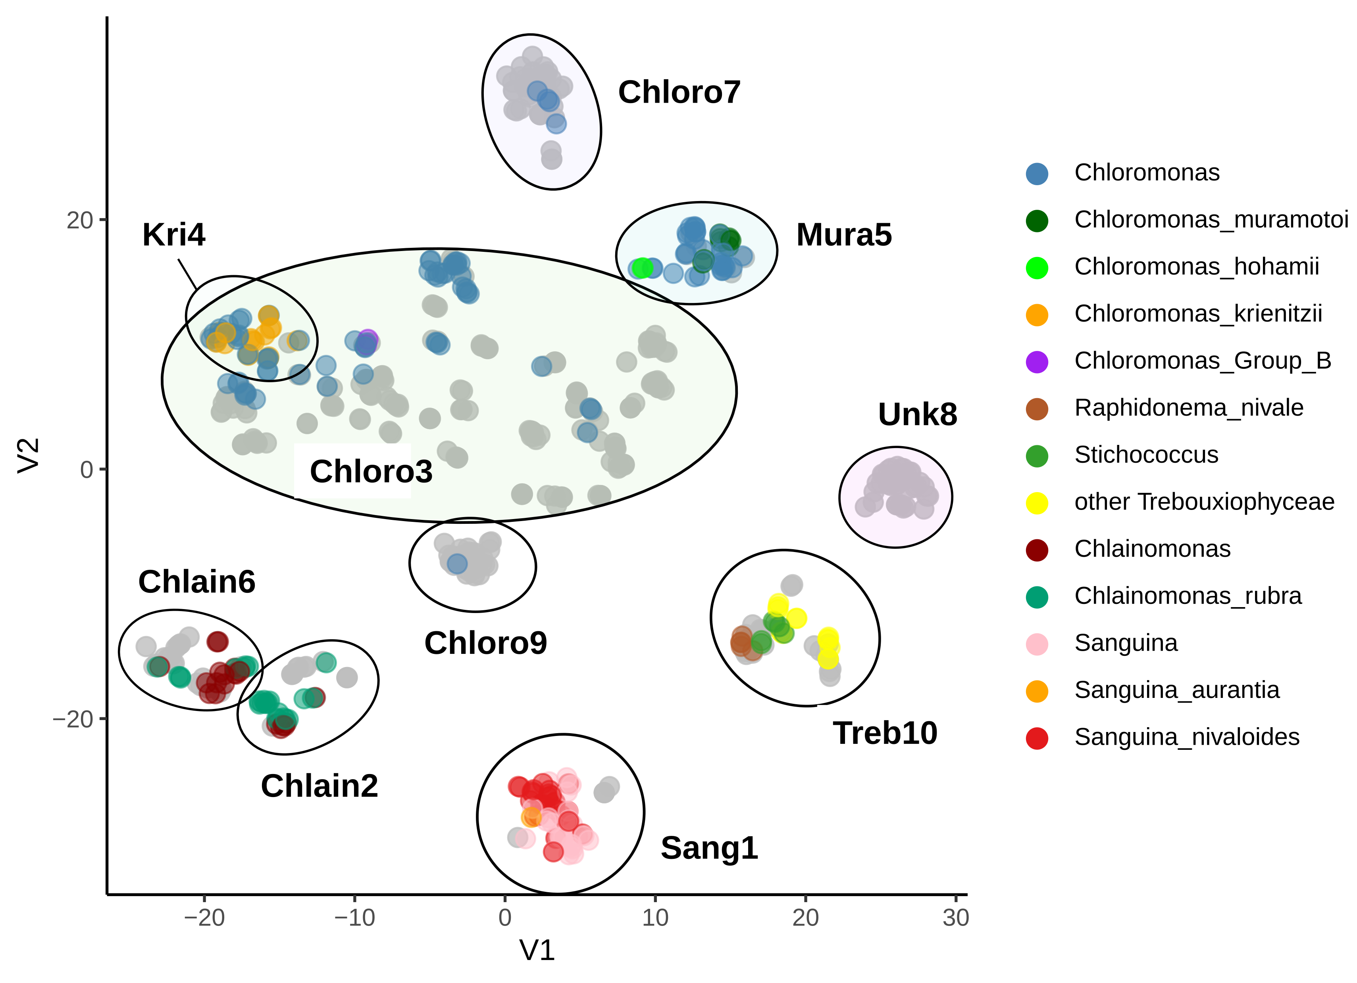

Figure 1. t-SNE clustering of snow algae rbcL amplicon sequence variants (ASVs). Colored points correspond to genus and species level assignment, grey points were not assigned at or below genus level. Labelled ellipses show OTUs. Perplexity = 30, theta = 0.5

##### pagebreak

Figure 2. Sample ordination plots. A. NMDS comparing sample similarity using OTUs, shaded by elevation. Vectors indicate relative contribution of taxa driving differences between samples. Stress = 0.183. B. NMDS showing weighted UniFrac distances between snow algae samples. Stress = 0.11.

##### pagebreak

Figure 3. Relative abundance heatmap of snow algae OTUs in each sample. Weight of color corresponds to the relative abundance of that OTU within a sample. Samples (rows) are grouped by the dominant cell morphology within that sample as determined by light microscopy. Within each morphology group samples are ordered by elevation, from low on the bottom to high on top. Sample IDs follow the convention: letters represent the mountain, and the number represents the order in which it was collected. Samples collected on the same day are labelled as .1, .2, and so on.

##### pagebreak

##### pagebreak

# Supplementary Data

Supplementary Figure 1. Maximum likelihood tree (IQTree) of snow algae rbcL ASVs. Colors correspond to OTU. Edges with bootstrap values < 80 are displayed as dotted lines.

##### pagebreak

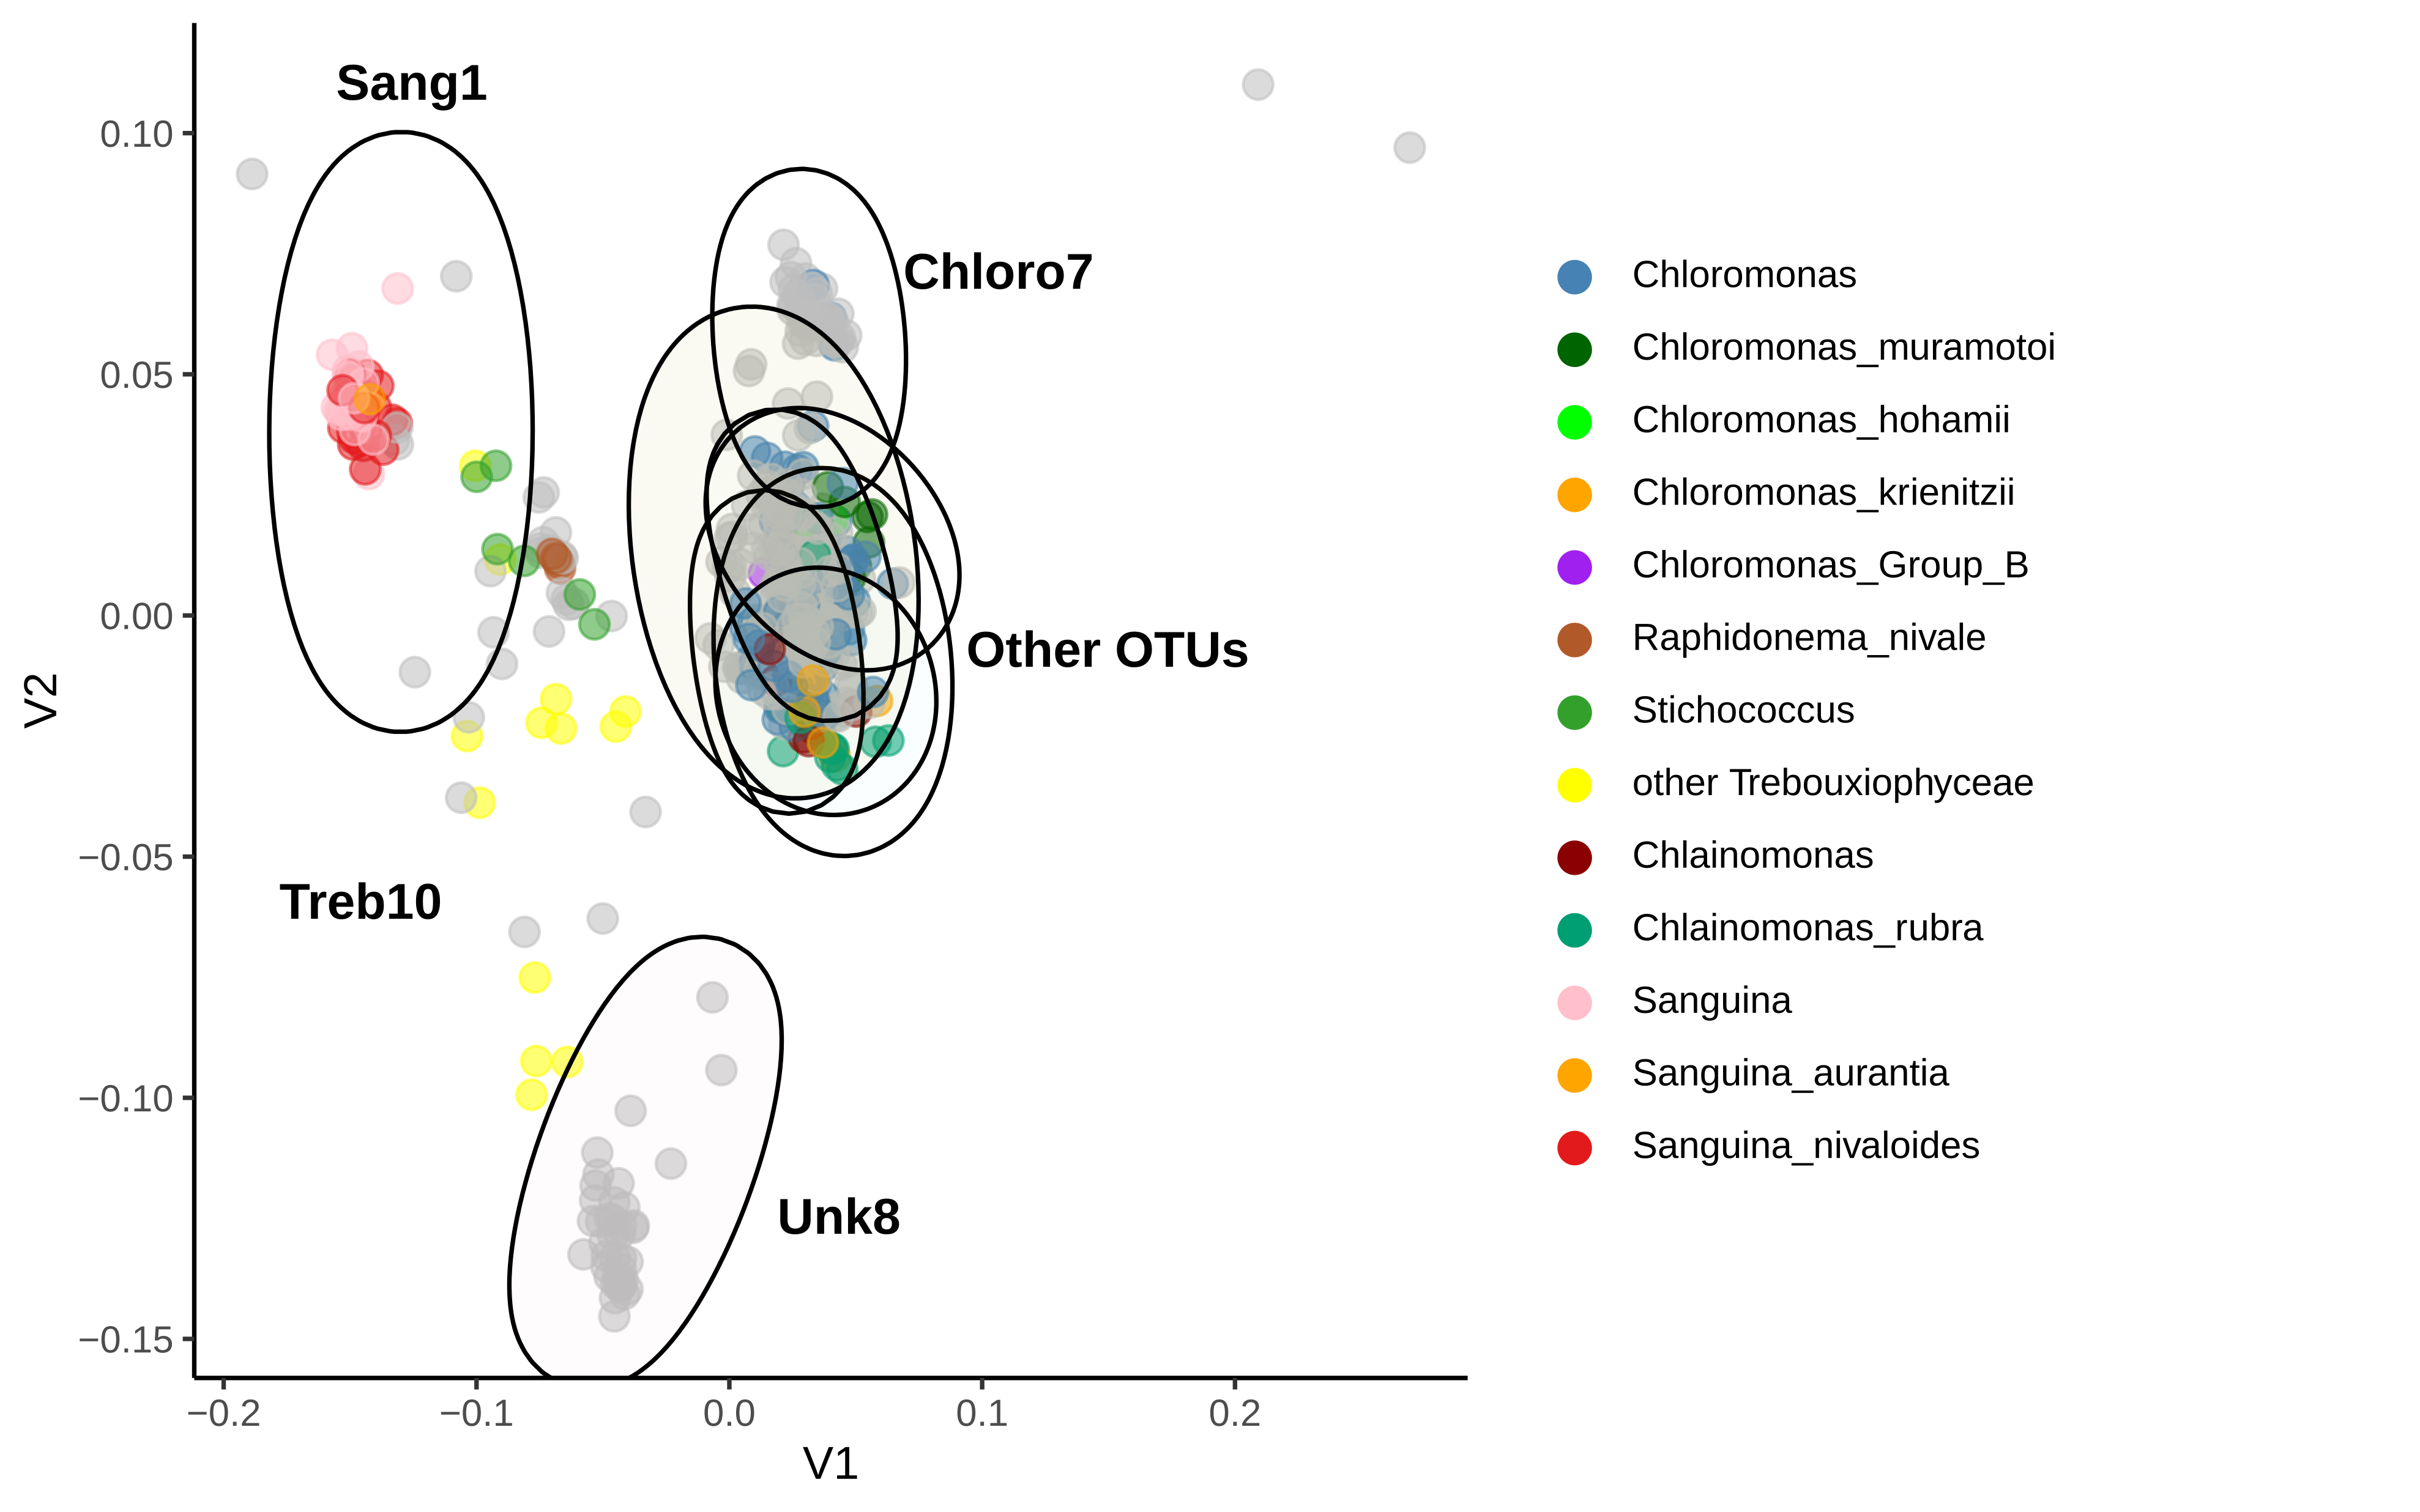

Supplementary Figure 2. MDS plot of rbcL ASVs, colored by taxa. Ellipses contain all ASVs within an OTU. Stress =

##### pagebreak

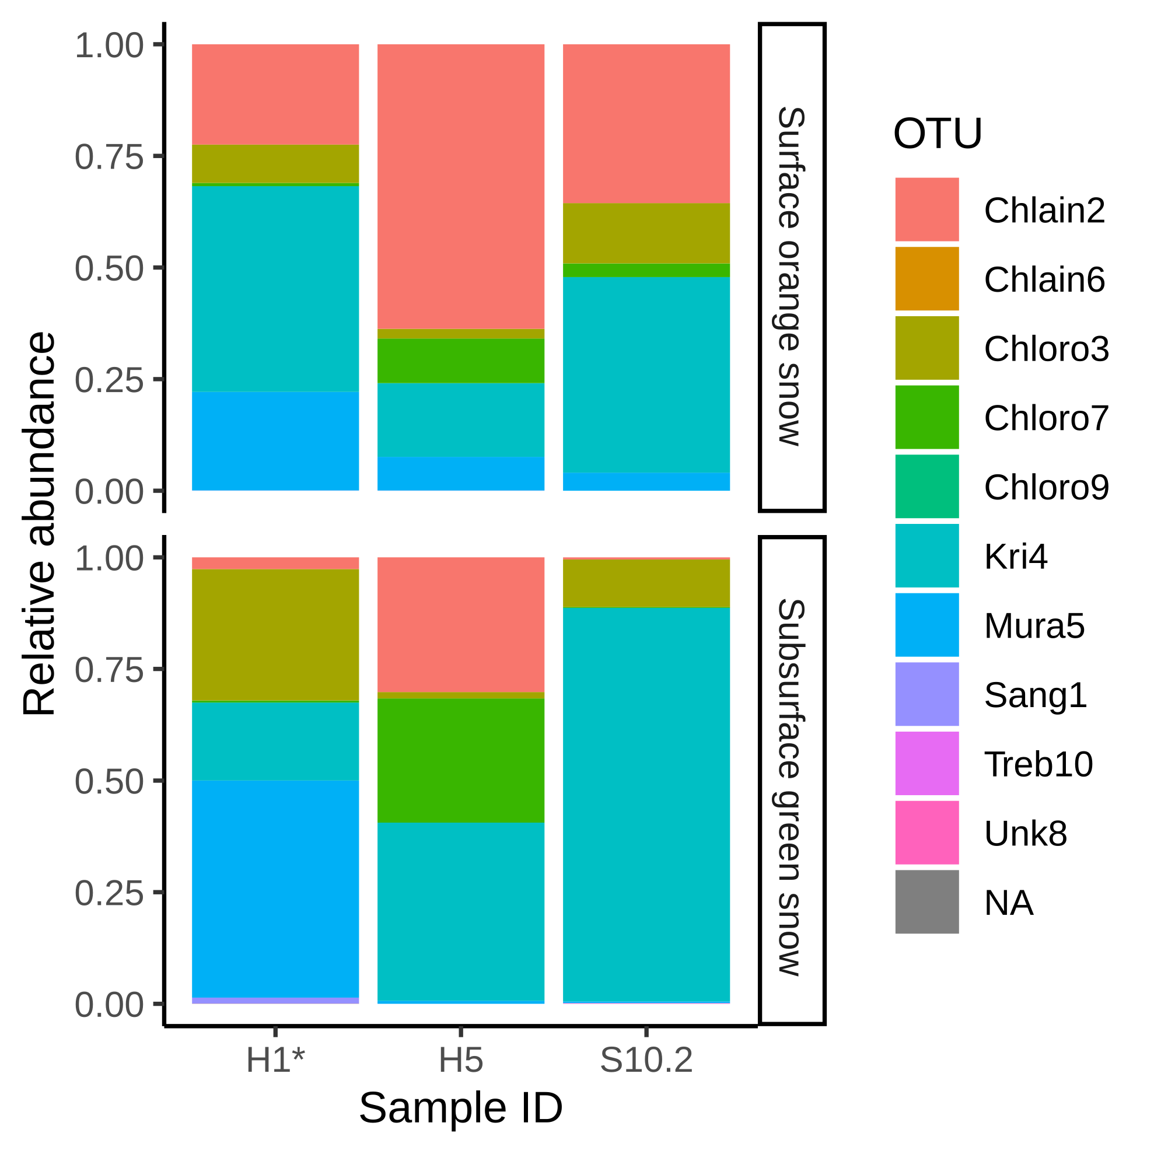

Supplementary Figure 3. Relative abundance barplots comparing community composition in surface orange snow and subsurface green snow. * designates depth and surface samples collected on different days.

##### pagebreak