I get the same policy for different values for pheads, but I get a different policy than the value iteration.

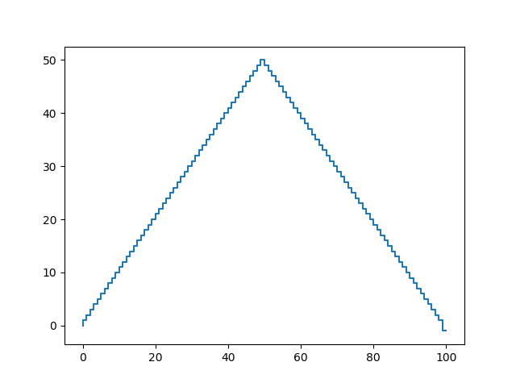

The policy I get for pheads = 0.4.

The value iteration and policy iteration have about the same runtime.