VSPC Setup Checklist and Setup Guide

Table of Contents
Site Test Checklist 2
Powering On and Accessing a Network 2
Setting up computers that will be connecting to the web application 2
Setting up computers that will be connecting to SCORE 2
Appendix A – Network Considerations 3
Appendix B – Operating System (OS) Requirements 3
Appendix C – Browser Requirements 4
Appendix D – Adobe Reader Requirements 4
Appendix E – Browser Setup 5
Using Adobe Reader with Internet Explorer: 5
Using Adobe Reader with Chrome 6
Using Adobe Reader with Firefox 7
Appendix F – Enabling Active X in Internet Explorer 8
Appendix G – Citrix Requirements 10

Site Test Checklist
Prior to the start of in–person voting, the items in this checklist should be completed for each VSPC location that will be used.

Powering On and Accessing a Network
□ | 1. | Verify that the computer station has access to an adequate power source. Computers and laptops should not be plugged directly into an outlet, but a surge protector.
□ | 2. | Connect computer(s) to the designated power source and power up.
□ | 3. | Connect computer(s) to a secure network. For network considerations, see Appendix A.

Setting up computers that will be connecting to the web application
 |  | When testing, the Sandbox environment should be used.
□ | - A | After turning each computer on, verify that each computer has met the minimum OS requirements.  For OS requirements, see Appendix B.
□ | - B | Verify that each computer has met the minimum browser requirements.  For browser requirements, see Appendix C.
□ | - C | Verify that each computer has Adobe Reader installed.  For Adobe Reader requirements, see Appendix D.  For Browser/Adobe setup help, see Appendix E.  For Internet Explorer/ActiveX help, see Appendix F.
□ | - D | Log into the VSPC module:  - Perform a search for some voters  - Issue a ballot and print a label  VC Programmer Counties:  - Issue a DRE ballot and verify that the VC Programmer filename/file location setup works appropriately.  BOD Counties:  - Issue a paper ballot or mail ballot, and click the Print Ballot button. Verify that the file is created as expected.

Setting up computers that will be connecting to SCORE
□ | - A | After turning each computer on, verify that each computer has met the minimum OS requirements.  For OS requirements, see Appendix B.
□ | - B | Verify that each computer has met the minimum browser requirements.  For browser requirements, see Appendix C.
□ | - C | Verify that each computer has the correct Citrix client installed.  For Citrix requirements, see Appendix F.
□ | - D | Log into SCORE:  - Perform a search for some voters  - Issue a mail/replacement ballot and print a label

Appendix A – Network Considerations
This information is for county IT departments if they are utilizing custom network settings to allow/disallow web traffic for specific IP ranges and addresses.
Network Allowances
  - Allows Network Traffic to the following IP ranges:
    - VSPC services including MyConnection server, SCORE Citrix Application, network testing, and VSPC web application.
        - IP Range
- 165.127.101.0/24
- 165.127.101.1-254
- 165.127.111.96/28
- 165.127.111.97-110
        - Services
          - Score.sos.colorado.gov (443)
          - MyConnection network testing (80,443,20001,20002)
          - VSPC web application (443)
    - Colorado Department of State web site and other service including the voter registration web application.
      - CDOS Main Network (Web Site & Other Services)
        - 165.127.77.129 - 165.127.77.190
        - Services
          - www.sos.state.co.us (80,443)

Appendix B – Operating System (OS) Requirements

Allowable Operating Systems and Versions:
- Windows 8.1
- Windows 8
- Windows 7
- Windows Vista

Appendix C – Browser Requirements

Internet Explorer** | Chrome | Firefox
Version 10 recommended  (may use 9 or above) | Current version or preceding version | Current version or preceding version

**Internet Explorer must be used if your county intends to use VSPC’s VC Programmer or Ballot-On-Demand features
Current denotes that we support the current stable version of the browser and the version that preceded it. For example, if the current version of a browser is 24.x, we support the 24.x and 23.x versions.

Appendix D – Adobe Reader Requirements

A current, supported version of Adobe Reader should be installed.
The current version is XI (11.0.10).
This can be obtained for free at the link below:
http://get.adobe.com/reader/
A previous version of Adobe Reader may be used, but must be supported.
The currently supported versions of Adobe are:
- Adobe Reader X
- Adobe Reader XI
Appendix E – Browser Setup
Your browser may need to be configured to recognize Adobe Reader as the default reader. Additionally, you may need to enable Active X Controls to use the BOD and VC Programmer features in Internet Explorer.

Using Adobe Reader with Internet Explorer:
- From Internet Explorer, select Tools, then Internet Options
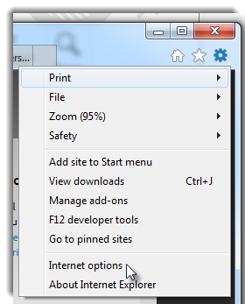
- Select the Programs tab
- Click the Manage Add-ons button

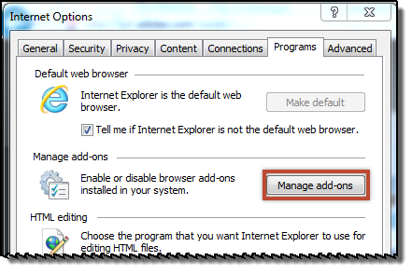

- Adobe PDF Reader should appear in your list of Add-ons under Toolbars and Extensions. Verify that the Status is set to Enabled. If not, enable the add-on by clicking the Enable button on the screen.
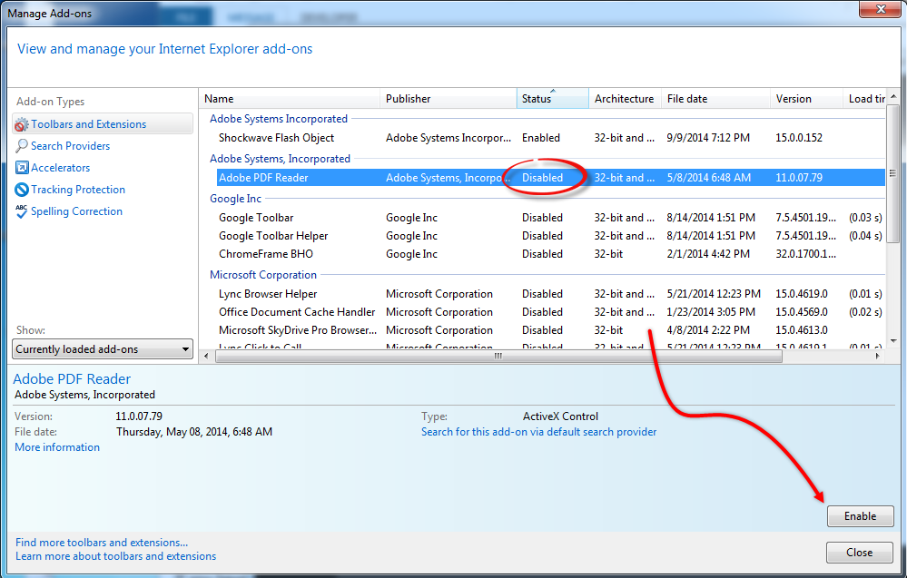

Using Adobe Reader with Chrome
- From the file menu in Chrome, select Settings
Alternatively, type in chrome://plugins directly into the URL field and skip to Step 5
- Select Advanced Settings from the bottom of the settings list
- From the Privacy section, select Content Settings
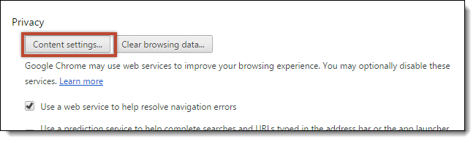

- In the Plug-Ins section, click the Disable individual plug-ins… link

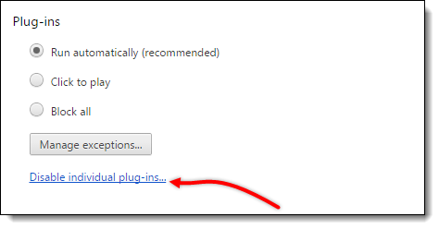

- Find Adobe Reader in the list of plug-ins and select Enable

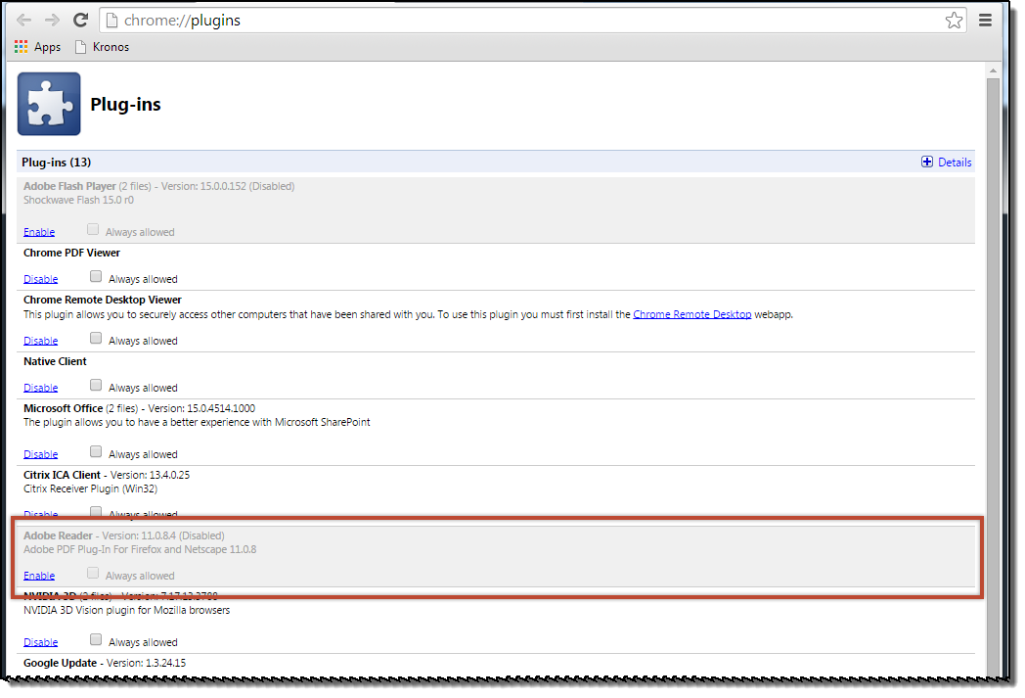

Using Adobe Reader with Firefox
- From the file menu, select Options
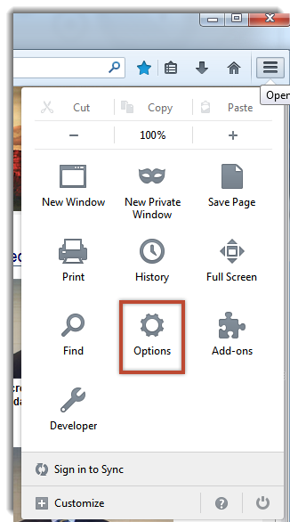
- Select the Applications tab
- For the Content types below, change the Action type to: “Use Adobe Acrobat (in Firefox)”
  - Adobe Acrobat Forms Document
  - Adobe Acrobat XML Data Package File
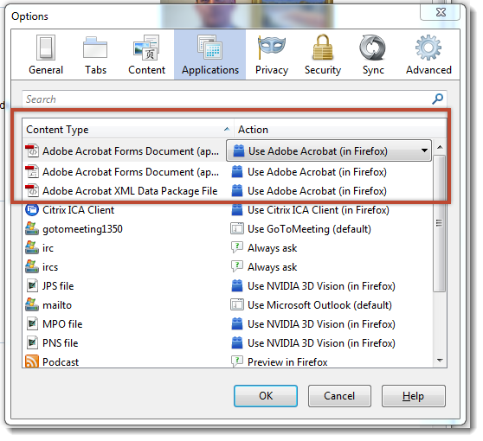
- Click OK

Appendix F – Enabling Active X in Internet Explorer
To utilize the VC Programmer and Print BOD features, you will need to enable Active X to function appropriately in Internet Explorer.
Step 1: Add https://webscore.sos.colorado.gov to your Trusted Sites
- Select Tools, then Internet Options

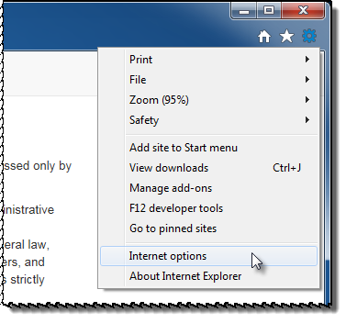
- Select the Security tab

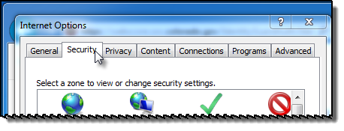

- Click on the Trusted Sites Zone and then the Sites button

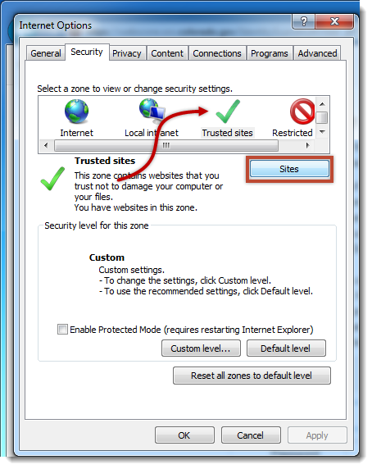

- Type in the URL: https://websocre.sos.colorado.gov and click the Add button
- Uncheck the Require server verification (https:) for all sites in this zone box
- Click Close

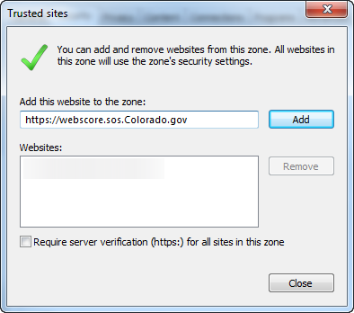

- Checkmark the Enable Protected Mode checkbox is checked, and click on the Custom level button

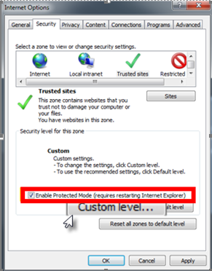

- Scroll down to the parameter titled: ‘Initialize and script ActiveX controls not marked as safe for scripting’ and select Enable
- Click the OK button and then click OK again to exit all screens
- Restart your web browser

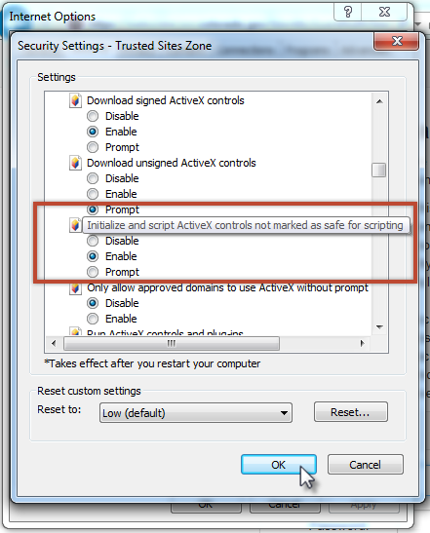

Appendix G – Citrix Requirements

Counties using the SCORE app should have installed: Citrix Receiver 4.1 and above.

