38.201

1.

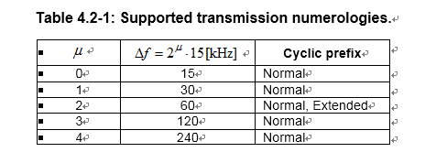

2.

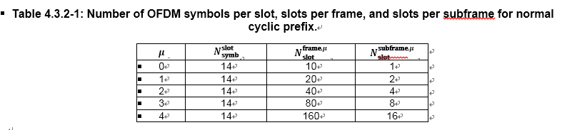

3. An antenna port is defined such that the channel over which a symbol on the antenna port is conveyed can be inferred from the channel over which another symbol on the same antenna port is conveyed.

What does this mean ? I interpret this as follows :

Each Antenna ports carries its own resource grid and a specific set of reference signal in the grid. The channel properties for RE(resource element) for the reference signal is assumed to be same (or very close to same) as the resource elements for other data(e.g, REs for PDSCH). Due to this facts, we can help demodulate the data by using the channel information obtained by the anaysis of reference channel.

4.3GPP TS 38.101-1

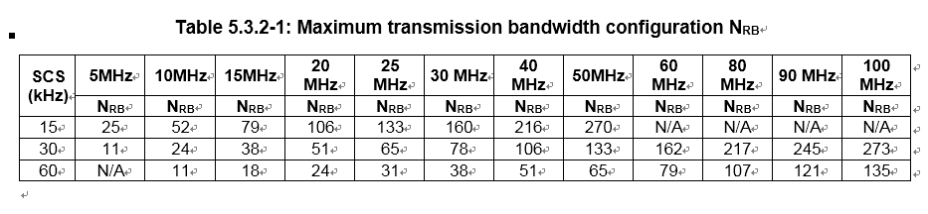

38.215