
ISPAPI Registrar Module
Domain Management using BLESTA & HEXONET

Version 1.0.0 (or later version)
December 10, 2018



COPYRIGHT NOTIFICATION
Copyright ©2018 HEXONET GmbH. All rights reserved.

DISCLAIMER AND LIMITATION OF LIABILITY
HEXONET GmbH and its affiliates (“HEXONET”) have made efforts to ensure the accuracy and completeness of the information in this document. However, HEXONET makes no warranties of any kind (whether express, implied or statutory) with respect to the information contained herein. HEXONET assumes no liability to any party for any loss or damage (whether direct or indirect) caused by any errors, omissions or statements of any kind contained in this document. Further, HEXONET assumes no liability arising from the application or use of the product or service described herein and specifically disclaims any representation that the products or services described do not infringe upon any existing or future intellectual property rights. Nothing herein grants the reader any license to make, use, or sell equipment or products constructed in accordance with this document. Finally, all rights and privileges related to any intellectual property right described in this document are vested in the patent, trademark, or service mark owner, and no other person may exercise such rights without express permission, authority, or license secured from the patent, trademark, or service mark owner.

HEXONET reserves the right to make changes to any information herein without further notice.

NOTICE AND CAUTION
Concerning Patent or Trademark Rights
The inclusion in this document, the associated on-line file, or the associated software of any information covered by any patent, trademark, or service mark rights will not constitute nor imply a grant of, or authority to exercise, any right or privilege protected by such patent, trademark, or service mark. All such rights and privileges are vested in the patent, trademark, or service mark owner, and no other person may exercise such rights without express permission, authority, or license secured from the patent, trademark, or service mark owner.

This document was created using LibreOffice 3

ISPAPI Registrar Module
Domain Management using BLESTA & HEXONET
Version 1.0.0 (or later version)


December 10, 2018

HEXONET GmbH
Talstrasse 27
66424 Homburg
Germany

E-Mail: support@hexonet.net
Internet: http://www.hexonet.net

Table of Contents
Supported Features 4
Installation 5
Set up a Cron Job 5
Configuration 6
Reseller Credentials 6
How to sell domains using Blesta and HEXONET 7
Create package group 7
Create package 7
Create order form 10
Search example 13
Add/Transfer Domain on Admin area 14
Manage Domain Names 17
Additional domain fields 20
Support 20

Supported Features
The registrar module supports the following functions and features:
- Domain Registration
- Additional domain fields
- Domain Transfer (with AuthInfo code support)
- Domain Management
- Domain Locking
- Update Contact Information
- Change Nameservers
- EPP code
- Domain Renewal
- Support for Operational Test and Evaluation environment (OT&E)
- Support for WHOIS Privacy / ID Protection
- Support for additional TLD-specific fields for registration

Installation

Copy all files from the install/ subdirectory to your Blesta directory, while keeping the folder structure intact.

E.g.
install/components/modules/ispapi/ispapi.php
=> Your_Blesta_Directory/components/modules/ispapi/ispapi.php

Set up a Cron Job
In order to automate tasks within Blesta, a cron job must be created.
More information on how to set up the cron job, can be found here (section 4):
https://docs.blesta.com/display/user/Installing+Blesta

Configuration

Reseller Credentials
In the Blesta Admin area, go to
Settings > Modules > Available
Install the new registrar ”ISPAPI vx.y.z”, and enter your HEXONET credentials. You can create your account here: https://www.hexonet.net/sign-up
If you want to use the “TestMode”, you have to create your OT&E account here: https://www.hexonet.net/signup-ote

To enter your credentials, go to
Settings > Modules > Installed > Ispapi module → Manage > Add Account
You can add multiple accounts there. Check ‘Sandbox’ if it represents your OT&E account.
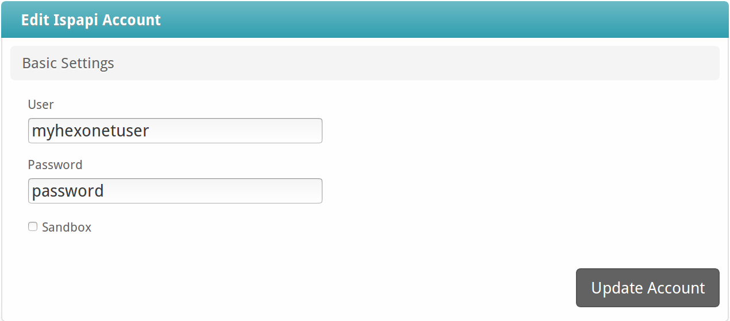

Make sure that the account you are using is set to renewal mode AUTOEXPIRE in your Control Panel, otherwise domains might be renewed without being paid for by the customer

How to sell domains using Blesta and HEXONET
This link provides general information on how you can sell domains using Blesta and a registrar module: https://docs.blesta.com/display/user/Selling+Domains
In the following, you will find example configuration settings for our ISPAPI registrar module in Blesta.

Create package group
Packages > Package Groups > + > Create Group
Example:
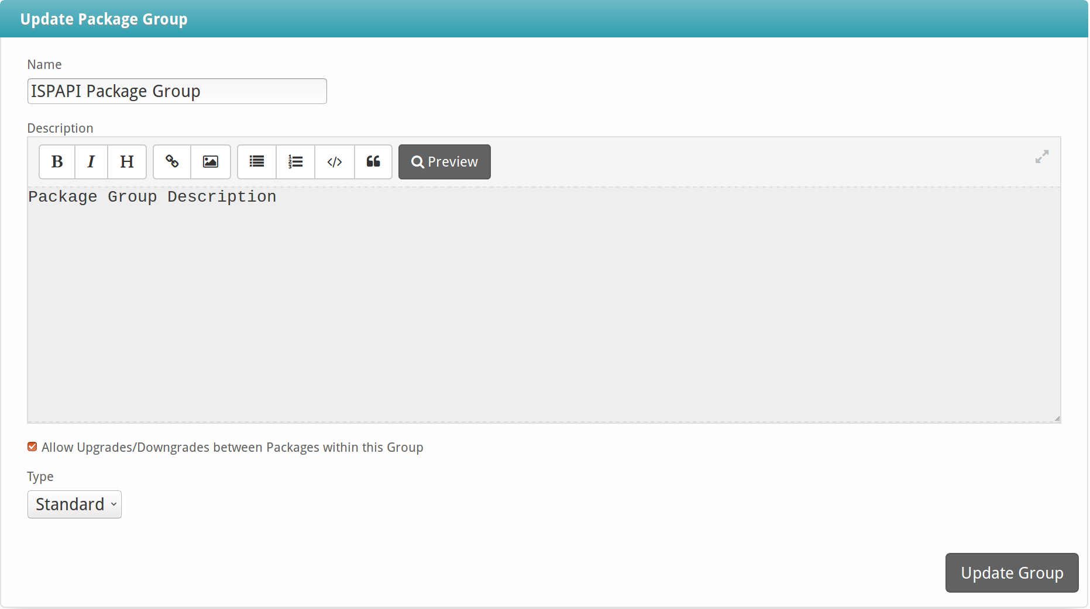

Create package
Create a package for each TLD.
Packages > Browse Packages > + >
A package contains the TLD, its pricing, the assigned registrar module, a default nameserver configuration etc.

Basic section of a package
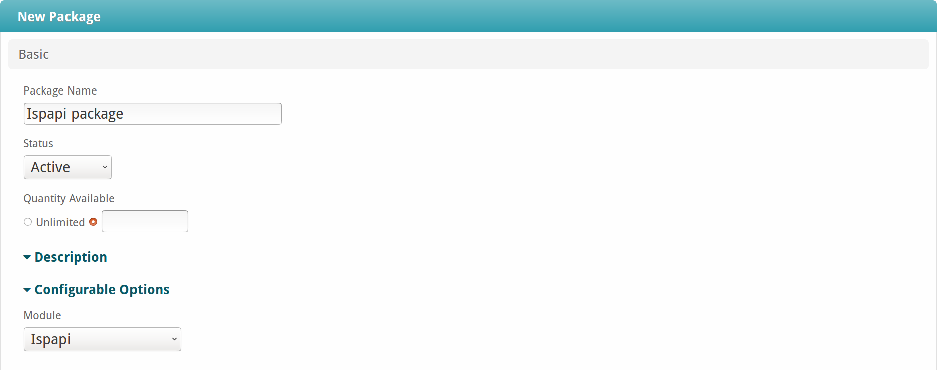

Module options
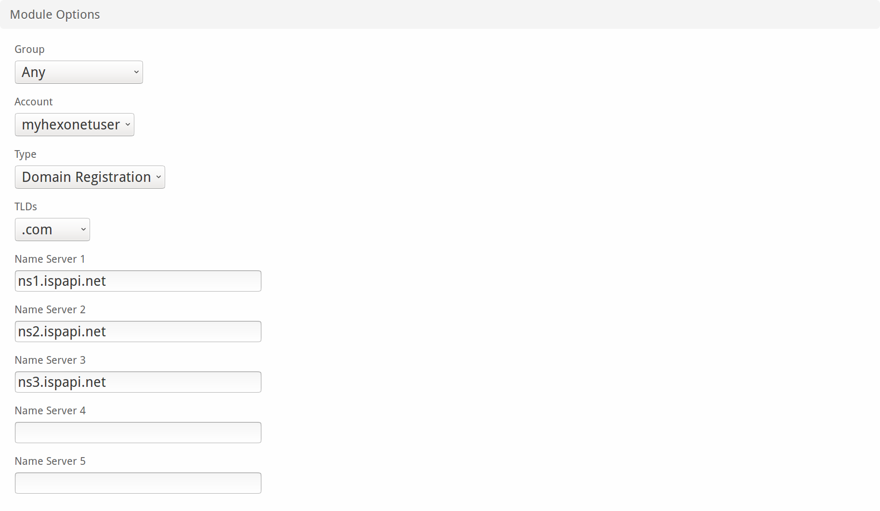

Pricing
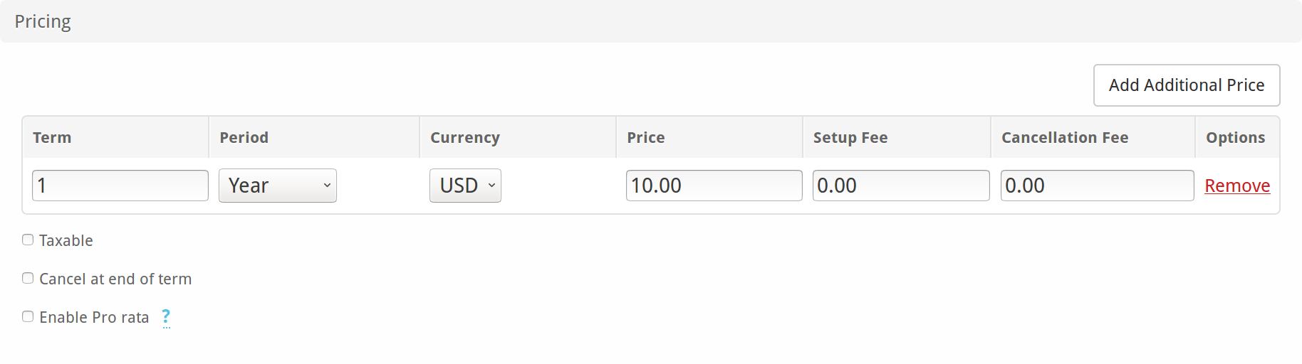
You will find your pricing for TLDs in the HEXONET control panel under your account. Click there on your account name at the top right corner > Billing > Prices & Costs > Domains
Note: Please notice that the default registration and renewal period is set to one year (1Y) at HEXONET.

Group Membership
If you wish to group your package under the created package group, select ‘Select from Available Groups” and move the group from the right to left multi-select box.
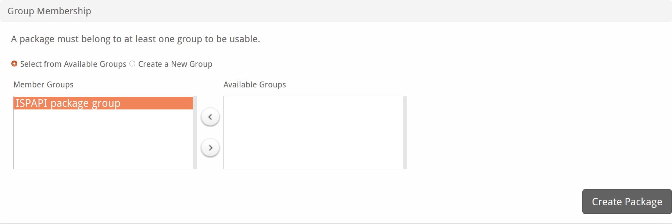
Now click on ‘Create Package’ to create the package.

Create order form
Packages > Order Forms > + > Add Form

Basic
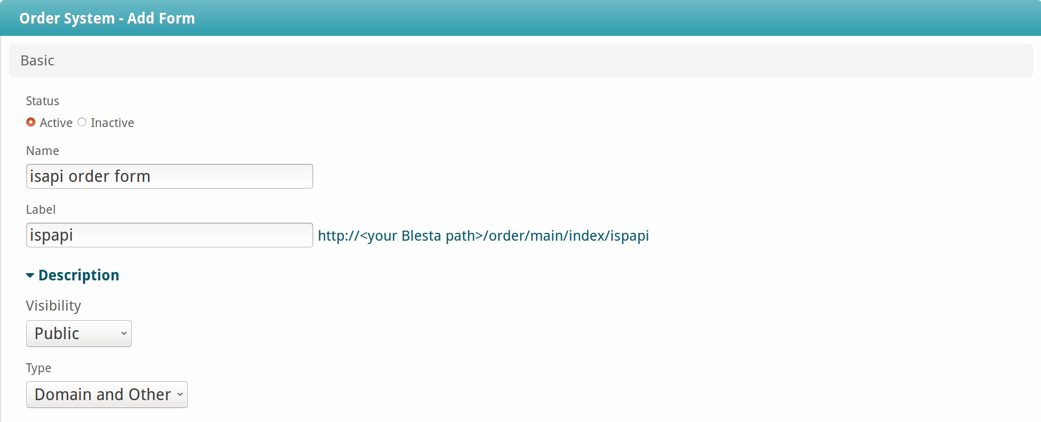
Set ‘Type’ to ‘Domain and Other’ for selling domains in the order form.

Template
Select a template of your choice. Template selection and configuration of other available options are described here in more details: https://docs.blesta.com/display/user/Selling+Domains in the section ‘Create an order form > Basic’.

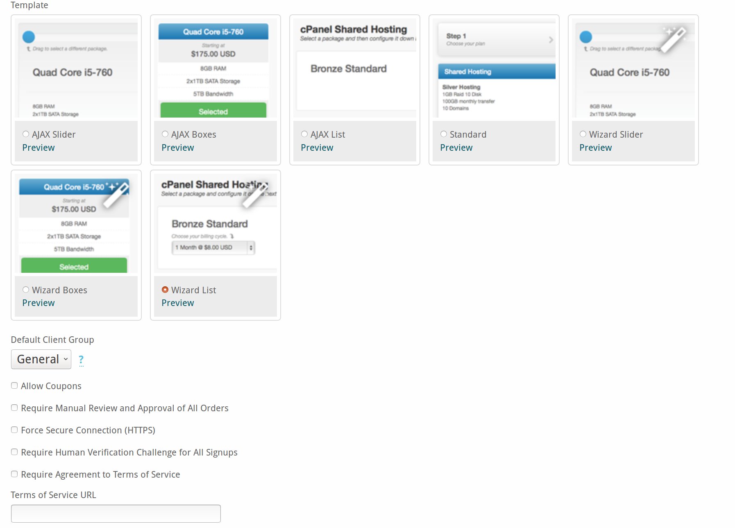

Domain Package Group
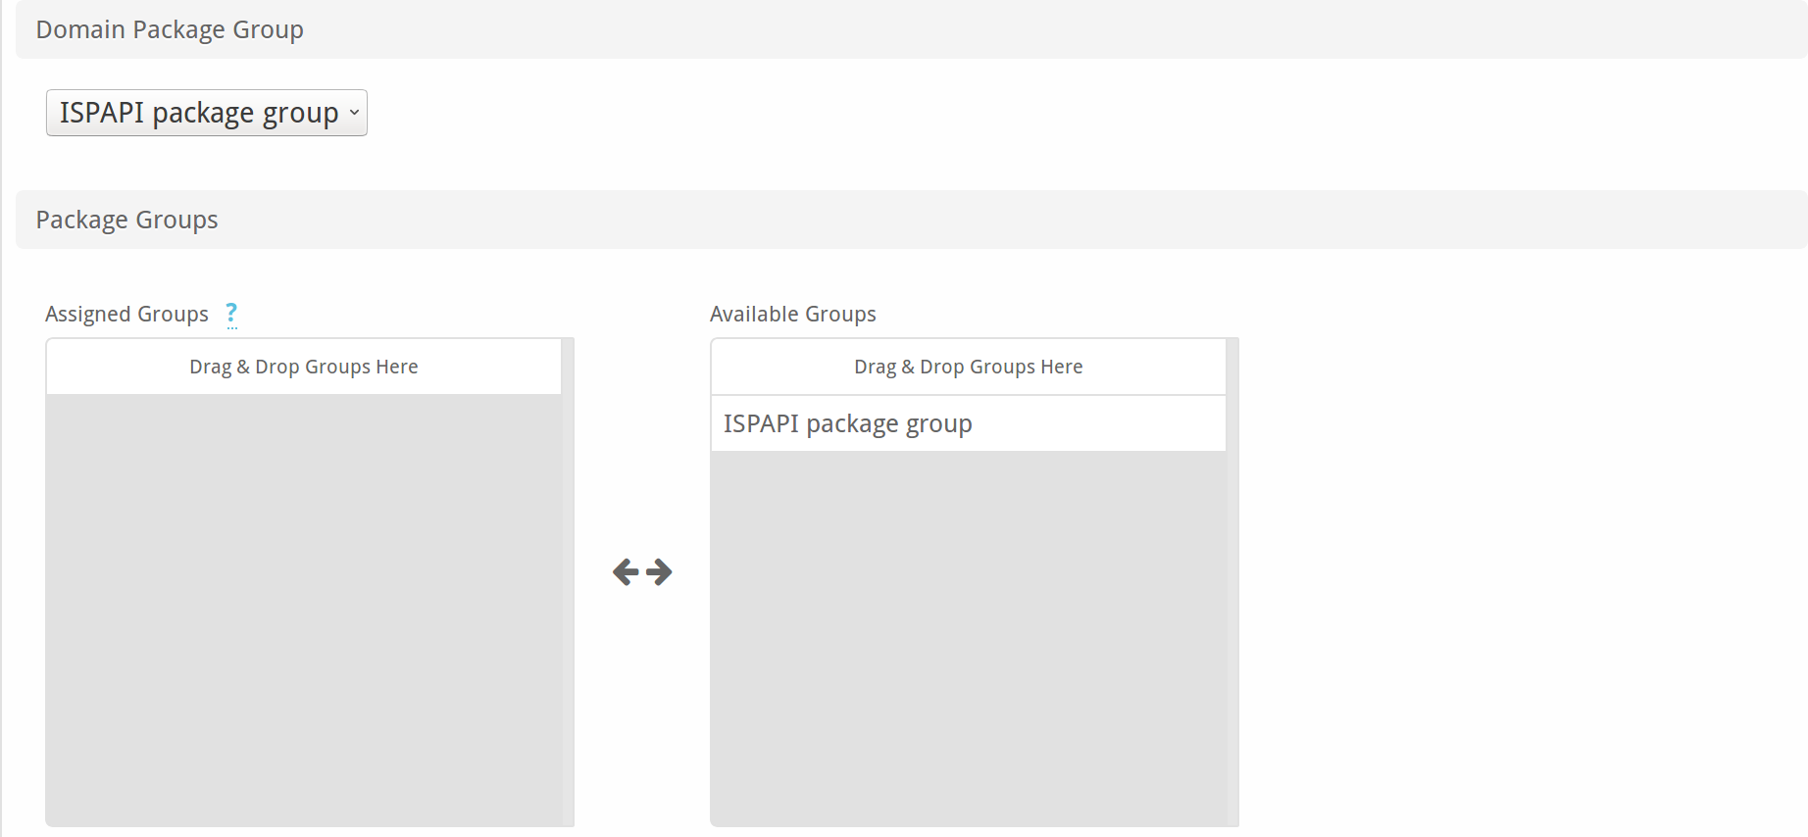

In the ‘Domain Package Group‘ section, select your package group under ‘Domain Package Group’. ‘Package Group’ section is only required when you want to sell hosting as well as domains. In our example, we are only focusing on selling domains, so that we do not assign a group there.

Currencies and Gateways
See the Blesta documentation https://docs.blesta.com/display/user/Selling+Domains.
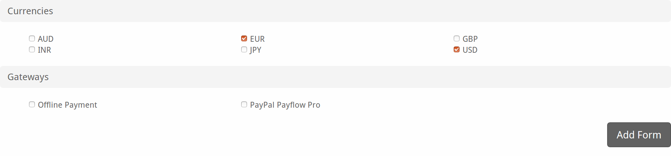

Search example
On the Blesta client area > Order
Type your term, check TLDs from the selection and click on ‘Check Availability’. To transfer a domain click on ‘Transfer’ button.
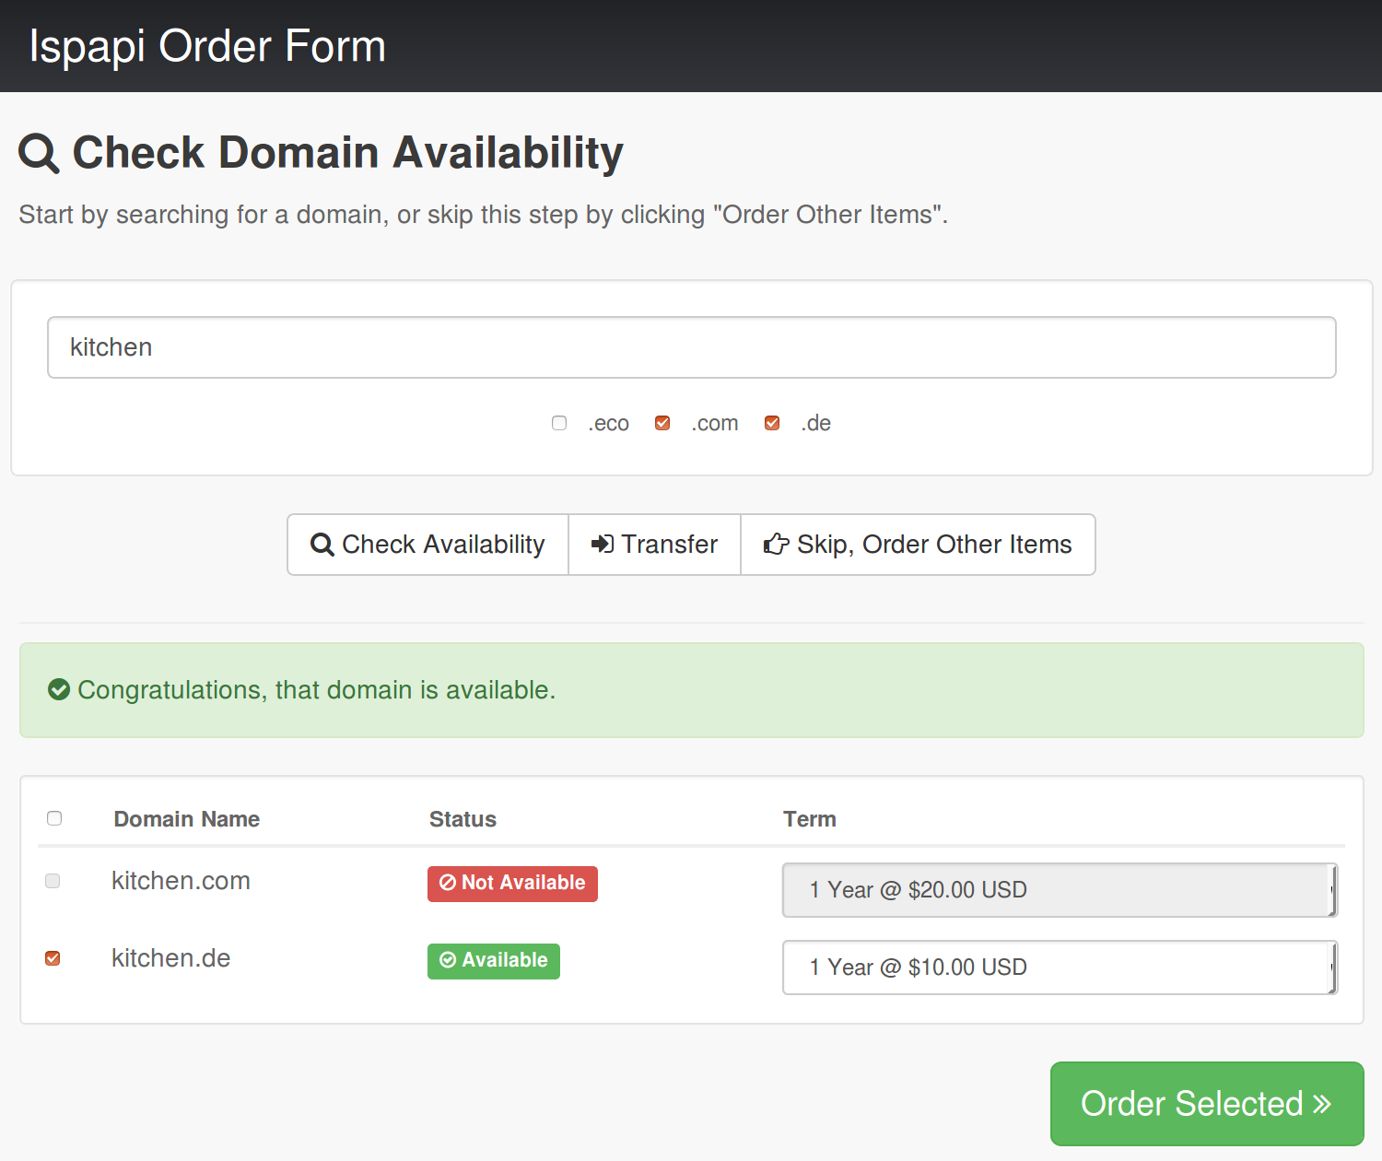

Add/Transfer Domain on Admin area
In the admin area, go to
Clients > select your client > Add Service > select package from the package group > Continue
Enter the Term, Status as Active, Domain Name and Nameservers. Click on Continue. On the next page, click on ‘Add Service’ to register the domain name.
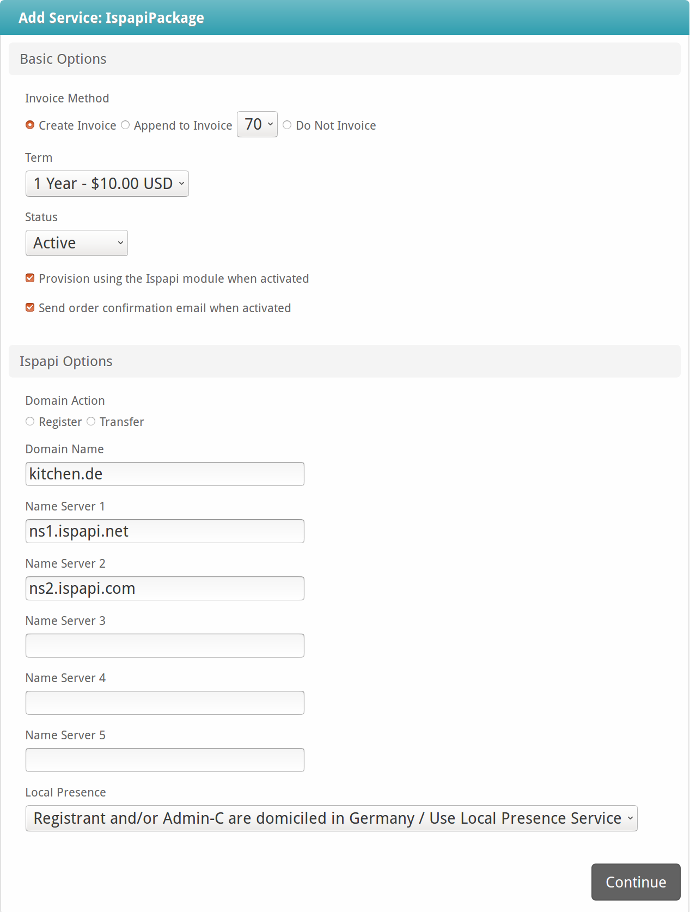

To transfer a domain, click on the ‘Transfer’ radio button. It allows you to enter the EPP code for the domain name.
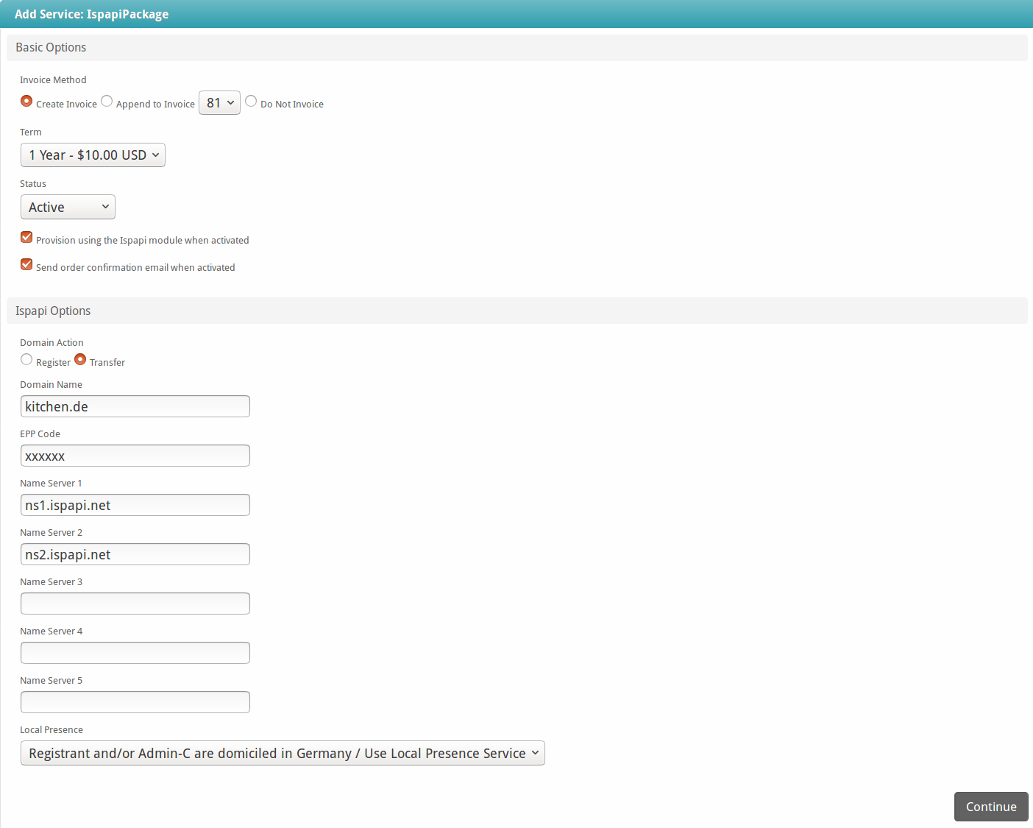

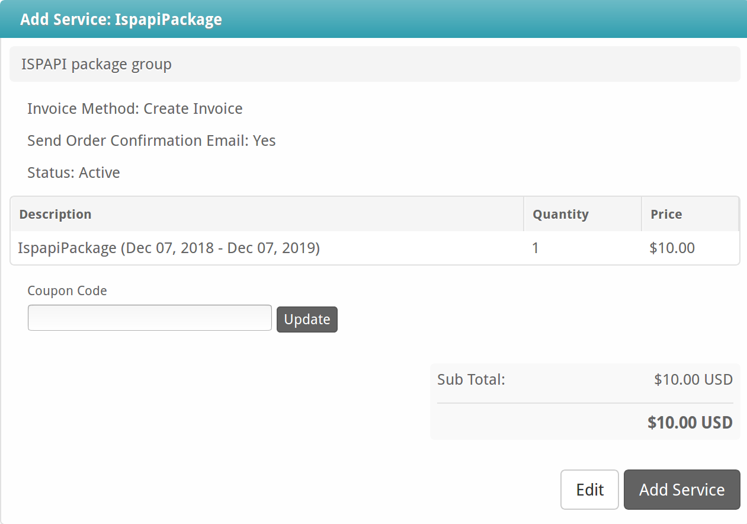

Manage Domain Names
Clients > select your client > Manage >

Domain information at HEXONET

Domain information at HEXONET includes status and expiry date of a domain at HEXONET. You can find it under ‘Basic Options’ page of a domain name.
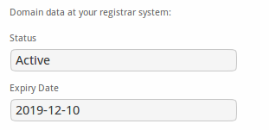

Renew a Domain

To manually renew a domain from Blesta, select time period from the drop down list and click on ‘Save’ in the ‘Basic Options’ page of a domain name.
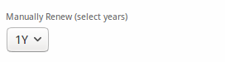

Contact information of a domain
Clients > select your client > Manage > Whois
Contact information of a registered domain name can be found in the ‘Whois’ tab. The ISPAPI registrar module allows you to modify the contact information and save the changes. These changes automatically sync to the HEXONET system.

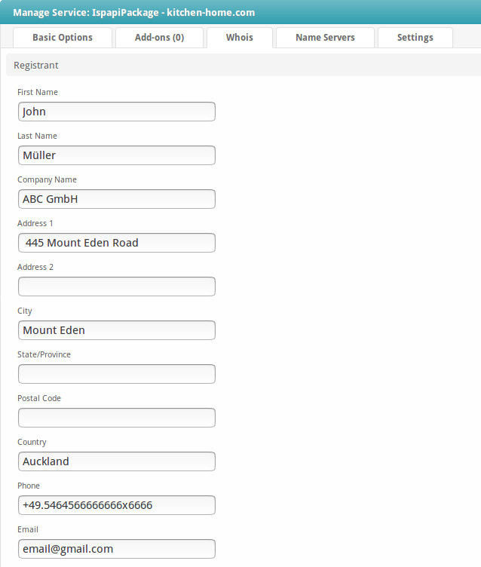

Name Servers of a domain
Clients > select your client > Manage > Name Servers
Name servers of a registered domain name can be found in the ‘Name Servers’ tab. The ISPAPI registrar module allows you to modify this information and save the changes. These changes automatically sync to the HEXONET system.
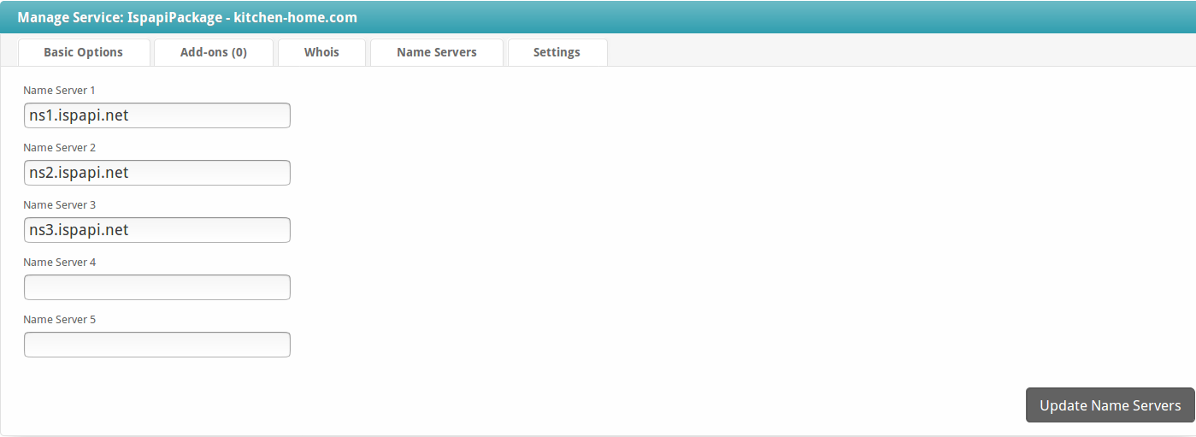

Settings of a domain
Settings of a domain include – Registrar Lock, EPP code, Whois Privacy settings.
Whois privacy setting will only be displayed if the TLD supports that setting. These settings of a registered domain can be found in the ‘Settings’ tab.
The ISPAPI registrar module allows you to modify this information and save the changes. These changes automatically sync to the HEXONET system.
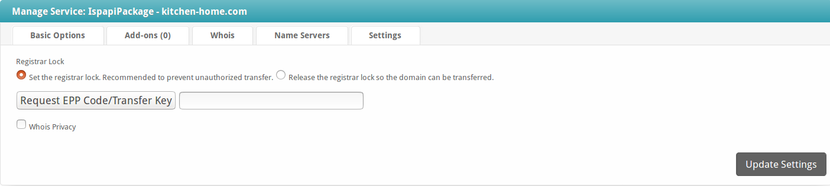

Additional domain fields
The registration of some extensions requires additional domain fields. (e.g. Legal Type for a .CA domain etc.) in special cases.
Additional fields are already included in the module. When you enter a domain to register, the additional fields will be automatically displayed.

Support
If you cannot find what you need here, please visit our online wiki or contact our support and we will be happy to assist you.
- Wiki: wiki.hexonet.net
- Technical Support: https://hexonet.support or help@hexonet.support

