***BASIC WHMCS REGISTRAR MODULE INSTALLATION***

Extract the full folder “internetbs” and its content under:

/YourLocalPath/whmcs/modules/registrars

Remember to replace “/YourLocalPath” with the actual location where you installed WHMCS.

Double check your previous operation; “internetbs” should appear under the following path:

/YourLocalPath/whmcs/modules/registrars/

2) From WHMCS administration page enable our module:
"Setup->Products/Services->Domain Registrars" and look for “Internetbs” and click the “Activate” button. Then click the “Configure” button and:

For production/live enter your API key and password as provided by us.

For testing just tick the "TestMode" checkbox and enter the following credentials:

API key: testapi
Password: testpass.

Now click the button named “Save Changes”.

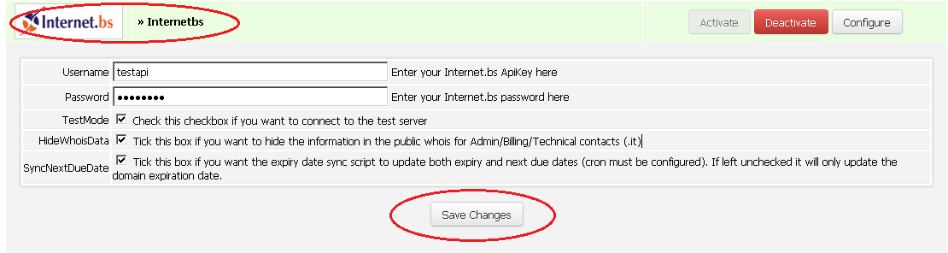

NOTE: If you plan on configuring the cron job to synchronize expiration dates of your domains (useful when you have pending transfers or have autorenewal enabled for your domains in your account on our system) when the “SyncNextDueDate” checkbox is not checked the script will only update the status and the expiration date. If you check the “SyncNextDueDate” it will also update the Next Due Date which determines the time when WHMCS will issue a new invoice for the domain. This only applies if you are using our custom sync script and not the WHMCS built in domainsync.php script (from the crons folder).

After clicking “Save Changes” go to “Setup->Products/Services->Domain Pricing” and from the drop down list select “Internetbs” for each TLDs (domain extension) you want to manage using our module. For more details please refer to the picture below:
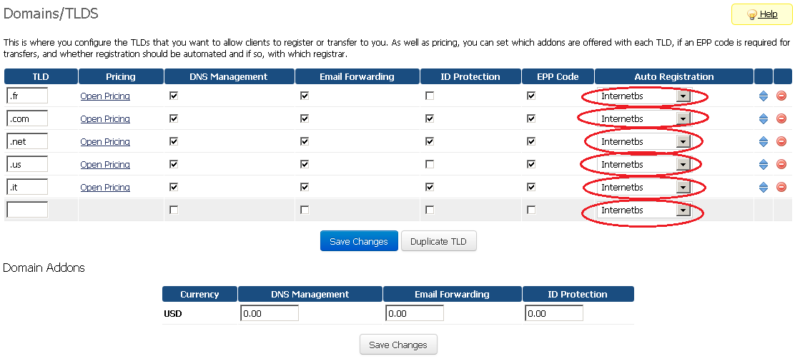

Copy trademarkClaim.php to root of your WHMCS installation.
Copy trademarkClaim.tpl to the your current template directory.

Copy internetbs_ updatewhoisservers.php and internetbs_domaincheck.php and paste to /YourLocalPath/whmcs/.

Run the following url in your browser
YourWhmcsUrl/internetbs_updatewhoisservers.php

IMPORTANT NOTE: If you want to enable premium domains in whmcs, you need to make sure that you define an exchange rate between USD and your currency in Admin the menu Setup→Payments→Currencies. Our module explicitly sets USD when checking the price for premium names and USD price will be sent back to us when confirming the price for the premium name at registration time. Also you need to enable premiu domains for your API KEY in your account in the reseller settings page (need to change “Allow premium domains operations” from NO to YES).

***ADVANCED WHMCS REGISTRAR MODULE INSTALLATION***
***supporting .eu, .be, .it, .fr, .re, .asia, .us and .uk ***

IMPORTANT NOTE: If you are upgrading from a previous version of our module please execute the following SQL query on the WHMCS database:

UPDATE `tbldomainsadditionalfields` INNER JOIN `tbldomains` ON `tbldomains`.id=`tbldomainsadditionalfields`.`domainid` SET `tbldomainsadditionalfields`.`name`='VATTAXPassportIDNumber' WHERE `tbldomainsadditionalfields`.`name`='VAT/TAX/Passport/ID Number' AND `tbldomains`.`registrar`='internetbs'

In order for WHMCS to support .eu, .be, .it, .fr, .re, .asia, .us and .uk domains, you have to perform the following additional steps:

- Complete the BASIC MODULE INSTALLATION first.
- Copy the file itterms.html to the root of your WHMCS installation
- For WHMCS version below 7
Open the local file /YourLocalPath/whmcs/includes/additionaldomainfields.php

and append the following line at the very end of the file:
include(ROOTDIR."/modules/registrars/internetbs/internetbs_additionaldomainfields.php");

For WHMCS version 7 onwards
Open the local file
/YourLocalPath/whmcs/resources/domains/dist.additionalfields.php
and append the following line at the very end of the file:

include(ROOTDIR."/modules/registrars/internetbs/internetbs_additionaldomainfields.php");

For .it you also need to copy the file itterms.html from the archive into the root folder of your whmcs installation. (/YourLocalPath/whmcs/). This file contains the .it terms and conditions in English. If you want to use the Italian version use the file itterms-it.html but rename it itterms.html.

***HOOK INSTALLATION***

If you are updating module in order to detect hook file - ”hooks.php” and to start running it for the module, you must edit and resave domain registrar configuration. This file contains validations for domain.

***Multilingual Support***
To add support for multiple languages, please do as following steps.
- Begin by opening existing language file “italian.php” in folder “languages”.
- Save the file with new name and save it to “lang/overrides” in WHMCS root directory. Give the name for which you want to add translation. For example, For Italian language save it as “italian.php”
- Translate the words and phrases contained within it into your new language. Be careful not to change key names, only the words and phrases contained within the quotes on each line.

We have included translation for Italian language. To make it available in WHMCS do as following steps.
- In “lang” folder of your WHMCS root directory, create folder “overrides” (If not exists).
- Copy file “italian.php” from “languages” folder to “overrides” folder.

You can now configure your price list and enjoy our module!

