ISPAPI Backorder Addon
Resell Domain Backorders using WHMCS & HEXONET

Version 1.1.0
September 6, 2017



COPYRIGHT NOTIFICATION
Copyright ©2017 HEXONET GmbH. All rights reserved.

DISCLAIMER AND LIMITATION OF LIABILITY
HEXONET GmbH and its affiliates (“HEXONET”) have made efforts to ensure the accuracy and completeness of the information in this document. However, HEXONET makes no warranties of any kind (whether express, implied or statutory) with respect to the information contained herein. HEXONET assumes no liability to any party for any loss or damage (whether direct or indirect) caused by any errors, omissions or statements of any kind contained in this document. Further, HEXONET assumes no liability arising from the application or use of the product or service described herein and specifically disclaims any representation that the products or services described do not infringe upon any existing or future intellectual property rights. Nothing herein grants the reader any license to make, use, or sell equipment or products constructed in accordance with this document. Finally, all rights and privileges related to any intellectual property right described in this document are vested in the patent, trademark, or service mark owner, and no other person may exercise such rights without express permission, authority, or license secured from the patent, trademark, or service mark owner.

HEXONET reserves the right to make changes to any information herein without further notice.

NOTICE AND CAUTION
Concerning Patent or Trademark Rights
The inclusion in this document, the associated on-line file, or the associated software of any information covered by any patent, trademark, or service mark rights will not constitute nor imply a grant of, or authority to exercise, any right or privilege protected by such patent, trademark, or service mark. All such rights and privileges are vested in the patent, trademark, or service mark owner, and no other person may exercise such rights without express permission, authority, or license secured from the patent, trademark, or service mark owner.

This document was created using LibreOffice 3

ISPAPI Backorder Addon
Resell Domain Backorders using WHMCS & HEXONET
Version 1.1.0

September 6, 2017

HEXONET GmbH
Talstrasse 27
66424 Homburg
Germany

E-Mail: support@hexonet.net
Internet: http://www.hexonet.net

Table of Contents
Introduction 4
Supported Features 5
Getting Started 6
1.Requirements 6
2.Installation 6
3.Configuration 7
a) Addon Activation 7
b) Addon Configuration 7
c) Add Cron Jobs 9
d) Import Drop List 10
e) Customize Email Templates [optional] 10
Technical information 11
1. Functioning 11
a) The Backorder Failed 11
b) The Backorder was Successful 11
Single backorder 11
Multiple backorder 12
2. Process Diagram for Backorders 13
Frontend 14
Backend 16
Support 20

Introduction

Expiring domain names is one of the fast growing and most lucrative businesses in the domain industry. When a domain name expires and the underlying registry makes that domain name available to the public (drops) some of these expired domains names are valuable for existing Internet traffic or simply for the name’s intrinsic worth. Resellers looking to increase profits should consider offering domain name backordering.
The ISPAPI Backorder Addon for WHMCS allows any reseller to quickly and easily offer domain name backorders. Once the module is installed, operations are fully automated.

Supported Features

The ISPAPI Backorder Addon supports the following functions and features:

- High Performance Drop-Catching Technology
- Supports gTLDs: .ASIA .BIZ .CLUB .COM .INFO .MOBI .NET .ORG .TOP
- Supports many Donuts and Rightside TLDS
- Supports ccTLDs: .CC .CH .CO .DE .LI .ME .TV .US
- Extra Commissions are Paid to Resellers for Successful Backorders
- Backorders are Free to Place and the Backorder Fee is Paid Only on Successful Registration
- Multiple Currencies Supported
- Multi-lingual (available in English, German with more to come)
- Includes a Backorder Domain Name Search Engine
- Automatic Drop List Update
- Auction Platform for Handling Multiple Backorders
- Easy to Install and Operate

Getting Started

Requirements

In order to run the ISPAPI Backorder Addon, your WHMCS installation must meet the following requirements:
- WHMCS version 7.0 or higher.
- PHP with ZIP Extension installed.
- ISPAPI Registrar Module version 1.0.44 or higher –
available at https://wiki.hexonet.net/index.php/WHMCS_Modules.
- HEXONET Live or Test Account configured in the ISPAPI Registrar Module – create a free account at www.hexonet.net.
- Server time should be set to UTC

Installation

Copy the whole “ispapibackorder” directory to the “modules/addons/” directory.

Configuration

Addon Activation

In the WHMCS Admin area, go to Setup => Addon Modules
Activate the ISPAPI Backorder Addon and give the module “Full Administrator” Access Control rights.

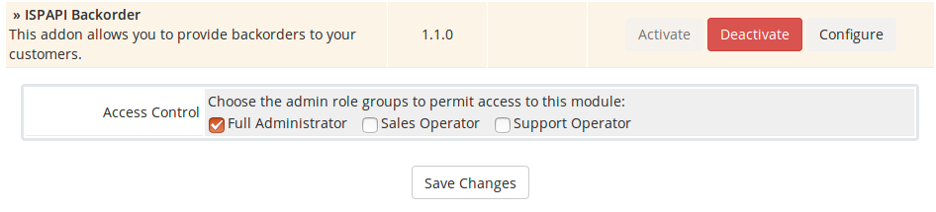

Addon Configuration

In the WHMCS Admin area, go to Addons => ISPAPI Backorder
Select the “Pricing” tab and enter the desired prices you wish to charge your customers. Please keep in mind the price you will be charged (reseller prices are available on HEXONET’s web Control Panel).

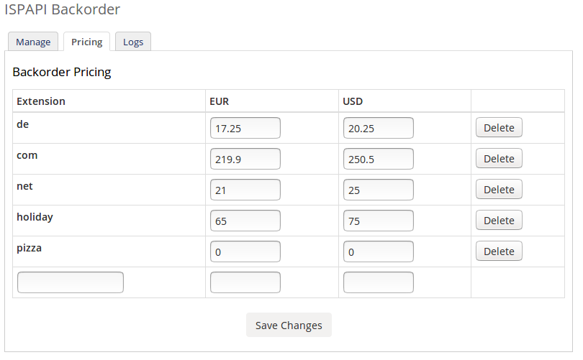

Add Cron Jobs

In order to fully automated the module, additional cron jobs must be installed.
Please configure the following cron jobs on your server.

1 0,10 * * * php -q {PATH_TO_WHMCS}/modules/addons/ispapibackorder/crons/daily_import_pendingdomainlist.php >/dev/null 2>&1
1 1,11 * * * php -q {PATH_TO_WHMCS}/modules/addons/ispapibackorder/crons/daily_dropdate_synch.php >/dev/null 2>&1
*/5 * * * * php -q {PATH_TO_WHMCS}/modules/addons/ispapibackorder/crons/batch.php >/dev/null 2>&1

* Replace {PATH_TO_WHMCS} with the real path of your WHMCS installation.

The batch.php cron job should run every 5 minutes.
The batch_import_pendingdomainlist.php cron job should run twice a day at 0:01 and 10:01.
The daily_dropdate_synch.php cron job should run twice a day at 1:01 and 11:01.

Import Drop List

The first time using the module, you must import the drop list. In order to do that just execute the following script from your command line:

- Go to the “crons” directory of the module
- Execute: php -q daily_import_pendingdomainlist.php
The script takes a few minutes to complete.

Customize Email Templates [optional]

The module comes with one pre-installed email template. The template is called “backorder_lowbalance_notification” and is available under Setup => Email Templates.
This template is used to send email notices to customer that do not have enough funds in their accounts to properly process a domain name backorder. Failure to provide additional funds will result in a domain name backorder to be abandoned.
Resellers can customize the content of this template.

Technical information

Functioning

Once the module is completely installed and configured your customers will be able to backorder domain names. Keep in mind that backordering domain names is based on a PREPAID balance. Customers with insufficient account funds will result in their backorders being abandoned. Your customers can add funds with WHMCS’ default “Add Funds” functionality.
PLEASE KEEP IN MIND THAT, the reseller must also have enough prepaid funds in their HEXONET account that covers all the pending backorders of their customers. Reseller’s with insufficient funds will also have some or all of their domain name backorders fail.
- Your customers can click on a domain backorder, which will set the backorder status for the respective domain name to REQUESTED.
- Three (3) days before the drop date of a backordered domain name, the backorder status is set to ACTIVE. This will trigger the system to obtain the backorder fees from the customer’s account and hold those funds as reserved. Again, if the customer has insufficient funds, a low balance notification email is sent and the backorder itself will remain status REQUESTED.
- Two (2) hours before the respective domain name’s drop time, the status of the backorder will change from ACTIVE to PROCESSING. Once in processing backorders can’t be deleted.
- The drop-catch system will then try to obtain the respective domain name..
There are different backorder results:

The Backorder Failed
If the system failed to get the domain name the backorder status will change from PROCESSING to FAILED and the reserved monies will be released.

The Backorder was Successful

Single backorder
If the system successfully got the domain and the customer was the only person on the system to have backordered the domain name (single backorder), then the status will change from PROCESSING to PENDING-PAYMENT and the customer will receive an invoice, indicating they have obtained the backorder they have requested. And since backordering is a prepaid system, the invoice will be immediately and automatically paid. The backorder status will be changed from PENDING-PAYMENT to SUCCESSFUL. The acquired domain name will now be displayed in the customer’s account.

Multiple backorder
If a domain backorder was successfully obtained, but two (2) or more accounts placed backorders for the same domain name (multiple backorders) then the domain name will go to a private auction (between the backorder participants) at www.premiumsale.com. Emails are automatically sent to the participants by the auction house Premiumsale and the status of the backorder will change from PROCESSING to AUCTION-PENDING.
The losers of the auction at PremiumSale.com will have the status of their backorders changed from AUCTION-PENDING to AUCTION-LOST. Any reserved money held for the backorder will be released.
The winning customer of the private auction, once the winning auction bid is paid to PremiumSale.com will have the status of their backorder changed from AUCTION-PENDING to AUCTION-WON. The winning and paid domain name will show up in the account of the winning bidder.

Process Diagram for Backorders
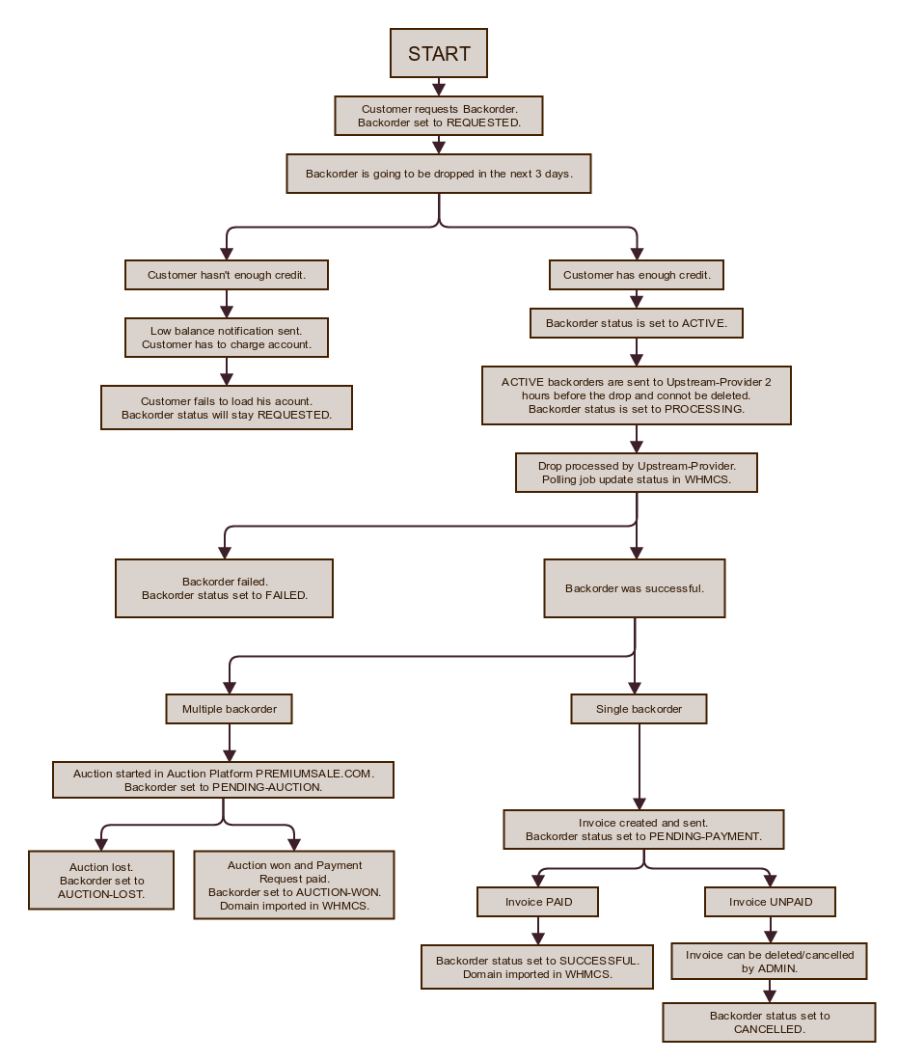

Frontend

Once the addon installed, a new item named “Backorders” will be displayed in the Navigation.
This new navigation item contains 2 pages:
- Expiring Domains
- My Backorders

Expiring Domains screenshot
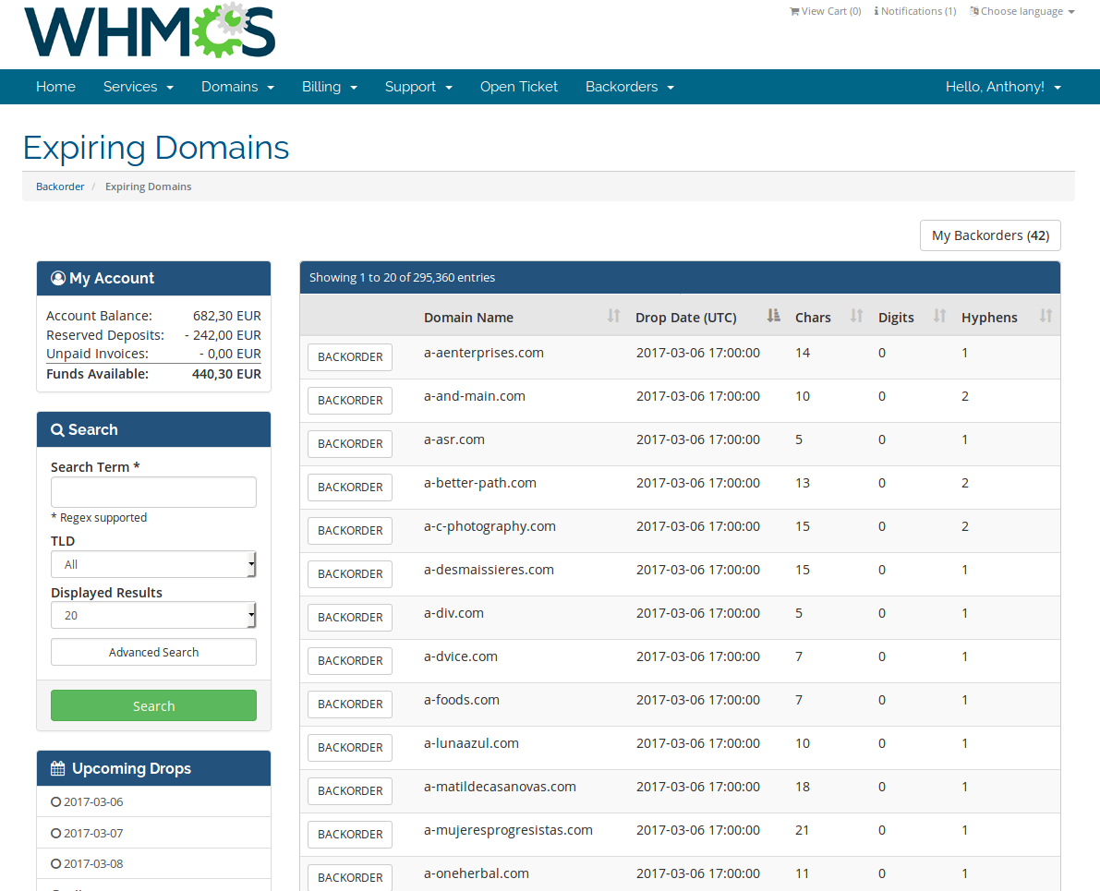

My Backorders screenshot
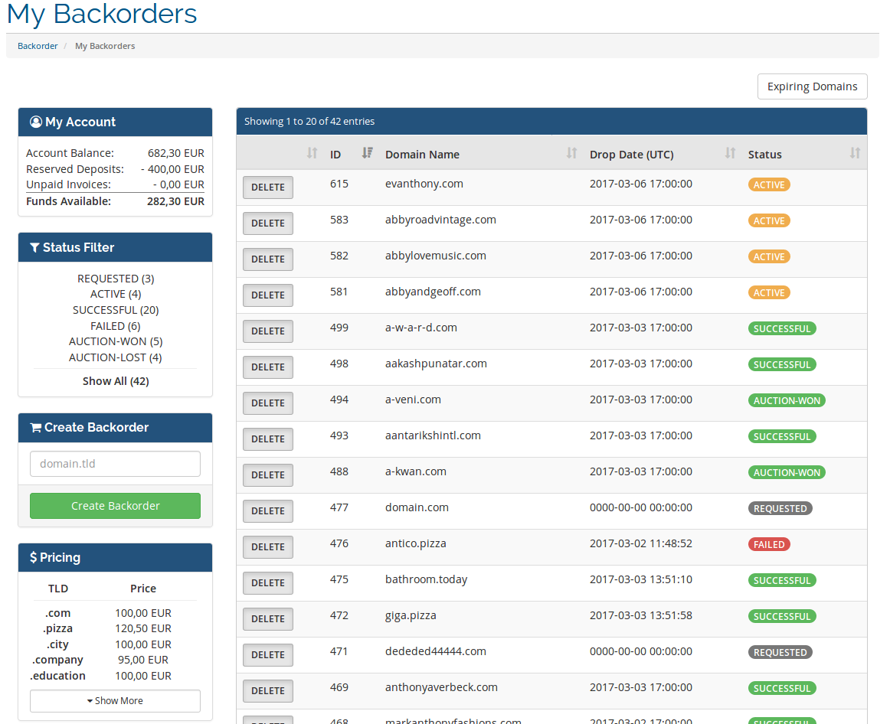

Backend

In the admin area of WHMCS a new item will be displayed under Addon => ISPAPI Backorder.
The backend part of this module contains 3 pages:
- Manage
This page allows to manage all the existing backorders.
- Pricing
This page allows to manage the pricing of each TLDs. If a price is set to 0 or empty then the customer will not be able to backorder this TLD.
- Logs
This page allows to search for a domain and see all the status changes. This is very useful to see what happened exactly to a backorder.

Manage page screenshot
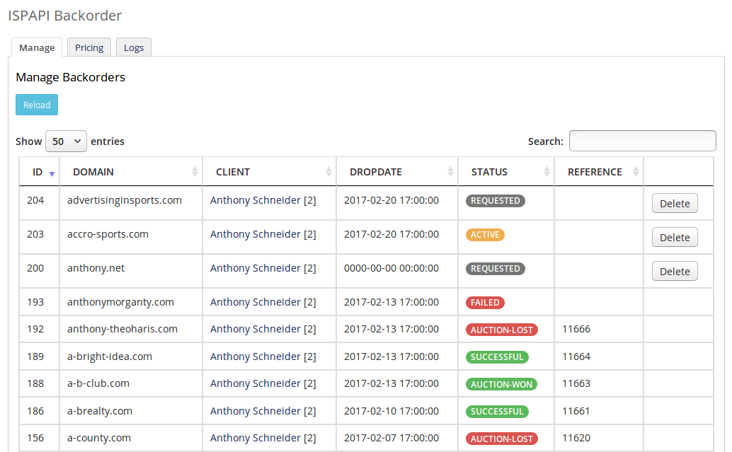

Pricing page screenshot
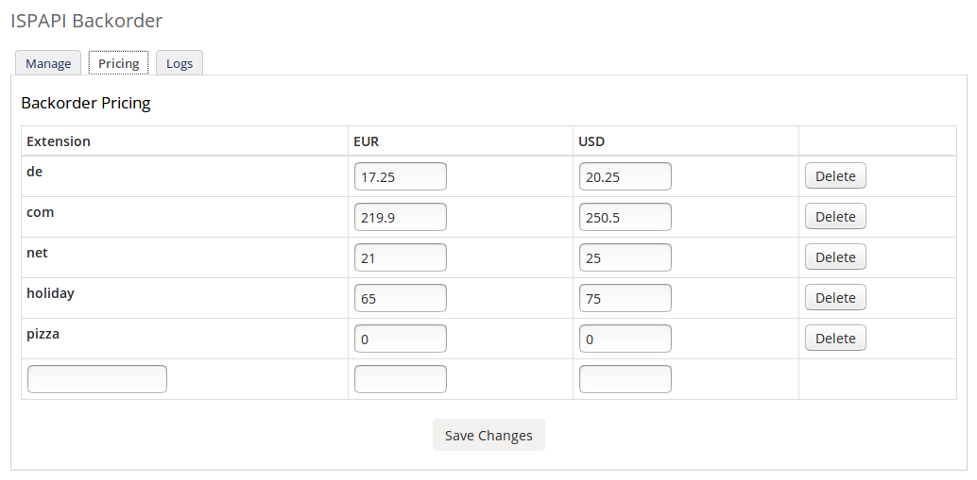

Logs page screenshot
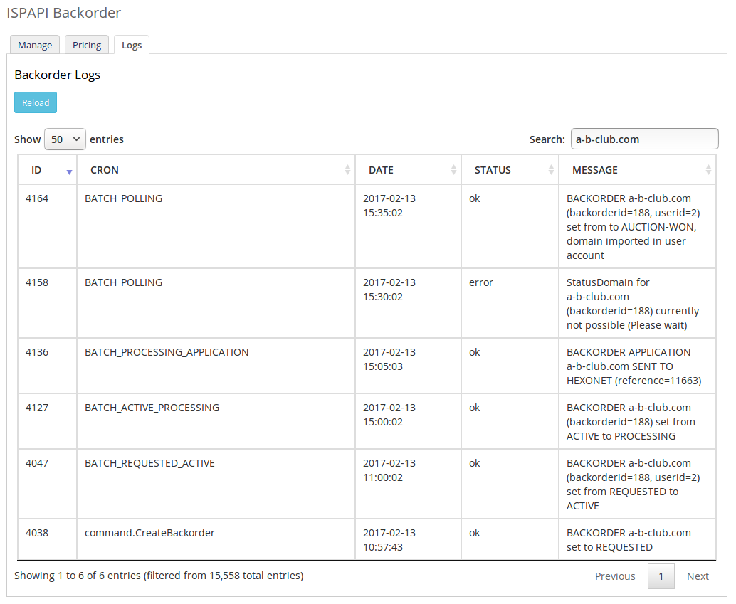

Support

For support, please visit our online wiki or contact us:
- Wiki: wiki.hexonet.net
- Technical Support: support@hexonet.net

