ISPAPI DomainCheck Addon
High performance availability check using WHMCS & HEXONET

Version 7.1
July 10, 2017



COPYRIGHT NOTIFICATION
Copyright ©2017 HEXONET GmbH. All rights reserved.

DISCLAIMER AND LIMITATION OF LIABILITY
HEXONET GmbH and its affiliates (“HEXONET”) have made efforts to ensure the accuracy and completeness of the information in this document. However, HEXONET makes no warranties of any kind (whether express, implied or statutory) with respect to the information contained herein. HEXONET assumes no liability to any party for any loss or damage (whether direct or indirect) caused by any errors, omissions or statements of any kind contained in this document. Further, HEXONET assumes no liability arising from the application or use of the product or service described herein and specifically disclaims any representation that the products or services described do not infringe upon any existing or future intellectual property rights. Nothing herein grants the reader any license to make, use, or sell equipment or products constructed in accordance with this document. Finally, all rights and privileges related to any intellectual property right described in this document are vested in the patent, trademark, or service mark owner, and no other person may exercise such rights without express permission, authority, or license secured from the patent, trademark, or service mark owner.

HEXONET reserves the right to make changes to any information herein without further notice.

NOTICE AND CAUTION
Concerning Patent or Trademark Rights
The inclusion in this document, the associated on-line file, or the associated software of any information covered by any patent, trademark, or service mark rights will not constitute nor imply a grant of, or authority to exercise, any right or privilege protected by such patent, trademark, or service mark. All such rights and privileges are vested in the patent, trademark, or service mark owner, and no other person may exercise such rights without express permission, authority, or license secured from the patent, trademark, or service mark owner.

This document was created using LibreOffice 3

ISPAPI DomainCheck Addon
High performance availability check using WHMCS & HEXONET
Version 7.1

July 10, 2017

HEXONET GmbH
Talstrasse 27
66424 Homburg
Germany

E-Mail: support@hexonet.net
Internet: http://www.hexonet.net

Table of Contents
Introduction 4
Supported Features 6
Getting started 7
1.Requirements 7
2.Installation 7
3.Configuration 8
a) Addon activation 8
b) Addon configuration 8
c) Premium Pricing 11
d) Domain Pricing 13
e) Switching the template 14
f) Allow the Smarty PHP Tags 14
g) Redirect or replace the WHMCS domainchecker file 15
h) Enable Module Debug Logging 15
4.Test your installation 16
Start selling domains 17
1. Standard domains 17
2. Aftermarket Premium domains 18
3. Registry Premium domains 19
Special Features 20
1. Trigger the search over the URL 20
Support 21

Introduction

The ISPAPI DomainCheck Addon provides your customer a new simple and usable way to check the availability of domains. It supports all the new TLDs (.GURU, .BIKE, .TODAY, …), the NAMEMEDIA Aftermarket Premium Domains and the Donuts, RightSide, .BUILD, .CEO & .MENU Registry Premium Domains and many others.
This new checker connects automatically with the configured ISPAPI registrar module and provides high speed checks for TLDs with ISPAPI as registrar provisioning and normal checks (over WHOIS) for the others.
For better performance, the checker uses an ajax driven search and the search results are cached until the page is reloaded. The checker displays the TLDs in 2 levels of categories. Categorization can be easily done with an simple category editor available in the WHMCS backend.
The search can also be triggered over the URL, especially interesting when you've chosen to create a landing page for a special TLD. (See Special Features)

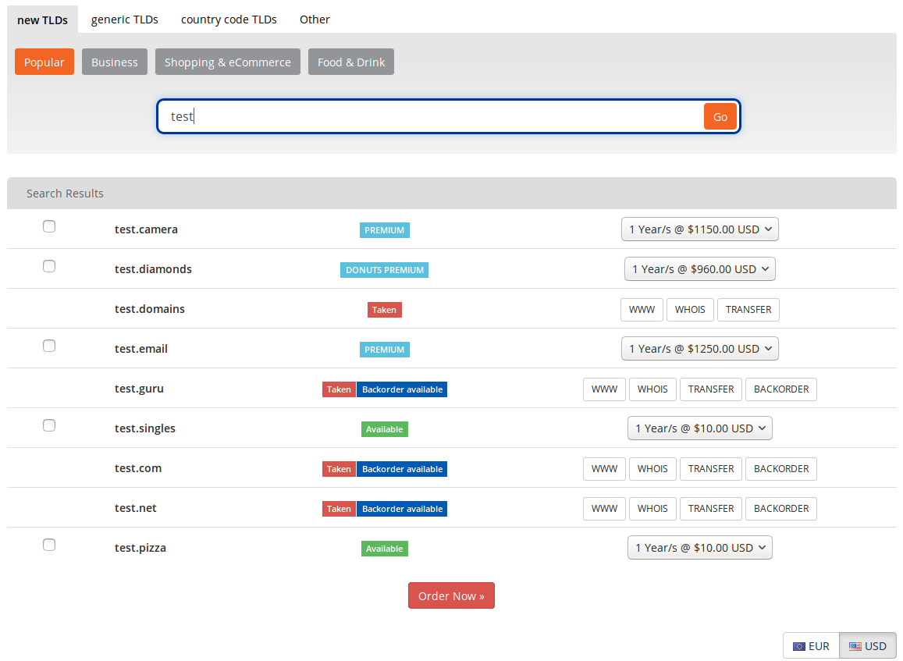

Supported Features

The ISPAPI DomainCheck addon supports the following functions and features:

- High-performance Domain Availability Checks using our registrar API
- Support for the new gTLDs (.BIKE, .EMAIL, .SEXY, and many others ...)
- Support of Namemedia Aftermarket premium domains
- Support of Donuts, RightSide, .BUILD, .CEO & .MENU Registry premium domains and many others.
- Categorization of the TLDs in 2 levels for an improved user experience
- Various performance optimizations
- Ajax driven search (no page reload)
- Multiple currencies
- Backorder button in the search results (If ISPAPI Backorder Module is installed.)
- Search trigger over the URL (interesting for landing pages)
  - For example: mydomainchecker.php?search=mydomain.com&cat=3
Will trigger the search of “mydomain.com” in the category ID=3
- Easy to install

Getting started

Requirements

In order to run the ISPAPI DomainCheck addon, your WHMCS installation must meet the following requirements:
- WHMCS version 7.0 or higher must be installed.
If you are using WHMCS 6.x, please ask us.
- ISPAPI Registrar Module version 1.0.15 or higher must be installed. This module can be downloaded here: https://wiki.hexonet.net/index.php/WHMCS_Modules.
- HEXONET Live or Test Account must be configured in the ISPAPI Registrar Module. Account creation is free on our website: www.hexonet.net.
- The standard WHMCS Cron Job must be configured. You will find all the information about this subject here: http://docs.whmcs.com/Crons.

Installation

Copy all files from the install/ subdirectory to your WHMCS installation root directory ($YOUR_WHMCS_ROOT), while keeping the folder structure intact.

E.g.
install/modules/addons/ispapidomaincheck/ajax.php
=> $YOUR_WHMCS_ROOT/modules/addons/ispapidomaincheck/ajax.php

Configuration

Addon activation

Within the WHMCS Admin area, go to
Setup => Addon Modules
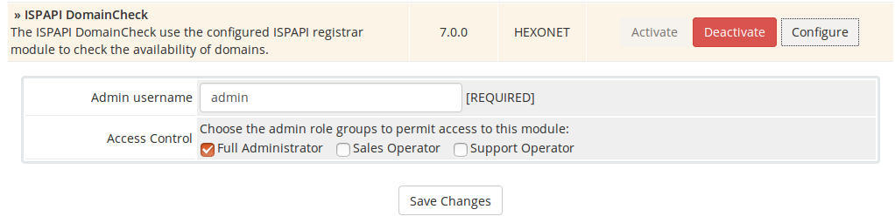
Activate the ISPAPI DomainCheck Addon, fill the admin username and give the module “Full Administrator” Access Control right.

Addon configuration

Within the WHMCS Admin area, go to
Addons => ISPAPI DomainCheck
Choose whether or not to show the aftermarket and the registry premium domains.
If you want to sell aftermarket Premium Domains and your WHMCS default currency is NOT set to USD you have to fill the conversion rates here.

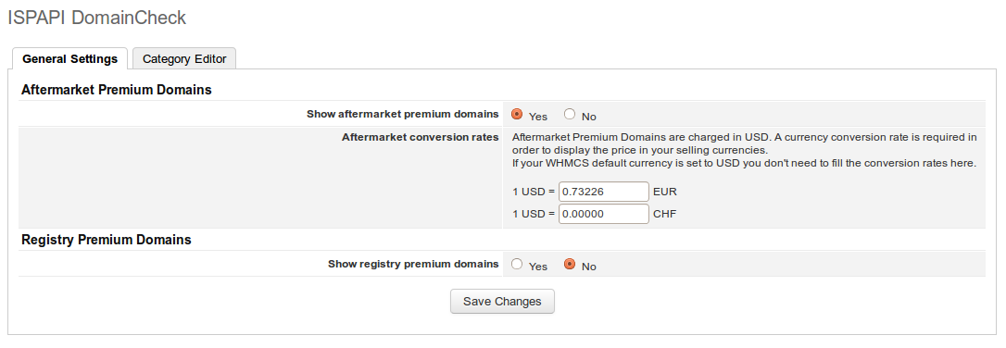

Click the “Category Editor” tab to create your own checker organized in 2 levels.
Please be aware that a TLD will only be displayed in the search results if it is also inserted in the Domain Pricing list. ( Setup => Products/Services => Domain Pricing )

E.g.
Backend
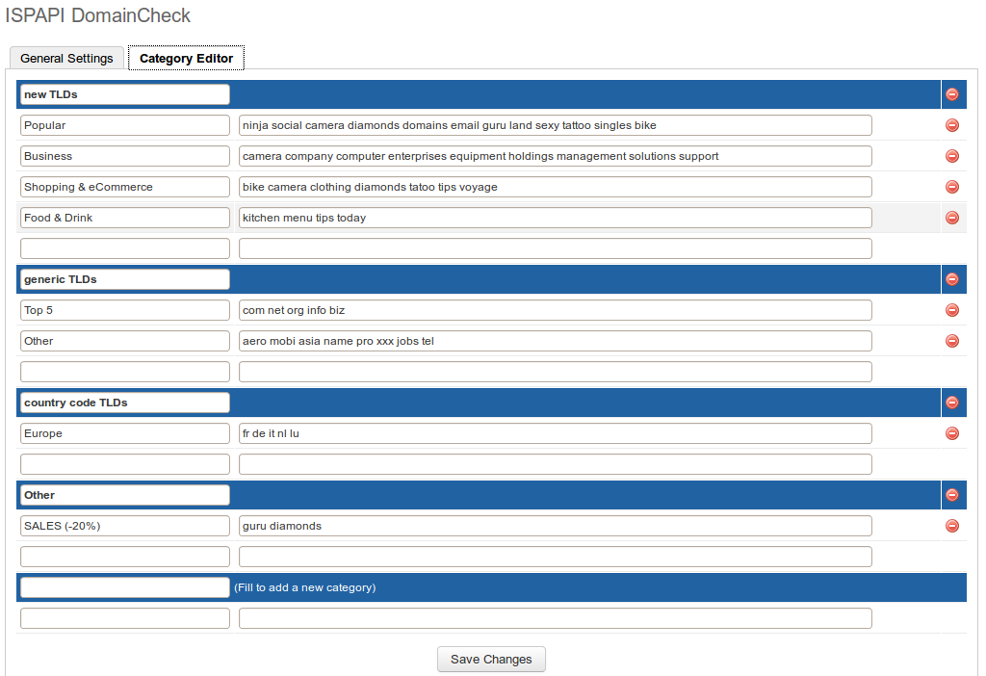

Frontend
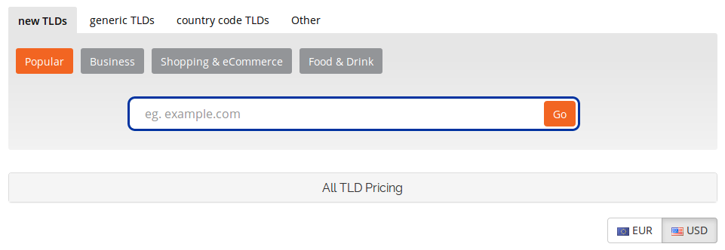

Premium Pricing

A new hidden product group named “PREMIUM DOMAIN” with several hidden products was created automatically by the installation.
NEVER EDIT THE GROUP NAME

- Registry Premium Products
The registries splits their premium domains into different classes. Each class is represented by one recurring product in WHMCS.
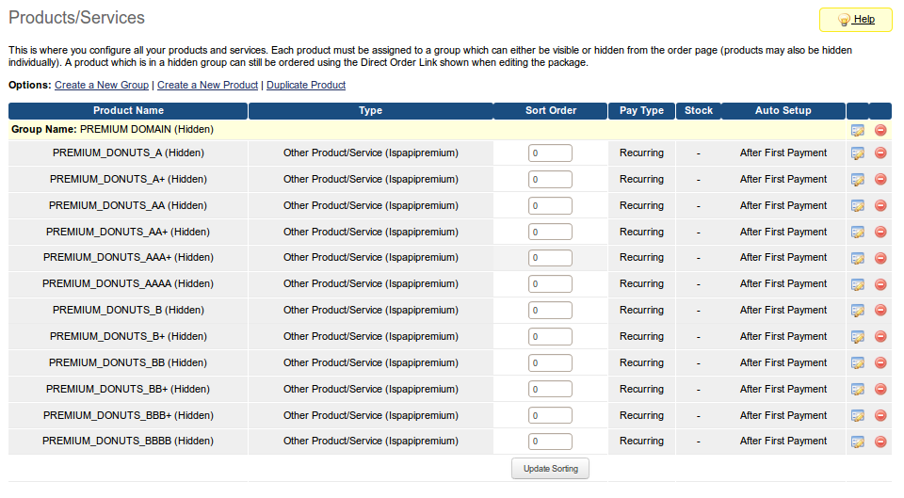
Initially, all products have been created without the price. You have to set the price of each product by editing each product. The price has to be set in the “Annually” column for all currencies.
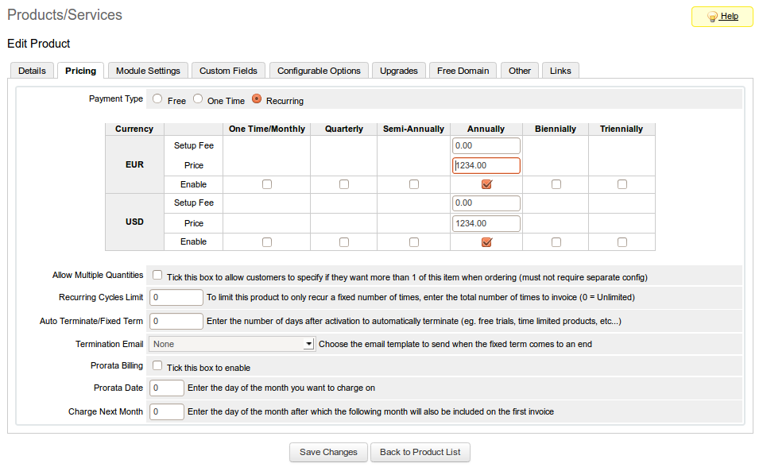
Not all price classes have been added in your system. Feel free to add new price classes by adding a new product. (you can check how it is configured in the existing products)

Domain Pricing

Fill all the TLDs you want to sell and select the registrar you want to use.
Be aware that high-performance domain availability checks using our registrar API will only be provided with the “Ispapi” and “Hexonet” registrar.

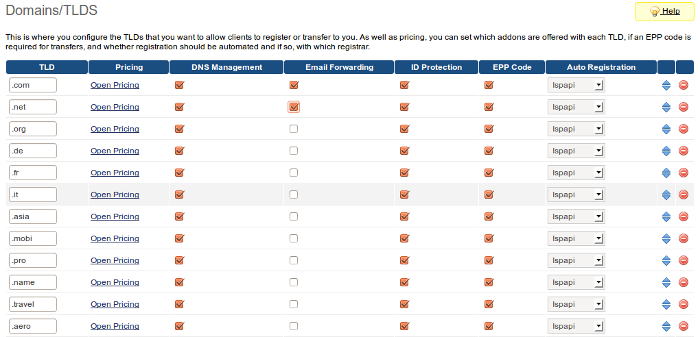

Switching the template

[ONLY REQUIRED IF YOU WANT TO SELL PREMIUM DOMAINS]

Within the WHMCS Admin area, go to
Setup => General Settings
Click the “Ordering” tab and set your Default Order Form Template to “Ispapi”.
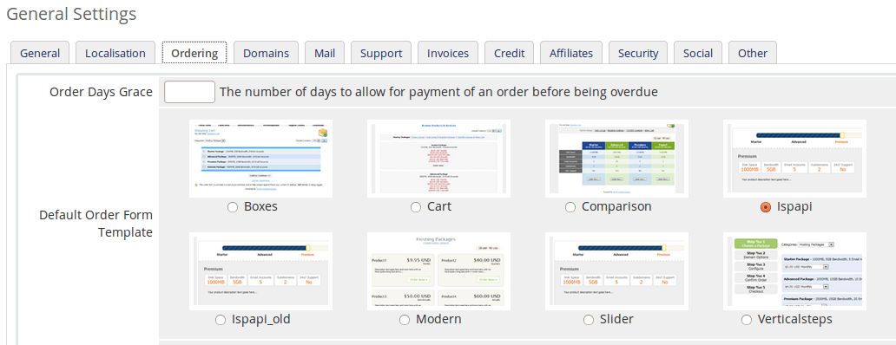
If you've developed your own orderform template and you don't want to change it, please contact us, we will be glad to assist you.

Allow the Smarty PHP Tags

Within the WHMCS Admin area, go to
Setup => General Settings
Click the “Security” tab and enable the Smarty PHP Tags.

Redirect or replace the WHMCS domainchecker file

There are 3 ways doing this task. Please choose one of them. We recommend using the first two methods because with the last you have to resume this task after each module update.

- Redirect the file
To redirect the WHMCS domainchecker.php to mydomainchecker.php, you have to add the following Apache configuration into your <VirtualHost> section:
RewriteEngine on
RewriteRule /domainchecker.php /mydomainchecker.php

- Add an .htaccess file
Create an “.htaccess” file in your WHMCS installation root directory with the following content:
RewriteEngine on
RewriteRule ^domainchecker.php$ mydomainchecker.php

- Replace the file
Rename the WHMCS domainchecker.php file into domainchecker_save.php and finally rename the mydomainchecker.php file into domainchecker.php.

Enable Module Debug Logging

Go to Utilities => Logs => Module Log and click the button ”Enable Debug Logging”. The module will log all important API commands. In case of problems the support will be able to react faster.

Test your installation

Go to your homepage, fill the input field with a domain and click the “Check Availability” button. If the result looks like the following screen-shot, your installation is a success and you are now ready to start selling domains with your new ISPAPI DomainCheck Addon.

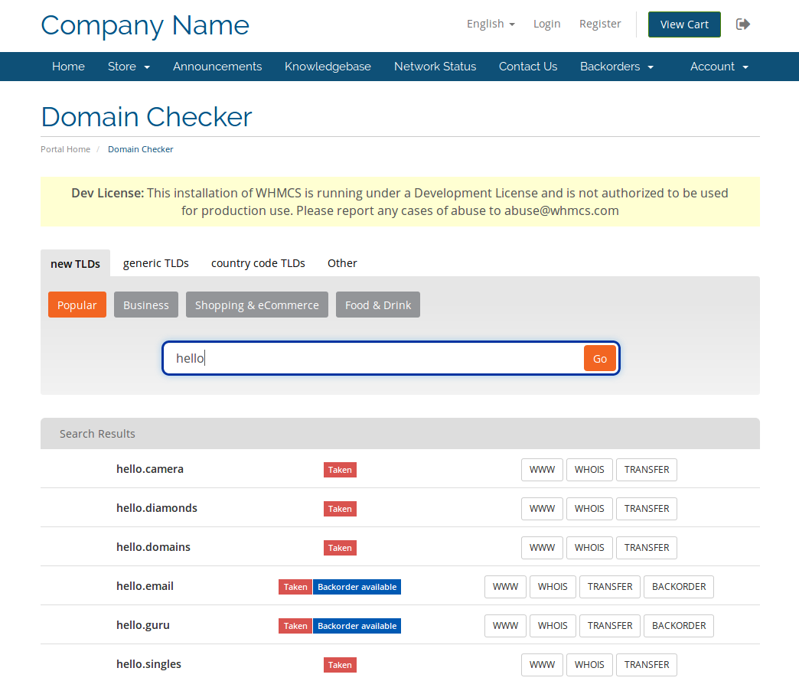

Start selling domains

Our ISPAPI DomainChecker Addon supports 3 types of domains:
- Standard domains
- Namemedia Aftermarket Premium domains
- Registry Premium domains

Standard domains


Standard
Domain
WHMCS
Domain

The well known way of ordering a normal domain:

- The customer creates a Standard Domain order.
- The domain will be displayed in the domain list and can be managed.

Aftermarket Premium domains

Aftermarket
Premium
Domain
WHMCS
Product
One Time
WHMCS
Domain

The price of a Namemedia Aftermarket Premium Domain is defined by Namemedia and it's a one time price for the registration.

The renewal price is no longer defined by Namemedia. The price will be the renewal price of the respective TLD you have configured in WHMCS.
The domain can be renewed manually by the customer in the domain configuration like a normal domain.

Workflow:
- The customer creates an Aftermarket Premium Domain order.
- A one time product will be created on the fly for this domain. (with the corresponding price)
- The domain will be first displayed in the product list.
- The progress of the domain application will be displayed in the product area. Once the domain status is set to “ACTIVE” the product will be displayed in the domain list and can be managed. This action is realized automatically when the customer opens the respective product in the product area and will also be done per cron job once per day.

Registry Premium domains

Registry
Premium
Domain
WHMCS
Product
Recurring
WHMCS
Domain
(free)

The registries splits its premium domains in different classes. Each class is represented by one recurring product in WHMCS. Your are allowed to define the price of each class in the product area. (See Premium Pricing)
The Registry Premium Domain can't be renewed at the normal TLD price but require the same price as the registration.
The domain can't be renewed manually by the customer but will be renewed automatically while the product isn't cancelled. The administrator is able to renew the product manually in the admin area.
In this case the domain is free because included with the product.

Workflow:
- The customer creates a Registry Premium Domain order.
- The corresponding recurring product for this domain will be assigned and ordered.
- The domain will be first displayed in the product list.
- The progress of the domain application will be displayed in the product area. Once the domain status is set to “ACTIVE” the product will be displayed in the domain list and can be managed. This action is realized automatically when the customer opens the respective product in the product area and will also be done per cron job once per day.

Special Features

1. Trigger the search over the URL

In some cases you would like to be able to trigger a search over the URL, our module can do that.
It is especially interesting when you've decided to create a landing page for a special TLD.

Example:
URL: www.yoursite.com/domainchecker.php?search=test.com&cat=5
This call will start a search of “test.com” and only display the TLDs configured in the category with ID=5.

Support

If you cannot find what you need here, please visit our online wiki or contact our support, we will assist you.
- Wiki: wiki.hexonet.net
- Technical Support: support@hexonet.net

