
ISPAPI DomainCheck Addon
High performance availability check using WHMCS & HEXONET

Version 7.3.0
April 16, 2018



COPYRIGHT NOTIFICATION
Copyright ©2018 HEXONET GmbH. All rights reserved.

DISCLAIMER AND LIMITATION OF LIABILITY
HEXONET GmbH and its affiliates (“HEXONET”) have made efforts to ensure the accuracy and completeness of the information in this document. However, HEXONET makes no warranties of any kind (whether express, implied or statutory) with respect to the information contained herein. HEXONET assumes no liability to any party for any loss or damage (whether direct or indirect) caused by any errors, omissions or statements of any kind contained in this document. Further, HEXONET assumes no liability arising from the application or use of the product or service described herein and specifically disclaims any representation that the products or services described do not infringe upon any existing or future intellectual property rights. Nothing herein grants the reader any license to make, use, or sell equipment or products constructed in accordance with this document. Finally, all rights and privileges related to any intellectual property right described in this document are vested in the patent, trademark, or service mark owner, and no other person may exercise such rights without express permission, authority, or license secured from the patent, trademark, or service mark owner.

HEXONET reserves the right to make changes to any information herein without further notice.

NOTICE AND CAUTION
Concerning Patent or Trademark Rights
The inclusion in this document, the associated on-line file, or the associated software of any information covered by any patent, trademark, or service mark rights will not constitute nor imply a grant of, or authority to exercise, any right or privilege protected by such patent, trademark, or service mark. All such rights and privileges are vested in the patent, trademark, or service mark owner, and no other person may exercise such rights without express permission, authority, or license secured from the patent, trademark, or service mark owner.

This document was created using LibreOffice 3

ISPAPI DomainCheck Addon
High performance availability check using WHMCS & HEXONET
Version 7.3.0

April 16, 2018

HEXONET GmbH
Talstrasse 27
66424 Homburg
Germany

E-Mail: support@hexonet.net
Internet: http://www.hexonet.net

Table of Contents
Introduction 4
Supported Features 5
Getting started 6
1.Requirements 6
2.Installation / Update 6
3.Configuration 7
a) Addon activation 7
b) Manage your categories 7
c) Regular domain pricing 9
d) DomainChecker Mode 10
e) Premium Domain pricing 11
f) Redirect or replace the WHMCS domainchecker file 12
g) Enable Module Debug Logging 13
4.Test your installation 14
Special Features 15
1. Trigger the search over the URL 15
Support 16

Introduction

The ISPAPI DomainChecker Addon module provides your customer a new simple and user-friendly interface to check the availability of domains.
With our module you will be able to support Premium Domains (Aftermarket and Registry Premium Domains) in just one (1) click.
An API suggestion engine has been integrated in the module to provide suggestions to the search.
The module connects to the configured ISPAPI registrar module to provide high-speed API availability checks. This module is also able to connect to our ISPAPI Backorder module (if installed) to display backorders in the search results.
For better performance, the module uses an Ajax-driven search and the search can be filtered by categories. The search can also be triggered directly by the URL, which is particularly useful when you want to create landing pages.
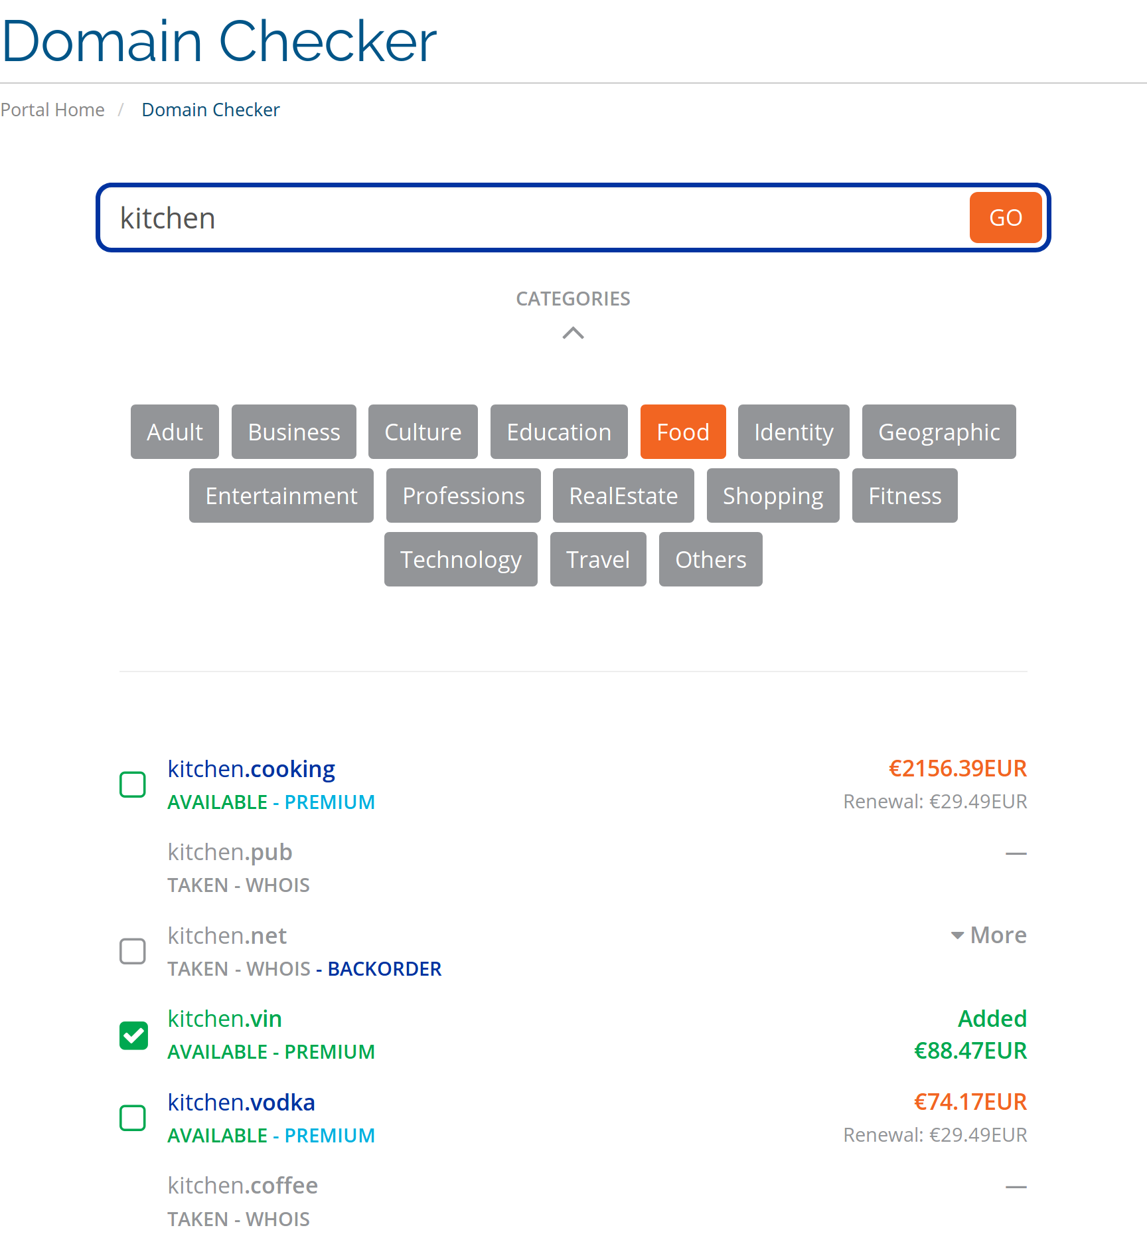

Supported Features
The ISPAPI DomainChecker addon supports the following functions and features:
- High-performance Domain Availability Checks using our registrar API
- Support of Premium Domains (Aftermarket and Registry Premium Domains)
- API Suggestion Engine integrated
- Categorization of the TLDs for an improved user experience
  - Default categories pre-configured
  - Search results based on the category selection
- Backorder button in the search results (if ISPAPI Backorder module installed)
  - Add or Remove backorders instantly in the search results
  - WHOIS information for taken domains
- Featuring each domain with availability and type of premium domain name
- Featuring prices of domains
  - Registration and renewal prices
  - Premium domains with markup prices
- Adding of domains to the cart instantly possible in the search results
- Removing of domains from the cart instantly possible in the search results
- Supports multiple currencies
- Support for English and German. (If any other language is required, please contact us)
- Ajax driven search (no page reload)
- Various performance optimizations
- Search trigger over the URL (helpful for landing pages)
  - For example: mydomainchecker.php?search=mydomain.com&cat=3
Will trigger the search of “mydomain.com” in the category ID=3
- Easy to install and use

Getting started

Requirements

In order to run the ISPAPI DomainChecker addon, your WHMCS installation must meet the following requirements:
- WHMCS version 7.0 or higher must be installed. (We recommend always using the latest version of WHMCS)
- ISPAPI Registrar Module version 1.0.53 or higher must be installed. This module can be downloaded here: https://wiki.hexonet.net/index.php/WHMCS_Modules
- HEXONET Live or Test Account must be configured in the ISPAPI Registrar Module. Account creation is free on our website: www.hexonet.net

Installation / Update

For a new installation, unzip the downloaded file and upload the content of the “install” folder to your WHMCS root directory.
For an update, unzip the downloaded file and upload the content of the “install” folder to your WHMCS root directory. Then go to Setup > Addon Modules > ISPAPI HP DomainChecker > Configure and click on the “Save Changes” button.

NOTE: The WHMCS root directory is the folder which contains the “configuration.php” file.

Configuration

Addon activation

Within the WHMCS Admin area, go to Setup > Addon Modules

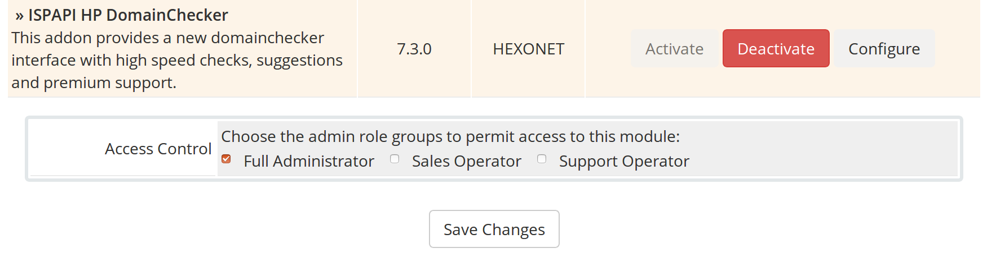
Activate the ISPAPI DomainChecker Addon, give the module “Full Administrator” Access Control right.

Manage your categories

In order to configure your Categories, go to Addons > ISPAPI HP DomainChecker
For a new installations, the default categories are directly pre-configured.
For updates, you can import the default categories by clicking the “Import Default Categories” button. (You’re currently configured categories won’t be deleted.)

Backend overview

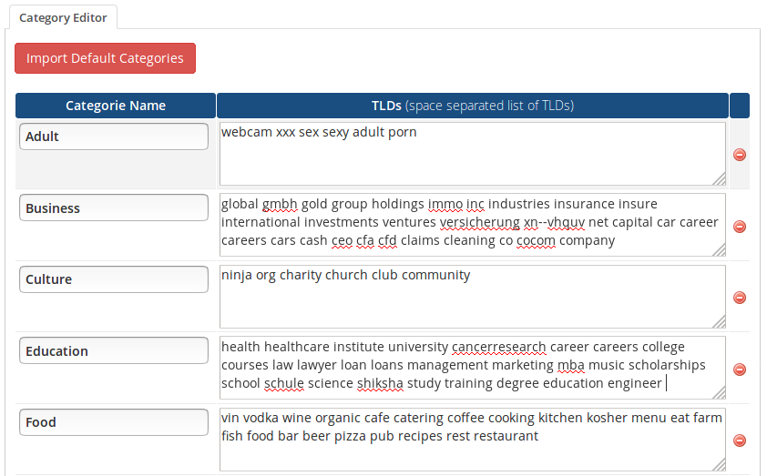
Frontend overview

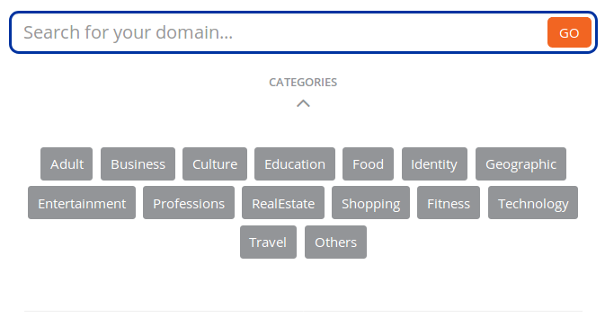

Regular domain pricing

Under Setup > Products/Services > Domain Pricing you will be able to configure and select the registrar for all the TLDs you want to sell.
Be aware that high-performance domain availability checks using our registrar API will only be provided with the “Ispapi” registrar. A fallback to the WHOIS Lookup will be done otherwise.

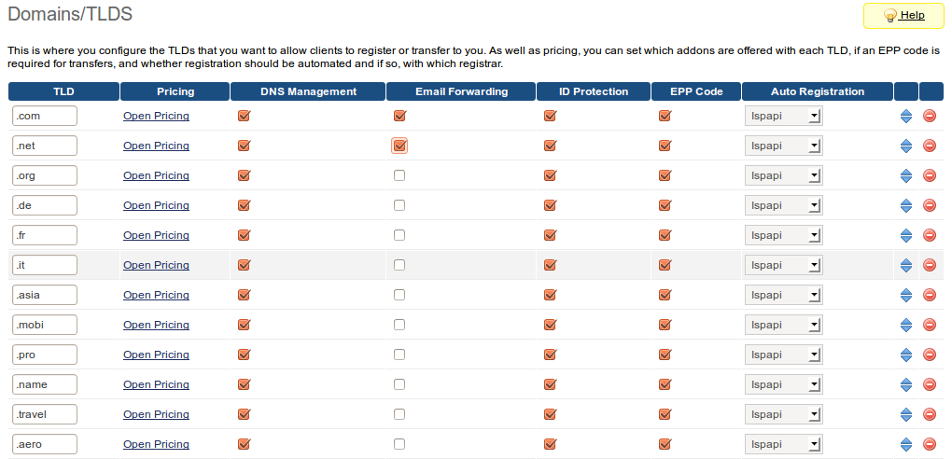

DomainChecker Mode
The module provides domain search results based on two different modes
1. Regular: regular search with the configured TLDs (default)
2. Suggestions: suggestions from our API

Regular mode is configured by default. To activate the suggestion mode, follow the below steps.
- Choose “HEXONET” in the lookup provider suggestions.
( Setup > Products/Services > Domain Pricing )
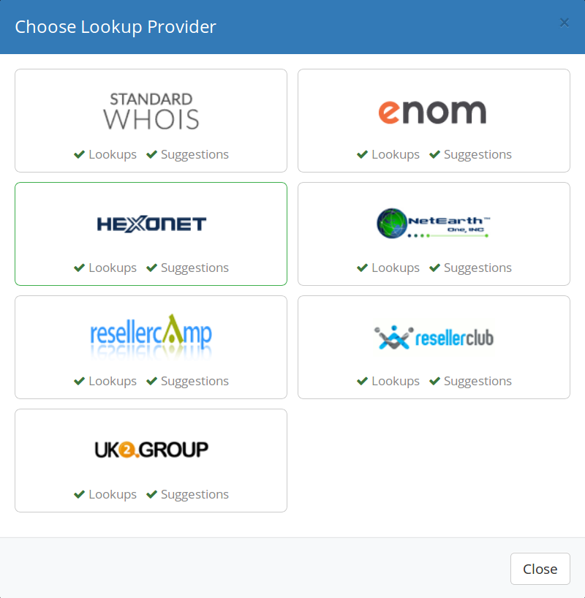

- Configure the lookup provider by activating the suggestion engine.
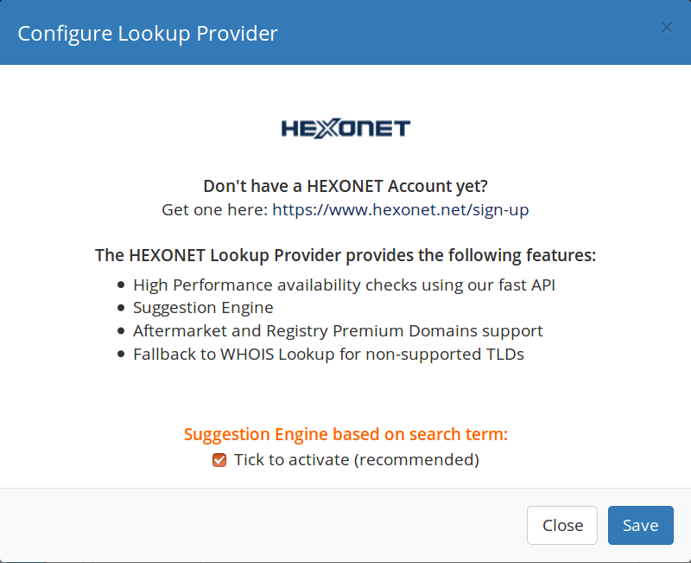

Premium Domain pricing

Our ISPAPI DomainChecker Addon supports Premium domain names. You can activate / deactivate them under:
Setup > Products/Services > Domain Pricing
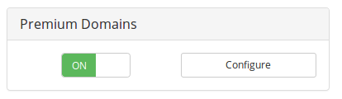
In order to add your Markup to the premium prices, use the “Configure” button.

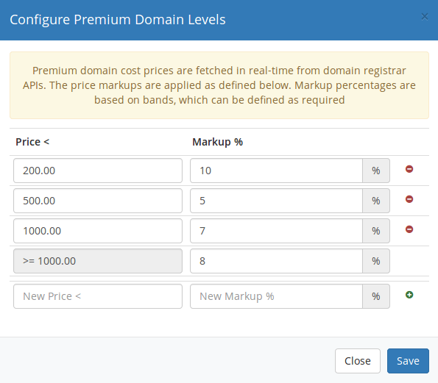

Redirect or replace the WHMCS domainchecker file

There are three (3) ways doing this task, please select one (1). We recommend using the first two (2) methods because with the last you have to resume this task after each module update.

- Redirect the file
To redirect the WHMCS domainchecker.php to mydomainchecker.php, add the following Apache configuration into your <VirtualHost> section:
RewriteEngine on
RewriteRule /domainchecker.php /mydomainchecker.php

- Add an .htaccess file
Create an “.htaccess” file in your WHMCS installation root directory with the following content:
RewriteEngine on
RewriteRule ^domainchecker.php$ mydomainchecker.php

- Replace the file
Rename the WHMCS domainchecker.php file into domainchecker_save.php, then rename the mydomainchecker.php file into domainchecker.php.

Enable Module Debug Logging

We recommend enabling the logging. The module will log all important API commands sent. In case of issues, HEXONET will be able to analyze the case.
Go to Utilities > Logs > Module Log and click the ”Enable Debug Logging” button.

Test your installation

Go to your homepage, fill the search field with a domain and click the “Go” button. If the result looks like the following screen-shot, your installation is a success and you are now ready to start selling domains with your new ISPAPI DomainChecker Addon.
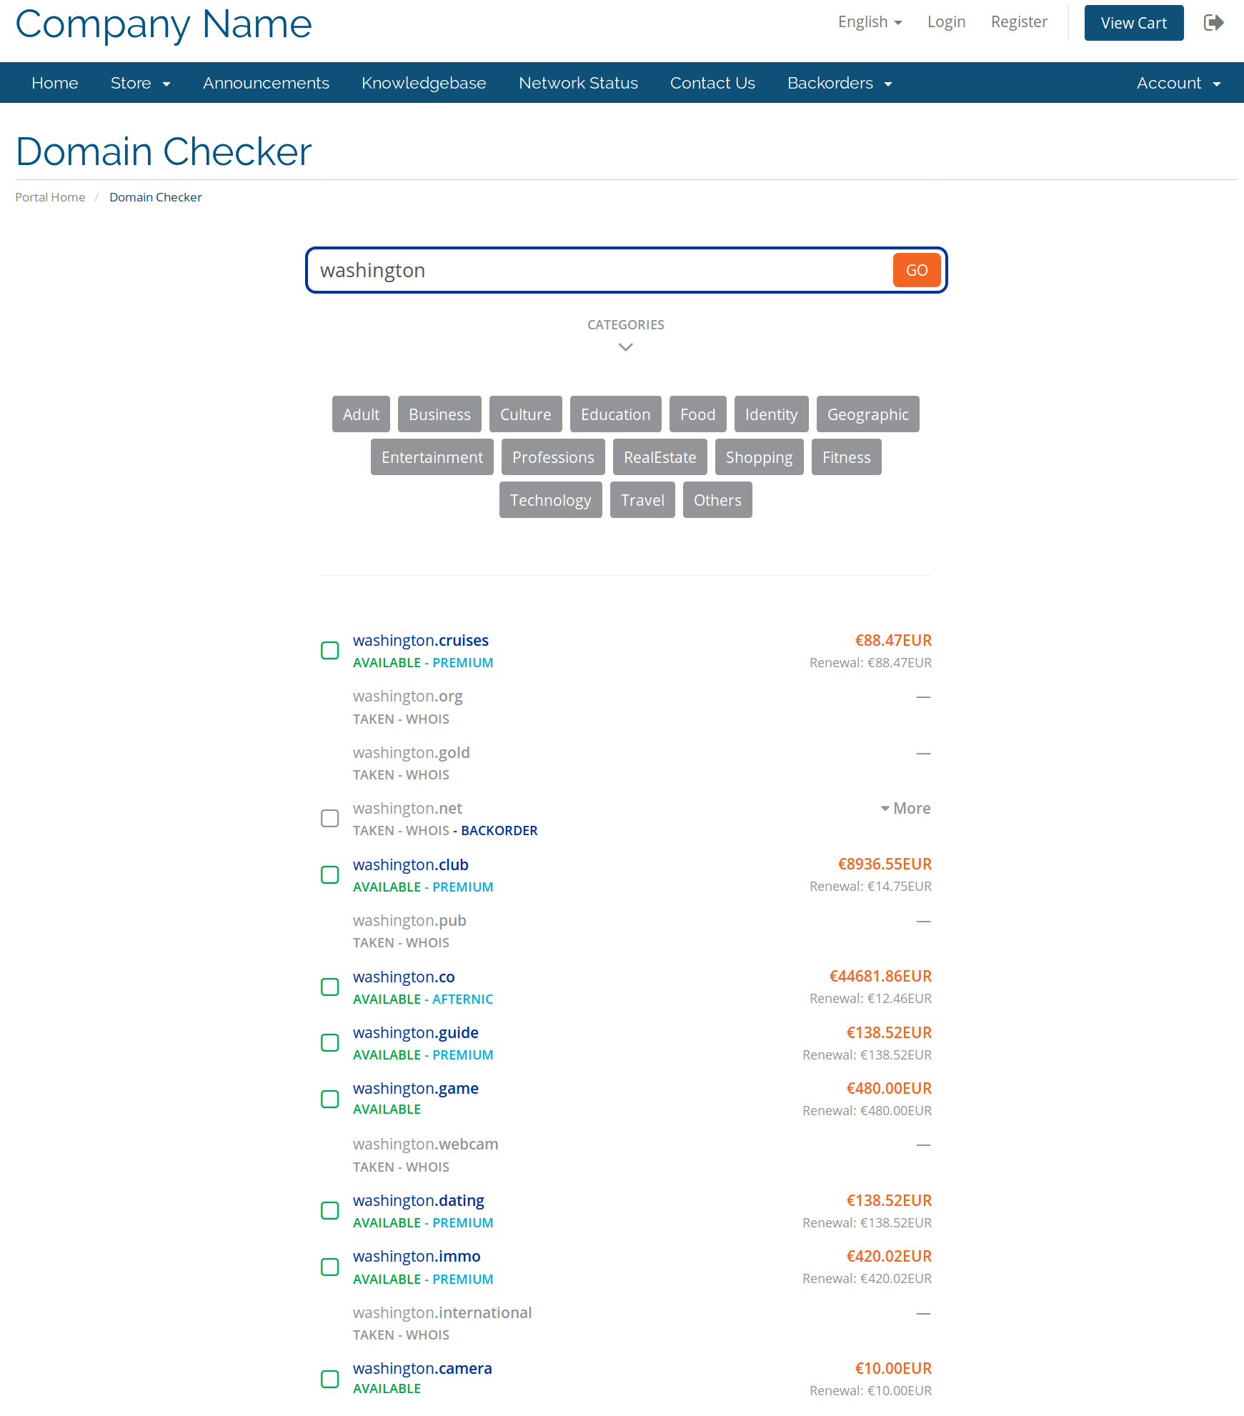

Special Features

1. Trigger the search over the URL

In some cases, you may want to be able to trigger a search over the URL, and our module can support that. It is especially useful when you've decided to create a landing page for a special TLD.

Example:
URL: www.yoursite.com/domainchecker.php?search=test.com&cat=5
This call will start a search of “test.com” and only display the TLDs configured in the category with ID=5.

Support

If you cannot find what you need here, please visit our online wiki or contact our support, and we will be happy to assist you.
- Wiki: wiki.hexonet.net
- Technical Support: support@hexonet.net or https://hexonet.support

