
ISPAPI Pricing Importer
Quickly update your WHMCS domain pricing list

Version 3.0.0 (or later version)
November 23, 2018



COPYRIGHT NOTIFICATION
Copyright ©2018 HEXONET GmbH. All rights reserved.

DISCLAIMER AND LIMITATION OF LIABILITY
HEXONET GmbH and its affiliates (“HEXONET”) have made efforts to ensure the accuracy and completeness of the information in this document. However, HEXONET makes no warranties of any kind (whether express, implied or statutory) with respect to the information contained herein. HEXONET assumes no liability to any party for any loss or damage (whether direct or indirect) caused by any errors, omissions or statements of any kind contained in this document. Further, HEXONET assumes no liability arising from the application or use of the product or service described herein and specifically disclaims any representation that the products or services described do not infringe upon any existing or future intellectual property rights. Nothing herein grants the reader any license to make, use, or sell equipment or products constructed in accordance with this document. Finally, all rights and privileges related to any intellectual property right described in this document are vested in the patent, trademark, or service mark owner, and no other person may exercise such rights without express permission, authority, or license secured from the patent, trademark, or service mark owner.

HEXONET reserves the right to make changes to any information herein without further notice.

NOTICE AND CAUTION
Concerning Patent or Trademark Rights
The inclusion in this document, the associated on-line file, or the associated software of any information covered by any patent, trademark, or service mark rights will not constitute nor imply a grant of, or authority to exercise, any right or privilege protected by such patent, trademark, or service mark. All such rights and privileges are vested in the patent, trademark, or service mark owner, and no other person may exercise such rights without express permission, authority, or license secured from the patent, trademark, or service mark owner.

This document was created using LibreOffice 3

ISPAPI Pricing Importer
Quickly update your WHMCS domain pricing list
Version 3.0.0 (or later version)


November 23, 2018

HEXONET GmbH
Talstrasse 27
66424 Homburg
Germany

E-Mail: support@hexonet.net
Internet: http://www.hexonet.net

Table of Contents
Supported Features 4
Installation 5
Configuration 6
Addon activation 6
Addon configuration 6
How can I update my prices? 8
Step 1 – Load prices 8
Step 2 – Update prices 8
Step 3 – Import Prices 9
Support 12

Supported Features
The ISPAPI Pricing Importer add-on supports the following features:
- Load TLDs with prices through three possible ways
  - HEXONET costs
  - HEXONET Price Classes
  - Custom CSV file
- Update existing extensions
- Flexible performance of step-wise pricing imports
- Support for different currencies
- Bulk price update by using a factor or a fixed amount
- Edition of prices individually
- Supported fields:
  - TLD
  - Register/Transfer/Renew pricing
  - DNS Management
  - Email Forwarding
  - ID Protection
  - EPP Code
  - Currency

Deleting extensions can only be done manually in the WHMCS backend.

Installation
Copy all files from the install/ subdirectory to your WHMCS installation root directory ($YOUR_WHMCS_ROOT), while keeping the folder structure intact.

E.g.
install/modules/addons/ispapidpi/ispapidpi.php
=> $YOUR_WHMCS_ROOT/modules/addons/ispapidpi/ispapidpi.php

Note: Make sure the value of variable ‘max_input_vars’ is higher in your php.ini file. We recommend at least 3000 as a value. The lower value of this variable (default value 1000) results in pricing importer module fail to import a larger number of TLDs.

Configuration

Addon activation

Within the WHMCS Admin area, go to
Setup > Addon Modules
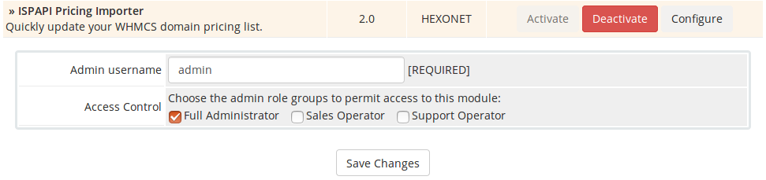
Activate the ISPAPI Pricing Importer Addon, fill your admin username and give the module “Full Administrator” Access Control right.

Addon configuration

Within the WHMCS Admin area, go to
Addons > ISPAPI Pricing Importer

You are now ready to quickly update your pricing list.

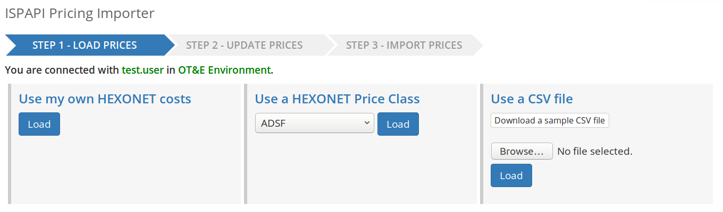

How can I update my prices?
In order to load and update your prices, simply follow the next steps:

Step 1 – Load prices
- Load your own HEXONET costs or a HEXONET price class or upload a CSV file
  - If you choose to upload a CSV file, you can download a sample CSV file.
  - Edit the generated CSV file by adding new TLDs with your new prices.
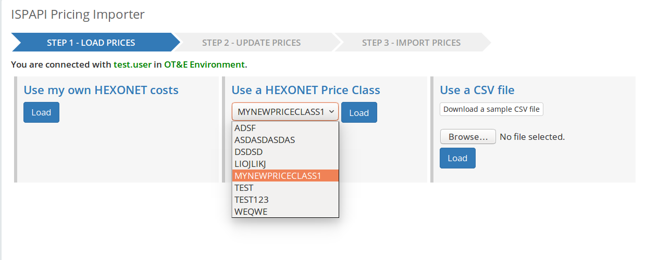

In the above screenshot, a price class is selected to load TLDs and prices of it.

Step 2 – Update prices
The following screenshot shows loaded TLDs and prices from a price class.
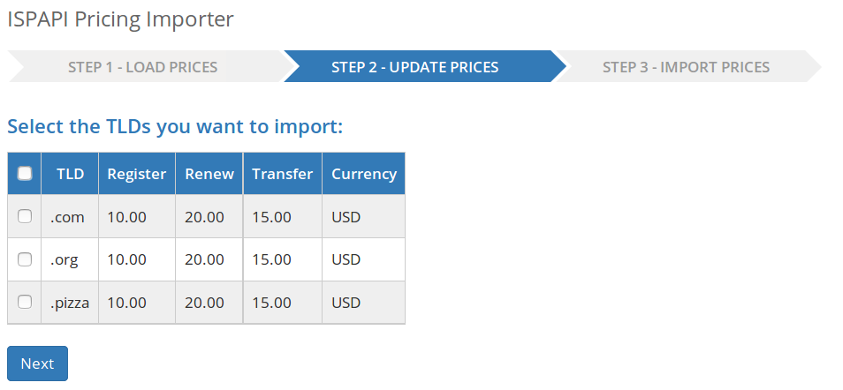

- You can now select TLDs that you wish to upload
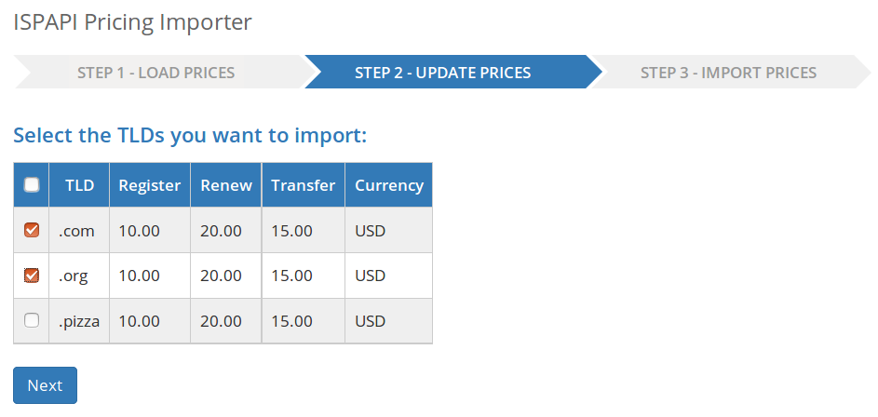

Step 3 – Import Prices
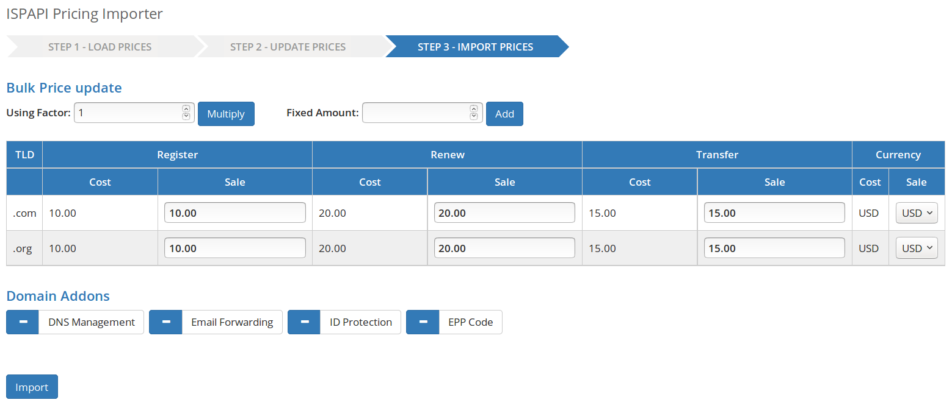
- In this step, actual costs and selling costs of each TLDs are dispalyed.
- You can update the prices in bulk by using a factor or a fixed amount.
  - Or you can edit sale prices individually.
- Additionally, you can select currency with which you would like to sell each TLD.
- Furthermore, you can select domain addons.
- If you wish to change your selection of TLDs, the module allows you to go back to previous steps and make a new selection.
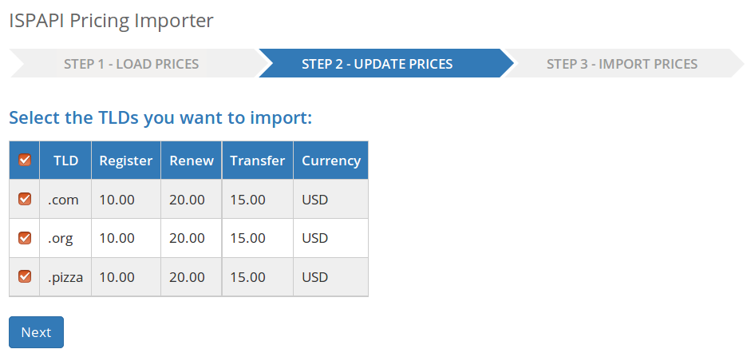
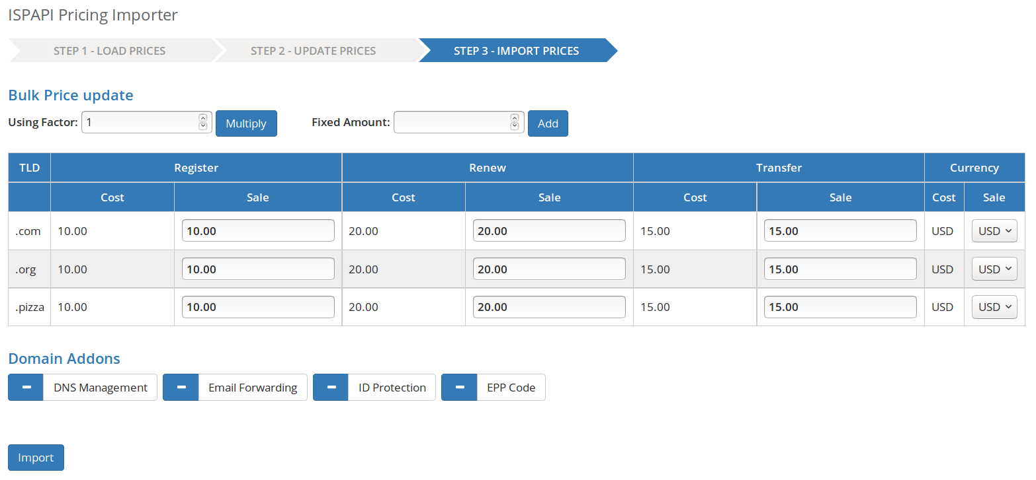

- Finally, import the updated pricing list. You're now done.
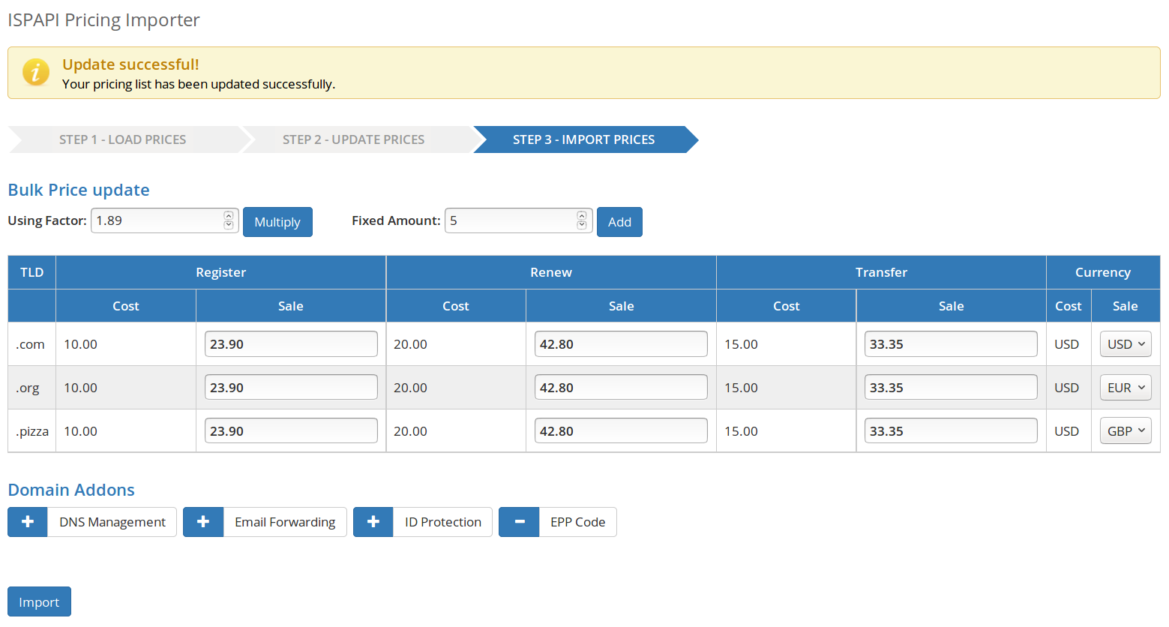

Support
If you cannot find what you need here, please visit our online wiki or contact our support, we will assist you.
- Wiki: wiki.hexonet.net
- Technical Support: support@hexonet.net

