
ISPAPI SSL Module
SSL Certificates Registration using WHMCS & HEXONET

Version 7.1.0 (or later version)
November 23, 2018



COPYRIGHT NOTIFICATION
Copyright ©2018 HEXONET GmbH. All rights reserved.

DISCLAIMER AND LIMITATION OF LIABILITY
HEXONET GmbH and its affiliates (“HEXONET”) have made efforts to ensure the accuracy and completeness of the information in this document. However, HEXONET makes no warranties of any kind (whether express, implied or statutory) with respect to the information contained herein. HEXONET assumes no liability to any party for any loss or damage (whether direct or indirect) caused by any errors, omissions or statements of any kind contained in this document. Further, HEXONET assumes no liability arising from the application or use of the product or service described herein and specifically disclaims any representation that the products or services described do not infringe upon any existing or future intellectual property rights. Nothing herein grants the reader any license to make, use, or sell equipment or products constructed in accordance with this document. Finally, all rights and privileges related to any intellectual property right described in this document are vested in the patent, trademark, or service mark owner, and no other person may exercise such rights without express permission, authority, or license secured from the patent, trademark, or service mark owner.

HEXONET reserves the right to make changes to any information herein without further notice.

NOTICE AND CAUTION
Concerning Patent or Trademark Rights
The inclusion in this document, the associated on-line file, or the associated software of any information covered by any patent, trademark, or service mark rights will not constitute nor imply a grant of, or authority to exercise, any right or privilege protected by such patent, trademark, or service mark. All such rights and privileges are vested in the patent, trademark, or service mark owner, and no other person may exercise such rights without express permission, authority, or license secured from the patent, trademark, or service mark owner.

This document was created using LibreOffice 3

ISPAPI SSL Module
SSL Certificates Registration using WHMCS & HEXONET
Version 7.1.0 (or later version)

November 23, 2018

HEXONET GmbH
Talstrasse 27
66424 Homburg
Germany

E-Mail: support@hexonet.net
Internet: http://www.hexonet.net

Table of Contents
Introduction 4
Supported Features 5
Getting started 6
Requirements 6
Installation 6
Configuration 7
Addon activation 7
Addon configuration 7
Import certificates 8
Wizard Mode 8
a) Step 1: Load SSL certificates 8
b) Step 2: Update prices and import certificates 9
c) Manage imported certificates 10
Manual Mode 11
a) Create a new group 11
b) Create a new product 11
Frontend overview 15
How to buy a certificate? 16
Support 20

Introduction

The ISPAPI SSL Module is a combination of an addon and a provisioning module.
The SSL addon provides a user friendly interface for your customers to load and import SSL certificates under a product group. In addition, it gives the possibility to compare cost and sale prices. Customer can simply update sale prices and import them.
The addon creates a product group at installation. It also configures the module settings and pricing at provisioning module when the SSL certificates are imported.
The SSL provisioning module connects to the configured ISPAPI registrar module to establish a possibility to register and maintain SSL certificates at HEXONET.

Supported Features
The ISPAPI SSL Module supports the following functions and features:
- Unified handling of different suppliers
- Support for testing environment
- Certificate products directly connected to the ISPAPI Registrar Module
- New SSL addon
  - Load available SSL certificates and import them under a product group
  - Bulk price update by using a profit margin
  - Support for different currencies

Getting started

Requirements
In order to run the ISPAPI SSL addon and provisioning modules, your WHMCS installation must meet the following requirements:
- WHMCS version 7.0 or higher must be installed. (We recommend always using the latest version of WHMCS)
- ISPAPI Registrar Module version 1.0.53 or higher must be installed. This module can be downloaded here: https://wiki.hexonet.net/index.php/WHMCS_Modules
- HEXONET Live or Test Account must be configured in the ISPAPI Registrar Module. Account creation is free on our website: www.hexonet.net

Installation
Copy files from the zip to your WHMCS installation root directory ($YOUR_WHMCS_ROOT), while keeping the folder structure intact.

E.g.
addons/ispapissl_addon
=> $YOUR_WHMCS_ROOT/modules/addons/ispapissl_addon

servers/ispapissl
=> $YOUR_WHMCS_ROOT/modules/servers/ispapissl

For an update, unzip the downloaded file and upload the content of addons and servers folders to your WHMCS root directory. Then go to Setup > Addon Modules > ISPAPI SSL Addon > Configure and click on the “Save Changes” button.

NOTE: The WHMCS root directory is the folder which contains the “configuration.php” file.

Configuration

Addon activation
Within the WHMCS Admin area, go to Setup > Addon Modules
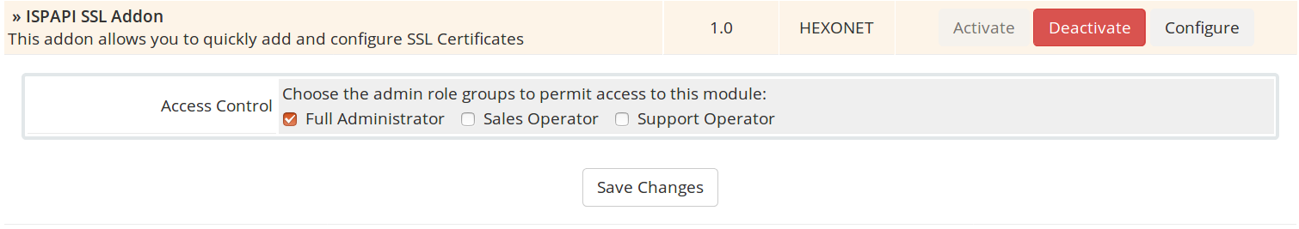
Activate the ISPAPI SSL Addon, give the module “Full Administrator” Access Control right.

Addon configuration
Within the WHMCS Admin area, navigate to Addons > ISPAPI SSL Addon

Import certificates
You are now ready to import SSL certificates.
Wizard mode explains how to import SSL certificates in an automated way.
Manual mode explains how to import SSL certificates manually.

Wizard Mode

Step 1: Load SSL certificates
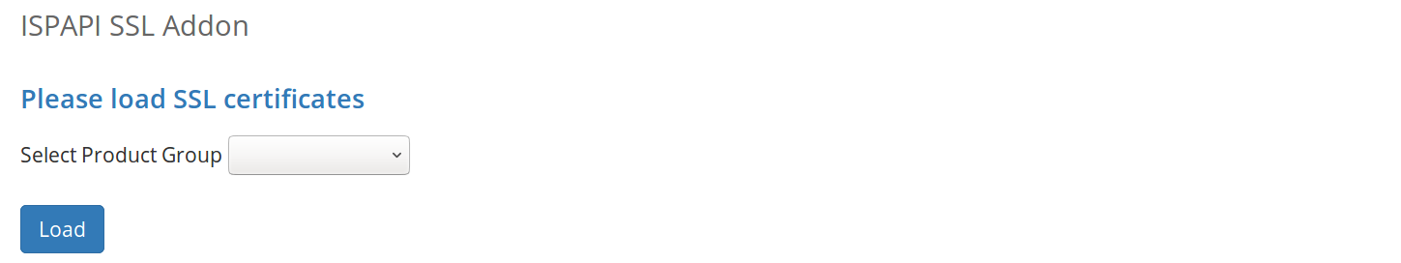

Step 2: Update prices and import certificates
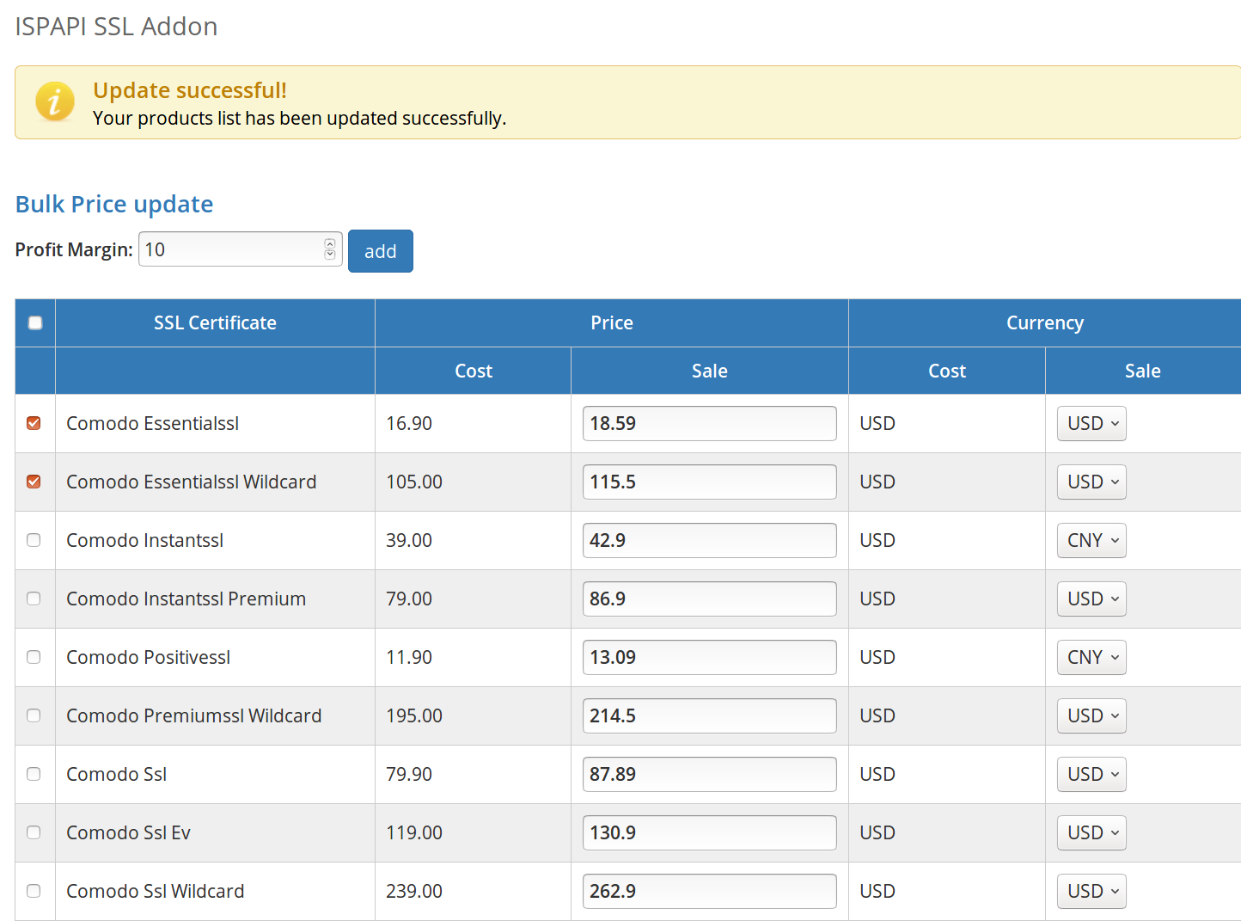

Manage imported certificates
Managing imported certificates can be done at Setup > Products/Services > Products/Services

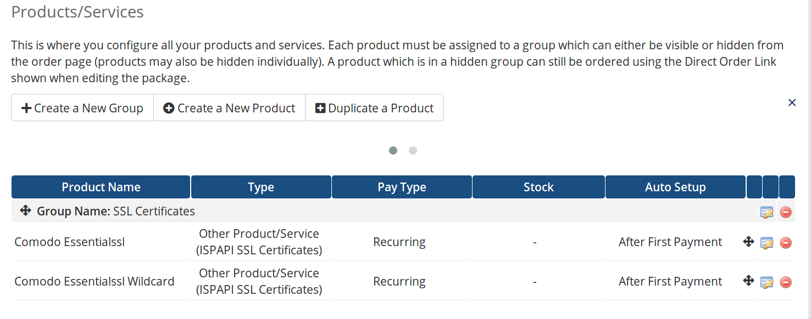

Update certificate settings if required:
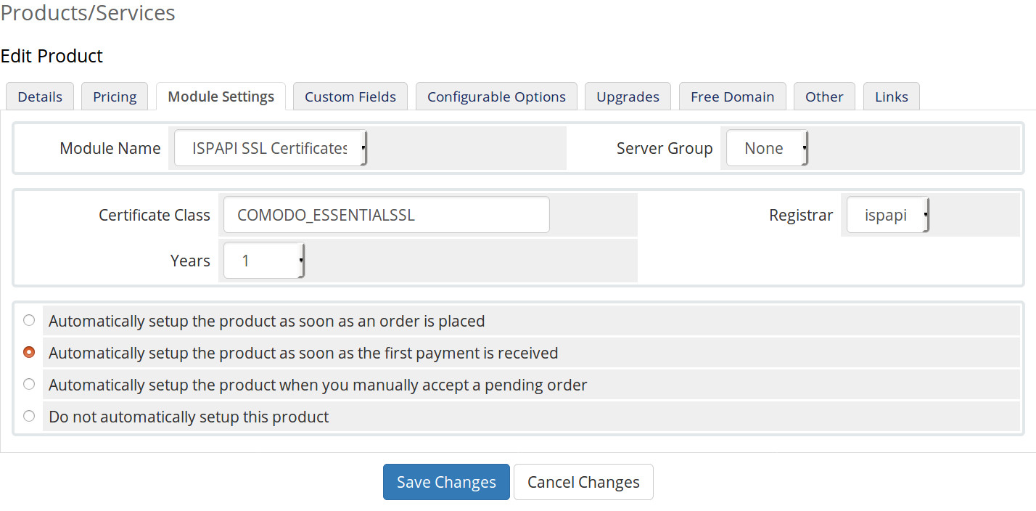

Manual Mode
Setup an SSL certificate product.
Within the WHMCS Admin area, navigate to Setup > Products/Services > Products/Services

a) Create a new group
In this example, we will name the new group as “SSL Certificates”.

b) Create a new product
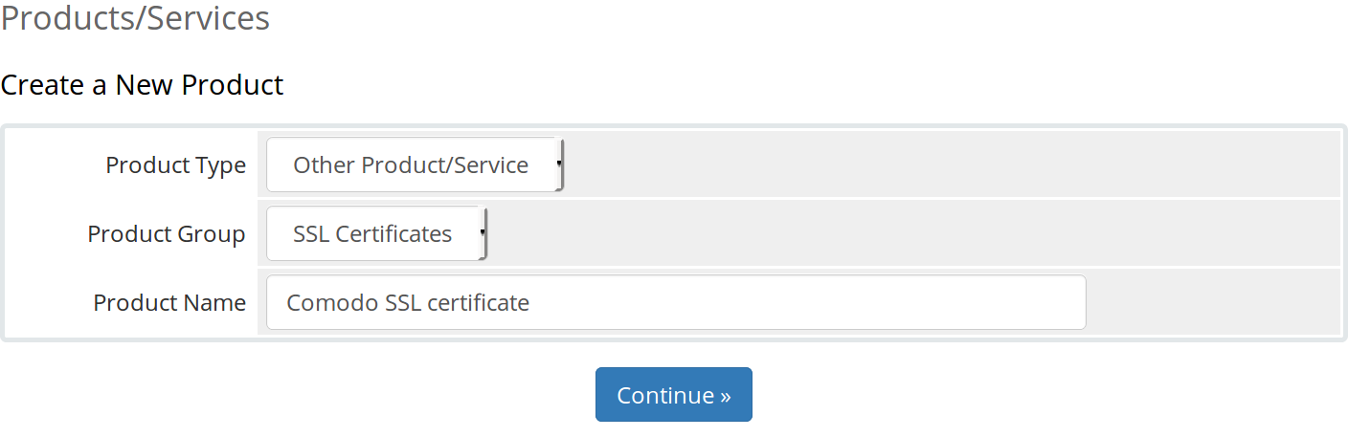

On the “Details” tab:
Set a Product Description (optional).
Ensure the Welcome Email field is set to “None” as the module sends its own email.
Ensure the Required Domain field is unchecked.
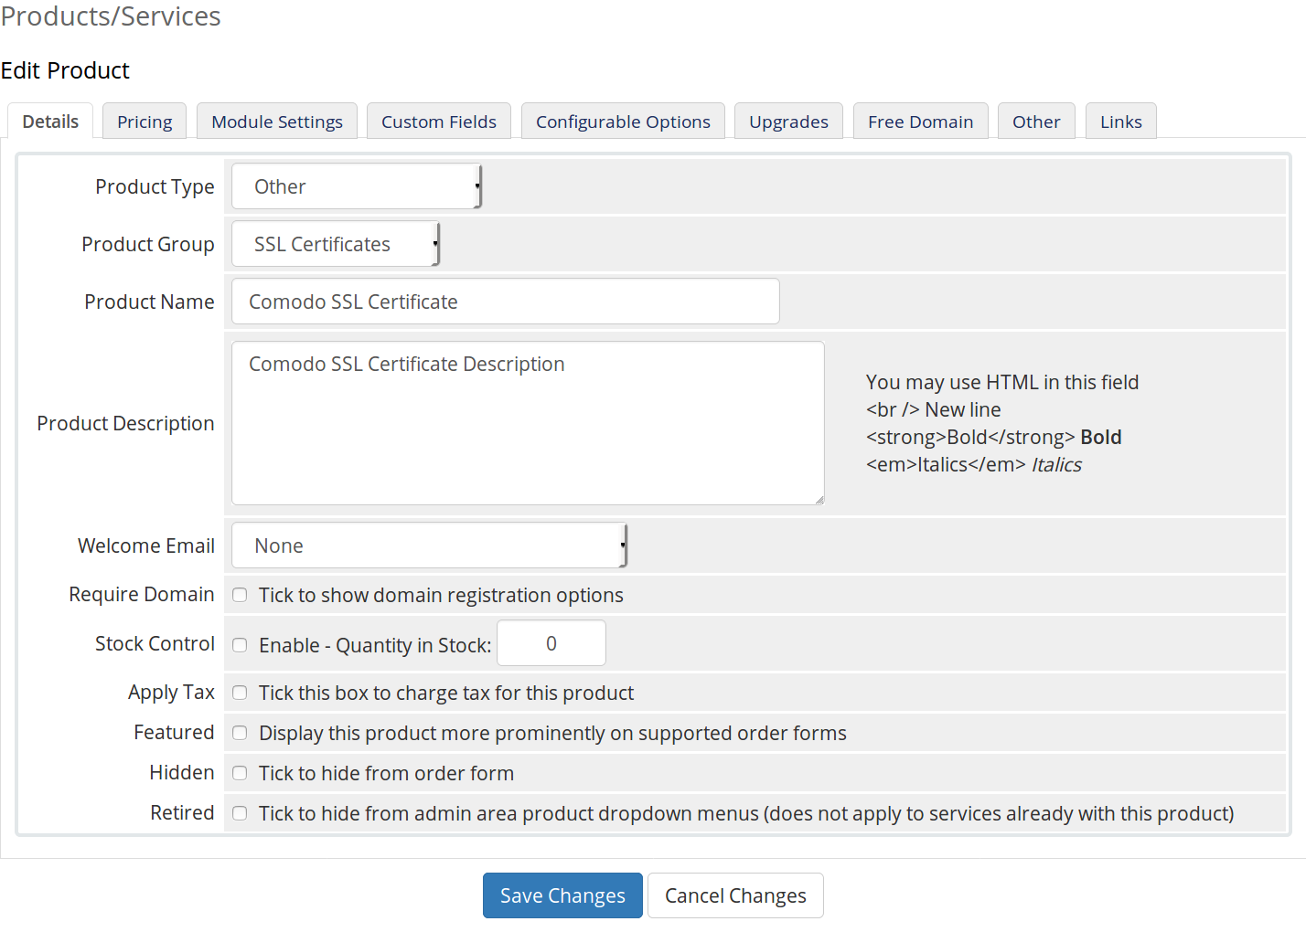

On the “Pricing” tab:
Set the Payment Type field to Recurring and set a price
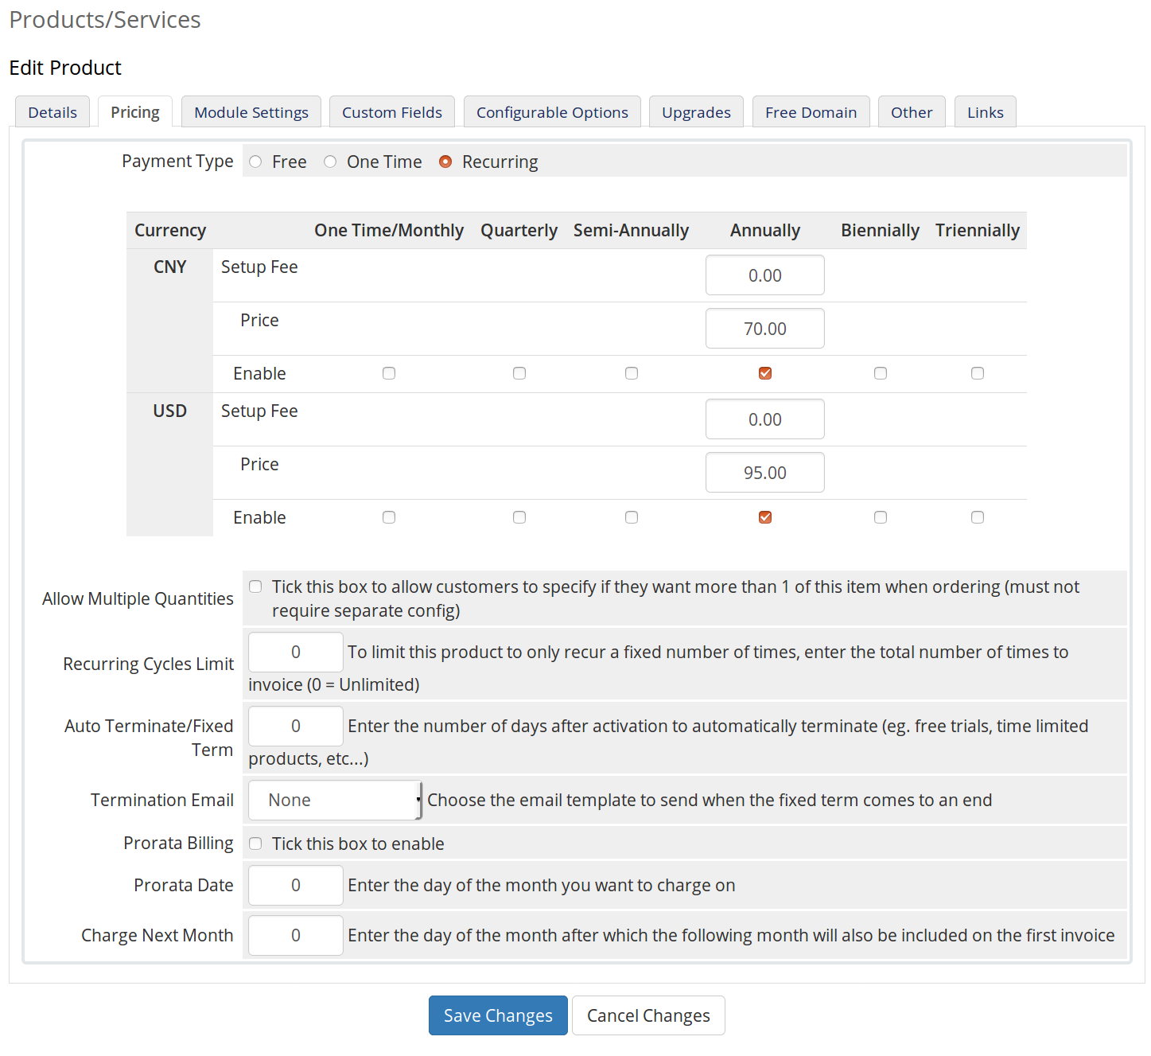

On the “Module Settings” tab:
Choose “ISPAPI SSL Certificate” for the module Name field. Other fields “Years” and “Registrar” are automatically filled and the connection between our API and product is established. If you configured a test account in ISPAPI registrar module, the product will be registered and managed in the test environment. if you configured a production account, the product will be registered and managed in the production environment.
Enter Certificate Class. Set “Automatically setup the product as soon as the first payment is received” to ensure the certificate is paid for before registration. Save changes.
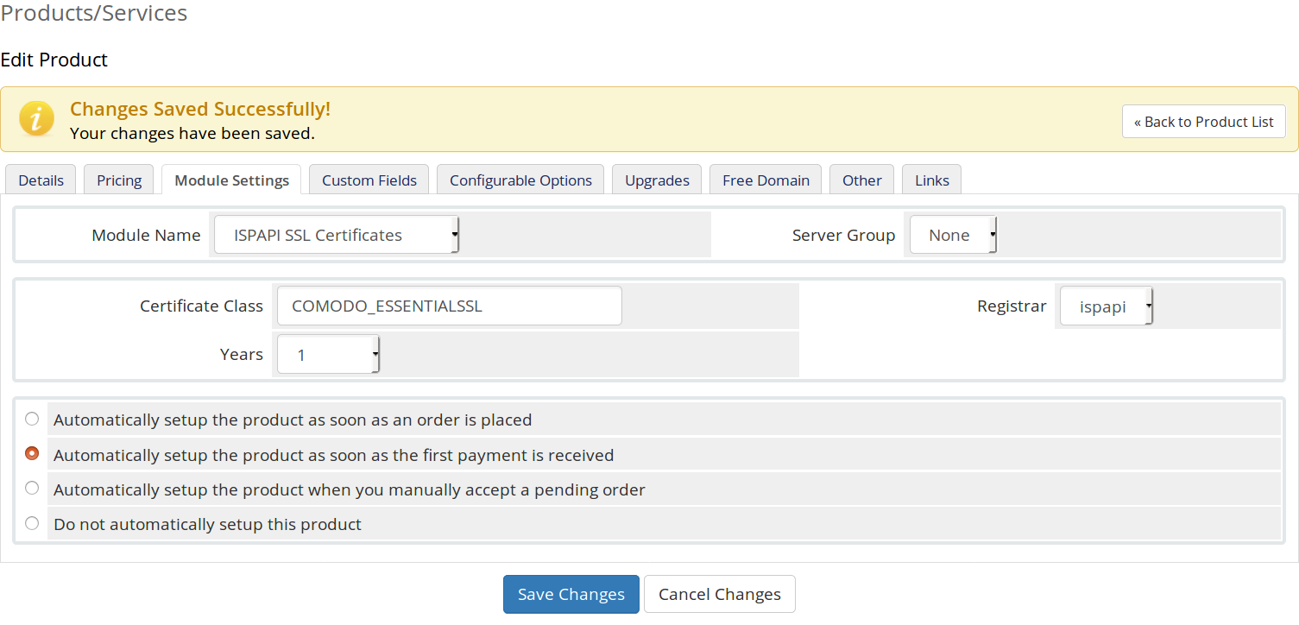

Frontend overview
WHMCS client area > Store > SSL Certificates
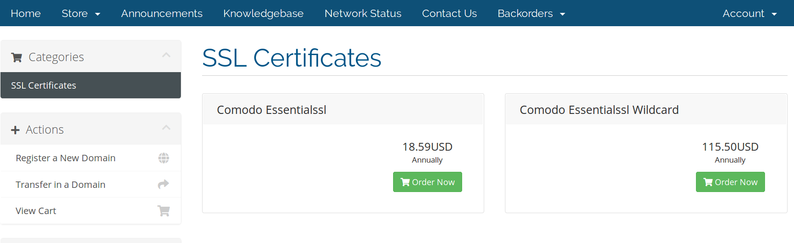

How to buy a certificate?
Go to the created certificate group on your WHMCS frontend and “Order Now” the just created certificate.
Follow the steps in the buying process.
Once the invoice is paid, you will receive an SSL certificate Configuration email, which contains a link to configure the new certificate.
Click this link or to go to the bought SSL certificate product page and click the “Configure SSL Certificate” button.
On this configuration page, you will be asked to provide a Web Server Type, a CSR and Administrative Contact Information.

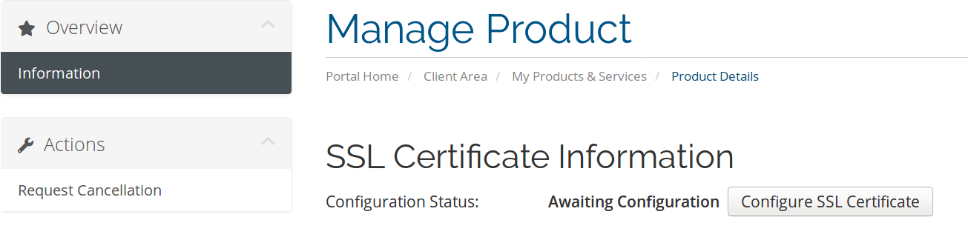

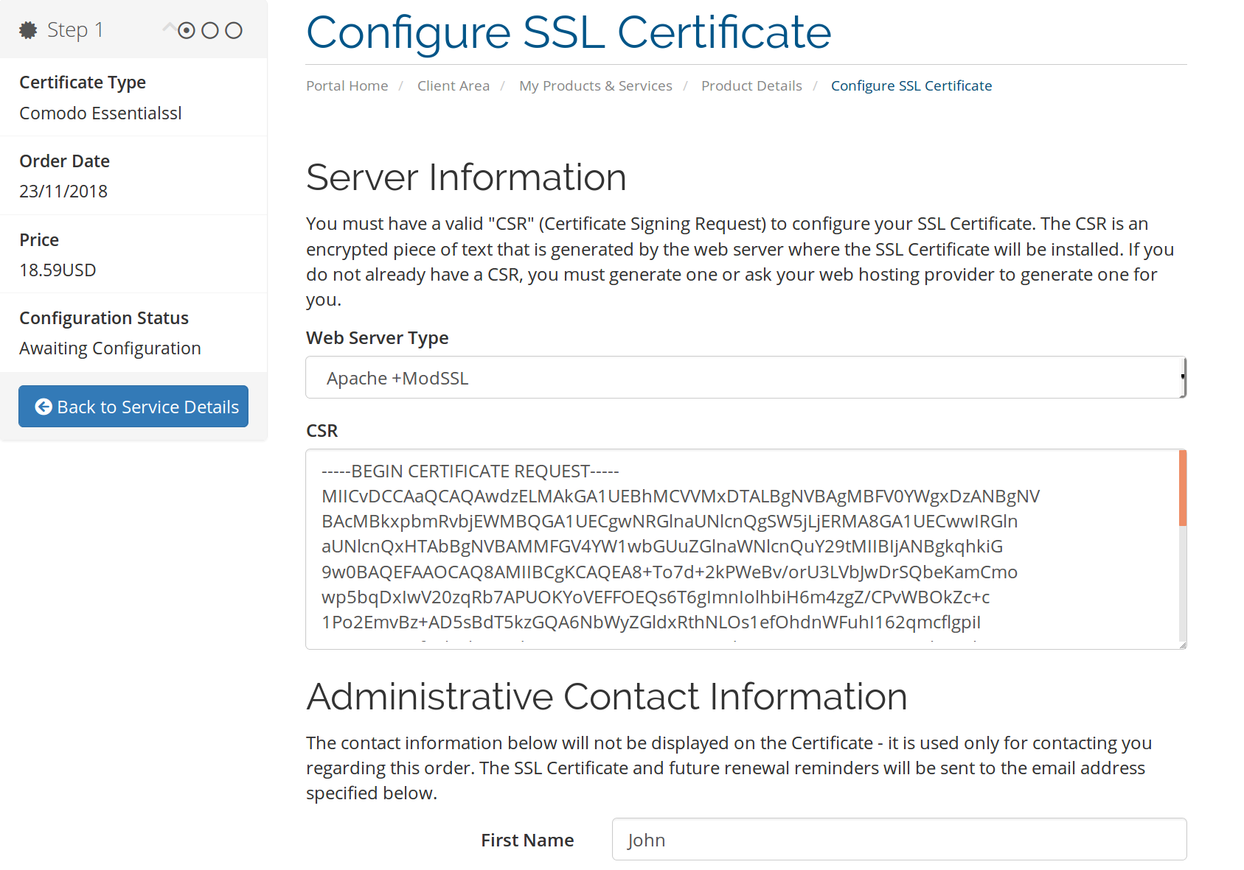

On the subsequent configuration page, you will be asked for a Certificate Approver Email.
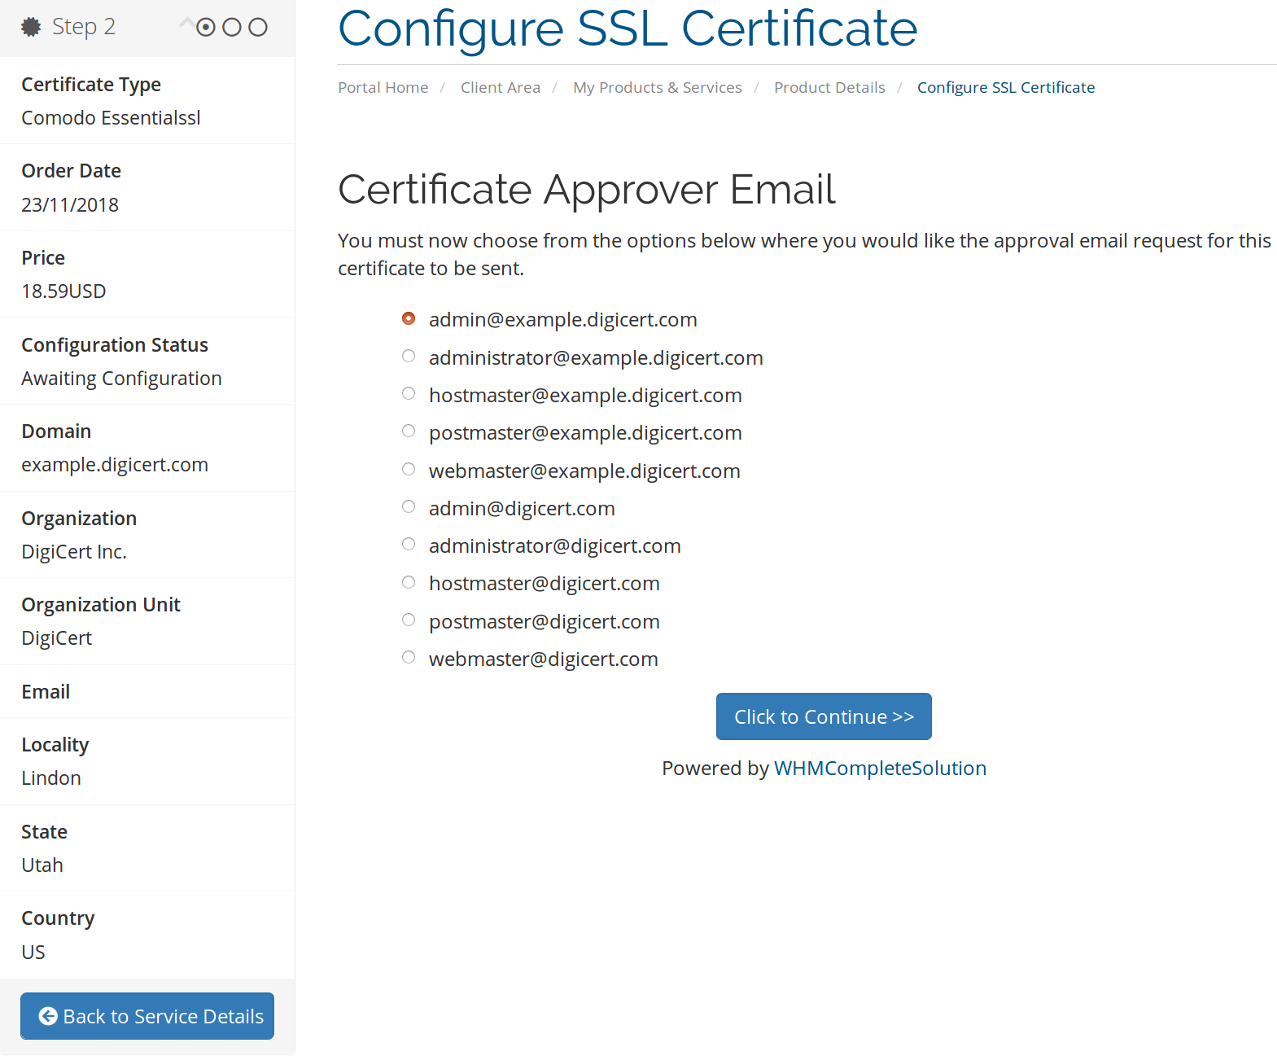

The configiuration is now completed
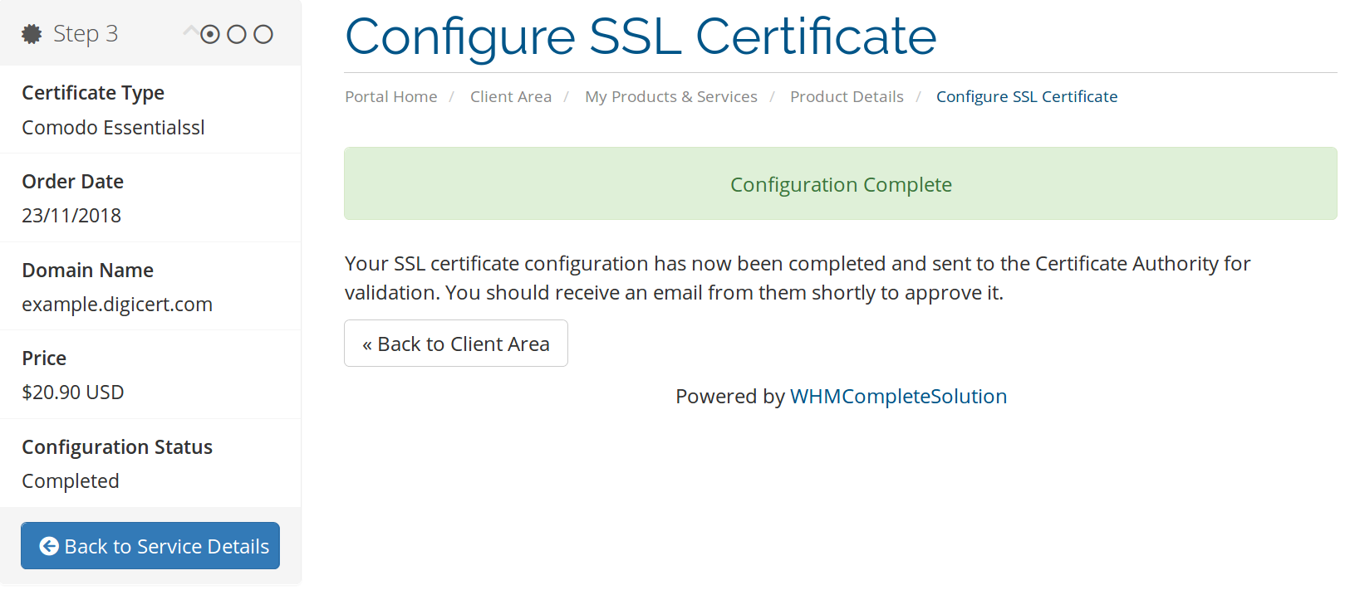

Support
If you cannot find what you need here, please visit our online wiki or contact our support, and we will be happy to assist you.
- Wiki: wiki.hexonet.net
- Technical Support: support@hexonet.net or https://hexonet.support

