
ISPAPI Registrar Module
Domain Management using WHMCS & HEXONET

Version 1.0.58 (or later version)
July 4, 2018



COPYRIGHT NOTIFICATION
Copyright ©2018 HEXONET GmbH. All rights reserved.

DISCLAIMER AND LIMITATION OF LIABILITY
HEXONET GmbH and its affiliates (“HEXONET”) have made efforts to ensure the accuracy and completeness of the information in this document. However, HEXONET makes no warranties of any kind (whether express, implied or statutory) with respect to the information contained herein. HEXONET assumes no liability to any party for any loss or damage (whether direct or indirect) caused by any errors, omissions or statements of any kind contained in this document. Further, HEXONET assumes no liability arising from the application or use of the product or service described herein and specifically disclaims any representation that the products or services described do not infringe upon any existing or future intellectual property rights. Nothing herein grants the reader any license to make, use, or sell equipment or products constructed in accordance with this document. Finally, all rights and privileges related to any intellectual property right described in this document are vested in the patent, trademark, or service mark owner, and no other person may exercise such rights without express permission, authority, or license secured from the patent, trademark, or service mark owner.

HEXONET reserves the right to make changes to any information herein without further notice.

NOTICE AND CAUTION
Concerning Patent or Trademark Rights
The inclusion in this document, the associated on-line file, or the associated software of any information covered by any patent, trademark, or service mark rights will not constitute nor imply a grant of, or authority to exercise, any right or privilege protected by such patent, trademark, or service mark. All such rights and privileges are vested in the patent, trademark, or service mark owner, and no other person may exercise such rights without express permission, authority, or license secured from the patent, trademark, or service mark owner.

This document was created using LibreOffice 3

ISPAPI Registrar Module
Domain Management using WHMCS & HEXONET
Version 1.0.58 (or later version)


July 4, 2018

HEXONET GmbH
Talstrasse 27
66424 Homburg
Germany

E-Mail: support@hexonet.net
Internet: http://www.hexonet.net

Table of Contents
Supported Features 4
Installation 6
Update 6
Configuration 7
Reseller Credentials 7
Nameservers 8
Cronjob configuration 8
Hexonet widget activation 9
Additional domain fields 10
HEXONET as Lookup Provider 12
UTF-8 Support 16
Domain Name WHOIS Privacy 17
Support for the new WHMCS 'toggle ID protection' functionality 17
Client area WHOIS Privacy management 17
Special features 19
.CA Registrant WHOIS Privacy 19
.CA Change of Registrant 19
.IT .CH .SE .SG .LI Change of Registrant 20
.SWISS Registrations 20
SRV Records support 22
DNSSEC Management support 23
Ispapi Domain Import Addon 24

Supported Features
The registrar module supports the following functions and features:

- Domain Registration
- Additional domain fields
- Domain Transfer (with AuthInfo code support)
- Domain Management
- Domain locking
- Update Contact Information (with UTF-8 support)
- Change Nameservers
- Glue Records - Nameserver Registration (Add, Modify, Delete)
- Explicit Deletions supported in Admin area
- Domain Renewal
- Special handling for registries without explicit renewals (many ccTLDs)
- DNS Management
- Record-Types: A, AAAA, MX, MXE, CNAME, TXT
- Allows user defined TTL values and MX priorities
- DNS Zone created automatically when adding a DNS record if no DNS Zone existing
- Email forwarding
- URL forwarding
- Redirect using HTTP
- Forward using HTML Frame
- Optional TLS/SSL for API connection
- Supports proxy server for accelerated API access
- Support for testing environment
- WHOIS Privacy management of .CA domain names
- Change of Registrant for .CA / .IT / .CH / .SE / .SG / .LI domain names
- Support for WHOIS Privacy / ID Protection
- Uses privacy service WHOISTRUSTEE.com
- ID Protection toggle in Admin area gets synchronized
- Client area WHOIS Privacy management
- Support for all bulk update operations
- Support for IDNs
- automatically selects IDNA2008 if supported by TLD (e.g. .de)
- uses API based IDN conversion by default
- can be configured to use PHP method instead
- Support for new domain sync method (_Sync)
- Workaround for ccTLDs that need to get renewed before expiration
- Support for .SWISS registrations
- Support for SRV records
- Support for DNSSEC Management
- Supports our High Performance Domainchecker Module
- Supports HEXONET as Lookup Provider
- High Performance availability checks using our fast API
- Suggestion Engine
- Aftermarket and Registry Premium Domains support.
- Fallback to WHOIS Lookup for non-supported TLDs

Installation
Copy all files from the install/ subdirectory to your WHMCS installation root directory ($YOUR_WHMCS_ROOT), while keeping the folder structure intact.

E.g.
install/modules/registrars/ispapi/ispapi.php
=> $YOUR_WHMCS_ROOT/modules/registrars/ispapi/ispapi.php

Update
To update the module, the right way is to simply upload the new version via FTP.

Configuration

Reseller Credentials
Within the WHMCS Admin area, go to
Setup => Products/Services => Domain Registrars

Activate the new registrar ISPAPI (New HEXONET Module), and enter your Hexonet credentials. You can create your account here: https://www.hexonet.net/sign-up
If you want to use the “TestMode”, you have to create your OTE account here: https://www.hexonet.net/signup-ote

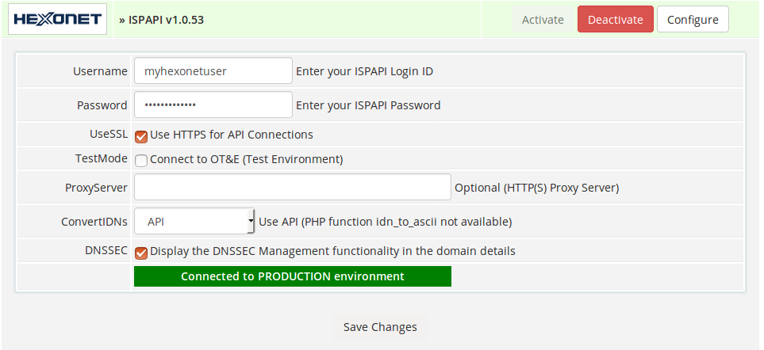

Make sure that the account you are using is set to renewalmode AUTOEXPIRE in your Control Panel, otherwise domains might be renewed without being paid for by the customer

Nameservers
If you want to use DNS, URL or Emailforwarding, domains must resolve to the ISPAPI nameserver cluster (ns1.ispapi.net, ns2.ispapi.net, ns3.ispapi.net).

You might want to enter them in Setup => General Settings => Domains as Default Nameservers for your customers:
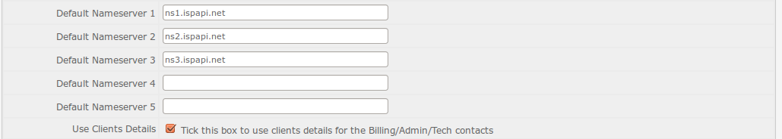
You can also create your own nameserver hostnames and use them, as long as they are registered and resolve to the correct IP addresses.

Cronjob configuration
In order to have your WHMCS always synchronized with our systems, you should make sure to run the WHMCS Domain Sync at least once per day:
php -q $YOUR_WHMCS_ROOT/crons/domainsync.php

More information about the Domain Sync can be found here:
http://docs.whmcs.com/Domains_Tab#Domain_Sync_Enabled

Hexonet widget activation
If you would like to keep your WHMCS modules up to date, you should activate the Hexonet widget which will display a message with a download link as soon as a new version is available.

To activate it, go in Setup => Staff Management => Administrator Roles select your administrator role and activate the “Hexonet” widget.

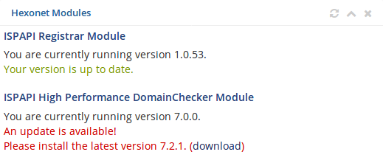

Additional domain fields
The registration of some extension requires sometimes additional domain fields. (e.g. Legal Type and CIRA Agreement for .CA domain)
In order to provide this additional fields on the registration page and map them with our module you have to extend the $additionaldomainfields array.
Prior to WHMCS 7.0, this file was located at /includes/additionaldomainfields.php
From WHMCS 7.0 on, to add new additional domains fields, create a new file named additionalfields.php within the /resources/domains/ directory.
Our module supports the following config fields: Ispapi-Name, Ispapi-Options, Ispapi-Replacements, Ispapi-IgnoreForCountries and Ispapi-Eval.
- Ispapi-Name (string): Name of the parameter in Ispapi
- Ispapi-Options (string): Comma-separated list of parameter values, the order must match the ones in Options. The mapping of values from Options to Ispapi-Options is stored in Ispapi-Replacements
- Ispapi-Replacements (array): If the parameter value is a valid key of this array, it gets replaced by the respective value. Indirect use via Ispapi-Options is preferred, direct use makes sense to map older values for backwards compatibility.
- Ispapi-Eval (string): PHP code to execute, the parameter value after all replacements is stored in $value

In our module you will find a file named “additionaldomainfields_sample.php” containing a lot of preconfigured extensions running with our systems. (updated on a regular basis) This file will assist you configuring the WHMCS additional domain fields.
Examples:
// Maps the "Application Purpose" value on the Ispapi parameter
// "X-US-NEXUS-APPPURPOSE".
// e.g. for "Government purposes": X-US-NEXUS-APPPURPOSE=P5
$additionaldomainfields[".us"][] = array(
"Name" => "Application Purpose",
"Type" => "dropdown",
"Ispapi-Name" => "X-US-NEXUS-APPPURPOSE",
"Ispapi-Options" => ",P1,P2,P3,P4,P5",
"Options" => ",P1 - Business use for profit,P2 - Non-profit business; club; association; religious organization; etc.,P3 - Personal Use,P4 - Educational purposes,P5 - Government purposes",
"Default" => "",
"Required" => true
);

// Maps the "Nexus Country" value on the Ispapi parameter
// "X-US-NEXUS-VALIDATOR", converting to uppercase.
// e.g. for "de": X-US-NEXUS-VALIDATOR=DE
$additionaldomainfields[".us"][] = array(
"Name" => "Nexus Country",
"Type" => "text",
"Description" => "<div>Specify the two-letter country-code of the registrant (if Nexus Category is either C31 or C32).</div>",
"Size" => "2",
"Default" => "",
"Required" => false,
"Ispapi-Name" => "X-US-NEXUS-VALIDATOR",
"Ispapi-Eval" => '$value = strtoupper($value);'
);

// Custom local presence service for .it
$my_local_presence = array(
"FIRSTNAME" => "John",
"LASTNAME" => "Doe",
"ORGANIZATION" => "Local Presence",
"STREET" => "Via Presence 123",
"CITY" => "Milano",
"STATE" => "MI",
"ZIP" => "12345",
"COUNTRY" => "IT",
"PHONE" => "+39.123456",
"EMAIL" => 'info@localprecense.it'
);

$additionaldomainfields[".it"][] = array(
"Name" => "Local Presence",
"Type" => "dropdown",
"Options" => ",Use Local Presence Service",
"Default" => "",
"Required" => false,
"Ispapi-Options" => "0,1",
"Ispapi-Eval" => 'if ( $value ) {
$command["OWNERCONTACT0"] = $my_local_presence;
$command["ADMINCONTACT0"] = $my_local_presence;
}'
);

HEXONET as Lookup Provider
The HEXONET lookup provider yields high performance availability checks of the domains using our fast API. For the domains that are not supported by HEXONET, the lookup fallbacks to WHOIS. In order to utilize this feature, you just have to choose “HEXONET” in the lookup provider suggestions.
( Setup => Products/Services → Domain Pricing)

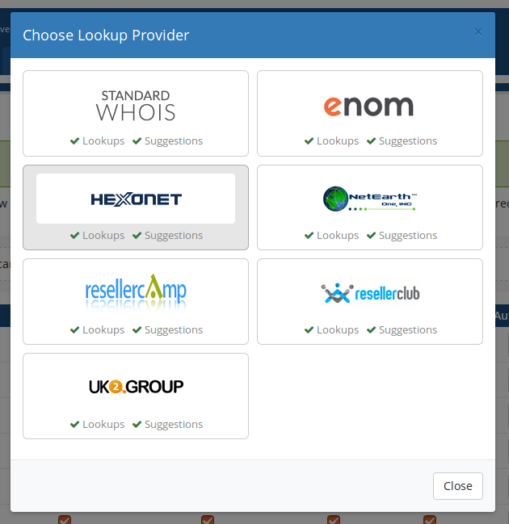
This new lookup feature requires at least WHMCS version 7.3

Configure the lookup provider by activating the suggestion engine for accurate and efficient search results.

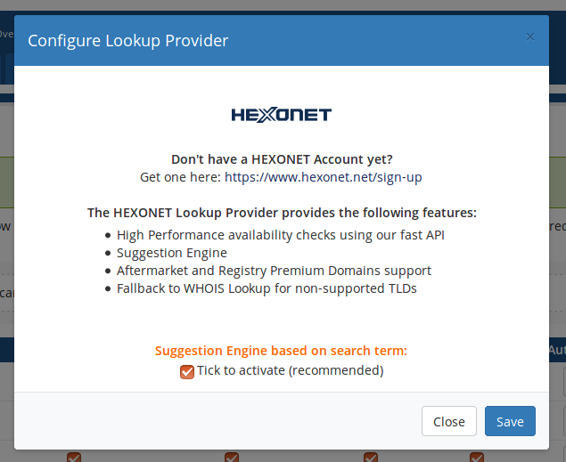

The Suggestion Engine provides fast domain suggestions based on the searched domain or keyword.
HEXONET is now providing Aftermarket and Registry premium domains support. (Without having to install our ISPAPI High Performance DomainChecker Module)
In order to see premium domains suggestions in the search results, configure the “Premium Domains” section in WHMCS.

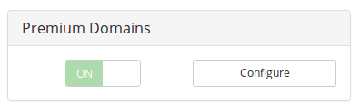

In order to configure your price markups for premium domains you can use the “Configure” button.

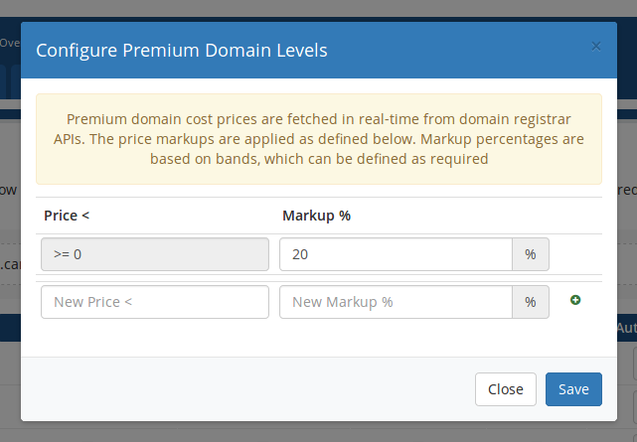

Search example
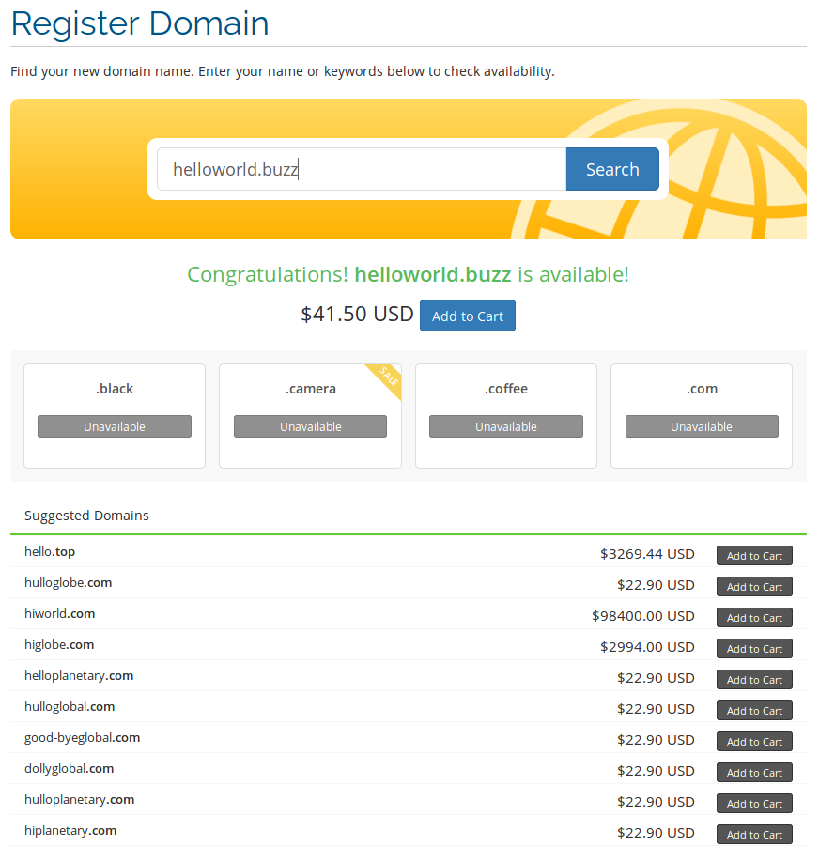

UTF-8 Support
For WHMCS < 5, if the system charset for WHMCS is set to utf8, the ISPAPI module will enable some workarounds to support UTF-8 for domain registrations, transfers and contact updates.
For WHMCS >= 5, it uses the original unmodified parameters as provided by the system.
WHMCS >= 6 decided to strip the umlauts in domain names and contacts. This module is able to fix this issue and will keep the umlauts.
In any case, the module should be able to handle umlauts and special characters in whois contacts, as long as the respective registry supports it.
For registries that don't support umlauts, some characters will be mapped automatically, e.g. é to e, ö to oe and so on.

IDN Support
In order to support IDN domains it is required to activate this option in the WHMCS Admin area under:
Setup => Generals Settings → Domains → Allow IDN Domains

Domain Name WHOIS Privacy

The registrar module fully supports the WHOIS Privacy service WHOISTRUSTEE.com:

Support for WHOIS Privacy (aka ID Protection in WHMCS) been integrated in two ways:

Support for the new WHMCS 'toggle ID protection' functionality
Whenever the ID protection flag gets enabled or disabled in the WHMCS Admin area, the module synchronizes the new protection status to the domain.
This functionality is compatible to the WHMCS API “domaintoggleidprotect” call.
If the ID Protection flag gets disabled in the Admin area, clients will not be able to re-enable WHOIS Privacy themselves, but it can only be re-enabled by an admin!

Client area WHOIS Privacy management
The registrar module registers a new client area function, which will only be visible when using a template thats compatible to the new WHMCS 5 default one.
In the Management Tools section of a domain that got ID Protection enabled, there's a new item called WHOIS Privacy .

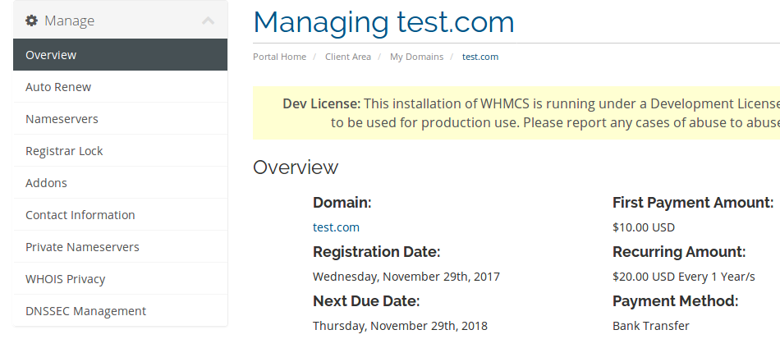
Using that new function, a client can verify the current protection status, and enable or disable it automatically.
The new WHOIS Privacy page looks as follows (protection is enabled in example):

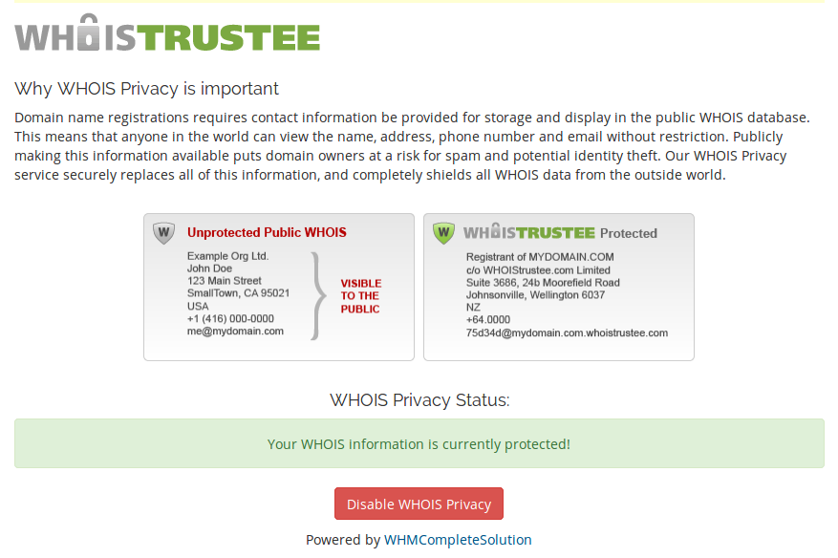

Special features

.CA Registrant WHOIS Privacy
The new WHOIS Privacy page for .CA domain names looks as follows (protection is enabled in example):
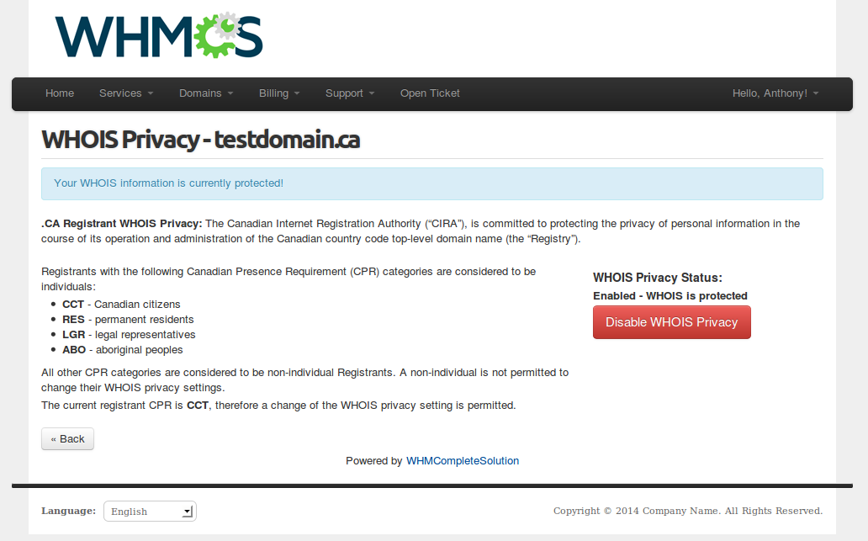

.CA Change of Registrant
The Change of Registrant page for .CA domain names is available under the Management Tools of a .CA domain.

.IT .CH .SE .SG .LI Change of Registrant
The change of Registrant of these TLDs requires a special procedure called TRADE. This function is available under the Management Tools of the domain.

.SWISS Registrations
Our registrar module is now supporting .SWISS registrations. (This function requires WHMCS 6.x)
.SWISS domain names are different and cannot be registered with the normal AddDomain command.
In order to apply for a .SWISS domain name it is always required to request a domain application with the AddDomainApplication command and to provide the class 'GOLIVE'.

Moreover .SWISS registrations require 2 additional domain fields. Please add the following code at the end of the includes/additionaldomainfields.php file:
## .SWISS DOMAIN REQUIREMENTS ##
$additionaldomainfields[".swiss"] = array();
$additionaldomainfields[".swiss"][] = array(
"Name" => "Enterprise ID",
"Type" => "text",
"Required" => true,
"Description" => "(must be CHE followed by 9 digits)",
"Ispapi-Name" => "X-SWISS-REGISTRANT-ENTERPRISE-ID",
);
$additionaldomainfields[".swiss"][] = array(
"Name" => "Intended use",
"Type" => "text",
"Required" => true,
"Ispapi-Name" => "X-CORE-INTENDED-USE",
);

This function uses HOOKS and in order to activate these hooks you have to go to:
Setup => Products/Services => Domain registrars, click the “Configure” button in the ISPAPI module line and finally click “Save Changes”.

Example of a .SWISS registration:
- Customer register a .SWISS domain (like he will register a normal domain)
- Once the invoice paid, the domain application will be sent
- The domain will be set to PENDING until the application process has been completed
- A cron job is checking the application status once a day
- If the application is successful the domain will be set to ACTIVE and the customer will be able to manage it.
- If the application is failed, the domain will be set to CANCELLED and you will have to refund the customer manually.

In order to work automatically the WHMCS Cron job has to be configured properly. Please have a look at this page: http://docs.whmcs.com/Crons

Further information regarding .SWISS is available in our wiki: https://wiki.hexonet.net/wiki/SWISS

SRV Records support
WHMCS doesn't allow SRV records. Our module makes it possible !
In order to activate that your have to update the clientareadomaindns.tpl file in your template directory.
In this file you will find 2 <select> tags. In the first you will have to add the following code:
<option value="SRV"{if $dnsrecord.type eq "SRV"} selected="selected"{/if}>SRV</option>

In the second you should add:
<option value="SRV">SRV</option>

Between the 2 tags there is an if statement, here you have to replace
{if $dnsrecord.type eq “MX”}
with
{if $dnsrecord.type eq "MX" || $dnsrecord.type eq "SRV"}

Now you are ready to support SRV records !

DNSSEC Management support
Please be advised that HEXONET’s nameserver cluster doesn't support DNSSEC yet, so you will need to setup your own DNSSEC enabled nameservers for now.
In order to activate this feature, within the WHMCS Admin area, go to
Setup => Products/Services => Domain Registrars => ISPAPI
and activate the DNSSEC checkbox.

In the domain details a new “DNSSEC Management” section will be displayed.
This feature allows your customers to add DS and KEY records and set the maxSigLife.

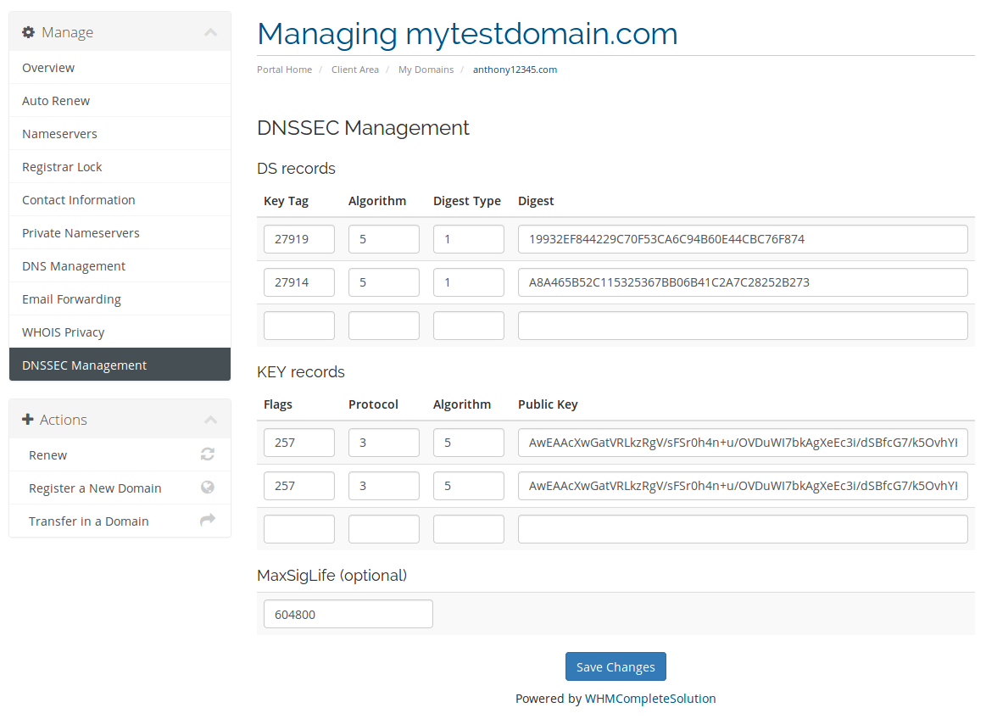

Ispapi Domain Import Addon
This package includes an domain importer addon. You can use it to automatically import domain names from your Hexonet account into your WHMCS.
To activate it, go in Setup => Addon Modules and activate the Ispapi Domain Import.
Once done, you will find a new menu item called Ispapi Domain Import under Addons

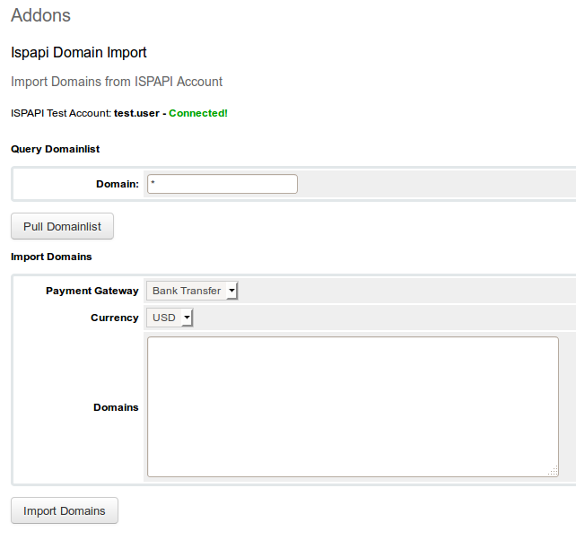
Just enter the list of domains into the Domains field, or pull the list from your account, select a payment gateway, a default currency for new client accounts, and press Import Domains.
For each domain, the tool will create a new WHMCS client account using the selected currency and the registrant info, if there's no existing WHMCS client account using the same email address.
Also it will use the current renewal prices as the recurring amounts of imported domain names, using the respective client account currency.

