**Tutorial**

**Robusta: A web application for assessing robustness and uncertainty in spatial analysis in archaeology**

Eduardo Herrera Malatesta, Faculty of Archaeology, Leiden University

Sebastien de Valeriola, Faculté de Lettres, Free University Brussels

In this tutorial, we will guide you through installing and running the Robusta web app locally on your computer. You do not need to be an expert in programming! Follow each step carefully, and you’ll have Robusta running in no time.

**1. Install R and RStudio**

R is the programming language we will use.

RStudio is a "friendly window" where you will open and run the app.

*Step 1.1: Install R*

Go to <https://cran.r-project.org/>

Click on your operating system (Windows, macOS, or Linux)

Download and install R by following the instructions.

*Step 1.2: Install RStudio*

Go to <https://posit.co/download/rstudio-desktop/>

Download and install RStudio Desktop (Free version).

**2. Install Git (Optional but Recommended)**

Git is a tool to download projects from GitHub.

Installing Git will make the next steps smoother.

*Step 2.1: Install Git*

Go to <https://git-scm.com/downloads>

Download and install Git for your operating system (accept the default options during installation).

If you cannot or do not want to install Git, don't worry! We'll also suggest a manual alternative later.

**3. Open RStudio and Create a New Project**

Now we are going to download ***Robusta*** directly from GitHub using RStudio (no need for scary command lines!).

*Step 3.1: Open RStudio.*

*Step 3.2: Click on:*

File → New Project...

*Step 3.3: In the New Project Wizard:*

Choose Version Control

Then choose Git

*Step 3.4: Fill the form:*

Repository URL:

Paste this: <https://github.com/centre-for-humanities-computing/robusta_webapp>

Project Directory Name:

It will automatically suggest a folder name (you can leave it as it is, e.g., robusta_webapp).

Create Project As Subdirectory of:

Choose a folder on your computer where you want to save it.

*Step 3.5: Click Create Project.*

Now RStudio will open the Robusta project on your computer!

**Alternative Way (If You Don't Have Git)**

If Git is not installed or you prefer another way:

Go to the GitHub page:

<https://github.com/centre-for-humanities-computing/robusta_webapp>

Click the green **Code** button → Download ZIP

Unzip the folder somewhere on your computer.

Open RStudio → File → Open Project → Find and open the ‘.Rproj’ file inside the unzipped folder.

**4. Install the Required R Packages**

Now we need to install some packages (small tools) that ***Robusta*** needs to run.

*Step 4.1:*

In RStudio's bottom left panel (Console), copy-paste the following and press Enter:

x <- c("shiny", "grid","sf", "gridExtra", "bslib", "zip", "shinyjs", "markdown",

"spatstat", "terra", "doParallel", "foreach", "tidyverse", "scales", "ggspatial",

"ggridges")

install.packages(x)

**5. Open the App and Run It**

*Step 5.1:*

In RStudio, find and open (click on it) the file called ‘app.R’ (it should be visible in the "Files" panel on the right).

*Step 5.2:*

Once ‘app.R’ is open, you will see a lot of code. Don't worry! You don't need to touch anything.

*Step 5.3:*

Click the Run App button at the top of RStudio. (It looks like a green "play" button)

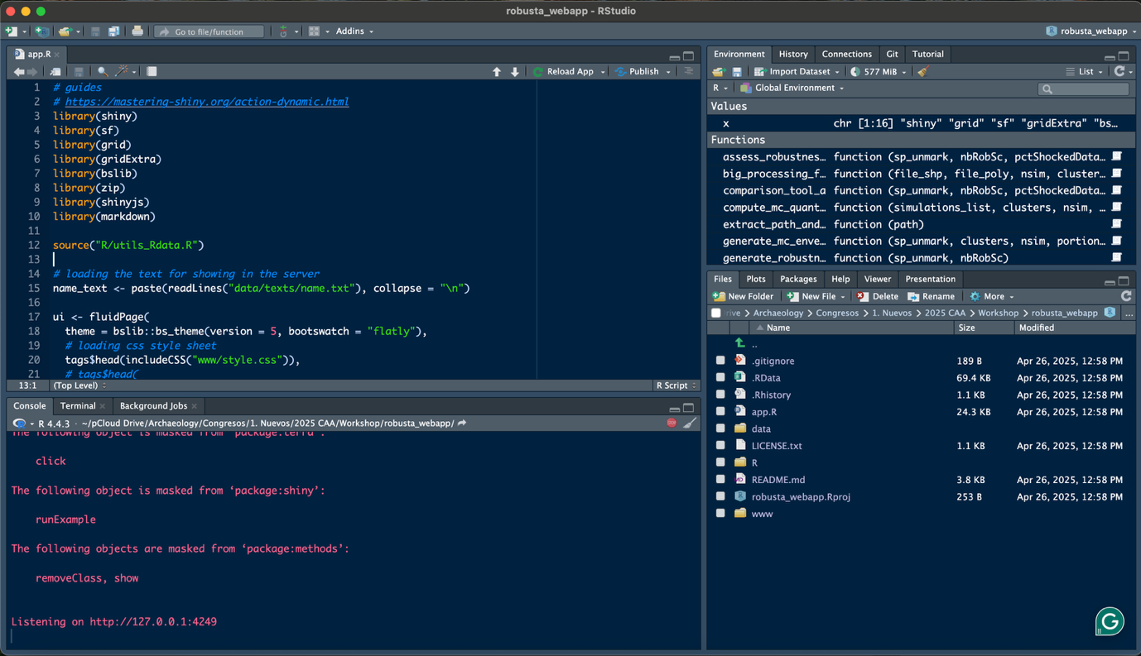

After a few seconds, Robusta will open in a window or browser tab!

You are all set! We hope you will enjoy the app and if you have any questions or suggestions, please contact us!

Eduardo Herrera Malatesta

Email: [ehmalatesta@yahoo.com](mailto:ehmalatesta@yahoo.com)

Sébastien de Valeriola

Email: [sebastien.de.valeriola@ulb.be](mailto:sebastien.de.valeriola@ulb.be)