**Medjugorje - Apparitions of Our Lady, Queen of Peace (1981-present)**

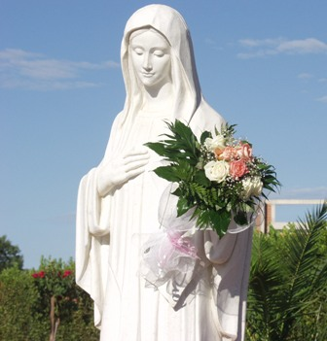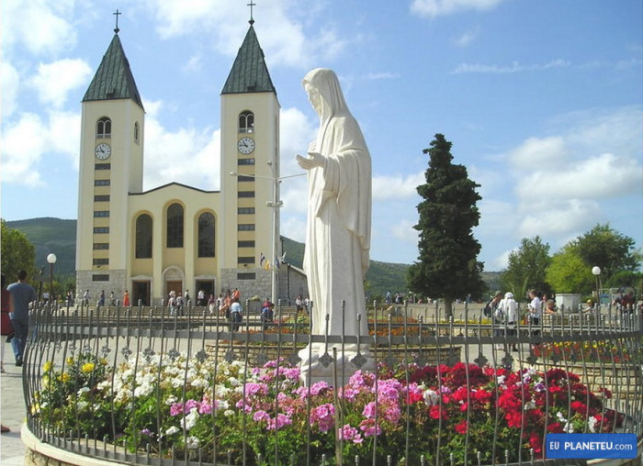  
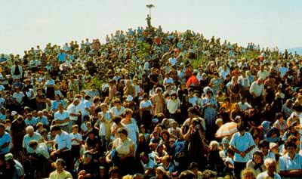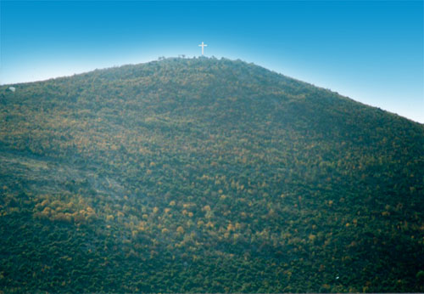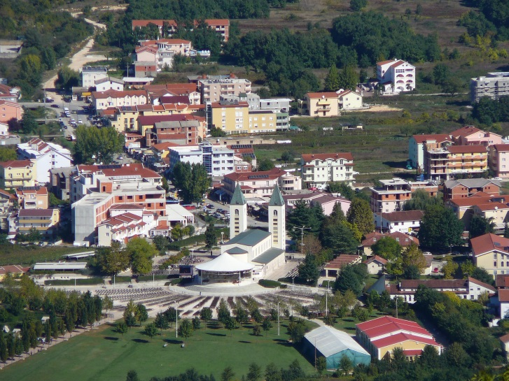

On June 24, 1981 in Bosnia, Yugoslavia the Blessed Mother began appearing to 6 children on a hill in Medjugorje, now known as Apparition Hill. From that day onward, she has visited daily. These children are now in their 40s and 50s. Tens of million people have visited Medjugorje since 1981. Many people have witnessed miracles in Medjugorje. The most important miracles are healing and conversion of heart to God.

We are on this earth to know, love and serve God just as the old Catechism said and that is what Our Lady is asking us to do. But people have forgotten that. So, she is here to remind us. What a loving God we have and a loving Mother to help us so much. Our Lady has come to draw us closer to God. Every month on the 25th of the month Our Lady gives a message for the world. She is also giving these six people 10 secrets about the future of the world. In Fatima Portugal in 1917, Our Lady gave the children 3 secrets. She has done similar things to other visionaries throughout history. At Medjugorje, when she gives one of the six people their 10th secret, she no longer appears to them but once per year. As of 2021, three of them (Mirjana, Jacov and Ivanka) have received 10 secrets; the other three (Vicka, Ivan and Maria) have received 9 and she still appears to them daily. Our Lady doesn’t want us concerned with secrets, what she wants is for us to change our hearts. She wants us to attend Mass, daily Mass if possible, pray, especially the rosary, go to Confession, read the bible and love our family, friends, neighbors and enemies and fast on bread and water twice a week. This all seems daunting when you first start out, but as Vicka one of the visionaries says, take baby steps, start slow.

Again, the secrets should not be our focus, but let's face one fact. God created this earth, the galaxies, everything. He sent us Jesus to show us how much He loves us and if you pray, He will open your heart and mind to how much. God is our loving Father who wants us to love Him back and love each other. God does not even have to warn us that the world is a mess; he could just end it all. He can do whatever He wants. But being such a loving Father, He is warning us again. He warned us at Fatima in 1917, but not many people are listening. We have been warned at Akita, Japan in 1973, an approved apparition, Kibeho in Africa 1981 - 1987, another approved apparition. Our Lady is warning her little children again and so please open your heart to her.

The yearly anniversary of Medjugorje is celebrated on the 25th of June at Our Lady's request. But the first day Our Lady actually appeared in Medjugorje was June 24, the feast of the birth of St. John the Baptist. 2000 years ago, St. John the Baptist called for repentance and prepared the way for Jesus. It is the same way now. The apparitions began on his feast day and Our Lady is telling us, repent and prepare for Jesus to come. She says these are the last apparitions on earth, that she will no longer appear on this earth as she has for 2000 years. The first apparition of the Blessed Mother was to St. James in Zaragoza Spain on January 2, 40 AD just 7 years after Jesus was crucified. St James is the name of the church in Medjugorje.

 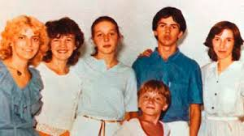

Pictures from 1981.

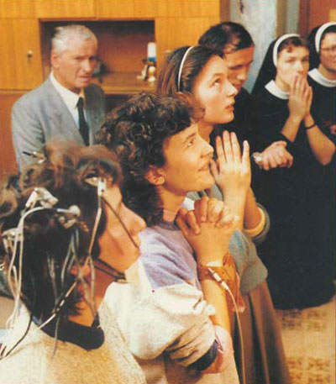 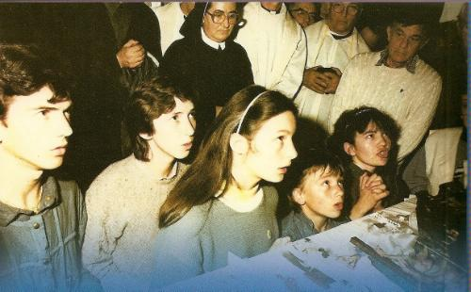 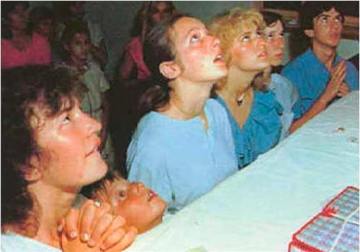

The visionaries in ecstasy - one being tested by scientists with electrodes.

See notes at bottom of document related to the testing.

***The Visionaries today***

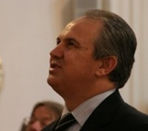 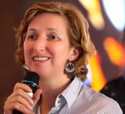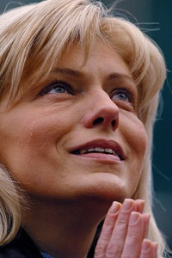

**Ivan Marija Mirjana**

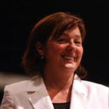 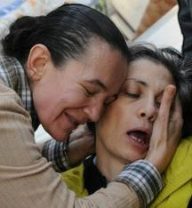 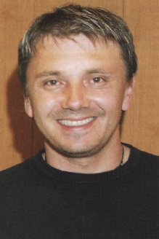

**Ivanka Vicka Jakov**

With past apparitions (Lourdes, 1858, Fatima, 1917, etc.), the Blessed Mother has only appeared a few times, but these apparitions are still happening daily for over 40 years. Wherever the visionaries are, Our Lady appears to them at 6:40 pm. Why has Our Lady been appearing for so long? The world is in a terrible state and she has come to warn us for the last time. On Sunday, May 2, 1982, Our Lady said to the visionaries: ***I have come to call the world to conversion for the last time. Later, I will not appear any more on this earth in this way.***

Our Lady told the children in 1981: ***I have come to tell the world that God exists. He is the fullness of life, and to enjoy this fullness and peace, you must return to God.***

Our Lady told the visionaries (and this is not just for them, but for us also): ***If you knew how much I love you, you would cry of joy.***

Our Lady is to give each of the 6 visionaries a total of 10 secrets. In the third secret Our Lady has promised to leave a supernatural, indestructible, and visible sign on the mountain where she first appeared. Our Lady said: ***This sign will be given for the atheists. You faithful must not wait for the sign before you convert; convert soon. This time is a time of grace for you. You can never thank God enough for His grace. The time is for deepening your faith, and for your conversion. When the sign comes, it will be too late for many.***

In 1981 the Blessed Mother told the 6 children: ***A great battle is about to take place. A battle between my Son and Satan. Human souls are at stake. I have come to call the world to conversion for the last time. Later, I will not appear any more on this earth. These apparitions are the last in the world. It is necessary for the world to be saved while there is still time.***

***A summary of some of the messages our Lady has given the visionaries***

God has chosen each one of you to have a part in the great plan for the salvation of mankind. You cannot fully understand how great your role is in God's design.

I desire you to grasp the seriousness of the situation and that much of what will happen depends on your prayers. You get lost easily in material and human things, and forget that God is your greatest friend. If only you knew how many graces God is giving you, you would pray without ceasing. I am inviting all of you, without exception, to the way of holiness in your life.

I call you to prayer, to have an encounter with God in prayer. Find yourself a special time when you could pray in peace and humility, and have this meeting with God the creator. Little children, at all times fill your heart with even the smallest prayers. I am with you and unceasingly keep watch over every heart which is given to me.

My angels, pray for unbelievers. People will tear their hair; brother will plead with brother, they will curse their past life, lived without God. They will repent, but it will be too late. Now is the time for conversion.  Those who do not believe do not know what awaits them. You must pray more for them. When you pray, you are so much more beautiful. You are like flowers, which after the snows, are bursting with beauty in their indescribable color.

Decide seriously for God because everything else passes away. Pray to be able to discover the greatness and joy of life which God gives you. Little children, you cannot open yourselves to God if you do not pray. I specially want you to renounce all the things to which you are attached but which are hurting your spiritual life.

I invite you to accept with seriousness and to live the messages which I am giving you. I am with you and I desire, dear children, that each one of you be ever closer to my heart. Therefore, little children, pray and seek the will of God in your everyday life. I desire that each one of you discover the way of holiness and grow in it until eternity. I will pray for you and intercede for you before God that you understand the greatness of this gift which God is giving me that I can be with you.

Dear children! Today I invite you to peace. I have come here as the Queen of Peace and I desire to enrich you with my motherly peace. Dear children, I love you and I desire to bring all of you to the peace which only God gives and which enriches every heart. I invite you to become carriers and witnesses of my peace to this unpeaceful world.

Dear children! I invite you to pray with the heart in order that your prayer may be a conversation with God. I desire each one of you to dedicate more time to God. I invite you to choose God before everything and above everything, so that He may work miracles in your life and that day by day your life may become joy with Him.

I desire that you love all men with my love. Only in that way can love reign over the world. Little children, you are mine. I love you and want you to surrender to me so that I can lead you to God.

I am calling you to that love which is loyal and pleasing to God. Little children, love bears everything bitter and difficult for the sake of Jesus who is love. Therefore, dear children, pray that God come to your aid, not however according to your desire, but according to His love. Surrender yourself to God so that He may hear you, console you and forgive everything inside you which is a hindrance on the way of love Dear children, glorify God with a hymn of love so that God's love may be able to grow in you day by day to its fullness.

I invite you all to rejoice in the life which God gives you. Little children, rejoice in God, the Creator, because He has created you so wonderfully. Pray that your life be joyful thanksgiving which flows out of your heart like a river of joy. Little children, give thanks unceasingly for all that you possess, for each little gift which God has given you, so that a joyful blessing always comes down from God upon your life.

Dear children, you are not conscious of how God loves you with such a great love because He permits me to be with you so I can instruct you and help you to find the way of peace. This way, however, you cannot discover if you do not pray. Therefore, dear children, forsake everything and consecrate your time to God and God will bestow gifts upon you and bless you. Little children, do not forget that your life is fleeting like a spring flower, which today is wondrously beautiful but tomorrow has vanished.

Mirjana has shared some vague details of the secrets:

Before the visible sign is given to humanity, there will be three warnings to the world. The warnings will be in the form of events on earth. Mirjana will be a witness to them. Ten days before one of the admonitions, Mirjana will notify a priest of her choice. The witness of Mirjana will be a confirmation of the apparitions and a stimulus for the conversion of the world. After the admonitions, the visible sign will appear on the site of the apparitions in Medjugorje for all the world to see. The sign will be given as a testimony to the apparitions and in order to call people back to faith.   
The ninth and tenth secrets are serious. They concern chastisement for the sins of the world. Punishment is inevitable, for we cannot expect the whole world to be converted. The punishment can be diminished by prayer and penance, but it cannot be eliminated. Mirjana says that one of the evils that threatened the world, the one contained in the seventh secret, has been averted thanks to prayer and fasting. That is why the Blessed Virgin continues to encourage prayer and fasting: You have forgotten that through prayer and fasting you can avert wars and suspend the laws of nature.   
After the first admonition, the others will follow in a rather short time. Thus, people will have some time for conversion. That interval will be a period of grace and conversion. After the visible sign appears, those who are still alive will have little time for conversion. For that reason, the Blessed Virgin invites us to urgent conversion and reconciliation. The invitation to prayer and penance is meant to avert evil and war, but most of all to save souls.   
According to Mirjana, the events predicted by the Blessed Virgin are near. By virtue of this experience, Mirjana proclaims to the world: "Convert as quickly as possible. Open your hearts to God."

The Blessed Virgin showed Marijana, as in a film, the realization of the first secret. The earth was desolate. The Blessed Mother said “It is the upheaval of a region of the world. God does not have a hard heart. Look around you and see what men do, then you will no longer say that God has a hard heart. How many people come to church, to the house of God, with respect, a strong faith, and love of God? Very few! Here you have a time of grace and conversion. It is necessary to use it well."

Dear children! Do not forget that you are here on earth on the way to eternity and that your home is in Heaven. If you would abandon yourselves to me, you will not even feel the passage from this life to the next life. You will begin to live the life of Heaven from this earth. God is sending me to warn you and to show you the right way.  Do not shut your eyes before the truth, my children. Your time is a short time. Do not permit delusions to begin to rule over you.

Our Lady showed Mirjana what is waiting for us if there is not the holiness in our hearts and our brotherly union in Christ. Mirjana said, “It was not nice at all.”

The Gospa said with sadness: Those who say, 'I do not believe in God, ' how difficult it will be for them when they will approach the Throne of God and hear the voice: Enter into Hell.

Tell the faithful that I need their prayers, and prayers from all the people. It is necessary to pray as much as possible and do penance because very few people have been converted up until now There are many Christians who live like pagans. God loves you very much. He loves you a hundred-fold more than your parents love you.

Let prayer be your life. Dear children, dedicate your time only to Jesus and He will give you everything that you are seeking.

Dear children, I am calling you to sincere prayer with the heart so that every prayer of yours may be an encounter with God. In your work and in your everyday life, put God in the first place.

You seek God only when sicknesses, problems and difficulties come to you and you think that God is far from you and is not listening and does not hear your prayers. No, dear children, that is not the truth. When you are far from God, you cannot receive graces because you do not seek them with a firm faith.

Give witness by your life. Sacrifice your lives for the salvation of the world. I am with you, and I am grateful to you, but in heaven you shall receive the Father's reward which He has promised to you. Therefore, dear children, do not be afraid.

Dear children! I beseech you to take up the way of holiness beginning today. I love you and, therefore, I want you to be holy. Dear children, pray and accept all that God is offering you on a way which is bitter. But at the same time, God will reveal every sweetness to whomever begins to go on that way, and He will gladly answer every call of God. Do not attribute importance to petty things. Long for Heaven.

I invite all of you who have heard my message of peace to realize it with seriousness and with love in your life. There are many who think that they are doing a lot by talking about the messages, but do not live them. Dear children, I invite you to life and to change all the negative in you, so that it all turns into the positive and life.

I desire to teach you and help you to walk the way of holiness. There are many people who do not desire to understand my messages and to accept with seriousness what I am saying. But you I therefore call and ask that by your lives and by your daily living you witness my presence. If you pray, God will help you to discover the true reason for my coming. Therefore, little children, pray and read the Sacred Scriptures so that through my coming you discover the message in Sacred Scripture for you.

I invite you to pray for peace. I am seeking from you to renew fasting and prayer in your families. Dear children, I desire you to grasp the seriousness of the situation. I am with you and I am inviting you to begin to pray and fast seriously as in the first days of my coming.

May your day be interwoven with little ardent prayers for all those who have not come to know God´s love. I do not desire for you, dear children, to have to repent for everything that you could have done but did not want to.

I call you to follow me and to listen to my messages. Be joyful carriers of peace and love in this peaceless world. I am with you and I bless you all with my Son Jesus, the King of Peace.

May your faith, little children, not waver in any situation, not even in this time of trial. Go courageously with the risen Christ towards Heaven, which is your goal. I am accompanying you on this way of holiness and am placing all of you in my Immaculate Heart.

Little children, who prays does not fear the future and does not lose hope. You are chosen to carry joy and peace, because you are mine. I have come here with the name 'Queen of Peace' because the devil wants peacelessness and war, he wants to fill your heart with fear of the future - but the future is God's. Therefore, be humble and pray, and surrender everything into the hands of the Most High Who created you.

Reconcile with God, little children, and you will see miracles around you.

Listen and live what I tell you because it is important for you when I shall not be with you any longer that you remember my words and all that I told you.