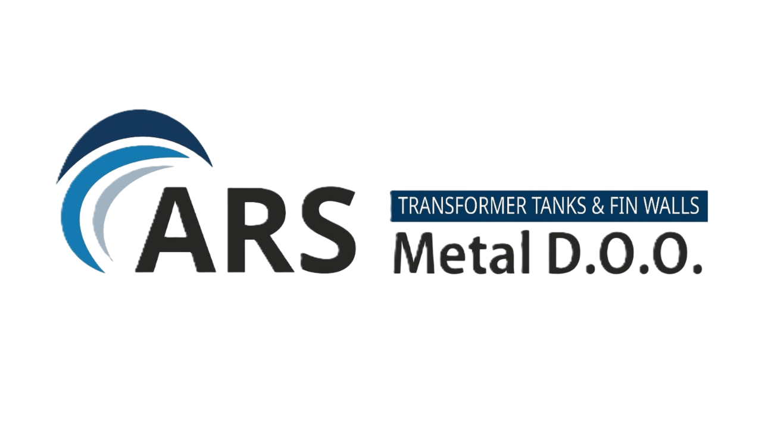
ARS METAL INDUSTRIES d.o.o.
Corporate Governance Charter

Purpose
This document defines the corporate governance framework of ARS Metal Industries d.o.o. It establishes principles, roles and responsibilities ensuring transparent, responsible and efficient company management.

Governance Principles
Principle | Description
Transparency | Open and transparent communication with shareholders, investors and partners.
Accountability | Management is responsible for operational performance and strategy execution.
Efficiency | Organizational structure supports fast and effective decision-making.
Risk Control | Implementation of internal control systems and risk management processes.

Governance Structure
Governance Level | Responsibility
Shareholders | Define strategic direction, investment objectives and capital structure.
Managing Director / CEO | Responsible for overall company management and strategy execution.
Finance (CFO) | Financial planning, budgeting and cost control.
Operations (COO) | Production management, logistics and operational efficiency.
Commercial | Sales, marketing and market development.

Decision-Making Framework
• Analysis of operational and financial implications
• Consultation between relevant management functions
• Formal approval by management or shareholders depending on decision level

Internal Control System
• Budget and cost control
• Financial reporting procedures
• Operational risk management

Compliance and Ethics
The company operates in compliance with Montenegrin legislation, international business ethics standards and principles of responsible corporate conduct.

Governance Monitoring
The governance framework is periodically reviewed through internal controls, financial reporting and operational process evaluations.

Strategic Importance
A clear governance structure increases investor confidence, improves decision-making efficiency and strengthens risk management within the company.

