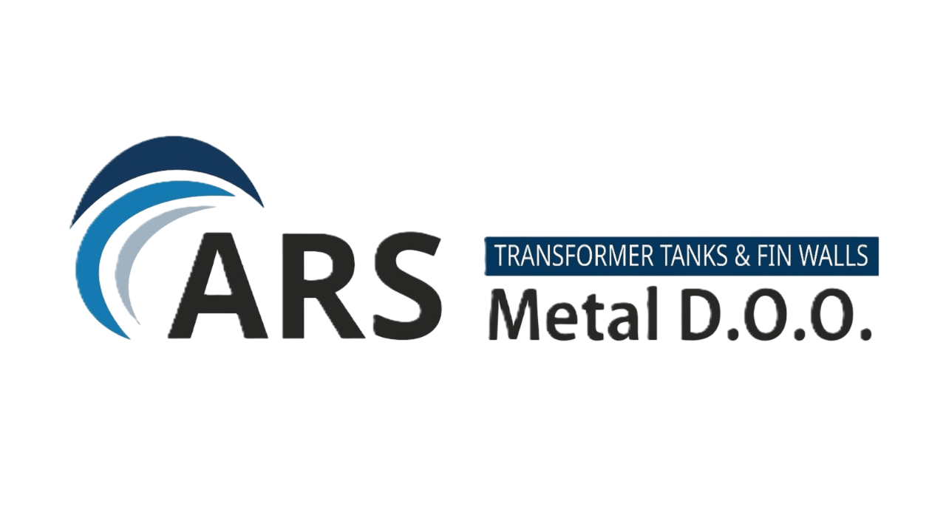
ARS METAL INDUSTRIES d.o.o.
Industrial Company Profile

Company Facts
Company | ARS Metal Industries d.o.o.
Location | Tuzi, Montenegro
Industry | Metal fabrication / energy infrastructure
Core Products | Transformer tanks, corrugated walls
Steel Processing Capacity | ~9,000 tons annually
Target Market | EU & Western Balkans

Company Overview
ARS Metal Industries develops industrial capacity for manufacturing transformer tanks and corrugated wall systems used in electrical power infrastructure.
The planned facility will process approximately 9,000 tons of steel annually and serve transformer manufacturers across Europe and the Western Balkans.

Industrial Production Flow
RAW STEEL
Steel plates / coils
STEEL PROCESSING
Cutting • Bending • Welding
TRANSFORMER COMPONENTS
Transformer Tanks • Corrugated Walls
ENERGY INDUSTRY CLIENTS
Transformer Manufacturers • Grid Projects

Competitive Advantages
First-Mover Advantage – No specialized transformer component manufacturing in Montenegro.
Strategic Supply Chain – Steel sourcing from Turkey and EU suppliers.
Cost Competitiveness – Lower industrial production costs compared with Western Europe.

Energy Infrastructure Market Growth
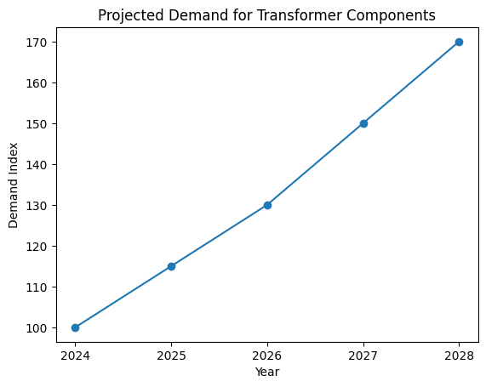

Development Vision
ARS Metal Industries aims to become a regional supplier of transformer components integrated into the European energy equipment supply chain.

