ONE-PAGE EXECUTIVE SUMMARY
FACTORY ACQUISITION
Net Price: 600,000 € | VAT (21%): 126,000 € | Total: 726,000 €
Installed Value: ~750,000 €+ | Market Value: ~500,000 € | Offer: 600,000 €
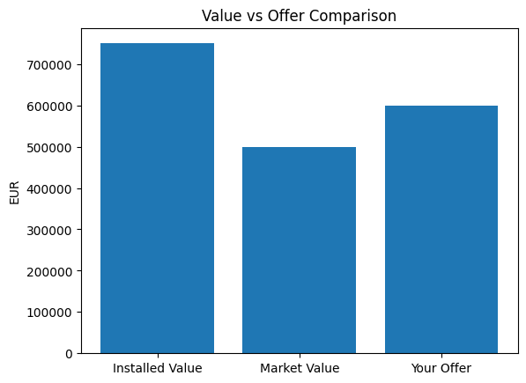
This chart shows the relationship between installed system value, market value, and the agreed offer. The offer includes a premium justified by time-to-market advantage and elimination of execution risk.

