01.02 – ORG-002
EXECUTIVE SUMMARY
TITAN GRID SMART FACTORY – FINAL INVESTMENT CASE

Project: TITAN Grid Smart Factory
Entity: ARS Metal Industries d.o.o.
Classification: Strategic Near-Shoring & Green Infrastructure Investment
Prepared by: Danijela Đurović Keskin, Chief Financial Officer (CFO)
Date: March 2026

1. PROJECT SCOPE AND MISSION
TITAN Grid is a purpose-built industrial facility located in Tuzi, Montenegro, focused on manufacturing transformer tanks and related components essential to the European energy infrastructure sector.

The project provides transformer OEMs across Southeast and Central Europe with a reliable regional manufacturing alternative to long-distance, high-risk supply chains.

Developed on a 22,742 m² site, the facility integrates advanced automated production technologies to deliver consistent industrial quality and superior operational efficiency.

2. CORE INVESTMENT HIGHLIGHTS
• Total Investment: €16.0 million
(CAPEX: €13.8 million | Working Capital: €2.2 million)

• Near-Shoring Advantage:
Regional delivery lead times of 3–7 days compared to 60–90 days (and frequently longer) from Asia-based supply chains

• Industrial Automation:
Integration of 30kW CNC laser cutting and robotic welding for repeatable production quality and cost efficiency

• Energy Cost Stabilization:
1.4 MWp on-site solar generation covering a significant portion of electricity demand and reducing exposure to price volatility

• Sustainability Alignment:
Annual reduction of approximately 1,200 tonnes of CO₂, fully aligned with EU Green Deal objectives and institutional ESG criteria

3. FINANCIAL PERFORMANCE
The project is structured to generate stable operating cash flows under both base-case and downside scenarios.

• Revenue Profile:
Projected annual revenues of approximately €35–37 million at full operational capacity

• Operating Performance:
Cost structure supported by automation, material efficiency, and energy self-generation

• Debt Service Capacity:
• Base Case DSCR: 10.7×
• Stress Case DSCR: 2.95×

Stress testing includes revenue contraction, operating cost increases, and interest rate adjustments — with coverage remaining comfortably above standard lender thresholds in all modelled adverse scenarios.

4. STRATEGIC JUSTIFICATION
TITAN Grid directly addresses a structural supply constraint in the European transformer component market, where extended lead times are delaying grid reinforcement and renewable energy integration.

Strategic location advantages in Tuzi, Montenegro include:
• Proximity to EU markets
• Access to regional logistics corridors (including Port of Bar)
• Significant reduction in delivery times compared to overseas sourcing

The project strengthens regional industrial capacity, enhances supply-chain resilience, and supports the accelerated energy transition across Europe.

5. EXECUTIVE SNAPSHOT – LENDER KEY METRICS

Category | Metric | Status / Strength
------------------|-------------------------------------|--------------------------------------
Financing | €6.5M – €8.0M Senior Debt | Targeted for institutional green facilities
Credit Strength | Stress DSCR: 2.95× | Robust downside protection
Technology | Automated production (CNC + robotic)| Industrial-grade, repeatable efficiency
Energy / ESG | 1.4 MWp Solar + ~1,200 t CO₂/yr reduction | Cost stabilization & Taxonomy compliant

6. CONCLUSION
TITAN Grid is a structured, resilient industrial investment offering:
• a clearly defined market need
• a proven operational model (speed + automation + energy hedge)
• a conservative financial profile aligned with institutional lending criteria

In an environment of chronic transformer component shortages delaying billions in grid and renewable projects, TITAN Grid delivers tangible strategic value, downside protection, and full alignment with European energy and sustainability priorities.

FORMAL DECLARATION
This document has been prepared for the purpose of presenting the investment case of the TITAN Grid project to prospective financing institutions. All information is based on current assumptions and financial modelling and remains subject to further technical, financial, and legal due diligence.
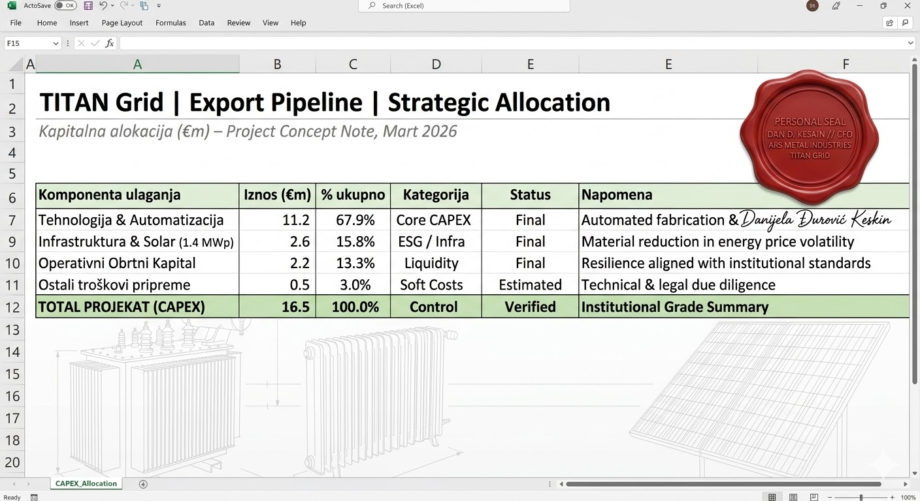
Respectfully submitted,

Danijela Đurović Keskin
Chief Financial Officer (CFO)
ARS Metal Industries d.o.o.

