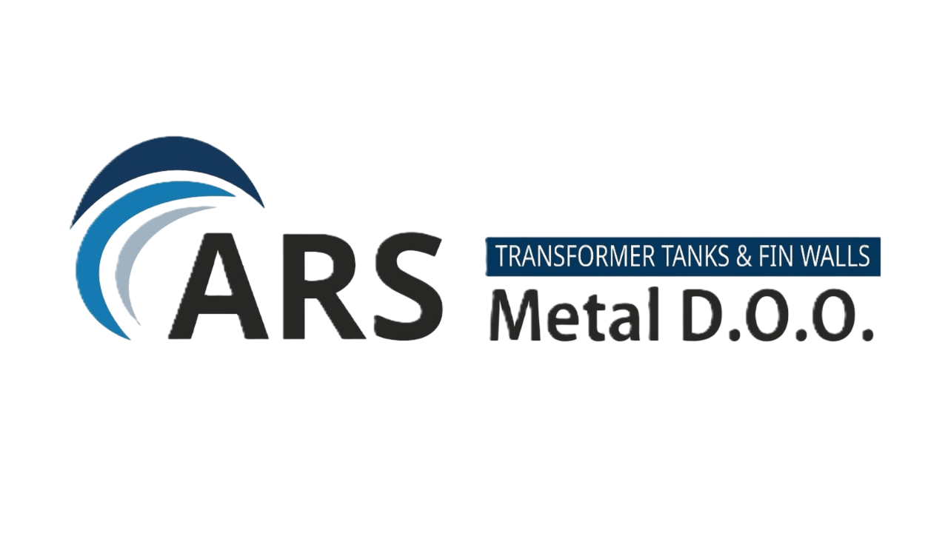
ARS METAL INDUSTRIES d.o.o.
Management Team Profiles

Purpose
This document presents the executive management team of ARS Metal Industries and outlines their roles, responsibilities and professional focus areas within the industrial development project.

Management Structure
CEO
Managing Director
CFO  Finance | COO  Operations | Commercial  Sales
Financial Strategy  Capital Management | Production  Industrial Operations | Market Development  Sales

Key Management Roles
Role | Key Responsibilities
CEO / Managing Director | Strategic leadership, partnerships, investor communication
Chief Financial Officer (CFO) | Financial strategy, funding structure, budgeting and reporting
Chief Operations Officer (COO) | Production planning, factory operations, industrial processes
Commercial Director | Sales strategy, market development, client relations

Executive Responsibilities
CEO – Defines company strategy, manages partnerships and leads project development.
CFO – Responsible for financial planning, capital structure and investor relations.
COO – Oversees industrial operations, production systems and operational efficiency.
Commercial – Develops markets, manages sales channels and export strategy.

Governance Decision Framework
Function | Focus
CEO | Strategy and investment decisions
CFO | Financial planning and capital management
COO | Production and operations management
Commercial | Sales and market development

Strategic Importance
A structured management team supports efficient decision-making, execution of industrial investment projects and transparent communication with investors and financial institutions.

