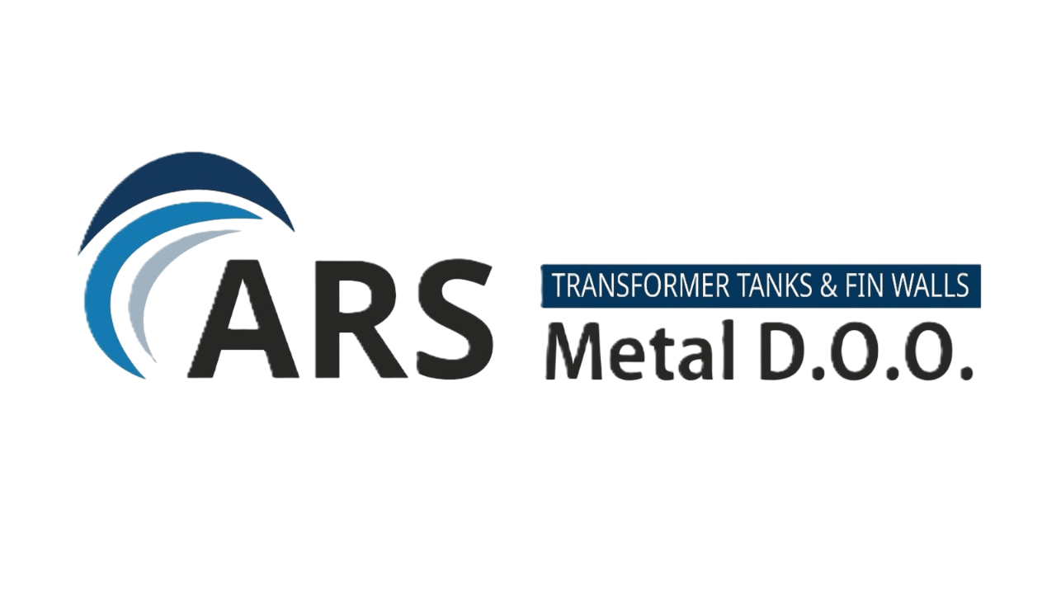
ARS METAL INDUSTRIES d.o.o.
Shareholder Structure

Ownership Overview
ARS Metal Industries d.o.o. is incorporated in Montenegro as a limited liability company (d.o.o.). The ownership structure is clearly defined and compliant with Montenegrin corporate law, allowing transparent governance and potential participation of strategic investors.

Current Shareholder Structure
Shareholder | Ownership | Capital Contribution | Role
Founder / Majority Owner | 100% | Founding capital | Strategic management

Capital Structure
• founding capital
• additional shareholder investments
• project development investments
Investments to date include industrial site preparation, infrastructure works and project development activities.

Future Ownership Structure (Post-Investment Scenario)
Shareholder | Ownership | Role
Founder | 60–70% | Strategic leadership
Strategic Investor | 20–30% | Capital and industrial partnership
Employee Share Option Pool | 5–10% | Management incentive

Governance Principles
Ownership Transparency – All shareholders and capital shares are clearly defined.
Responsible Capital Allocation – Capital is used exclusively for industrial development.
Strategic Partnership Readiness – The company remains open to strategic investors.

Investor Transparency
The company can provide full documentation confirming ownership structure:
• Articles of Incorporation
• Registration in the Central Registry of Business Entities
• Capital structure documentation

Strategic Implication
A transparent ownership structure enables efficient decision-making, improved access to financing and increased investor confidence.

