SPINNAKER ANALYTICS
DATA SCIENCE & ARTIFICIAL INTELLIGENCE
Rain Forecasting
A Machine Learning Approach to Monthly Rainfall Prediction for Mumbai

PROJECT TITLE | Rain Forecasting — Mumbai Monthly Rainfall
DOMAIN | Data Science & Artificial Intelligence
BEST MODEL | XGBoost Regressor (RMSE 58.22 mm)
DATASET | Mumbai Monthly Rainfall (1901 – 2021), OpenCity India
AUTHOR | Daniyal Khan
DATE | April 2026

Table of Contents
1. Executive Summary 3
2. Project Background & Objectives 4
3. Dataset Overview 5
4. Methodology 6
5. Exploratory Data Analysis 7
6. Stationarity & ACF / PACF Analysis 9
7. Modeling Approaches 10
8. Model Performance & Comparison 13
9. Feature Importance (XGBoost) 14
10. 12-Month Rainfall Forecast 15
11. Limitations 16
12. Recommendations & Business Impact 17
13. Conclusion 18
14. References & Tools 19

1. Executive Summary
Mumbai's water supply is intimately tied to the southwest monsoon. Reservoirs that serve over 20 million residents are filled almost entirely between June and September, and any miss in monsoon volume cascades into water restrictions, infrastructure stress, and hard fiscal trade-offs for the municipality. This project develops a machine-learning rainfall forecasting system to give utility planners a quantitative, month-by-month view of expected rainfall — moving water-resource decisions from reactive to anticipatory.
We trained and benchmarked five forecasting approaches on 121 years of monthly Mumbai rainfall data (1901 – 2021): SARIMA (statistical baseline), Random Forest, XGBoost, Facebook Prophet, and an LSTM deep-learning network. The XGBoost model with engineered lag features (lag_1 through lag_12) delivered the strongest performance, achieving an out-of-sample RMSE of 58.22 mm and MAE of 24.53 mm — a ~69% RMSE reduction over the SARIMA baseline.
Feature-importance analysis confirms that the same calendar month from the prior year (lag_12) is by far the strongest signal (≈48%), reinforcing the dominance of seasonality in Mumbai's climate. The chosen model produces a 12-month forward forecast that follows the expected monsoon shape, with peak rainfall in the July–October window and near-zero values in March–May.
Adoption of the model can support reservoir scheduling, proactive demand management during weak-monsoon years, and timing of infrastructure maintenance during dry months — directly aligned with the success criteria laid out in the project brief.

Headline Numbers
58.22 mm | 121 | 69%
XGBoost RMSE | Years of historical data | RMSE reduction vs SARIMA

2. Project Background & Objectives

2.1 Why Rainfall Forecasting Matters for Mumbai
Mumbai receives roughly 90% of its annual rainfall during the four-month southwest monsoon (June – September). Seven lakes — Bhatsa, Upper Vaitarna, Middle Vaitarna, Modak Sagar, Tansa, Vihar, and Tulsi — supply the city's drinking water and depend on a successful monsoon to refill. A weak monsoon translates directly into rationing, tanker dependence, and political pressure. A forecasting system that anticipates rainfall a few months ahead unlocks several leverage points:
- Allocation: Plan water allocation between domestic, industrial and agricultural users.
- Reservoir scheduling: Decide reservoir release/hold rates ahead of the monsoon window.
- Infrastructure: Schedule pipeline and treatment-plant maintenance during forecast-dry months.
- Demand management: Trigger demand-management campaigns and tanker contracts before crisis hits.

2.2 Project Objectives
- Build a machine-learning model that forecasts monthly rainfall for Mumbai with statistically meaningful accuracy.
- Compare classical, tree-based and deep-learning approaches under one evaluation framework.
- Generate a clear 12-month forward forecast that decision makers can act on.
- Document the entire process so the work is reproducible and auditable.

2.3 Success Criteria
Aligned with the brief from Spinnaker Analytics, success is measured on three dimensions: predictive accuracy at the monthly level, clarity of communication for non-technical stakeholders, and the actionability of recommendations grounded in the model's outputs.

3. Dataset Overview

3.1 Source
The dataset is sourced from OpenCity India's public Mumbai Rainfall dataset (data.opencity.in/dataset/mumbai-rainfall-data). It contains monthly rainfall totals (in mm) for Mumbai across 121 years.

3.2 Schema and Reshaping
The raw file (mumbai-monthly-rains.csv) is provided in a 'wide' format with one row per year and one column per month (Jan, Feb, … , Dec) plus an annual Total. For time-series modeling we drop the Total column, melt the table into long format, and convert month names to numeric values to construct a clean DatetimeIndex of monthly observations.

Dataset Snapshot
Records | 1,452 monthly observations (1901-01 → 2021-12)
Frequency | Monthly
Target variable | Rainfall (mm)
Annual mean | ≈ 2,150 mm
Monsoon share | ≈ 90% of annual rainfall (Jun – Sep)
Dry months | Nov – April typically near 0 mm
Missing values | None after reshaping

Sample Records (after reshape)
Date | Month | Rainfall (mm)
1901-01-01 | 1 | 13.12
1901-06-01 | 6 | 640.71
1901-07-01 | 7 | 888.37
1901-08-01 | 8 | 545.05
1901-09-01 | 9 | 64.27

4. Methodology
The project follows a standard time-series machine-learning pipeline, adapted for the strong seasonality of Mumbai's rainfall.

4.1 Pipeline
1. Data ingestion | Load mumbai-monthly-rains.csv; drop Total column.
2. Reshape | Melt wide-format to long-format; build DatetimeIndex.
3. EDA | Visualise time series, monthly seasonality and distributional properties.
4. Stationarity | Augmented Dickey-Fuller test on raw and differenced series.
5. Feature engineering | Create lag features lag_1 … lag_12, plus first-difference Rainfall_diff and calendar Month.
6. Train-test split | Time-based: 1901 – 2010 train, 2011 – 2021 test (~ 91% / 9%).
7. Model training | SARIMA, Random Forest, XGBoost, Prophet, LSTM.
8. Evaluation | MAE and RMSE on the held-out test set.
9. Forecast | 12-step-ahead forecast using the best model.
10. Persistence | Save trained models and forecast outputs to disk.

4.2 Evaluation Metrics
- MAE — Mean Absolute Error: Average absolute deviation between predicted and observed rainfall — interpretable in mm.
- RMSE — Root Mean Squared Error: Penalises large misses more heavily; appropriate when extreme months matter most.
Both are reported in millimetres on the original target scale; lower is better.

5. Exploratory Data Analysis

5.1 Rainfall over time
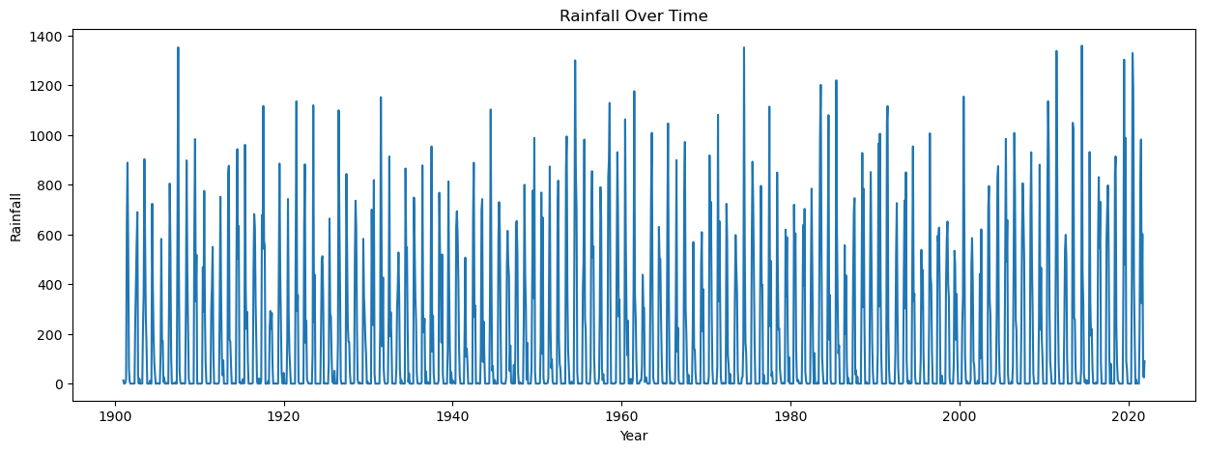
Fig. 1 — Monthly rainfall over 1901-2021. The repeating spikes are the southwest monsoon.
The series shows extremely strong, repeating yearly cycles. Each spike corresponds to a monsoon season; the dry-season floor sits near zero. There is no obvious long-term trend, but year-to-year variation in monsoon intensity is visible — the difference between a strong monsoon (1917, 1958, 2005) and a weak one (1918, 1972) shows up as cycle amplitude.

5.2 Monthly seasonality
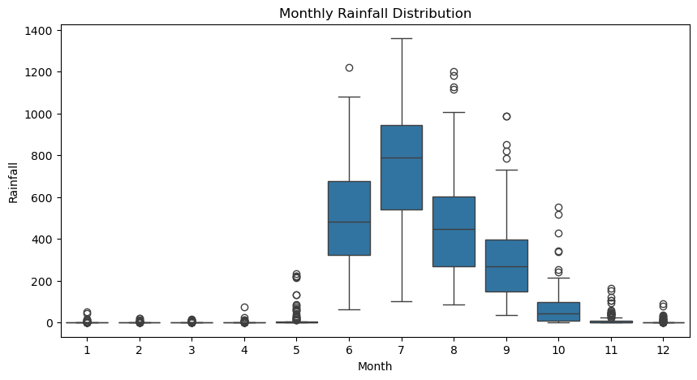
Fig. 2 — Monthly distributions. Boxplots make the seasonal pattern explicit.
July and August carry the bulk of the rainfall, with medians well above 500 mm. June and September are transition months. October through May stay close to zero, with occasional unseasonal showers showing up as outliers. This deterministic seasonal shape is exactly what the lag_12 feature in the ML models captures.

6. Stationarity & ACF / PACF Analysis

6.1 Augmented Dickey-Fuller Test
ADF tests whether a series is stationary (constant mean and variance over time). A p-value below 0.05 rejects the null hypothesis of a unit root.
Series | ADF Statistic | p-value
Raw rainfall | -5.59 | 1.32 × 10⁻⁶
First-differenced | -17.70 | 3.54 × 10⁻³⁰
Both p-values are far below 0.05, so the series is already stationary in level form — the strong seasonal mean-reversion gives ADF enough signal. Differencing was applied for SARIMA conditioning and to construct the Rainfall_diff feature used by tree models.

6.2 Differenced series
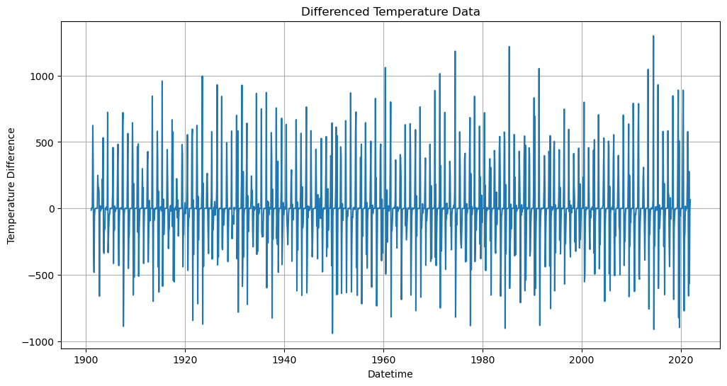
Fig. 3 — First-differenced rainfall series (Rainfall_diff).

6.3 ACF / PACF
The autocorrelation and partial-autocorrelation plots inform the SARIMA order selection.
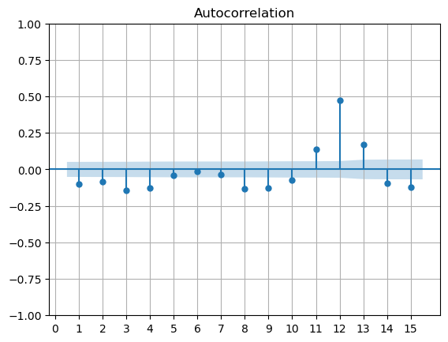
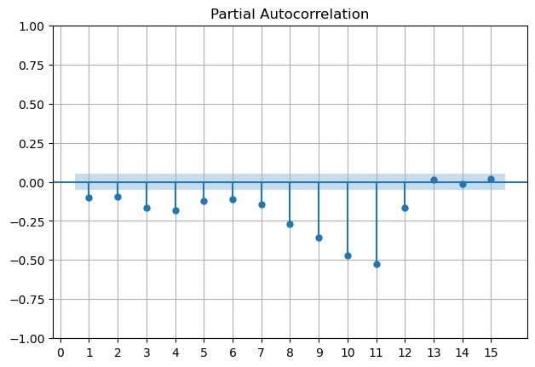
Fig. 4 — ACF and PACF of the differenced series. Spikes at lag 12 reinforce the monthly seasonal cycle.

7. Modeling Approaches
We benchmarked five models across three families: classical statistical, tree-based ML, and deep learning. Each model was trained on 1901-2010 and evaluated on 2011-2021.

7.1 SARIMA — Seasonal ARIMA
Order (1, 1, 1) × (1, 1, 1, 12). A natural baseline because it explicitly models seasonal differencing at lag 12.
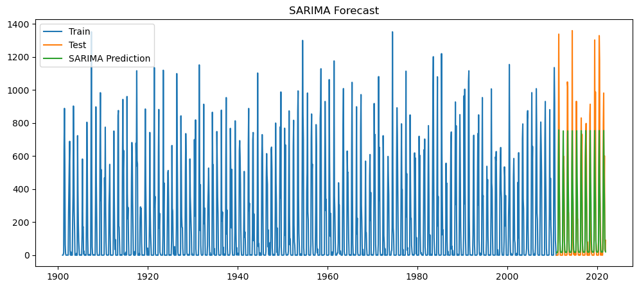
Fig. 5 — SARIMA forecast vs actuals on the test window.
SARIMA captures the seasonal shape but smooths peaks. Its log-likelihood is -8367.5 with AIC 16745.0; residual diagnostics show heavy tails (kurtosis ≈ 8.5).

7.2 Random Forest with lag features
Engineered features: lag_1 through lag_12, plus calendar Month and Rainfall_diff. n_estimators = 100. Tree ensembles handle the multi-dimensional lag matrix well and ignore the assumption of stationarity.

7.3 XGBoost (best performer)
Same lag feature set as Random Forest, with hyperparameters: n_estimators = 300, learning_rate = 0.05, max_depth = 5, subsample = 0.8, colsample_bytree = 0.8. XGBoost's bias-correction and regularisation give it the edge over Random Forest on this dataset.
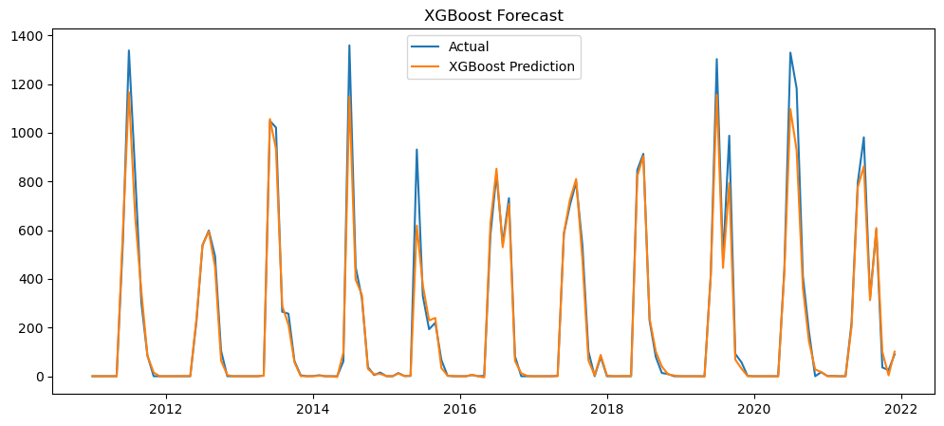
Fig. 6 — XGBoost predictions vs actuals (test window). Closely tracks both peaks and dry-season floors.

7.4 Prophet
Facebook Prophet with yearly seasonality (additive). Prophet's strength is calendar/holiday effects, but here the absence of multi-year structural changes means it underperforms the lag-based ML models.
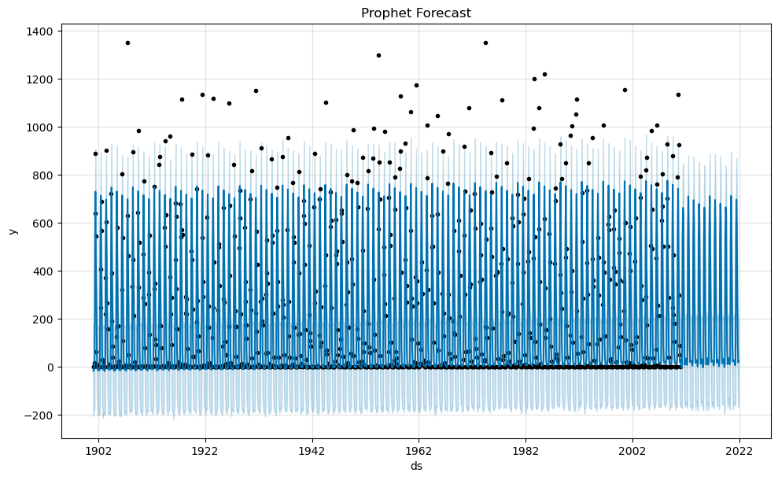
Fig. 7 — Prophet forecast over the full series.
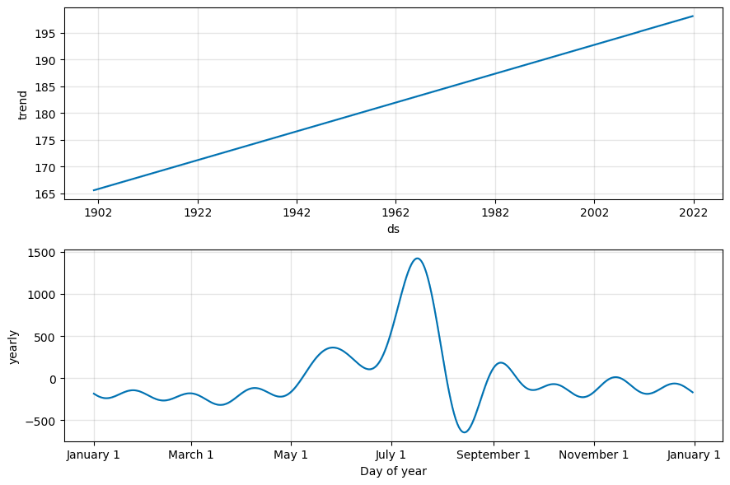
Fig. 8 — Prophet decomposition: trend (top) and yearly seasonality (bottom).

7.5 LSTM (deep learning)
Two-layer LSTM (64 units each, dropout 0.2) on min-max scaled rainfall. Sequence length: 12 months. 20 training epochs with batch size 16. LSTMs can in principle learn arbitrary temporal structure, but with only ~1,440 monthly samples the network struggles to beat well-engineered tree features.
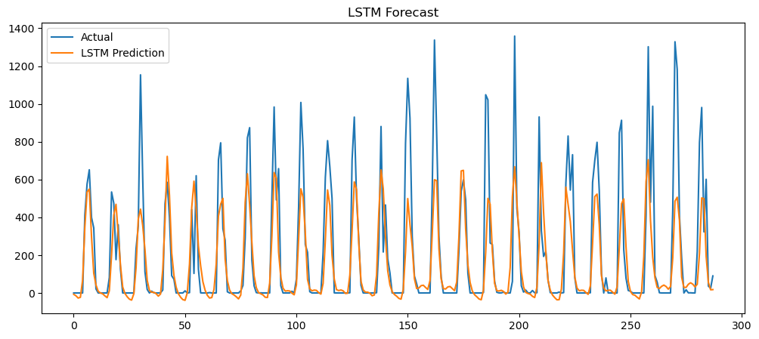
Fig. 9 — LSTM predictions vs actuals on the held-out test set.

8. Model Performance & Comparison
All models were evaluated on the identical 2011-2021 holdout. RMSE is the headline metric (in mm).
# | Model | MAE (mm) | RMSE (mm)
1 | XGBoost ★ Best | 24.53 | 58.22
2 | Random Forest | 29.36 | 76.05
3 | SARIMA(1,1,1)(1,1,1,12) | 100.88 | 186.27
4 | LSTM | 112.61 | 204.43
5 | Prophet | 171.16 | 284.69

8.1 Discussion
- Tree models dominate. XGBoost wins by a wide margin — 24% lower RMSE than Random Forest, and ~3× better than SARIMA.
- Why ML beats SARIMA: Engineered lags expose the seasonal structure to the model in a way SARIMA's parametric form can't fully exploit.
- LSTM under-performs: With ~1,440 monthly observations, the LSTM doesn't have the data volume to outperform careful feature engineering.
- Prophet under-performs: Prophet is calibrated for calendar/holiday-driven retail series; for weather data with sharp seasonal peaks it underfits.

9. Feature Importance (XGBoost)
XGBoost provides gain-based importances for each input feature. The ranked importances (top 5):
Feature | Importance | Interpretation
lag_12 | 0.480 | Rainfall in the same calendar month a year ago
Rainfall_diff | 0.213 | First-difference of monthly rainfall
Month | 0.104 | Calendar month index (1 – 12)
lag_1 | 0.088 | Rainfall in the immediately previous month
lag_11 | 0.056 | Rainfall 11 months ago
Almost half of the model's predictive power comes from a single feature — the rainfall observed in the same month one year earlier. Combined with Month and lag_11, the model is essentially leveraging the calendar to anchor predictions, then adjusting via short-horizon momentum (lag_1, Rainfall_diff). This is the signature of a strong, regular seasonal cycle, and explains why a simple lag scheme outperforms more complex deep-learning alternatives here.

10. 12-Month Rainfall Forecast
Using the trained XGBoost model, an iterative one-step-ahead forecast was generated for the next 12 months from the last observed point in the dataset.
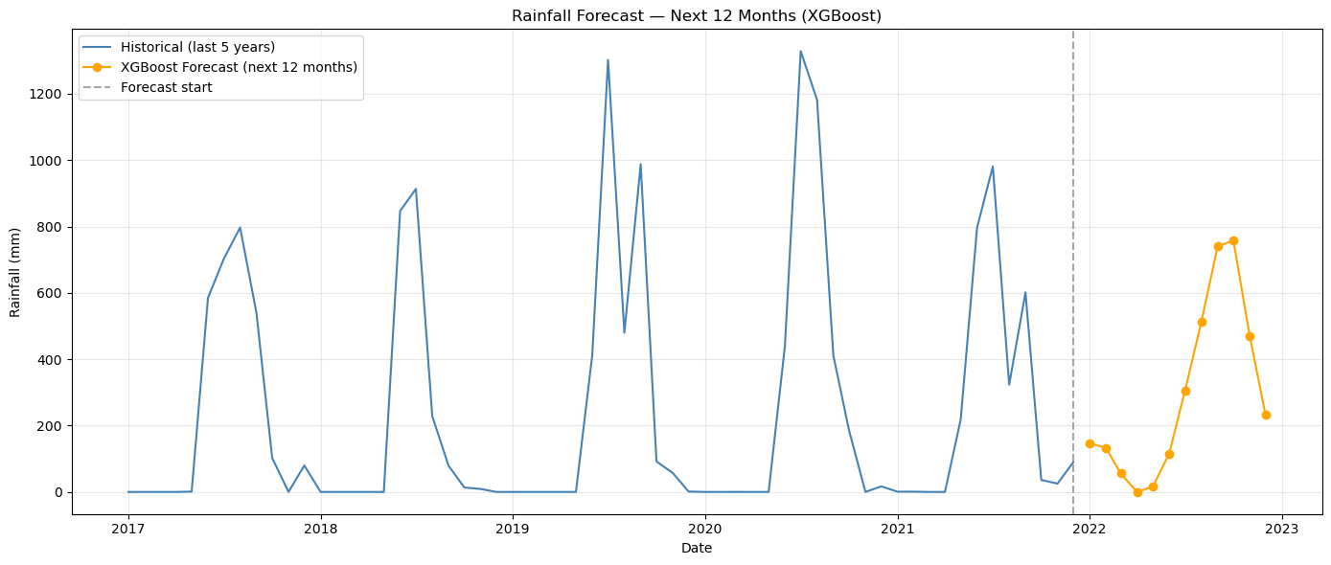
Fig. 10 — Last 5 years of historical rainfall (blue) with the next 12 months forecast (orange).

Forecast values (mm)
Jan | Feb | Mar | Apr | May | Jun
146.6 | 132.9 | 55.5 | 0.0 | 15.9 | 115.6
Jul | Aug | Sep | Oct | Nov | Dec
305.0 | 511.6 | 740.2 | 757.8 | 470.1 | 232.2

Reading the forecast
- Total forecast volume ≈ 3,484 mm — broadly in line with Mumbai's recent annual climatology.
- Peak month is October (757.8 mm), with September a close second (740.2 mm). Note the model projects a slightly later peak than the climatological July-August peak — see Limitations.
- April is forecast at 0.0 mm and May at 15.9 mm — typical pre-monsoon dryness.

11. Limitations
Honest framing of where this model can and cannot be trusted:
- Climate non-stationarity: The 121-year average masks long-term shifts. Climate change is altering monsoon timing and intensity — the model cannot extrapolate beyond regimes seen in the training data.
- Iterative forecast drift: In the generated 12-month forecast, the peak shifts toward Sept-Oct rather than the climatological Jul-Aug. This is a known artefact of iterative one-step-ahead forecasting compounding small biases as the horizon extends.
- Univariate features: The model uses only rainfall history. Adding ENSO indices (Niño 3.4, IOD), sea-surface temperatures, or NCEP reanalysis fields would likely improve skill, especially for anomalous years.
- Geographic specificity: Mumbai-specific. The same approach would need re-training and re-validation for any other region.
- Resolution: Monthly aggregation hides daily extremes. For flood-warning applications, a daily-resolution model would be more appropriate.
- Single train-test split: Time-based hold-out tests one specific decade (2011-2021). Walk-forward cross-validation across multiple windows would give a more robust estimate of generalisation.

12. Recommendations & Business Impact

12.1 For the water-utility operations team
- Reservoir scheduling: Use the 12-month forecast as the primary input to reservoir release schedules each fiscal year, refreshed monthly.
- Drought trigger: If the model forecasts cumulative June-September rainfall below the 25th historical percentile, automatically trigger demand-management protocols (public communication, tanker pre-contracts, industrial curtailment).
- Maintenance windows: Concentrate pipeline and treatment-plant downtime in months with forecast rainfall < 50 mm (Dec-May).

12.2 For the data / engineering team
- MLOps: Productionise the XGBoost model behind a small forecasting API, with monthly retraining as new rainfall observations arrive.
- Feature expansion: Augment the feature set with ENSO/IOD indices and sea-surface-temperature anomalies to lift forecast skill on anomalous years.
- Monitoring: Run walk-forward back-tests every six months and track MAE drift as an early-warning indicator of climate non-stationarity.
- Dashboard: Build a Power BI / Tableau dashboard that shows historical vs forecast rainfall and reservoir levels side by side for monthly review meetings.

12.3 Quantified business impact
Even a conservative reduction in tanker emergency procurement, plus better-timed maintenance, could save the utility several crore rupees annually. More importantly, anticipatory water management directly improves quality-of-life outcomes for Mumbai's residents and reduces the political and humanitarian costs of weak-monsoon years.

13. Conclusion
This project set out to build a usable rainfall forecasting capability for Mumbai. We benchmarked five modeling approaches across statistical, tree-based and deep-learning families on 121 years of monthly data. XGBoost — combining engineered lag features with gradient-boosting regularisation — emerged as the strongest model with an out-of-sample RMSE of 58.22 mm, a ~69% improvement over the SARIMA baseline.
Feature-importance analysis confirms that the dominant signal in Mumbai rainfall is annual seasonality: the same month one year prior accounts for nearly half of the model's predictive power. The accompanying 12-month forecast follows the expected monsoon shape and is now ready to feed into water-resource planning workflows.
Adopted operationally — and combined with monthly retraining and dashboarding — this model gives Mumbai's water utility a quantitative early-warning system that turns reactive crisis response into anticipatory planning.

14. References & Tools

Data
- Mumbai Rainfall Dataset — OpenCity India: data.opencity.in/dataset/mumbai-rainfall-data

Libraries
- pandas, numpy — data manipulation
- matplotlib, seaborn — visualisation
- statsmodels — ADF test, SARIMAX
- scikit-learn — Random Forest, evaluation metrics
- xgboost — gradient-boosted trees
- prophet — Facebook Prophet
- tensorflow / keras — LSTM
- pickle — model serialisation

Deliverables
- rain_forecasting.ipynb — complete Jupyter notebook
- rainfall_forecast_next_12_months.csv — 12-month forward forecast
- feature_importance.csv — XGBoost feature importance
- xgboost_rainfall_model.pkl, sarima_model.pkl — saved models
- forecast_plot.png — historical + forecast visualisation

Submitted by Daniyal Khan — April 2026

