**Register.html**

<!DOCTYPE html>

<html lang="en">

<head>

    <meta charset="UTF-8">

    <meta name="viewport" content="width=device-width, initial-scale=1.0">

    <title>Login Form</title>

    <link rel="stylesheet" href="test.css">

</head>

<body>

    <div class="login">

        <div class="image">

            <img src="1.png" alt="Login Image" height="400" width="400">

        </div>

        <div class="form">

            <h2>Register</h2>

            <input type="text" placeholder="User Name">

            <input type="email" placeholder="Email">

            <input type="password" placeholder="Password">

            <button onclick="window.location.href = 'login.html';">Register</button>

            <p class="redirect">Already have an account? <a href="login.html" onclick="switchForm('register')">Login here</a></p>

            <form>

            <p class="message">Success!!!!!!</p>

        </div>

    </div>

</div>

</body>

</html>



**Login.html**

<!DOCTYPE html>

<html lang="en">

<head>

    <meta charset="UTF-8">

    <meta name="viewport" content="width=device-width, initial-scale=1.0">

    <title>Login Form</title>

    <link rel="stylesheet" href="test.css">

</head>

<body>

    <div class="login">

        <div class="image">

            <img src="4.png" alt="Login Image" height="400" width="400">

        </div>

        <div class="form">

            <h2>Login</h2>

            <input type="email" placeholder="Email">

            <input type="password" placeholder="Password">

            <button onclick="login()">Login</button>

            <p class="redirect">Don't have an account? <a href="registration.html" onclick="switchForm('register')">Register here</a></p>

        </div>

    </div>

</div>

</body>

</html>

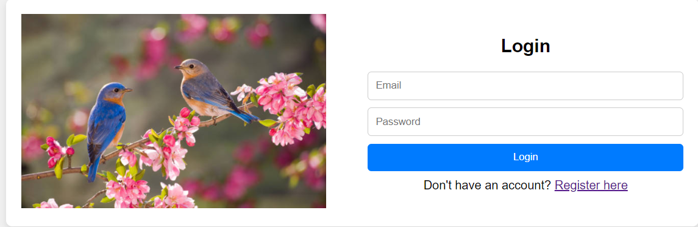

**Test.css**

body {

  font-family: Arial, sans-serif;

  margin: 0;

  padding: 0;

  display: flex;

  flex-direction: column;

  align-items: center;

  justify-content: center;

  height: 100vh;

  background-color: #f0f0f0;

}

.box {

  display: flex;

  justify-content: center;

  width: 600px;

}

.registration,

.login {

  display: flex;

  align-items: center;

  margin: 20px;

  background-color: #fff;

  border-radius: 8px;

  box-shadow: 0 4px 8px rgba(0, 0, 0, 0.1);

}

.image {

  width: 50%;

  padding: 20px;

}

.image img {

  max-width: 100%;

  height: auto;

}

.form {

  width: 50%;

  padding: 20px;

}

.form h2 {

  margin-bottom: 20px;

  text-align: center;

}

.form input {

  width: 100%;

  padding: 10px;

  margin-bottom: 10px;

  border: 1px solid #ccc;

  border-radius: 5px;

  box-sizing: border-box;

}

.form button {

  width: 100%;

  padding: 10px;

  background-color: #007bff;

  color: #fff;

  border: none;

  border-radius: 5px;

  cursor: pointer;

  transition: background-color 0.3s ease;

}

.form button:hover {

  background-color: #0056b3;

}

.redirect {

  margin-top: 10px;

  text-align: center;

}