Task 1 Nested if-else:
Write a C program that takes a student's age and marks as input. First check whether the student's
age is 18 or above. If the age requirement is satisfied, then check whether the student's marks are 50
or above. If both conditions are satisfied, display "Eligible for Admission"; otherwise, display an
appropriate message.
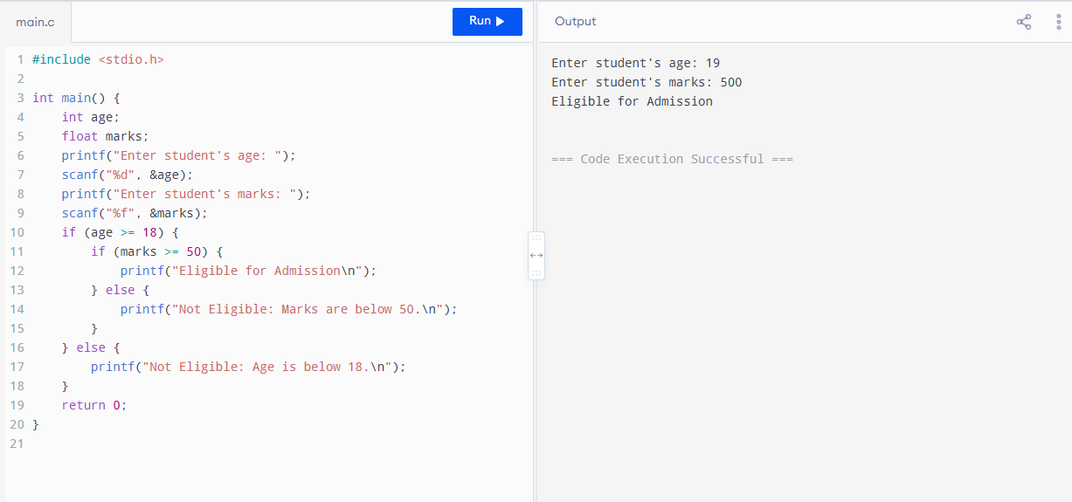

Task 2 Nested if-else:
Write a C program for a driving license system. Ask the user whether they have a CNIC (1 = Yes, 0 =
No). If the user has a CNIC, then check whether they have passed the driving test (1 = Yes, 0 = No). If
both conditions are satisfied, display "License Can Be Issued"; otherwise, display an appropriate
message. Use a nested if-else structure.
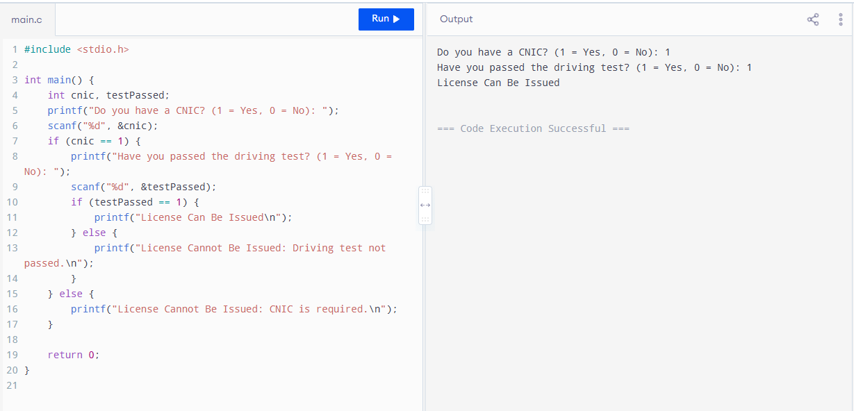

Task 4 Ternary operator:
Write a C program that takes a student's marks as input and uses the ternary operator to display
"Pass" if the marks are 50 or above and "Fail" otherwise. Do not use if-else

