Google Earth Engine Integration with Open Data Cube

Andrew Lubawy  
Analytical Mechanics Associates

September 2020

# Prerequisites

## Setup Google API for Google Earth Engine

The first step is to setup the API to use the [Google Earth Engine REST API](https://developers.google.com/earth-engine/reference). To do this you need to create a project here: <https://console.cloud.google.com/>. Go to the [API & Services Dashboard](https://console.cloud.google.com/apis/dashboard) from the developer console.

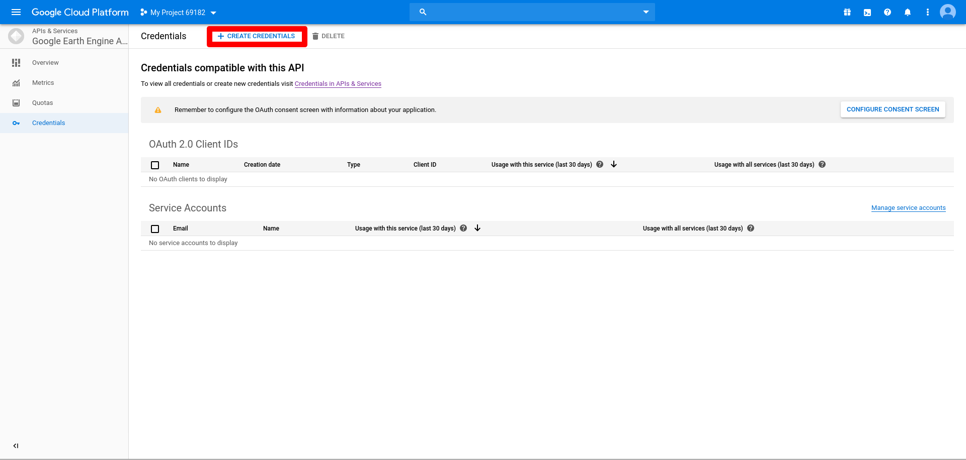

Create credentials

Select the button in the red box according to Figure 1. This will pull up the API library. Search for Earth Engine, select it, and then enable it for the project.

The next step to setup the API is to create a Service Account. To do this navigate to the [API & Services Credentials](https://console.cloud.google.com/apis/api/earthengine.googleapis.com/credentials) page for the API.

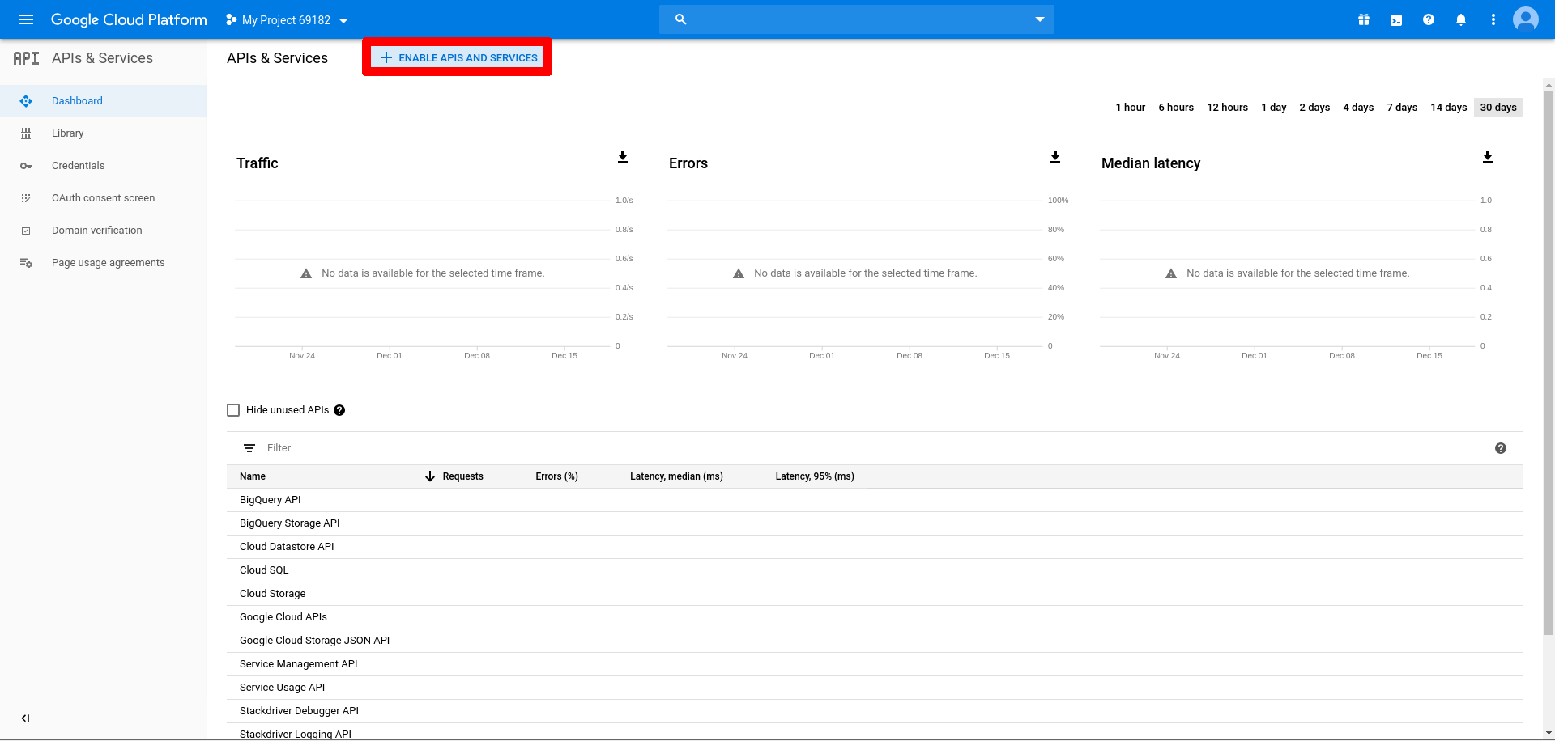

Enabling APIs and services

Click the button in the red box for Figure 2 and select Service Account. Fill out the form and click next. You will likely need to add Owner roles in the next section. Click the Role selection box, type Owner in the filter field, and then select the Owner choice to add it as the Role. Click next. In this section click add key and select the JSON option. This will download a JSON file with your key’s credentials for the Service Account. **Keep this file secure and don’t lose it.** This file will act as the API key for accessing GEE data. Once you’ve got the file, click done.

This last step is only necessary if the GEE REST API is still unreleased to the public and if you have the proper permissions to do so. If those conditions are met then you will have to email a Google employee your Service Account email as indicated by the red box from the [API & Services Credentials](https://console.cloud.google.com/apis/api/earthengine.googleapis.com/credentials) page in Figure 3.

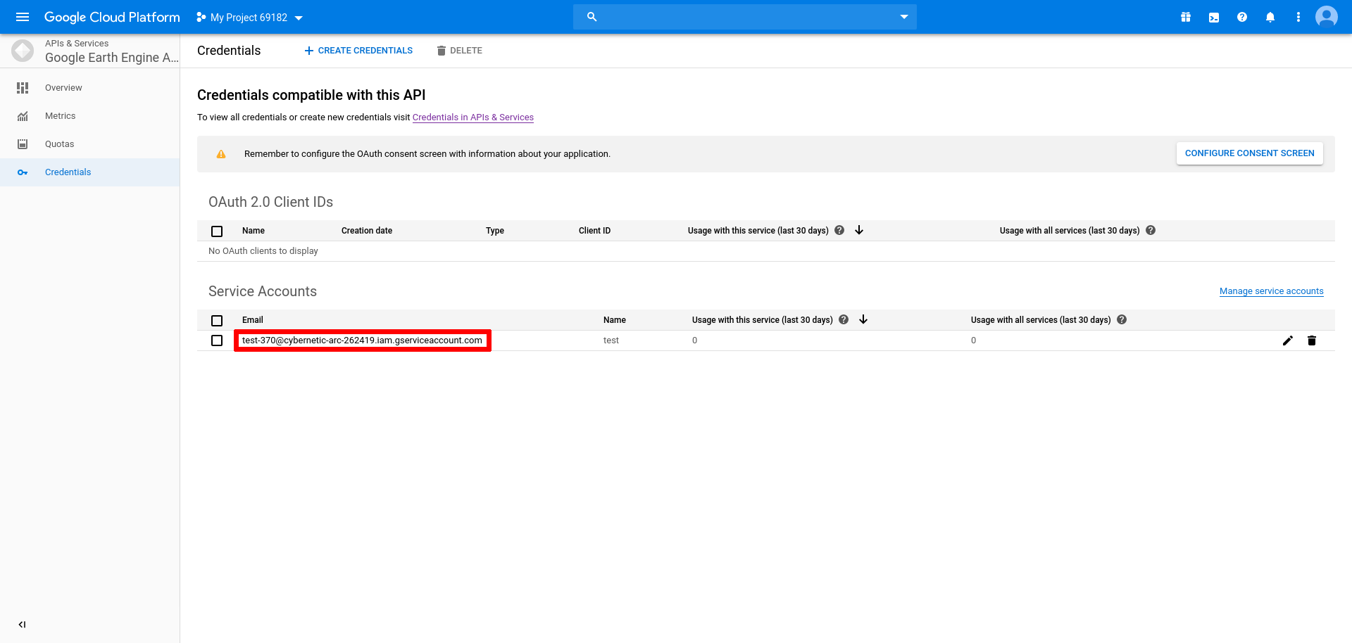

Service account email

# ODC with GEE Usage

## Installing ODC

Setup is simple and straightforward. You can follow one of the installation instructions here: <https://datacube-core.readthedocs.io/en/latest/ops/install.html>. Our preferred method is to setup a Python virtualenv and use pip install datacube and some extra packages pip install jupyter matplotlib scipy. More suggested packages can be found in the CEOS SEO [GitHub repository for Jupyter notebook utilities](https://github.com/ceos-seo/data_cube_utilities).

The other option is to have ODC install datacube with the odc-gee package which includes it as a required dependency.

## Indexing Data

Indexing data is nearly identical to [normal ODC indexing](https://datacube-core.readthedocs.io/en/latest/ops/indexing.html) and makes heavy use of modified [AWS S3 indexing scripts](https://github.com/opendatacube/datacube-dataset-config/blob/master/scripts/index_from_s3_bucket.py). It also uses the following Python packages:

* google-api-python-client
* google-auth
* google-auth-oauthlib

These packages make it easy to authenticate and connect with the GEE API. This will allow for using the API to retrieve metadata on products to be indexed.

The first step to indexing is to create a product definition. This process can be found in the ODC documentation: <https://datacube-core.readthedocs.io/en/latest/ops/product.html>. The primary goal is to define the most relevant and basic information about a [GEE catalog entry](https://developers.google.com/earth-engine/datasets). If using the odc-gee package, it is important to make sure aliases are included in the measurements field with the first alias in the list being the defined band in the GEE catalog. For example, the blue band in a Sentinel-2 product will have "B2" as the first alias. This is to allow products to change names while retaining the mapping to the band name as defined by the API. It also performs a check to make sure a dataset has all the required bands to prevent a failure to index. Sentinel-1 is an example of this where it will rarely exclude the typical "VV" and "VH" bands for "HH" and "HV" instead. ODC needs all bands defined in the product specification to be present. The odc-gee also includes a script to guide the process. This can be ran by running new_product <product-name>.yaml.

An example of a Sentinel-1 product definition for Google Earth Engine (note: single precision float32 was chosen over original data’s double precision float64 to conserve memory on load):

name: s1_google  
description: Sentinel-1A/B SAR sigma0 scenes, processed by Google - Apply orbit  
file, GRD border noise removal, thermal noise removal, radiometric calibration,  
and terrain correction (SRTM 30m DEM).  
metadata_type: eo  
  
metadata:  
 format: {name: GeoTIFF}  
 instrument: {name: SAR}  
 platform: {code: SENTINEL-1}  
 product_type: GRD  
  
storage:  
 crs: EPSG:4326  
 resolution:  
 longitude: 0.0000898311175  
 latitude: -0.0000898311175  
  
measurements:  
 - name: vh  
 aliases: [VH]  
 dtype: float32  
 nodata: 0  
 units: 'DN'  
  
 - name: vv  
 aliases: [VV]  
 dtype: float32  
 nodata: 0  
 units: 'DN'

The next step is to create a dataset configuration file. This requires a little more effort than just following the [ODC guide](https://datacube-core.readthedocs.io/en/latest/ops/dataset_documents.html) for datasets, but it should still be a simple process. The S3 script linked earlier is modified and used here with the ODC guide as a blueprint for doing the same for GEE data. Instead of grabbing the metadata from an AWS S3 bucket, the data will be retrieved through the API libraries linked above. This will need the service account credentials downloaded in the prerequisites section.

The major difference between the S3 and GEE indexing will be in the band path format. GEE indexed data is accessed by using rasterio which wraps GDAL which smartly picks a driver for [pulling from the GEE API](https://gdal.org/drivers/raster/eedai.html). Therefore the band path will need to be in a format that GDAL will recognize and which the API driver will use: EEDAI:[asset][:band_names].

An example of a Sentinel-1 band path for GEE in ODC broken up into its various parts:

'EEDAI:' + 'projects/earthengine-public/assets/' +  
'COPERNICUS/S1_GRD/S1A_IW_GRDH_1SDV_20160121T181002_20160121T181027_009596_00DF74_ABC5'  
+ ':VV'

Currently, this entire process has been turned into various Python modules, and on top of those is now a script which can do this process in a more automated fashion. This is in the odc-gee package and can be used like so for a specified Sentinel-1 product: index_gee --asset COPERNICUS/S1_GRD --product s1_google. This will iterate through every available image in the GEE catalog entry for its entire time extent. It will then attempt to parse the image’s metadata into a dataset document to add to the ODC index. Other options are available for specifying regions or allowing updates in the index.

### How the API is Parsed

The script uses the [GEE REST API](https://developers.google.com/earth-engine/reference). It specifically queries the [listImages endpoint](https://developers.google.com/earth-engine/reference/rest/v1alpha/projects.assets/listImages) to receive a list of datasets. Then it will iterate over the results and parse the available metadata into a format for an ODC dataset document: <https://datacube-core.readthedocs.io/en/latest/ops/dataset_documents.html> (currently using the deprecated EO format). The dataset document is constructed using what was defined in the product definition as well as what is provided by the metadata from the API result.