**PMS – Health Visitor Team Black**



**Organizer**

**UML Diagrams**

Gruppenmitglieder:

Bühler Ueli

Jahn Tim Allan

Kandiah Rajilatha

Klembowski Raphael

Ristic Nikola

Sutter Christoph

Version 0.1

Inhaltsverzeichnis

1. UML Domain Model 3

2. UML Sequence Diagram 4

2.1 Trigger Evaluation 4

2.2 Update Report 5

3. UML Class Model 6

# UML Domain Model

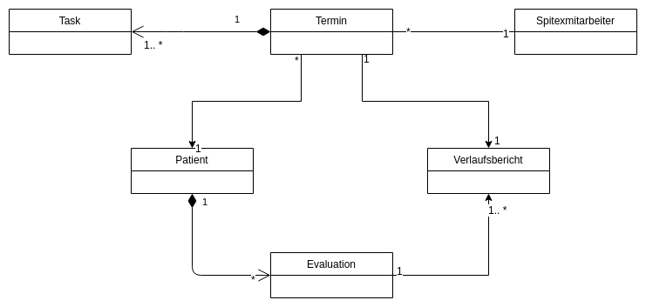

# UML Sequence Diagram

## Trigger Evaluation

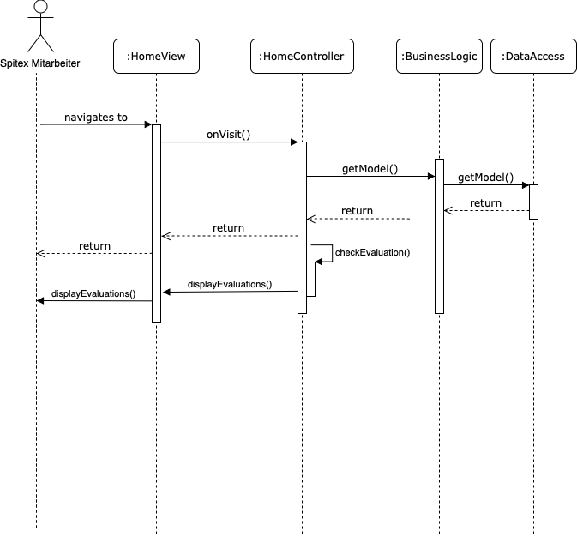

## Update Report

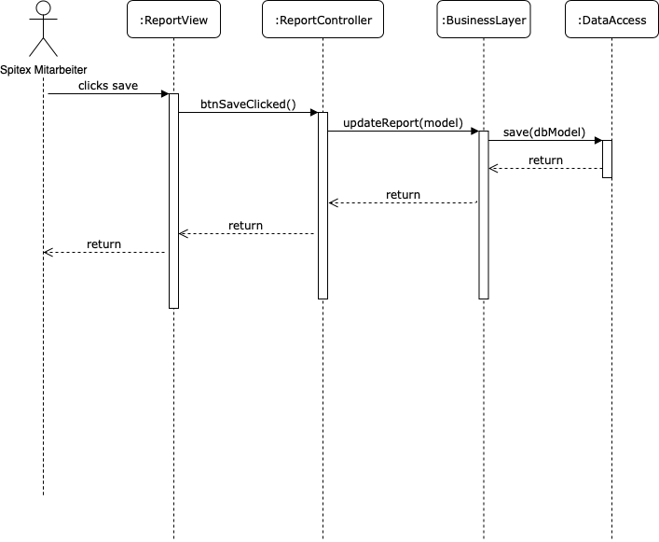

# UML Class Model

