Proton NMR

Sketch the predicted proton NMR that would be acquired from the following molecules

Example 1

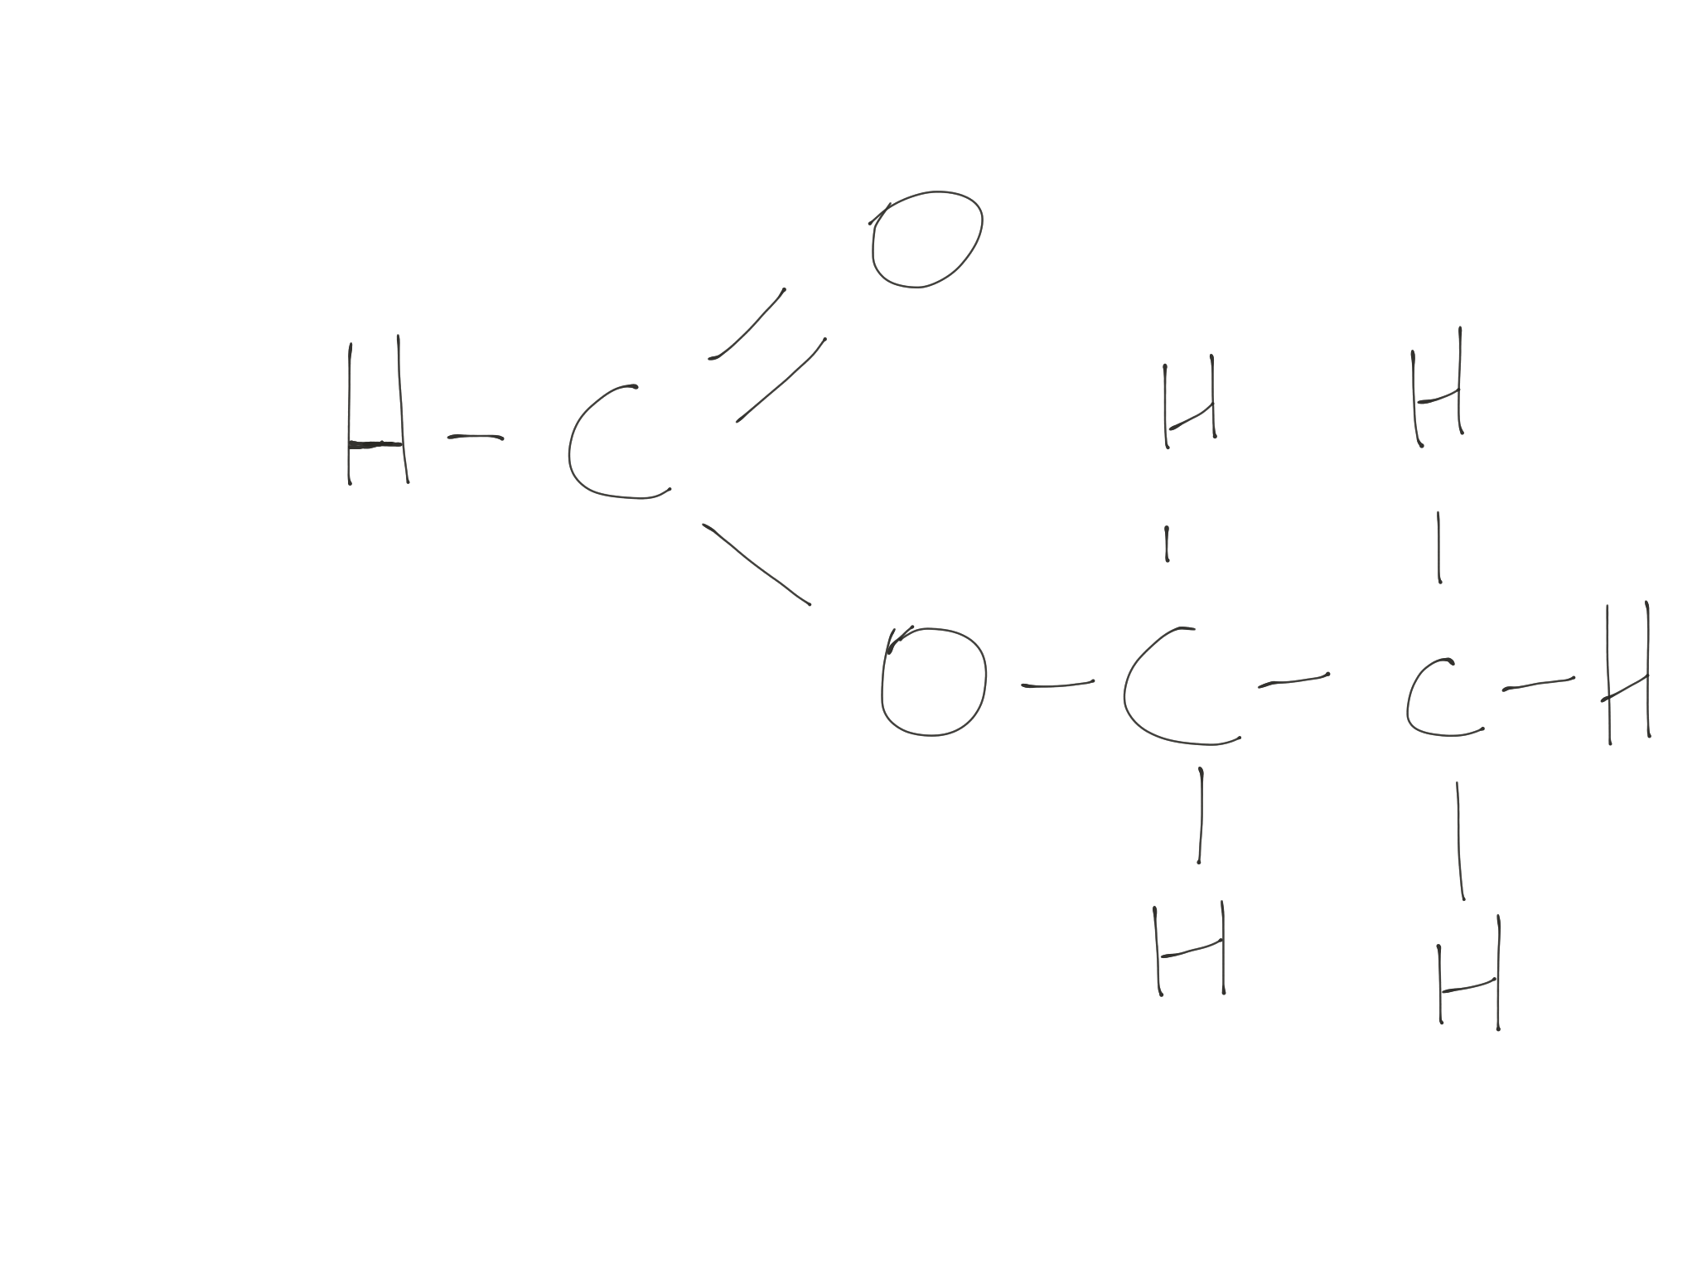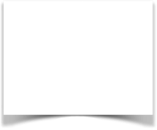

Ethyl methanoate

Chemspider reference

http://www.chemspider.com/Chemical-Structure.7734.html

Expected peak types

Methyl group - triplet. Split by the two protons of the neighbouring CH2 group.

CH2 (methylene) group - quadruplet. Split by the 3 protons of the neighbouring methyl group

Methanoate proton - singlet. No neighbouring protons.

Positions

Methyl - in aliphatic methyl region 1

Methylene - further down field 4

Methanoate proton pulled a long way downfield by electron withdrawing effect of carboxylate group

8

Spectrum

<http://www.sigmaaldrich.com/spectra/fnmr/FNMR000378.PDF>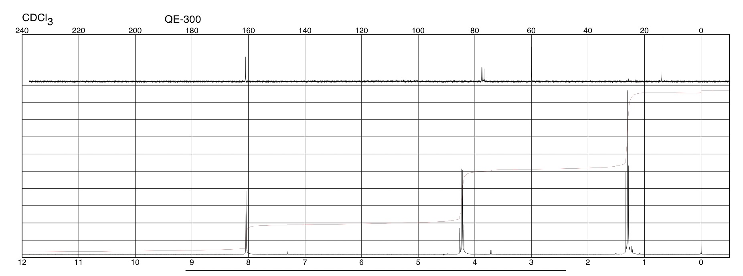

Exercise

1. Methylbenzene
2. 3phenylpropan1ol
3. Ethanal
4. Propanone
5. Diethylether