SKEMA WEBSITE BUMAWA
Bahan Konten Pembuatan Website

1. MENU WEBSITE
Menu : Home - our services - our clients - our vacancies - our contact (acses internal ORDAL)
Tambahkan kontak nomor 085285858080

And a counter to display how many people have visited the website.

2. HERO / OPENING CONTENT
Strategies are devised
under unified coordination.
Executed
with a single goal: delivering solutions.



3. PT BUMI MAKMUR WARADANA
PT BUMI MAKMUR WARADANAAccelerating Investment Through Strategic, Targeted, and Measurable Approaches.
 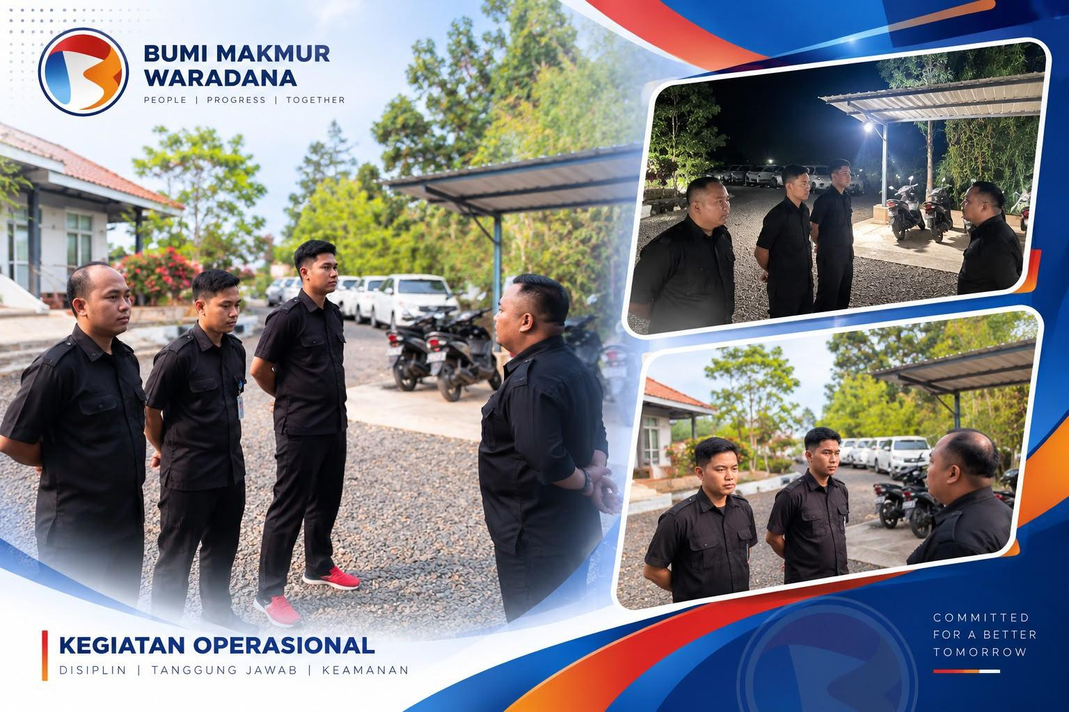

4. PT GARDA AMANAH SOLUSINDO
PT GARDA AMANAH SOLUSINDO
Driving Sustainable Business Growth Through Integrated and Strategic Solutions.
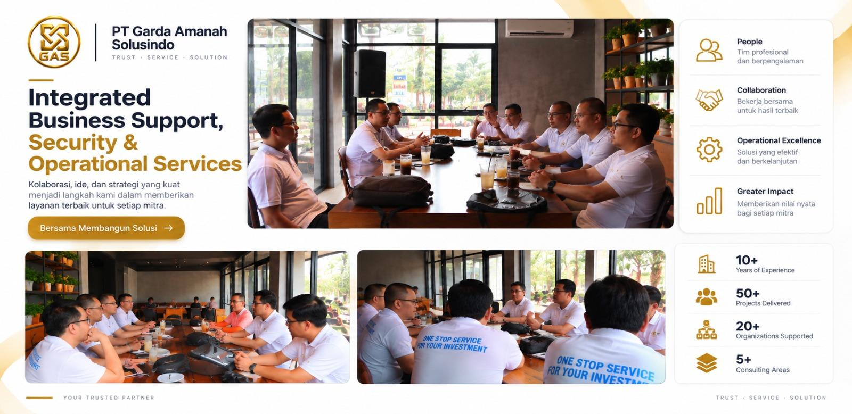

5. CORE STATEMENT
One Strategic Partner. Integrated Solutions. Sustainable Growth.
We deliver integrated business and operational solutions that enable organizations to optimize resources, mitigate risks, strengthen security, improve productivity, and build resilient operational capabilities for sustainable long-term growth.

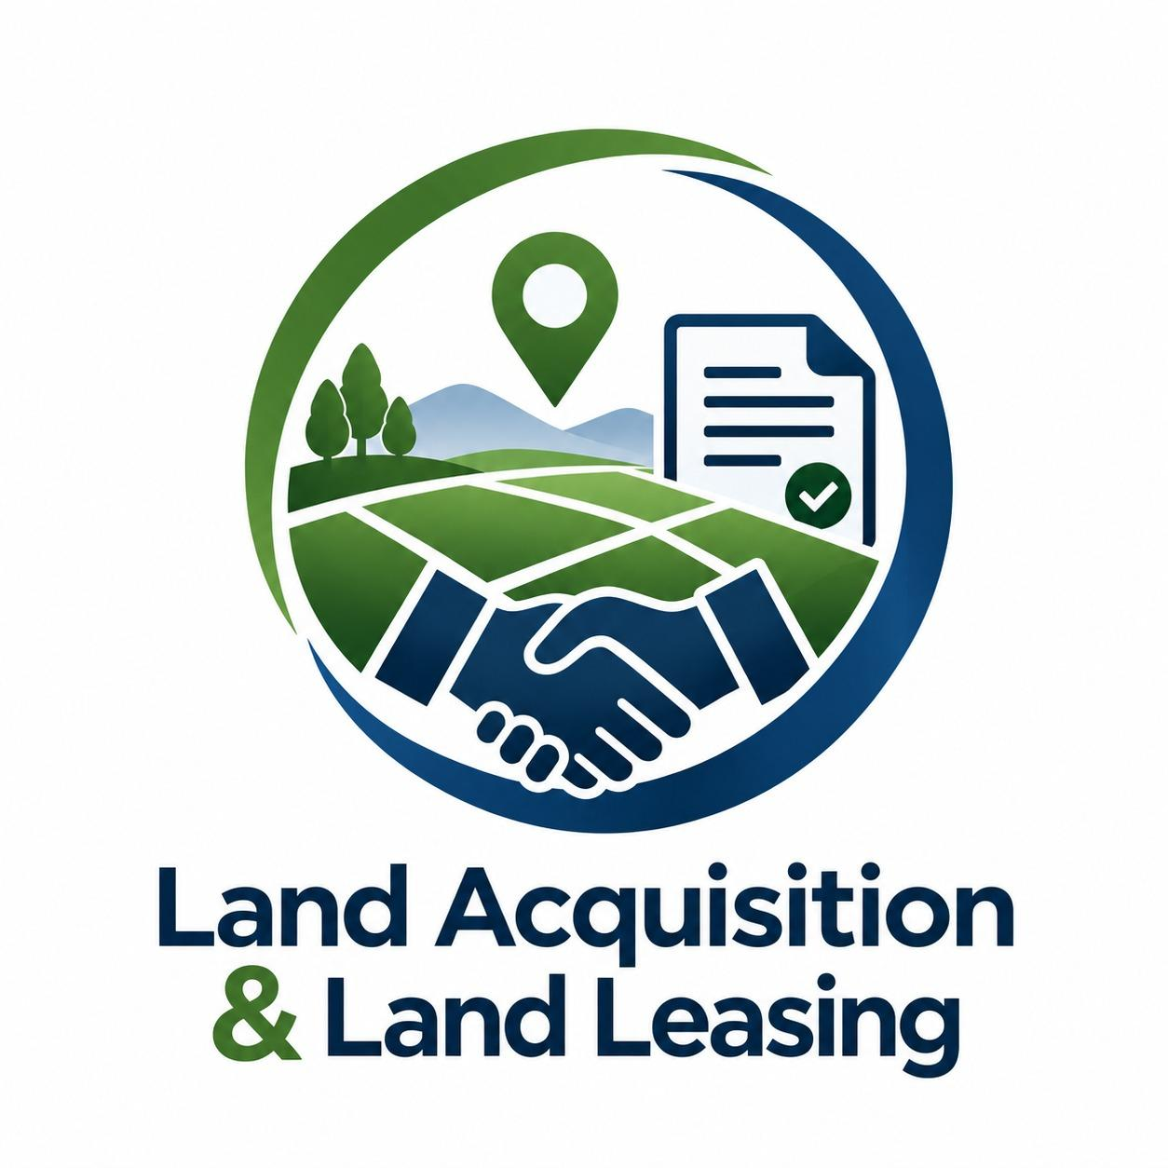 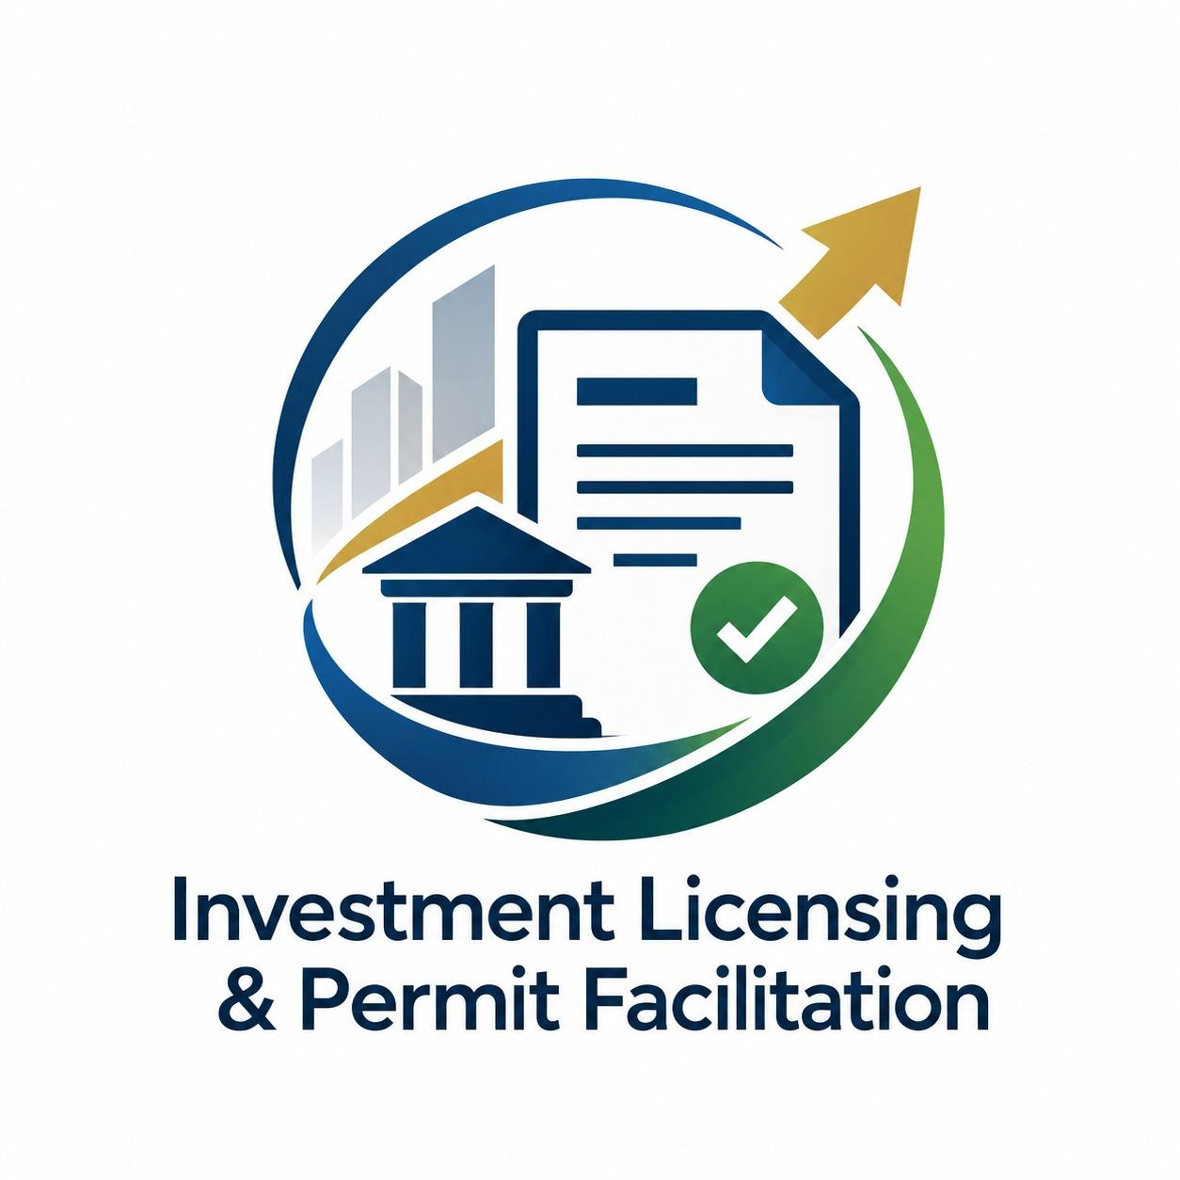
6. OUR SERVICES

6.1 PT Bumi Makmur Waradana
Investment, Land & Project Development Services
PT Bumi Makmur Waradana provides strategic services that support the investment and project development process, from licensing and land acquisition to site preparation and construction project support.
- Investment Licensing & Permit Facilitation
- Land Acquisition & Land Leasing — Purchase or Lease
- Land Clearing, Cut & Fill
- Building Approval (PBG) Facilitation
- Construction & Project Development Support
- Business & Operational Licensing Services

6.2 PT Garda Amanah Solusindo
Integrated Business Support, Security & Operational Services
PT Garda Amanah Solusindo provides integrated operational and business support solutions designed to strengthen workforce management, security, asset protection, receivables management, investigation, and sustainable community development.
- Job Supply & Labour Supply Services
- Certified Security Personnel Services
- Accounts Receivable (AR) Management
- Asset Management Services
- Anti-Counterfeit Management
- Survey, Inspection & Investigation Services
- Heavy Equipment Rental Services
- Social Mapping &Data- Driven CSR Program Development

7. VISION, MISSION DAN VALUE PT BUMI MAKMUR WARADANA
Vision :Our vision is to be a "One Stop Solution For Your Business."
This vision reflects our commitment that PT Bumi Makmur Waradana will always be ready to provide comprehensive solutions to resolve the wide range of business challenges you face.
Mission : To realize this vision, PT Bumi Makmur Waradana will always strive to provide the latest solutions, or the best solutions, and if that is not possible, we are ready to offer an alternative solution.
Value :
1.Customer Focus: Prioritizing client satisfaction by delivering quality, well-targeted service.
2.Creativity: Developing innovative and inspiring solutions.
3.Integrity: Upholding transparency and business ethics.
4.Comprehensiveness: Providing complete and integrated business solutions.
5.Synergy: Building collaboration with various parties to achieve the best results.

8. CLIENT PT BUMI MAKMUR WARADANA
NAME OF COMPANY | JOB ASSIGNMENT
PT Super Unggas Jaya | Business Permit
PT Bayer Indonesia | Business Permit
PT Bayer Indonesia | Land Acquisition
PT Bayer Indonesia | Labour Service & Security
PT Bayer Indonesia | CSR Planning
PT Wiyakta Great Solution | Land Acquisition
PT Wiyakta Great Solution | Labour Service & Security
PT Wiyakta Great Solution | Product Counterfeiting
Lentera Coffee & Chicken | Labour Service & Security
PT Citra Sinergi Talenta | Labour Service & Security
PT Mriga Buana Swarga | Labour Service & Security
PT Mriga Buana Swarga | AR Management Service
PT Mriga Buana Swarga | Tax Consulting
PT Mangkubumi Utama Sejahtera | Labour Service & Security
PT Mangkubumi Utama Sejahtera | Tax Consulting
PT Byakta Loka Hijau Kirana | Labour Service & Security
PT Byakta Loka Hijau Kirana | Tax Consulting
PT CJ Feed and Care Indonesia | AR Management Service
PT CJ Feed and Care Indonesia | Compliance Audit
PT Cheil Jedang Feed Kalimantan | AR Management Service
PT Cheil Jedang Superfeed Serang | AR Management Service
PT CJ Cheil Jedang Feed Lampung | AR Management Service
PT CJ Feed Jombang | AR Management Service
PT CJ Feed Semarang | AR Management Service
PT Sumber Agung | Tax Consulting
PT Fajar Nasional Cipta | Product Counterfeiting

9. Project portofolio PT. Garda Amanah Solusindo
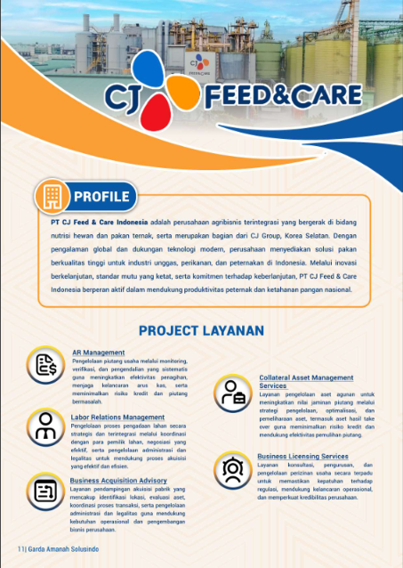 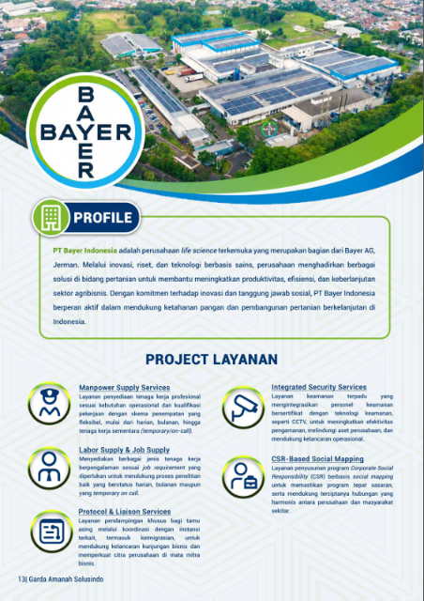 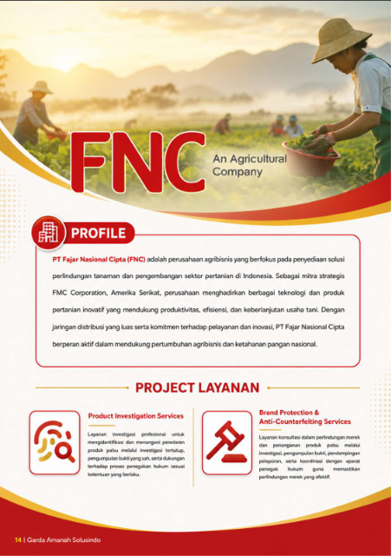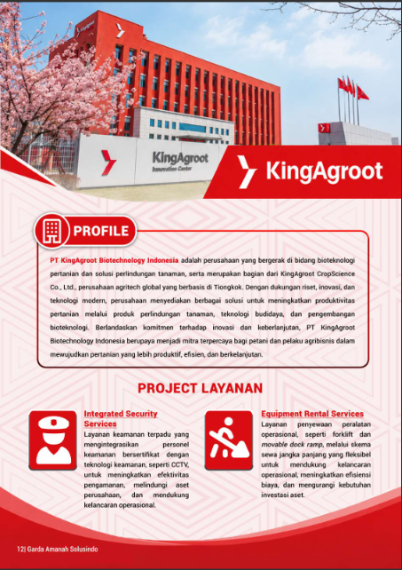

PT Bumi Makmur Waradana
Investment, Land & Project Development Services
PT Bumi Makmur Waradana supports investment and business development through licensing, legal compliance, consulting, and related strategic services, guided by its "One Stop Solution for Your Business" approach.
1. Investment Licensing & Permit Facilitation
Summary: Permit processing from investment approvals through operational licences.
Article: We manage permit documentation from the initial investment stage through to operational licensing. Our team coordinates with relevant authorities to help clients move through regulatory requirements in an organised and timely manner.
2. Land Acquisition & Land Leasing
Summary: Land preparation and procurement for business and project development, by purchase or lease.
Article: We help clients secure and prepare land for business areas, in line with the required topographic standards. Our team supports the process from site identification through to administrative and legal completion.
3. Land Clearing, Cut & Fill
Summary: Site preparation to make land ready for construction.
Article: We support land preparation works, including clearing and levelling, so that sites meet the technical and topographic requirements of the planned development.
4. Building Approval (PBG) Facilitation
Summary: Assistance with building approval as a legal prerequisite for construction.
Article: We assist clients in preparing and submitting the documentation needed to obtain the Building Approval (PBG), helping ensure that construction proceeds in compliance with applicable regulations.
5. Construction & Project Development Support
Summary: Coordination support throughout project development and construction.
Article: Our founders bring hands-on experience in leading factory construction and acquisition projects. We apply this experience to help clients coordinate stakeholders, manage local and bureaucratic challenges, and keep projects on track.
6. Business & Operational Licensing Services
Summary: Business and operational permits so companies can operate in compliance.
Article: We handle the investment and operational permits that businesses need to begin and sustain operations, allowing clients to focus on their core activities.

PT Garda Amanah Solusindo
Integrated Business Support, Security & Operational Services
PT Garda Amanah Solusindo provides operational support solutions covering workforce, security, receivables, asset management, investigation, and community programs, helping clients operate more effectively, efficiently, and securely.
1. Job Supply & Labour Supply Services
Summary: Experienced manpower matched to job requirements on daily, monthly, or temporary/on-call terms.
Article: We supply workers according to each client's job requirements and operational needs. Flexible engagement schemes allow companies to adjust their workforce without adding to internal administrative burden.
2. Certified Security Personnel Services
Summary: Certified security personnel, integrated with security technology such as CCTV.
Article: We combine certified security personnel with technology-based monitoring to protect company assets, facilities, and people, and to support smooth daily operations.
3. Accounts Receivable (AR) Management
Summary: Systematic monitoring, verification, and control of trade receivables.
Article: We help clients improve collection effectiveness and maintain healthy cash flow through structured receivable monitoring and control. This reduces credit risk and the incidence of problem receivables.
4. Asset Management Services
Summary: Management and optimisation of collateral assets to support receivable recovery.
Article: We manage collateral assets through structured handling, optimisation, and maintenance, including assets acquired through take-over. This helps preserve collateral value and supports more effective recovery of receivables.
5. Anti-Counterfeit Management
Summary: Investigation and brand protection support against counterfeit products.
Article: We identify and address counterfeit product circulation through covert investigation and the collection of valid evidence. We also assist with reporting and coordinate with law enforcement, in accordance with applicable regulations.
6. Survey, Inspection & Investigation Services
Summary: Investigation, verification, and risk identification to support informed decisions.
Article: We conduct field investigations and verification to identify potential risks, giving clients accurate information to support decision-making and risk mitigation.
7. Equipment Rental Services
Summary: Flexible operational equipment rental for project and daily operational needs.
Article: We provide operational equipment, such as forklifts and movable dock ramps, through flexible long-term rental schemes. This supports operational continuity and reduces the need for asset investment.
8. Social Mapping & Data-Driven CSR Program Development
Summary: CSR programs built on social mapping to ensure they are well targeted.
Article: We design Corporate Social Responsibility programs based on social mapping surveys around the client's operating site, supporting harmonious relationships between the company and surrounding communities.

