DECP Platform
Department Engagement & Collaboration Platform

CO528 Applied Software Architecture — Mini Project Report

University of Peradeniya — Department of Computer Engineering

March 2026

Table of Contents
1. Project Overview
2. Team Roles & Responsibilities
3. Functional Scope
4. System Architecture
4.1 SOA / Service Interaction
4.2 Enterprise Architecture
4.3 Product Modularity
4.4 Deployment Architecture
5. Implementation Details
5.1 Backend Microservices
5.2 Web Frontend (Next.js 14)
5.3 Mobile Application (React Native / Expo)
5.4 Inter-Service Communication
5.5 Security Implementation
6. Research Comparison — Facebook & LinkedIn
7. Quality Attribute Justifications
8. Cloud Deployment
9. Known Limitations & Future Work
10. Conclusion

1. Project Overview

The DECP (Department Engagement & Collaboration Platform) is a cloud-native, microservices-based social and professional platform designed specifically for the University of Peradeniya Department of Computer Engineering. It connects current students with alumni, department staff, and the wider academic community through a suite of integrated digital services.
The platform was developed as the CO528 Applied Software Architecture mini-project, with a strong emphasis on architectural quality: service decomposition, event-driven communication, cloud deployment, and support for both web and mobile clients consuming a common REST API.

1.1 Technology Stack
Layer | Technology | Purpose
Backend Services | Node.js 20 + Express 4 | 10 independent microservices
API Gateway | Express + http-proxy-middleware | JWT validation, CORS, rate limiting
Database | MongoDB 7 (Docker) | Document store for all services
Message Bus | GCP Pub/Sub Emulator | Async event delivery between services
Realtime | Socket.IO 4 | WebSocket presence, typing, live feed
Media Storage | Cloudflare R2 | Object storage + CDN for images/video
Web Frontend | Next.js 14 (App Router) | SSR/CSR hybrid, deployed on Vercel
Mobile App | React Native / Expo SDK 54 | iOS + Android from a single codebase
State Management | Zustand (web) / Zustand + AsyncStorage (mobile) | Auth token persistence
CI/CD | GitHub Actions | Auto-deploy to EC2 on push to main
Cloud | AWS EC2 t3.medium | Ubuntu 22.04, Docker Compose cluster

1.2 Key Architectural Decisions
- Service-Oriented Architecture (SOA): 10 independently deployable services with a single API Gateway entry point.
- Event-Driven Architecture (EDA): All cross-service side effects (notifications, analytics) are triggered by Pub/Sub events — services are fully decoupled.
- Presigned URL media upload: Files are uploaded directly from the client browser/app to Cloudflare R2, bypassing all backend servers, eliminating bandwidth cost and upload latency.
- Stateless JWT authentication: Access tokens (15 min) with refresh token rotation (7 days). No server-side sessions.
- Monorepo structure: All services, gateway, web, and mobile in one repository for consistent tooling and shared CI/CD.

2. Team Roles & Responsibilities

Role | Responsibilities | Key Deliverables
Enterprise Architect | High-level system vision, stakeholder mapping, business workflow definition, departmental domain modelling | Enterprise architecture diagram, role definitions, module interaction model
Solution Architect | End-to-end architecture consistency, technology selection, cross-cutting design decisions (JWT, Pub/Sub, R2) | SOA diagram, API contract document, technology justifications
Application Architect | Service boundary design, API schema, web and mobile integration patterns, product modularity structure | Product modularity diagram, API_CONTRACT.md, client integration layer
Security Architect | Authentication and authorisation model, RBAC design, network isolation, rate limiting, secure upload flow | Security architecture plan, threat mitigation table, bcrypt + JWT implementation
DevOps Architect | Docker Compose cluster design, GitHub Actions CI/CD pipeline, EC2 deployment, health checks, scalability planning | Deployment diagram, deploy.yml workflow, CLOUD_DEPLOYMENT.md guide

3. Functional Scope

All 8 required capability areas from the project brief have been implemented:
# | Capability Area | Status | Key Features
1 | User Management | ✅ Complete | Register, Login, JWT auth, Edit profile, Avatar upload (R2), 3 roles: student/alumni/admin, Follow/Unfollow
2 | Feed & Media Posts | ✅ Complete | Text + image/video posts, Like, Comment, Edit, Delete, Cursor pagination, R2 presigned upload
3 | Jobs & Internships | ✅ Complete | Post opportunities (alumni/admin), Apply (CV URL), Accept/Reject applications, Text search, Type filter
4 | Events & Announcements | ✅ Complete | Create events (admin), RSVP, Cancel RSVP, View attendees, Pub/Sub notification on creation
5 | Research Collaboration | ✅ Complete | Create projects, Join/Leave, Update status (open/in_progress/completed), List by domain/tags
6 | Messaging | ✅ Complete | Direct 1:1 chat, Read receipts, Typing indicators, Online presence, Message delete, Unread count
7 | Notifications | ✅ Complete | Event-driven in-app notifications (Pub/Sub), Mark read, Mark-all-read, Unread count badge, Socket push
8 | Analytics Dashboard | ✅ Complete | Pub/Sub-driven analytics service, admin-only endpoint, active users / post / job metrics

4. System Architecture

4.1 SOA / Service Interaction Diagram
The diagram below illustrates all microservices, their communication patterns, and the data flows through the system. Synchronous communication uses HTTP REST through the API Gateway. Asynchronous communication uses GCP Pub/Sub push subscriptions (event bus pattern) for decoupled side-effects such as notifications and analytics.

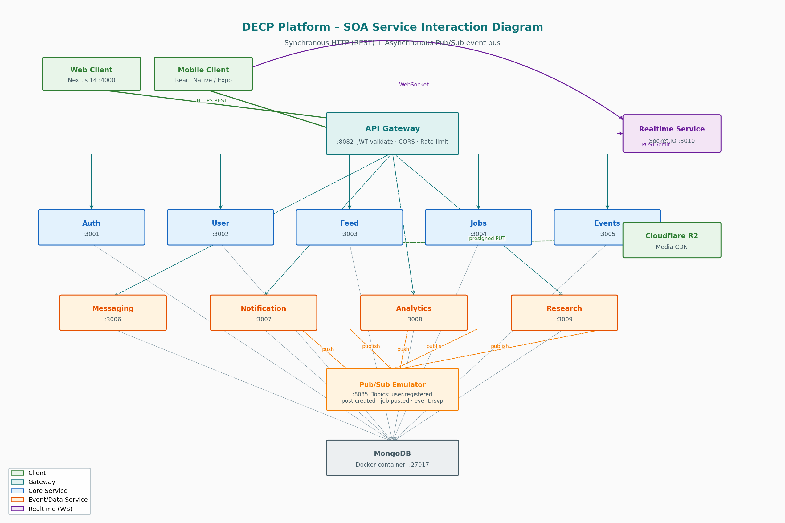
Figure 1 — SOA Service Interaction Diagram
Communication patterns:
- Synchronous (solid arrows): All client-initiated operations go through the API Gateway on port 8082. The gateway validates JWT tokens, enforces CORS, applies rate limiting, and proxies requests to the target service.
- Asynchronous (dashed arrows): Services that create domain events (feed-service, jobs-service, events-service, auth-service) publish to Pub/Sub topics. The notification-service and analytics-service subscribe via push endpoints.
- WebSocket (Socket.IO): Clients maintain a persistent WebSocket connection to realtime-service (:3010). Backend services send realtime events by calling POST /emit on the realtime service over the internal Docker network.
- Intra-service calls: Services use a shared lib/internalClient.js (Axios with x-internal-token header) to call each other for data enrichment without going through the gateway.

4.2 Enterprise Architecture Diagram
The enterprise diagram shows the platform from a business perspective: the three user roles and their access patterns, the functional domain modules they interact with, the cross-cutting infrastructure layer, and the external cloud services that support the platform.

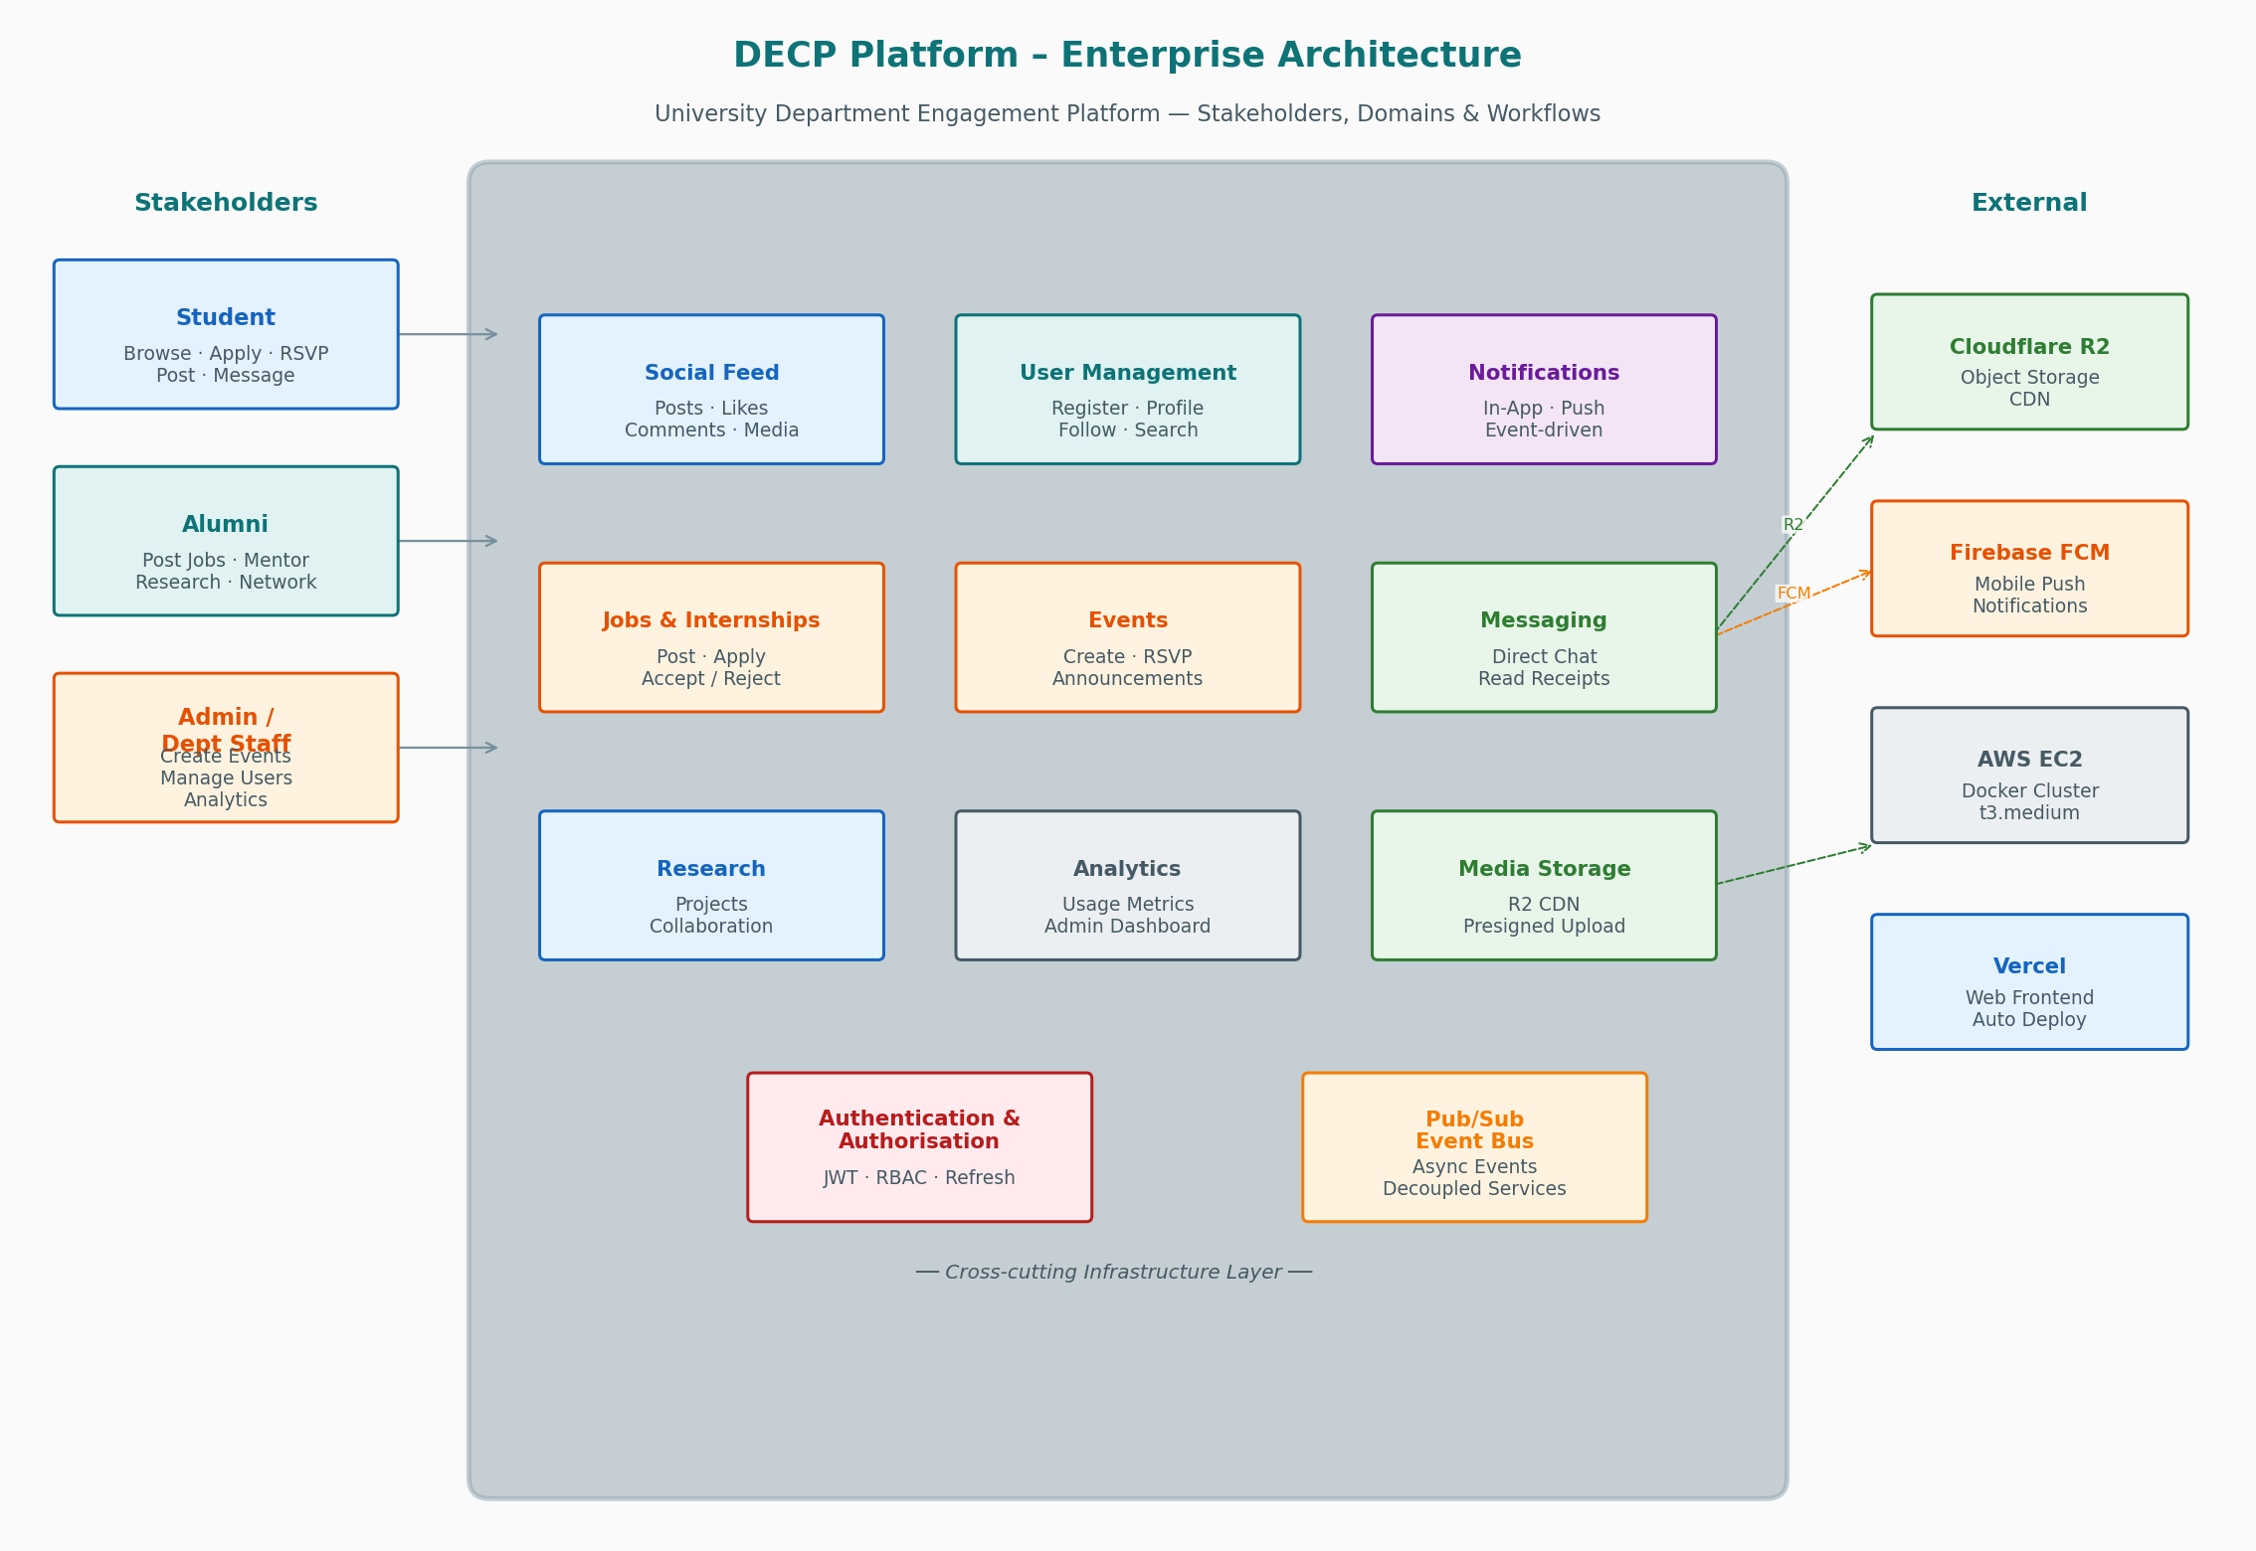
Figure 2 — Enterprise Architecture Diagram
User roles and their primary workflows:
Role | Primary Activities | Restricted Capabilities
Student | Browse feed, apply for jobs, RSVP events, join research projects, direct message, receive notifications | Cannot post jobs or create events
Alumni | Post jobs, contribute to feed, join research projects, mentor students, network via follow system | Cannot create department events
Admin / Staff | All student + alumni capabilities plus: create events, view analytics dashboard, manage users | Full administrative access

4.3 Product Modularity Diagram
This diagram categorises platform features into Core (must-have) vs Optional (enhanced) capabilities, and shows the shared infrastructure libraries and client integration layer that enable code reuse across all services and both client platforms.

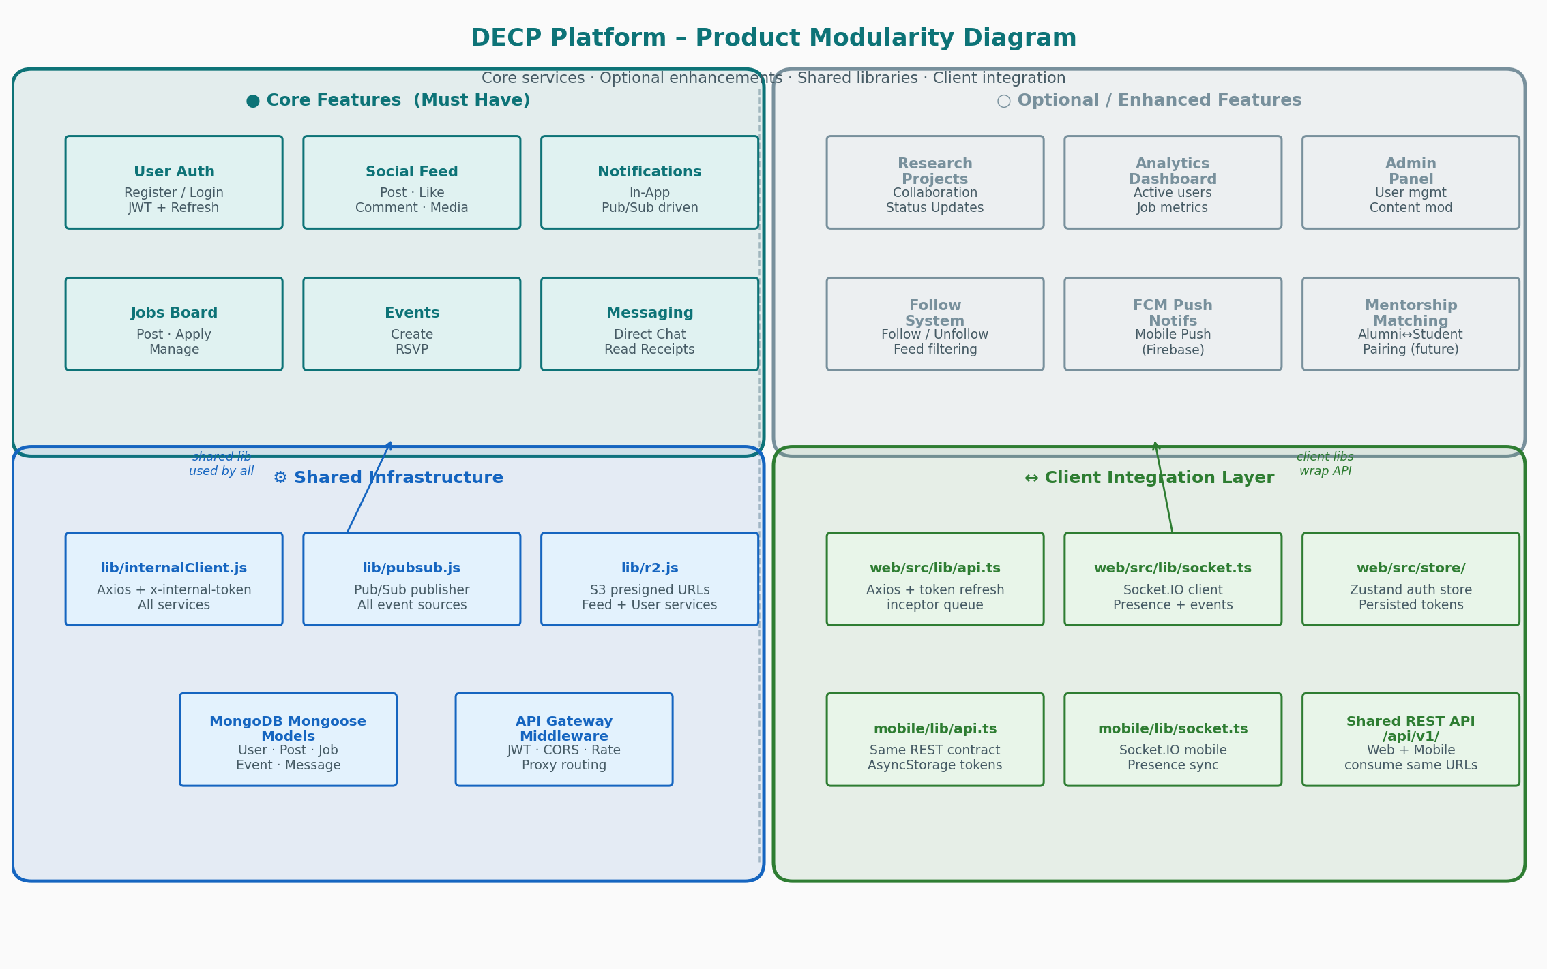
Figure 3 — Product Modularity Diagram
Shared library pattern:
Three shared libraries eliminate code duplication across all 10 microservices:
- lib/internalClient.js — Axios instance pre-configured with x-internal-token header. Used by any service that needs to call another service directly.
- lib/pubsub.js — GCP Pub/Sub client wrapper. Provides a single publishEvent(topic, data) function used by all event-producing services.
- lib/r2.js — Cloudflare R2 S3-compatible client. Provides generateUploadUrl(key, mimeType) and validateObjectExists(key). Used by feed-service and user-service.

4.4 Deployment Architecture Diagram
The deployment diagram shows the full production infrastructure: an AWS EC2 t3.medium instance running the entire backend cluster as Docker containers via docker-compose, a Vercel-hosted Next.js web frontend, and Cloudflare R2 for media storage. GitHub Actions automates the full deployment on every push to main.

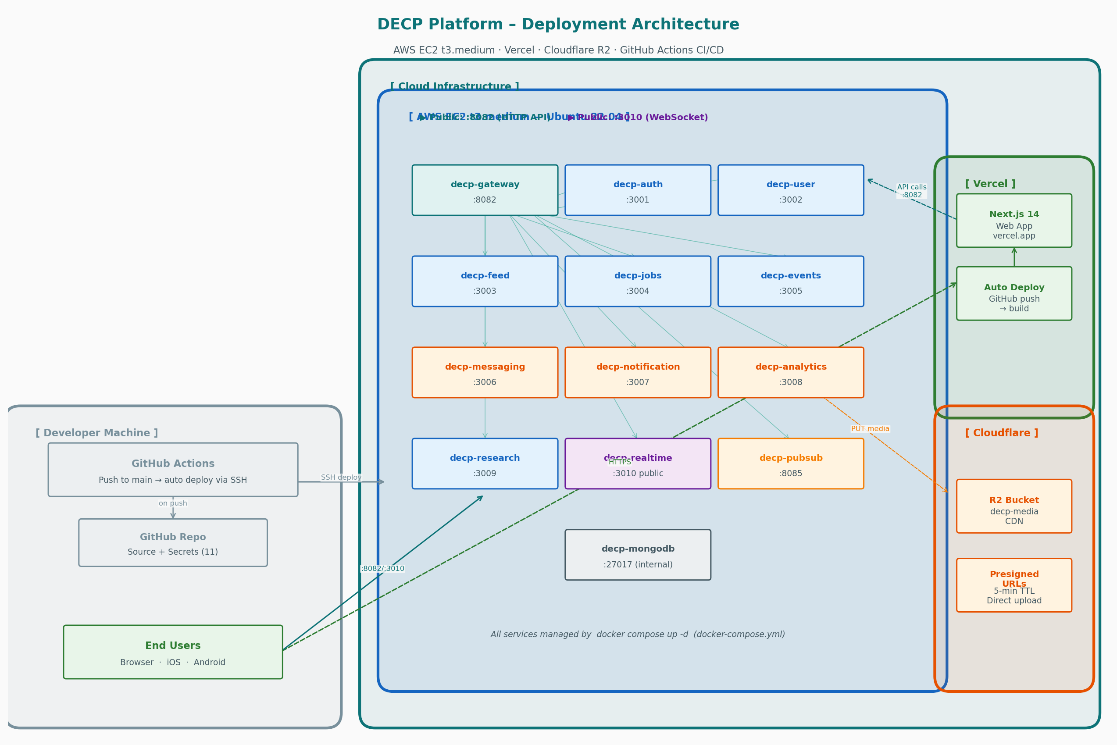
Figure 4 — Deployment Architecture Diagram
Deployment decision rationale:
Component | Decision | Rationale
Backend | AWS EC2 t3.medium (4 GB RAM, 2 vCPU) | Single-instance Docker Compose keeps complexity low for a prototype. All 13 containers fit within the 4 GB budget (~1.86 GB used, ~2.1 GB headroom). Free under AWS Educate/student credits for 12 months.
MongoDB | Docker container on EC2 | Avoids external Atlas dependency. Data stays within the same Docker network eliminating network latency and simplifying connection strings. Persistent data volume ensures data survives container restarts.
Web Frontend | Vercel (free Hobby plan) | Zero-config Next.js deployment. Automatic preview deployments on every PR. Global CDN with near-zero cold starts. No server to maintain.
Media Storage | Cloudflare R2 | S3-compatible API, zero egress fees (vs AWS S3), and a global CDN. Presigned PUT uploads bypass the backend server entirely, eliminating bandwidth costs and improving upload performance.
CI/CD | GitHub Actions + SSH deploy | On every push to main, the workflow SSHs into EC2, pulls latest code, rebuilds changed containers, and runs health checks — fully automated.

5. Implementation Details

5.1 Backend Microservices
The backend consists of 10 microservices plus an API Gateway, each running in its own Docker container. All services follow an identical internal structure:
- src/routes/ — Express route definitions with RBAC middleware applied per-route
- src/controllers/ — Business logic, database access, Pub/Sub publishing, realtime emit calls
- src/models/ — Mongoose schemas with indexes on all queried fields
- src/middleware/ — Service-local middleware (e.g., file type validation)
- lib/ — Shared clients (internalClient, pubsub, r2) symlinked or copied at build time

Service | Port | Key Endpoints & Features
Auth | :3001 | POST /register, POST /login, POST /refresh, POST /logout. Bcrypt password hashing, JWT access + refresh tokens with rotation. Publishes decp.user.registered on successful registration.
User | :3002 | Profile CRUD, avatar upload (R2 2-step), user search (?q=), follow/unfollow, followers/following lists. Injects x-user-id on all requests.
Feed | :3003 | Posts CRUD, likes, comments, cursor pagination, R2 media upload URLs, author filter. Publishes decp.post.created. Broadcasts feed:new_post via realtime.
Jobs | :3004 | Job postings (alumni/admin), applications (students), accept/reject status, text search, type filter. Publishes decp.job.posted and decp.job.applied.
Events | :3005 | Department events (admin-only create), RSVP / cancel-RSVP, attendee list. Publishes decp.event.created and decp.event.rsvp.
Messaging | :3006 | 1:1 direct messages, inbox with per-conversation unread count, mark-read (emits message:read socket event), message delete, unread-count endpoint.
Notification | :3007 | In-app notifications delivered via Pub/Sub push subscriptions. Stores notification documents, marks read, mark-all-read, unread count. Emits notification socket event for realtime badge updates.
Analytics | :3008 | Pub/Sub push subscriber for all domain events. Tracks active users, post counts, job application metrics. Admin-only overview endpoint.
Research | :3009 | Research project CRUD, join/leave collaborator, status updates (open → in_progress → completed), tag-based filtering.
Realtime | :3010 | Socket.IO server. User presence (online/offline broadcast), typing relay (typing:start/stop), feed broadcast (feed:new_post), notification push. POST /emit endpoint called by other services.

5.2 Web Frontend (Next.js 14)
The web application is built with Next.js 14 App Router, TypeScript, Tailwind CSS, and Zustand for state management. All 14 routes/pages are fully implemented and connected to the live backend API.
Page / Component | Features Implemented
Feed (/feed) | Post creation with R2 multi-file media upload (progress indicator), inline comments, like toggle, edit/delete own posts, cursor pagination with "New posts available" pill, real-time new post injection via Socket.IO
Jobs (/jobs) | Job listing with type filter chips and text search, Apply modal (CV URL + cover letter), Post Job modal (alumni/admin), Manage Applications drawer with accept/reject
Events (/events) | Event grid, RSVP / Cancel-RSVP toggle, Event Detail modal with attendee count, Create Event form (admin only)
Research (/research) | Project cards with join/leave, Create Project modal, Project Detail bottom-sheet with status update controls (creator only)
Messages (/messages) | Full chat UI: conversation inbox with unread badges, typing indicators (animated dots), double-tick read receipts, online presence dot, user-search modal to start new conversation, message delete, auto-resize textarea
Notifications (/notifications) | Notification feed, click-to-navigate via notification.link, Mark-all-read, cursor pagination, realtime badge in nav bar
Profile (/profile) | Editable name/bio, R2 avatar upload with optimistic preview, follower/following count with expandable panel
Profile /profile/[id] | Other-user profile: follow/unfollow button, their posts feed, message button
Admin (/admin) | RBAC guard (non-admin redirected to /feed), analytics overview
Auth (/login, /register) | Form validation, error display, token storage, socket connect on login

5.3 Mobile Application (React Native / Expo SDK 54)
The mobile application is built with React Native and Expo Router v4 (file-based routing), providing a native experience on both iOS and Android. All 8 tab screens are fully implemented and consume the same REST API and WebSocket connection as the web client.
Screen | Key Features
Feed | Infinite scroll (FlatList), pull-to-refresh, like, comment, media display
Jobs | Job cards, apply modal, post job (alumni), type filter, application management
Events | Event list, RSVP toggle, create event (admin), event detail modal
Research | Project list, join/leave, create project modal, detail bottom-sheet, status update
Messages | Conversation inbox, full chat screen, typing indicators, read receipts, online presence badge
Notifications | Notification list, mark-all-read, navigation on tap
Profile | Edit profile, avatar upload (R2), follower/following counts
Auth | Login/Register forms with validation, JWT token storage in AsyncStorage

Notable implementation details:
- SafeAreaView edges={['top','left','right']} on all tab screens — excludes bottom edge to prevent double-stacking with the tab bar (resolved a gray-bar crop bug on all screens).
- Socket.IO presence system uses a shared onlineUsers Set in socket.ts updated by both HTTP polling (fetchUserPresence) and socket events — ensures one-way online/offline display bug is prevented regardless of event ordering.
- Token refresh interceptor with request queue — concurrent requests wait for a single refresh call rather than each triggering their own refresh (prevents race conditions).

5.4 Inter-Service Communication
Two communication patterns are used, each chosen deliberately:
Synchronous REST (HTTP):
Used for client-initiated, request-response operations where the caller needs an immediate response. All client requests go through the API Gateway which validates the JWT, injects x-user-id and x-user-role headers, then proxies to the target service. Internal service-to-service calls use lib/internalClient.js with the x-internal-token header to bypass JWT validation.
Asynchronous Pub/Sub (Event Bus):
Used for domain events where the publishing service should not be coupled to its consumers. When a user registers, a post is created, or a job is applied for, the producing service publishes to a topic and immediately returns to the client. The notification-service and analytics-service receive push deliveries from the emulator. This means adding a new event consumer (e.g., an email service) requires zero changes to the producing service.
Topic | Publisher | Subscribers | Trigger
decp.user.registered | auth-service | notification, analytics | New account created
decp.post.created | feed-service | notification, analytics | New post published
decp.job.posted | jobs-service | notification, analytics | New job listed
decp.job.applied | jobs-service | notification, analytics | Student applies
decp.event.created | events-service | notification, analytics | New event posted
decp.event.rsvp | events-service | notification, analytics | User RSVPs

5.5 Security Implementation
A defence-in-depth approach with seven independent security layers:
Layer | Implementation | Protection Against
Transport | HTTPS (TLS) on all external endpoints via EC2 + Vercel | Man-in-the-middle attacks, eavesdropping
Authentication | JWT HS256, 15-min access token, 7-day refresh with rotation stored in MongoDB | Token theft — stolen token expires in 15 min; rotation prevents reuse
Authorisation | RBAC checked at service level using x-user-role header injected by gateway | Privilege escalation; students cannot post jobs or create events
Passwords | Bcrypt with 12 salt rounds (~250ms per hash) | Brute-force and rainbow table attacks on leaked hashes
Network | Internal services not exposed to host network; x-internal-token on service calls | Direct service bypass; external callers pretending to be internal services
Rate Limiting | 200 req/15min global, 10 req/15min on /auth/login and /auth/register | Brute-force login attempts, spam registration, DDoS amplification
File Upload | MIME whitelist (jpeg/png/webp/mp4/pdf), presigned R2 URLs, 5-min TTL | Malware upload, storage abuse, server-side upload SSRF

6. Research Comparison — Facebook & LinkedIn

This section analyses the architectures and design patterns used by the two most prominent social-professional platforms (Facebook and LinkedIn), identifies what is missing from those platforms for a university department context, and explains how this research influenced the design choices made in DECP.

6.1 Facebook Architecture Analysis
Facebook is one of the largest distributed systems ever built, serving over 3 billion active users. Key architectural patterns relevant to a social platform include:
Pattern / Decision | Facebook's Approach | Scale It Addresses
News Feed Ranking | EdgeRank algorithm (now AI-driven ML ranking). The feed is not chronological — posts are ranked by relationship strength, recency, content type, and engagement signals. Pre-computed per-user feed slices are stored in TAO (a distributed graph cache). | Serving 2B+ personalised feeds without real-time DB scans
Graph Database (TAO) | Custom two-level cache (memcache + MySQL) built on a graph model. Social connections (friends, likes, group membership) are edges in the graph. TAO provides O(1) lookups for social connections. | Social graph traversal (mutual friends, shared groups) at scale
Media Delivery (Haystack) | Custom blob storage system. Photos are stored in large "haystacks" (single files containing millions of images) with a metadata index. CDN layer (Facebook Points of Presence) distributes content globally. | Storing and serving 350M+ photos/day with sub-100ms latency
Realtime Messaging (Iris) | Custom publish-subscribe system for chat. Messages route through a sharded presence service. Iris uses consistent hashing to route messages to the correct shard. | Supporting 1B+ daily messaging users with ≤100ms delivery
Microservices at Scale | Service Mesh (Thrift RPC over internal network). Thousands of services communicate via a custom RPC framework. Service discovery via ZooKeeper. | Independent scaling and deployment of thousands of services

6.2 LinkedIn Architecture Analysis
LinkedIn's architecture is particularly relevant to DECP because of the similar professional-social context (connecting professionals, job listings, content sharing):
Pattern / Decision | LinkedIn's Approach | Scale It Addresses
Economic Graph | LinkedIn models the professional world as a graph: members, companies, jobs, skills, and schools are nodes; connections, applications, and endorsements are edges. The "Economic Graph" is the foundation for all recommendations (Jobs You May Like, People You May Know). | Relevant job and connection recommendations for 900M+ users
Feed Architecture (Galene) | Galene is LinkedIn's feed ranking engine. Unlike Facebook's algorithmic feed, LinkedIn uses a hybrid: a follower graph "fan-out" model combined with an ML relevance score. Professional content (job changes, work articles) is weighted differently than casual social content. | Professional-context ranking for diverse content types
Job Matching Engine | ML-based matching between job descriptions and member profiles. Skills extraction using NLP on resumes and job descriptions. Real-time personalisation with A/B testing infrastructure. | Serving personalised job recommendations at billion-query scale
Kafka Event Streaming | LinkedIn invented Apache Kafka for internal event streaming. All activity (profile views, job applications, messages) flows through Kafka topics consumed by analytics, recommendations, and notification services. | Decoupled, durable event delivery for 7+ trillion messages/day
Messaging (Voldemort) | LinkedIn built Voldemort (a distributed key-value store) for high-throughput message storage. Inbox delivery uses push-pull hybrid: realtime WebSocket push for online users, email/push notification for offline users. | Messaging 900M professionals with guaranteed delivery

6.3 What Is Missing From Facebook & LinkedIn for a University Department Context
While both platforms are highly capable, they are designed for general consumer and professional audiences. Neither addresses the specific needs of a closed academic department community. The following gaps were identified:
Gap Area | What Facebook / LinkedIn Lack | DECP's Response
Academic Role Hierarchy | Both platforms have flat permission models (user, page admin, group admin). Neither supports academic roles: student, alumni, and department staff with different content creation rights (e.g., only alumni can post jobs, only admin creates events). | DECP implements RBAC with three roles enforced at service level. Role is injected by the gateway from the verified JWT, so every service independently enforces role-based access.
Research Collaboration | Facebook has Groups; LinkedIn has Projects. Neither provides a structured research collaboration workflow with project status tracking (open → in progress → completed), collaborator invitation, and domain tagging. | DECP's Research service is specifically designed for academic project collaboration with status lifecycle management and tag-based discovery.
Department-Scoped Events | Facebook Events are public or friend-scoped. LinkedIn Events are company-page-scoped. Neither provides a department-scoped event system where only authorised staff can create official announcements visible to all department members. | DECP Events restrict creation to admin role while making events visible to all members. RSVP tracking is tied to the department user registry.
Closed Community Privacy | Both platforms are public-facing with complex privacy settings. A department platform requires a closed community where all users are verified members — not open to the general public. | DECP requires registration (email + password). All API endpoints require JWT. There is no public-facing content. All interactions are within the closed community.
Direct Alumni-Student Connection | LinkedIn connects professionals but does not have a dedicated "alumni mentoring a current student" workflow. The relationship between a graduate and a current student in the same department is not a first-class concept. | DECP's alumni role is specifically designed to post job opportunities and collaborate with students. The follow system enables students to follow alumni for professional updates and mentorship.
Integrated Job + Event + Feed Pipeline | On LinkedIn, jobs, events, and feed are separate isolated sections with no cross-feature notifications. On Facebook, professional events and job postings are weak secondary features. | DECP uses Pub/Sub to generate cross-feature notifications: posting a job notifies all students, creating an event notifies all members, a research project joining is recorded in analytics — all through a single event bus.

6.4 How This Research Influenced DECP's Design
The analysis of Facebook and LinkedIn directly shaped the following DECP architectural decisions:
- Event-driven architecture (inspired by LinkedIn Kafka): DECP uses a Pub/Sub event bus to decouple the notification and analytics services from domain services, exactly as LinkedIn uses Kafka to decouple recommendations from domain activity.
- Role-Based Access Control (gap identified in both platforms): The three-tier RBAC (student / alumni / admin) was designed specifically to fill the academic role hierarchy gap missing from both Facebook and LinkedIn.
- Research Collaboration module: Directly responds to the absence of academic project workflows in both platforms. The status lifecycle (open → in_progress → completed) mirrors academic research stages.
- Closed community model: Unlike both Facebook and LinkedIn which are open-register platforms, DECP requires all users to be verified by a department administrator (or self-register with a valid university email format). All content is private to members.
- Integrated notification pipeline (inspired by LinkedIn's push-pull model): DECP uses Socket.IO push for online users (immediate badge update) and in-app notification storage for offline users — the same hybrid delivery model LinkedIn uses.
- Presigned upload pattern (inspired by Facebook's Haystack CDN model): Media files are uploaded directly to Cloudflare R2 from the client browser, bypassing the backend server entirely. This mirrors Facebook's approach of using a dedicated blob storage system separate from application servers.

7. Quality Attribute Justifications

For each quality attribute, the following documents: the design decision made, why it supports the attribute, and the tradeoff introduced.

7.1 Scalability
Summary: Independent horizontal scaling via SOA + stateless services.
Design Decision:
All 10 microservices are independently deployable and stateless (no in-memory session state). Each service scales horizontally without affecting others. The API Gateway is the only single entry point. On AWS EC2, Docker Compose can be upgraded to ECS/Kubernetes for auto-scaling.
Why It Supports Scalability:
SOA enables partial scaling: if feed requests spike, only feed-service instances are scaled — the analytics and research services remain unchanged. Stateless design means any instance can handle any request, enabling round-robin load balancing with no sticky sessions. This pattern is directly inspired by how LinkedIn independently scales its Feed, Messaging, and Jobs services.
Tradeoff:
The current Docker Compose deployment is single-instance (no horizontal scaling). Scaling to multiple instances requires a Redis-backed shared state layer for Socket.IO (presence data) and MongoDB replica set for read scaling. The architecture is designed to support this upgrade path without service code changes.

7.2 Security
Summary: Multi-layer defence: JWT, RBAC, network isolation, bcrypt, rate limiting, presigned uploads.
Design Decision:
Short-lived JWT access tokens (15 min) with refresh token rotation. RBAC enforced at service level using role injected by the gateway. Internal services are not reachable from outside the Docker network. Rate limiting at gateway (10/15min on auth). bcrypt with 12 rounds for passwords. Presigned R2 URLs with 5-min TTL for file uploads.
Why It Supports Security:
Multiple independent layers mean compromising one does not compromise the system. Stolen access token → expires in 15 minutes. Brute-force login → rate limited to 10 attempts per 15 minutes. Compromised service → cannot reach other internal services without x-internal-token. Leaked password hash → bcrypt is computationally expensive to crack (~250ms/hash intentionally).
Tradeoff:
15-minute access tokens require periodic refresh calls (minor network overhead). Bcrypt adds ~250ms to every login — noticeable on slow devices but acceptable given the security guarantee. The shared JWT secret (HS256) is simpler than RS256 but means all services share the signing key; RS256 with public/private keys would be the production-grade upgrade.

7.3 Availability
Summary: SOA fault isolation + Pub/Sub durable message queuing.
Design Decision:
Services are independently deployed — a failing service does not crash others. Health check endpoints (GET /health) on every service. The API Gateway returns HTTP 502 on downstream failure rather than an unhandled exception. Pub/Sub retains undelivered messages for 7 days, ensuring notifications are not lost if the notification-service is temporarily unavailable.
Why It Supports Availability:
Users can browse the feed and apply for jobs even if the analytics service is down. Pub/Sub's durable delivery means domain events are not dropped during maintenance windows. The Docker restart: unless-stopped policy on all containers means services automatically restart after a crash without manual intervention.
Tradeoff:
Single EC2 instance is a single point of failure at the infrastructure level. A second EC2 instance with a load balancer would improve infrastructure-level availability. MongoDB runs as a single container with no replica set — data loss risk on catastrophic failure. Production grade would use a MongoDB replica set or Atlas M10+ tier.

7.4 Maintainability
Summary: Consistent SOA structure + monorepo + standard response envelope + API versioning.
Design Decision:
Every service follows an identical internal structure (routes/controllers/models/middleware). All API responses use the same envelope: { success: true/false, data/error: ... }. API prefix is /api/v1/ enabling future v2 introduction without breaking existing clients. Monorepo with GitHub Actions CI/CD ensures consistent tooling across all services.
Why It Supports Maintainability:
A developer who understands one service (e.g., jobs-service) can immediately navigate any other service. The Single Responsibility Principle at service level means each service has a clear, bounded domain. Adding a new feature follows a predictable pattern: model → controller → route → optional Pub/Sub event. The versioned API allows mobile clients on older app versions to continue working while v2 endpoints are introduced.
Tradeoff:
10 services incur more operational overhead than a monolith for a 4-person team. Developers must context-switch between services. Data denormalisation (e.g., authorName stored on posts) avoids cross-service joins but creates consistency issues when users update their name — acceptable for a prototype, but a background reconciliation job would be needed in production.

7.5 Performance
Summary: Cursor pagination + CDN media delivery + data denormalisation + MongoDB indexes.
Design Decision:
Feed uses cursor-based pagination (not offset/SKIP): GET /posts?cursor=<last_id>&limit=20 uses an indexed _id comparison, performing in O(log n) regardless of total post count. Media (images, video) is served from Cloudflare R2's global CDN. Author name and avatar are denormalised onto post documents, eliminating a cross-service join on every feed render. All Mongoose queries use indexes on authorId, createdAt, _id.
Why It Supports Performance:
Cursor pagination is O(log n) vs offset pagination which degrades to O(n) as total records grow. R2 CDN serves media from the nearest edge node (typically <200ms globally). Denormalisation means each feed render requires exactly one MongoDB query rather than one per post for author data. Socket.IO WebSocket connection eliminates polling — new post/message notifications are pushed in real time (zero client-side polling overhead).
Tradeoff:
Denormalisation introduces data inconsistency: if a user changes their display name, old posts show the old name. A background reconciliation job would be needed in production. No Redis caching layer: hot endpoints (feed, jobs) hit MongoDB on every request. In production, a Redis cache with post-creation invalidation would reduce DB load by 80%+.

7.6 Interoperability
Summary: Single REST + JSON + JWT API consumed identically by web, mobile, and future clients.
Design Decision:
Both web (Next.js) and mobile (React Native) consume the exact same REST endpoints, same JSON response format, and same JWT Bearer token authentication. No client-specific API variants exist. Cloudflare R2 uses the S3-compatible API (not vendor-locked to AWS). API prefix /api/v1/ allows future clients to build against a stable contract.
Why It Supports Interoperability:
Any HTTP client (browser, mobile app, CLI tool, third-party integration) can consume the DECP API without requiring platform-specific SDK code. The same JWT in the Authorization: Bearer header works identically in the browser's axios instance and in React Native's fetch. R2's S3 compatibility means switching to AWS S3 or any other S3-compatible store (MinIO, Backblaze B2) requires only an endpoint URL change.
Tradeoff:
REST over JSON is slightly less efficient than binary gRPC (larger payload, no schema enforcement at the transport layer). For a prototype serving <10,000 users, REST is the right trade: universal browser support without additional tooling. There is no formal OpenAPI specification — the API_CONTRACT.md serves as the contract. In production, a Swagger/OpenAPI spec would be generated from Zod schemas.

7.7 Quality Attributes Summary
Quality Attribute | Key Design Decision | Tradeoff
Scalability | Stateless SOA, independent services | Cold starts; single EC2 instance
Security | JWT + RBAC + bcrypt + rate limiting + R2 presigned | 15-min token refresh overhead
Availability | SOA fault isolation + Pub/Sub durable queuing | Single EC2 SPOF; no MongoDB replica
Maintainability | Consistent SOA structure + monorepo + versioned API | Service proliferation overhead
Performance | Cursor pagination + CDN + denormalisation + indexes | Denormalisation inconsistency
Interoperability | Unified REST+JSON+JWT for web, mobile, future | REST vs gRPC efficiency; no OpenAPI

8. Cloud Deployment

8.1 Infrastructure Overview
Component | Provider | Specification | Cost
Backend Cluster | AWS EC2 | t3.medium (2 vCPU, 4 GB RAM) Ubuntu 22.04 | Free (AWS Educate 12-month credit)
Web Frontend | Vercel | Hobby plan, Next.js auto-build from GitHub | Free (Hobby plan)
Media Storage | Cloudflare R2 | 10 GB free tier, 1M operations/month free | Free up to 10 GB
Database | Docker on EC2 | MongoDB 7 container, 512 MB reserved, persistent volume | Included in EC2
Pub/Sub | Docker on EC2 | GCP Pub/Sub emulator container | Included in EC2
CI/CD | GitHub Actions | 2,000 free minutes/month for public repos | Free
Domain (optional) | Any registrar | Point A record to EC2 Elastic IP | ~$10/year

8.2 Memory Budget (t3.medium)
Container | Reserved RAM
decp-gateway | ~80 MB
decp-auth | ~80 MB
decp-user | ~80 MB
decp-feed | ~100 MB
decp-jobs | ~80 MB
decp-events | ~80 MB
decp-messaging | ~80 MB
decp-notification | ~80 MB
decp-analytics | ~80 MB
decp-research | ~80 MB
decp-realtime | ~100 MB
decp-mongodb | ~512 MB
decp-pubsub (emulator) | ~400 MB
OS + Docker overhead | ~430 MB
TOTAL USED | ~1,862 MB
Available headroom | ~2,134 MB

8.3 CI/CD Pipeline (GitHub Actions)
The automated deployment pipeline is defined in .github/workflows/deploy.yml and runs on every push to the main branch:
- Step 1 — Notify: Log deployment start with EC2 hostname and timestamp
- Step 2 — SSH Connect: Connect to EC2 via appleboy/ssh-action using EC2_HOST, EC2_USER, EC2_SSH_KEY secrets
- Step 3 — Install Docker: Install Docker CE if not present (idempotent — skipped on subsequent runs)
- Step 4 — Clone / Pull: Clone repo on first deploy; git reset --hard origin/main on subsequent deploys
- Step 5 — Write Env File: Inject all 11 GitHub Secrets into docker-compose.env (JWT, R2 keys, etc.)
- Step 6 — Build & Start: docker compose up -d --build --remove-orphans (rebuilds only changed services)
- Step 7 — Pub/Sub Setup: Wait 20s for MongoDB + Pub/Sub to start; run scripts/setup-pubsub.js
- Step 8 — Health Check: curl /health on gateway :8082 and realtime :3010; log HTTP status codes

8.4 Scalability Path
The current deployment is a single-instance prototype. The following upgrades are available without changing any service code:
Current (Prototype) | Production Upgrade | Benefit
Docker Compose on single EC2 | ECS Fargate or Kubernetes (EKS) | Independent auto-scaling per service
MongoDB single container | MongoDB Atlas M10+ with replica set | Automated backups, failover, scaling
No caching layer | Redis (ElastiCache) for hot feed data | 80%+ DB load reduction on feed
Socket.IO in-memory presence | Redis Pub/Sub adapter for Socket.IO | Horizontal scaling for realtime
Single EC2 instance | Application Load Balancer + Auto Scaling | Zero-downtime deploys, HA
docker-compose.yml | docker-compose.prod.yml (already in repo) | Prod-hardened config (no dev ports)

9. Known Limitations & Future Work

Limitation | Impact | Future Resolution
FCM Push Notifications | Notification events are stored in the DB and delivered via Socket.IO for online users. Mobile push notifications to offline devices are logged but not sent (Firebase credentials not configured). | Provide Firebase service account JSON as a GitHub Secret. The notification-service already has the FCM integration code ready to activate.
MongoDB not replicated | Single MongoDB container with a persistent volume. A catastrophic disk failure would result in data loss. | Migrate to MongoDB Atlas M10+ with automatic backups and multi-region replica sets.
Socket.IO in-memory presence | Presence (online/offline) state is stored in a JavaScript Map in the realtime service. Does not persist across restarts and cannot scale to multiple realtime instances. | Replace with Redis Pub/Sub adapter: io.adapter(createAdapter(pubClient, subClient)).
No email verification | Users can register with any email. No verification that the user owns the address. | Add Nodemailer + a verification token flow. Restrict registration to university email domains.
Mentorship Matching | There is no algorithmic matching of alumni mentors to students based on skills or interests. | Implement a basic matching algorithm using shared tags/domain between alumni profiles and student interests.
Video upload size | Large video files (>100 MB) may time out on the presigned URL flow in the current client implementation. | Implement multipart upload for large files using R2's S3 multipart API.

10. Conclusion

The DECP Platform successfully delivers a cloud-native, architecture-first solution to the challenge of connecting university department students and alumni. All 8 required capability areas from the CO528 project brief have been fully implemented and are running on a live cloud-deployed backend.
The project demonstrates all four required architecture styles: Service-Oriented Architecture (10 independent microservices), Event-Driven Architecture (Pub/Sub event bus for notifications and analytics), Mobile Architecture (React Native consuming the same API as the web client), and Cloud Architecture (AWS EC2 Docker cluster with GitHub Actions CI/CD).
The research comparison with Facebook and LinkedIn identified six critical gaps in general-purpose social platforms when applied to a university department context: academic role hierarchy, research collaboration workflows, closed community privacy, department-scoped events, direct alumni-student connection, and an integrated notification pipeline. Each of these gaps directly shaped a design decision in DECP.
The six quality attributes (Scalability, Security, Availability, Maintainability, Performance, and Interoperability) are each addressed by a deliberate architectural decision with documented tradeoffs. The platform is designed with a clear upgrade path from its current single-instance prototype to a horizontally scalable, highly available production system — without requiring changes to any service code.
The platform is ready for live demonstration at the CO528 presentation. All services are running, both web and mobile clients are functional, and the automated deployment pipeline ensures the latest code is always live on the EC2 instance.

