**FAQ**

* What should be the format of matrix in .txt files?
* Almost any format will work with correct number of rows and columns inputted
* Suggested formats:

1. 1 2 3

4 5 6

1. 1 2 3;

4 5 6;

1. 1, 2, 3

4, 5, 5

1. {1, 2 3} , {4 5 5}

It reads the numbers separated by spaces or tabs or newlines while omitting all special characters and letters. So, even a 1 2 3 4 5 6 7 8 with no. of rows=2 and no. of columns=4 will be read as,

1 2 3 4

5 6 7 8

* What should be the format of list file in sorting?
* It must be a list in row order or column order,

E.g.: 1 2 3 4 5 5

Or

1

2

3

4

5

5

* Any commas or tabs or spaces are acceptable, if number of elements is given correctly.
* Where can I find the output files/ answers?
* When you click the ‘Send Request’ button, you will be redirected to a new page.
* There you will find the output in red lettered links. Right click the link and download your answers.
* What application could be used to open the Mandelbrot output image?
* Images are in the portable pixmap format (PPM) format. You can use Adobe Photoshop to open the image and then you can save it to required format.
* Or else use the software gimp from, <http://www.gimp.org/>.
* What if the output links are not available?
* If output links are not available, an error must have occurred
* You can read the error in the output page you get
* Correct the mistakes and try again

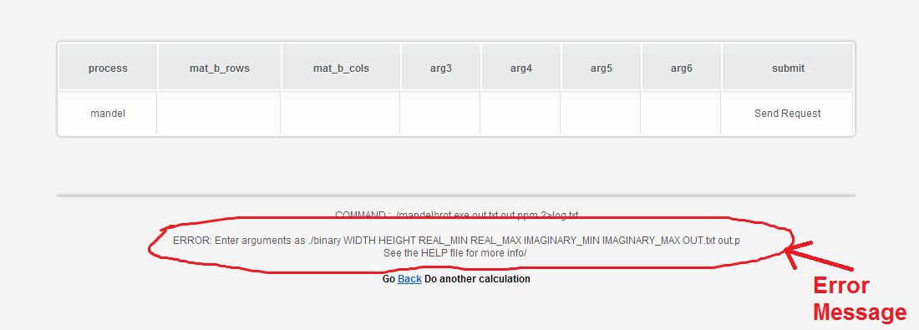

* What to do if I encountered with any unspecified errors, like Segmentation fault or some errors in results?
* Send a bug report to us to [hasindu2008@yahoo.com](mailto:hasindu2008@yahoo.com), with the name of task you used, the necessary input files and data’s.
* What if my output contain **Nan** or **inf** for any values?
* It is because, the numbers have exceeded the maximum floating point number supported in CUDA or division by 0 has occurred.
* If it is an inverse operation, double check whether the matrix is invertible.