Temperature Sensor

1. Connect data(middle) wire and Vcc via 10 K resistor.

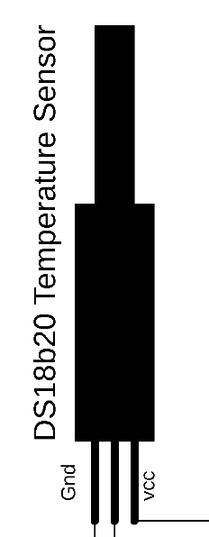

1. Connect data wire to PD2 in Arduino board and Vcc / GND appropriately.
2. Connect LCD display like in the diagram.

SDA to A4 and SDL to A5.

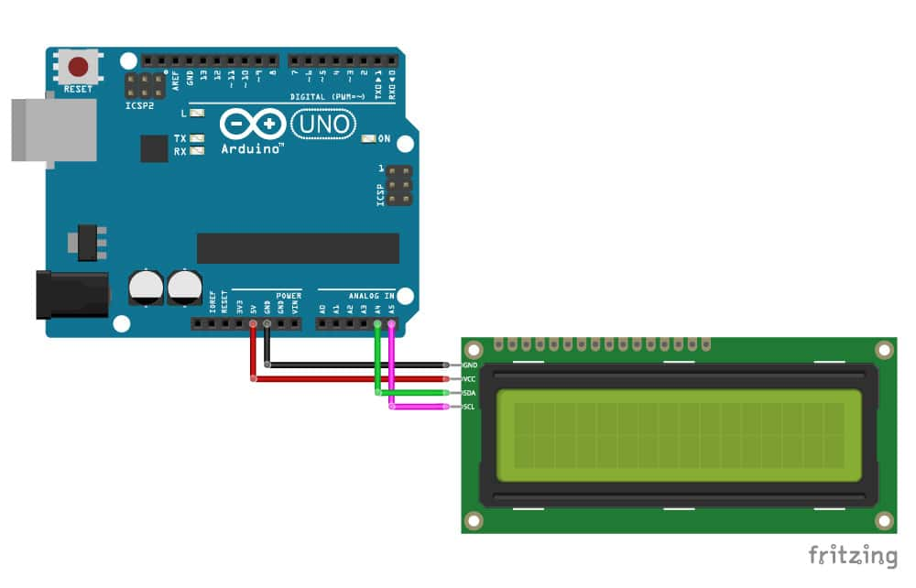

1. Test the sensor with different cases with

<OneWire.h>

<DallasTemperature.h> libraries

// Include the libraries we need

#include <OneWire.h>

#include <DallasTemperature.h>

// Data wire is plugged into port 2 on the Arduino

#define ONE_WIRE_BUS 2

// Setup a oneWire instance to communicate with any OneWire devices (not just Maxim/Dallas temperature ICs)

OneWire oneWire(ONE_WIRE_BUS);

// Pass our oneWire reference to Dallas Temperature.

DallasTemperature sensors(&oneWire);

// arrays to hold device address

DeviceAddress insideThermometer;

/*

* Setup function. Here we do the basics

*/

void setup(void)

{

// start serial port

Serial.begin(9600);

Serial.println("Dallas Temperature IC Control Library Demo");

// locate devices on the bus

Serial.print("Locating devices...");

sensors.begin();

Serial.print("Found ");

Serial.print(sensors.getDeviceCount(), DEC);

Serial.println(" devices.");

// report parasite power requirements

Serial.print("Parasite power is: ");

if (sensors.isParasitePowerMode()) Serial.println("ON");

else Serial.println("OFF");

// Assign address manually. The addresses below will beed to be changed

// to valid device addresses on your bus. Device address can be retrieved

// by using either oneWire.search(deviceAddress) or individually via

// sensors.getAddress(deviceAddress, index)

// Note that you will need to use your specific address here

//insideThermometer = { 0x28, 0x1D, 0x39, 0x31, 0x2, 0x0, 0x0, 0xF0 };

// Method 1:

// Search for devices on the bus and assign based on an index. Ideally,

// you would do this to initially discover addresses on the bus and then

// use those addresses and manually assign them (see above) once you know

// the devices on your bus (and assuming they don't change).

if (!sensors.getAddress(insideThermometer, 0)) Serial.println("Unable to find address for Device 0");

// method 2: search()

// search() looks for the next device. Returns 1 if a new address has been

// returned. A zero might mean that the bus is shorted, there are no devices,

// or you have already retrieved all of them. It might be a good idea to

// check the CRC to make sure you didn't get garbage. The order is

// deterministic. You will always get the same devices in the same order

//

// Must be called before search()

//oneWire.reset_search();

// assigns the first address found to insideThermometer

//if (!oneWire.search(insideThermometer)) Serial.println("Unable to find address for insideThermometer");

// show the addresses we found on the bus

Serial.print("Device 0 Address: ");

printAddress(insideThermometer);

Serial.println();

// set the resolution to 9 bit (Each Dallas/Maxim device is capable of several different resolutions)

sensors.setResolution(insideThermometer, 9);

Serial.print("Device 0 Resolution: ");

Serial.print(sensors.getResolution(insideThermometer), DEC);

Serial.println();

}

// function to print the temperature for a device

void printTemperature(DeviceAddress deviceAddress)

{

// method 1 - slower

//Serial.print("Temp C: ");

//Serial.print(sensors.getTempC(deviceAddress));

//Serial.print(" Temp F: ");

//Serial.print(sensors.getTempF(deviceAddress)); // Makes a second call to getTempC and then converts to Fahrenheit

// method 2 - faster

float tempC = sensors.getTempC(deviceAddress);

if(tempC == DEVICE_DISCONNECTED_C)

{

Serial.println("Error: Could not read temperature data");

return;

}

Serial.print("Temp C: ");

Serial.print(tempC);

Serial.print(" Temp F: ");

Serial.println(DallasTemperature::toFahrenheit(tempC)); // Converts tempC to Fahrenheit

}

/*

* Main function. It will request the tempC from the sensors and display on Serial.

*/

void loop(void)

{

// call sensors.requestTemperatures() to issue a global temperature

// request to all devices on the bus

Serial.print("Requesting temperatures...");

sensors.requestTemperatures(); // Send the command to get temperatures

Serial.println("DONE");

// It responds almost immediately. Let's print out the data

printTemperature(insideThermometer); // Use a simple function to print out the data

}

// function to print a device address

void printAddress(DeviceAddress deviceAddress)

{

for (uint8_t i = 0; i < 8; i++)

{

if (deviceAddress[i] < 16) Serial.print("0");

Serial.print(deviceAddress[i], HEX);

}

}

// https://github.com/milesburton/Arduino-Temperature-Control-Library

//LCD Display

// Include the libraries we need

#include <OneWire.h>

#include <DallasTemperature.h>

#include <Wire.h>

#include <LiquidCrystal_I2C.h>

LiquidCrystal_I2C lcd(0x27, 20, 4); //The LCD address and size. You can change according you yours

// Data wire is plugged into port 2 on the Arduino

#define ONE_WIRE_BUS 2 //pin for sensor

// Setup a oneWire instance to communicate with any OneWire devices (not just Maxim/Dallas temperature ICs)

OneWire oneWire(ONE_WIRE_BUS);

// Pass our oneWire reference to Dallas Temperature.

DallasTemperature sensors(&oneWire);

/*

The setup function. We only start the sensors here

*/

void setup(void)

{

// start serial port

Serial.begin(9600);

Serial.println("Dallas Temperature IC Control Library Demo");

// Start up the library

sensors.begin();

lcd.init();

// Print a message to the LCD.

lcd.backlight();

lcd.setCursor(0, 0);

lcd.print("DS18B20 TEST!");

lcd.setCursor(0, 1);

lcd.print("by miliohm.com");

delay(2000);

lcd.clear();

}

/*

Main function, get and show the temperature

*/

void loop(void)

{

// call sensors.requestTemperatures() to issue a global temperature

// request to all devices on the bus

Serial.print("Requesting temperatures...");

sensors.requestTemperatures(); // Send the command to get temperatures

Serial.println("DONE");

// After we got the temperatures, we can print them here.

// We use the function ByIndex, and as an example get the temperature from the first sensor only.

float tempC = sensors.getTempCByIndex(0);

// Check if reading was successful

if (tempC != DEVICE_DISCONNECTED_C)

{

Serial.print("Temperature for the device 1 (index 0) is: ");

Serial.println(tempC);

lcd.setCursor(0, 0);

lcd.print("Temperature:");

lcd.setCursor(0, 1);

lcd.print(tempC);

lcd.print((char)223);

lcd.print("C");

lcd.print(" | ");

lcd.print(DallasTemperature::toFahrenheit(tempC));

lcd.print(" F");

}

else

{

Serial.println("Error: Could not read temperature data");

}

}