**Smart Agricultural Monitoring System**

**3YP**

**Documentation**

**Software**

2025/02/20

* Flutter app has initialized.
* Connected it with the firebase project.
* Create some documents and collections in fire store.
* Some data has stored in it.
* Fire store has configured with the flutter app.
* Fetch data from the database to the ‘soilParameterDisplay’ screen.

**Project Folder Structure**

* Flutter code base is divided into multiple packages to have good maintainability and scalability.
* Here is a simple diagram that shows the code base structure.

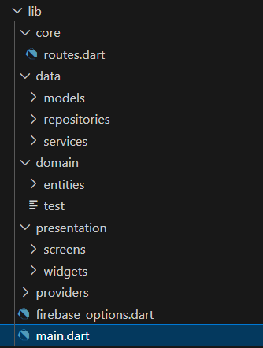

Common utilities like themes and configurations.

* Routing

Data sources are here.

* Data models
* Database connection
* Business logic (for Firebase)

Business logic and all the use cases

* This represents the data models as it is. (Same as in database.)

UI and Screens

* Individual Screens
* Reusable components like cards, buttons

Firebase Configurations

**..lib/domain/entities**

This represents Business logic, and it is independent of any data source (Fire Store)

This should be stable and rarely change.

Defines what data means in the context of business.

**..lib/data/models**

Contains data models. And they represent how data is structured when fetched from cloud fire store.

Contains database specific fields and the implementation of JSON serialization and deserialization. That means the conversion between the entities and raw data format.