AURA – Automated Urban Restaurant Assistant
An Intelligent Robotic Dining & Restaurant Management
Platform
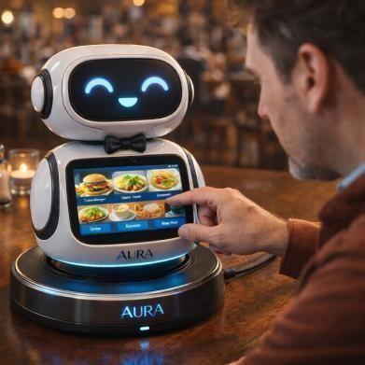

Overview
AURA is a smart robotic dining assistant and restaurant management platform designed to modernize dine-in food service by automating ordering, kitchen communication, billing, and customer interaction. The system integrates robotics, IoT communication, and a real-time software platform to reduce waiting time and improve restaurant efficiency.

In busy restaurants, customers often wait long periods to receive menus, place orders, re-order drinks, or request the bill. These manual workflows reduce customer satisfaction and place heavy pressure on service staff. AURA replaces these inefficient processes with an interactive robotic assistant that allows customers to manage their dining experience independently.

Problem
Urban cafés and restaurants commonly experience long waiting times for menus, difficulty finding waiters during peak hours, order mistakes due to manual note taking, billing delays, and staff shortages. These issues lead to poor service experience and lower restaurant productivity.

Solution
AURA provides a table-side robotic assistant equipped with a touchscreen interface. Customers can browse a visual menu, customize orders, place and re-order instantly, track preparation, pay using QR-based digital payment, and provide feedback. Orders are transmitted directly to the kitchen in real time, removing communication delays and human errors.

Key Innovative Features
- Interactive Human-Robot Interaction: Using touch sensors, the robot physically turns toward the customer who taps it, creating a natural and engaging interaction.
- Facial Expression Recognition: The robot’s camera observes customer facial expressions and reacts accordingly (e.g., offering help if confusion is detected or suggesting options when the customer appears undecided).
- Multilingual visual menu: English / Sinhala / Tamil
- Entertainment features including music and mini-games
- Automated birthday celebration mode
- Pre-booking table reservation with welcome experience

Restaurant Management System
Kitchen Dashboard: Displays incoming orders in real time for chefs.
Payment Dashboard: Tracks completed payments, pending bills, and transaction records. Central Monitoring Screen: Allows staff to view active tables, order status, and customer feedback in real time.

Customization
The robot can be customized to match the theme of a café or restaurant (modern café, kids’ restaurant, themed dining, or luxury hotel). This allows it to function both as a service assistant and a branding attraction.

Impact & Benefits
For Customers: Faster service, private dining, and better menu understanding.
For Restaurants: Reduced staff workload, fewer ordering errors, faster table turnover, improved customer satisfaction, and increased revenue through smart interaction and assistance.

Technology
Hardware: Raspberry Pi controller, touchscreen display, camera module, speakers, rechargeable battery.
Software: ReactJS frontend, Java Spring Boot backend (REST API), PostgreSQL database, MQTT communication protocol, and secure JWT authentication.

Security & Privacy
Encrypted payment communication, role-based system access, isolated café Wi-Fi network, and no storage of customer images or videos.

Conclusion
AURA transforms traditional restaurants into smart dining environments by integrating robotics with restaurant management software. By automating ordering, reservations, kitchen communication, and billing, the system enhances operational efficiency and customer experience, showing strong commercialization potential in the hospitality industry.

