Bill Ref. B01
Skytronic, Kohuwala | Date: 18/01/2026 | No: TRO 2765 | Amount: Rs. 7,650.00
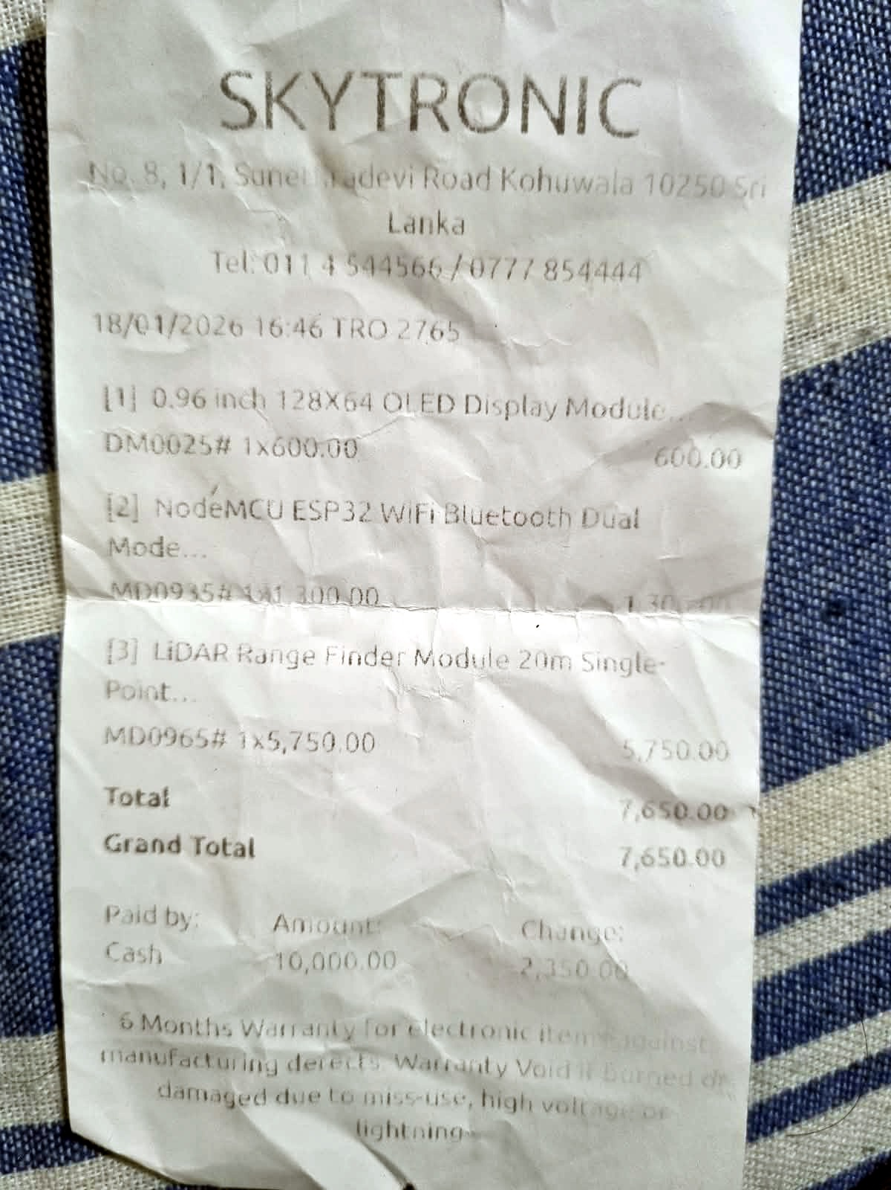
Bill Ref. B02
Skytronic, Kohuwala | Date: __/05/2026 | No: TRO 4940 | Amount: Rs. 10,360.00
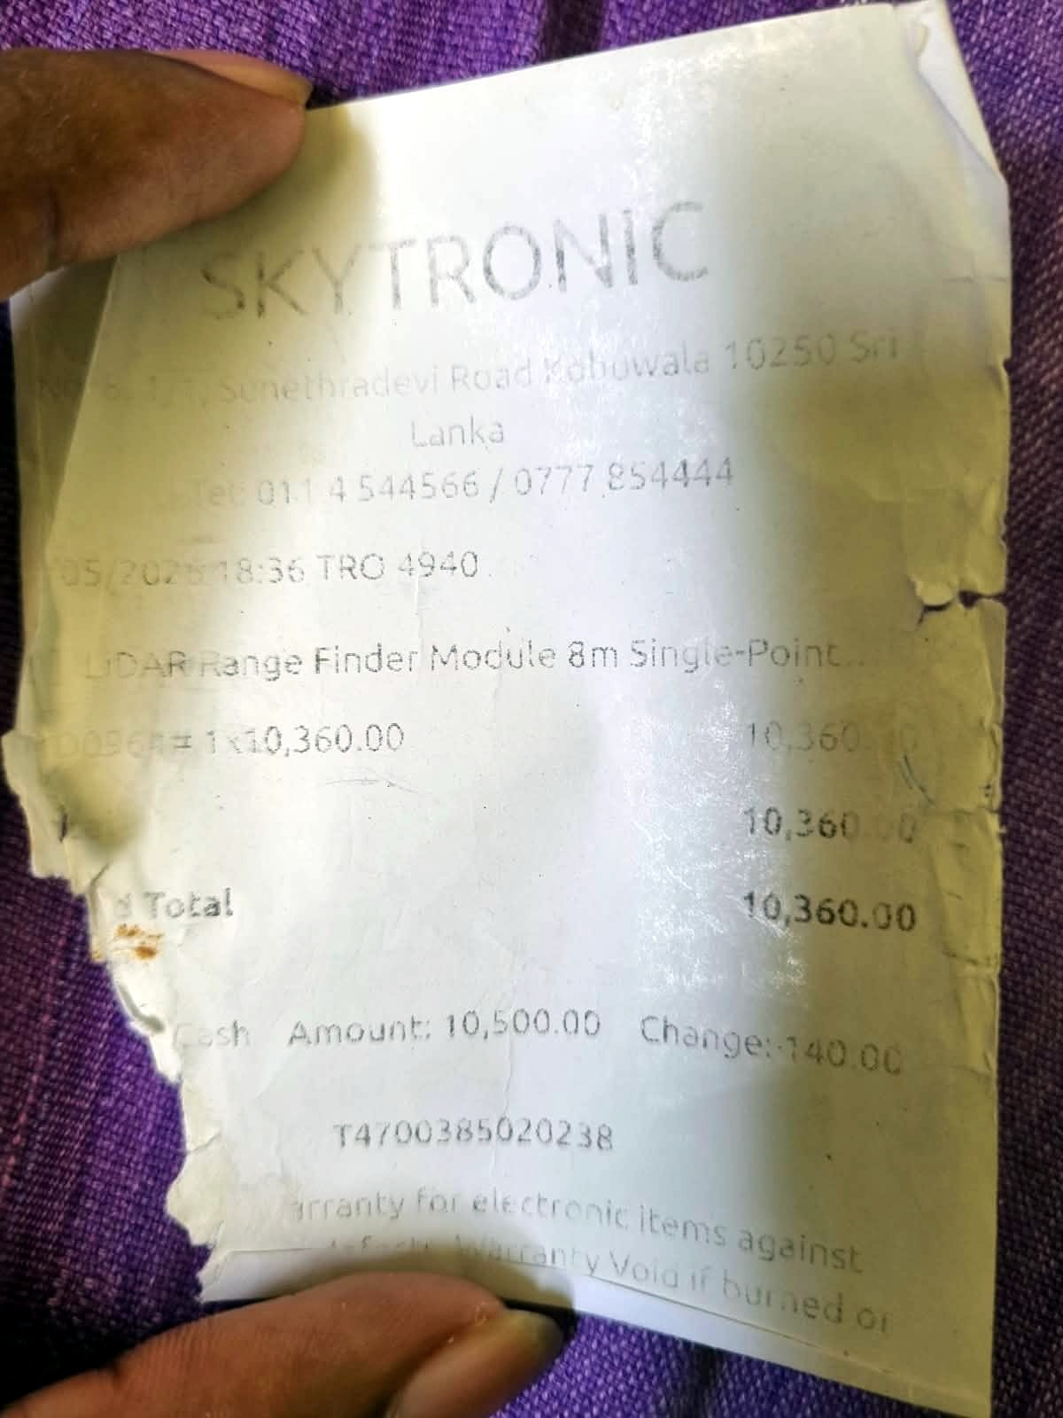
Bill Ref. B03
Alphatronic (Pvt) Ltd, Homagama | Date: 07/06/2026 | No: 26-200-007560 | Amount: Rs. 430.00
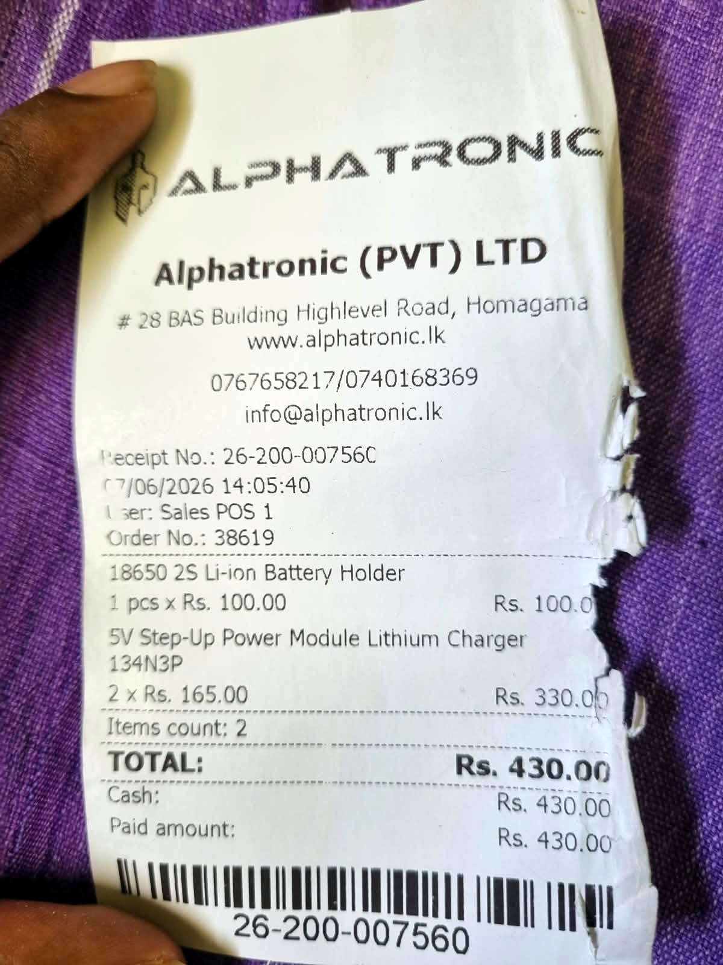
Bill Ref. B04
Skytronic, Kohuwala | Date: 10/06/2026 | No: TRO 2178 | Amount: Rs. 1,240.00
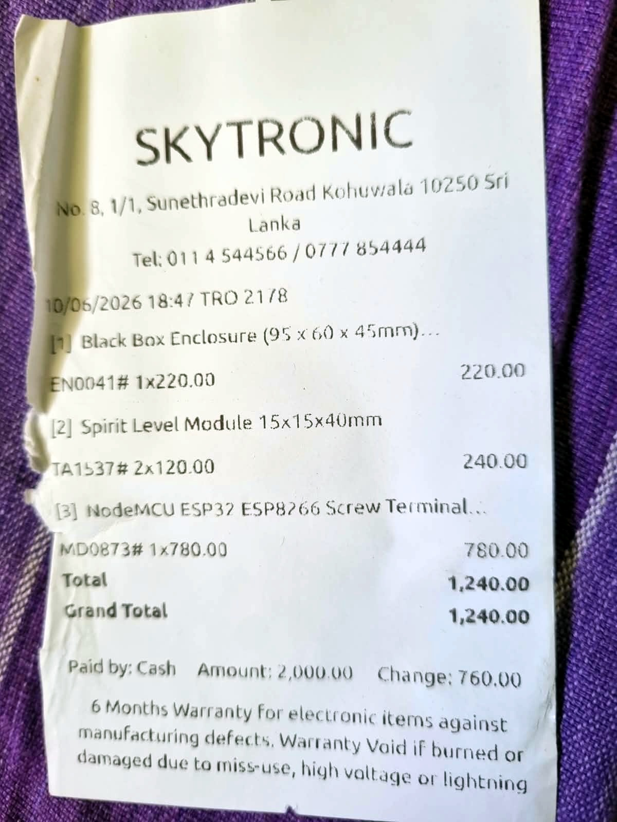
Bill Ref. B05
Skytronic, Kohuwala | Date: 11/06/2026 | No: TRO 2315 | Amount: Rs. 980.00
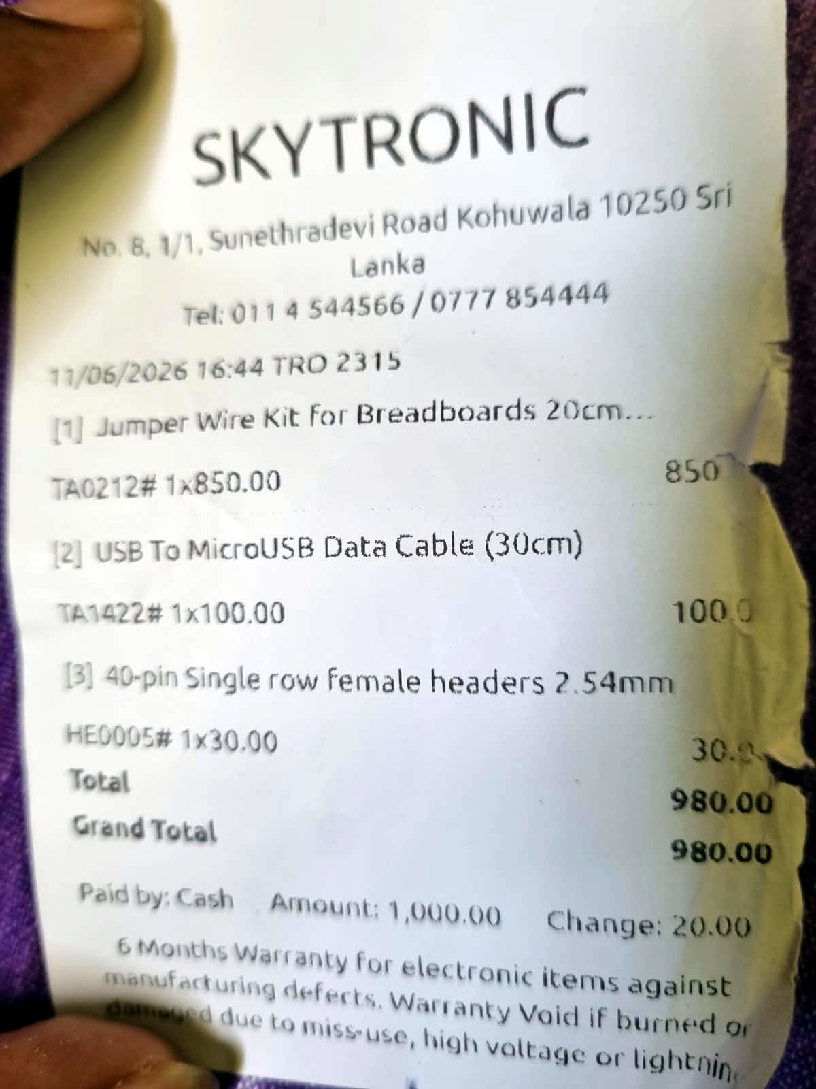
Bill Ref. B06
Duino Electronics, Kandy | Date: 14/06/2026 | No: SALE-1540 | Amount: Rs. 720.00
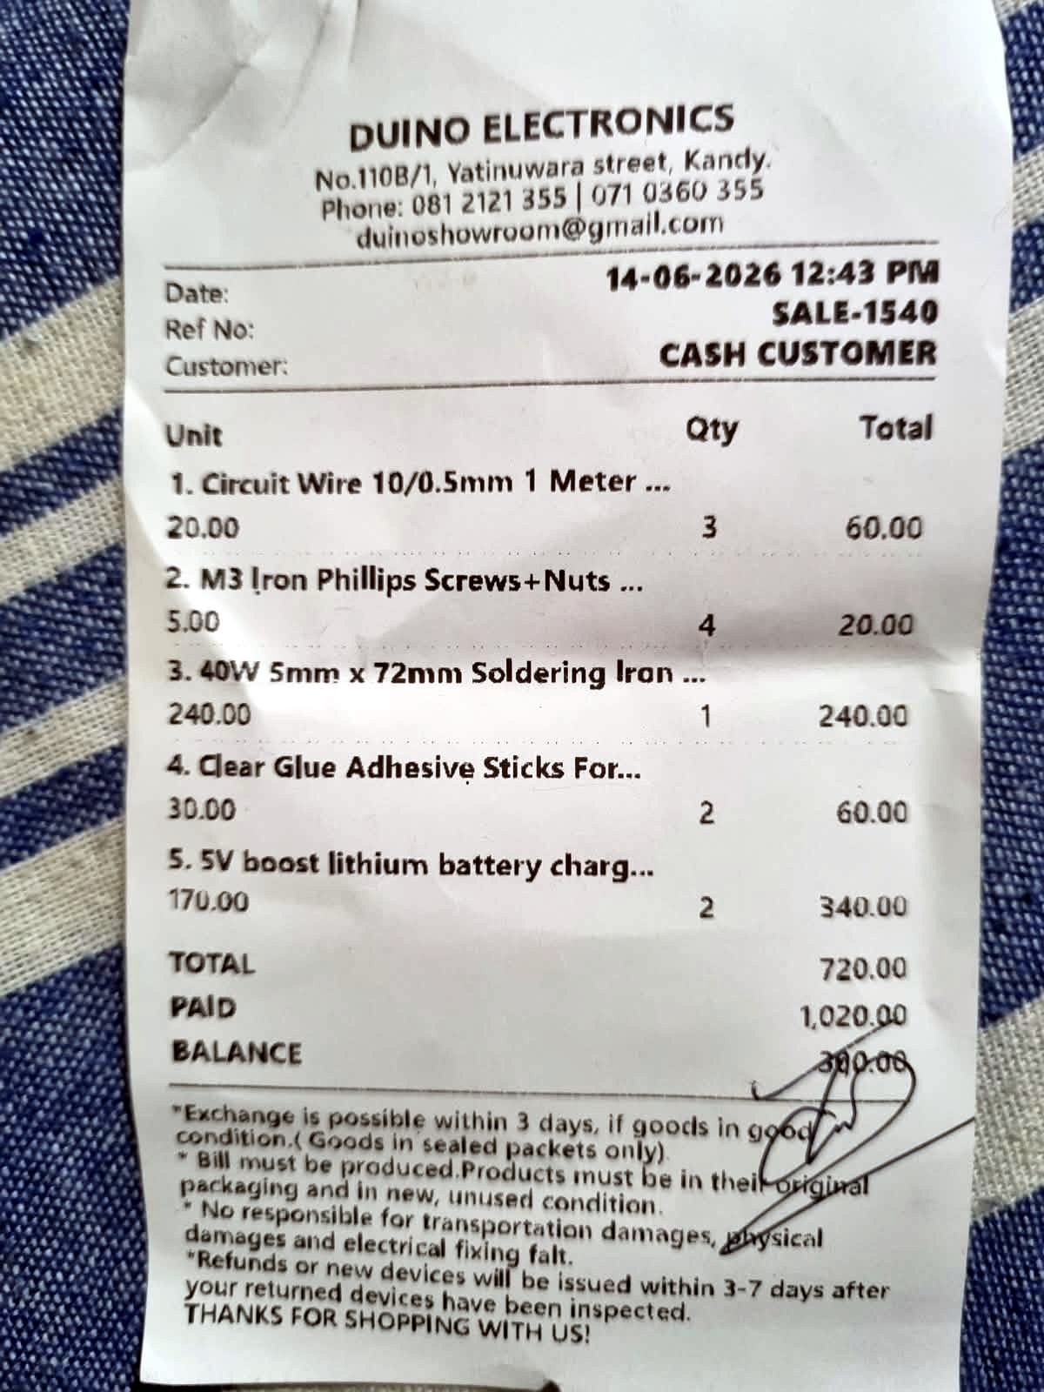
Bill Ref. B07
Duino Electronics, Kandy | Date: 28/07/2026 | No: SALE-4214 | Amount: Rs. 1,210.00
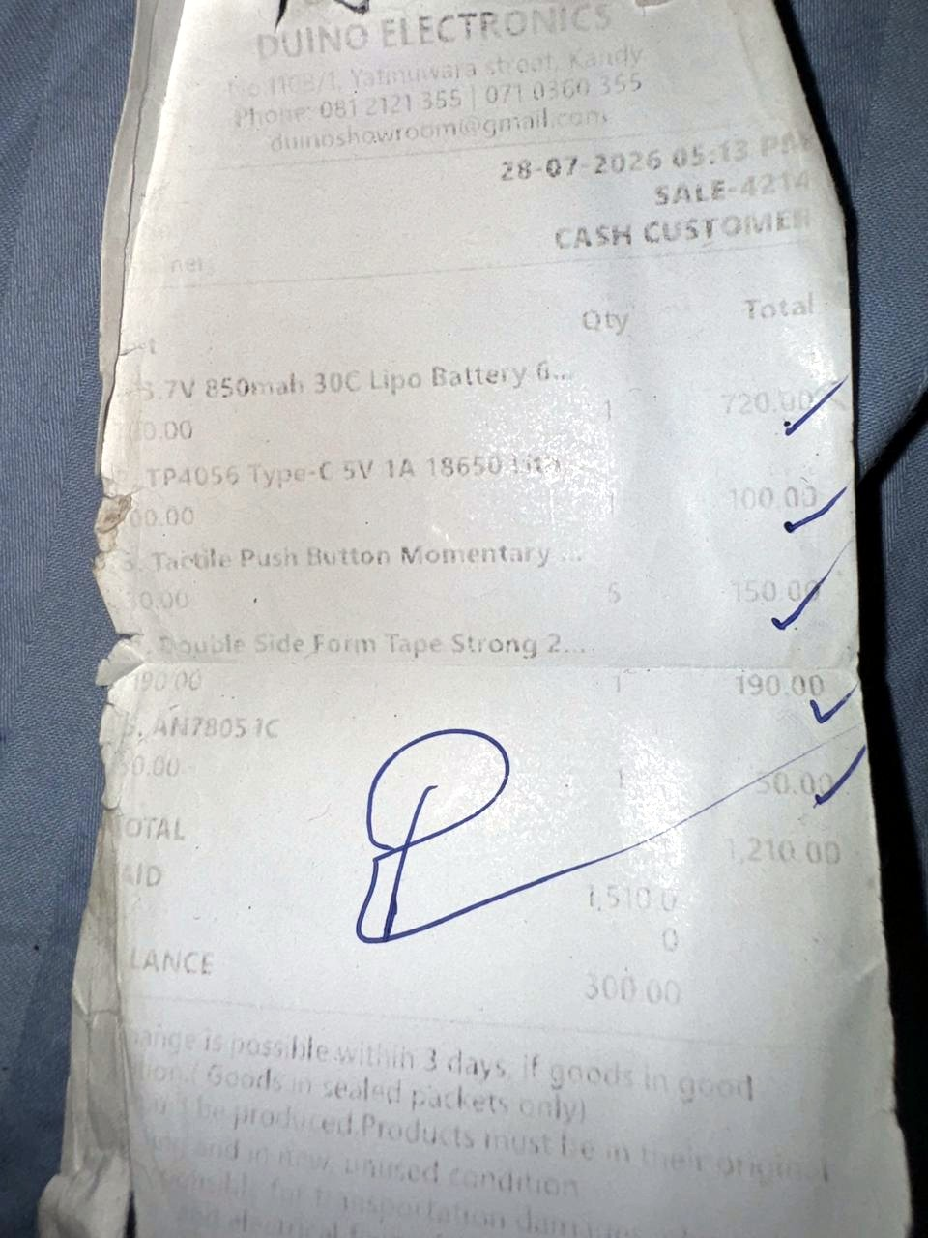
Bill Ref. B08
Duino Electronics, Kandy | Date: 28/07/2026 | No: SALE-____ (faded) | Amount: Rs. 500.00
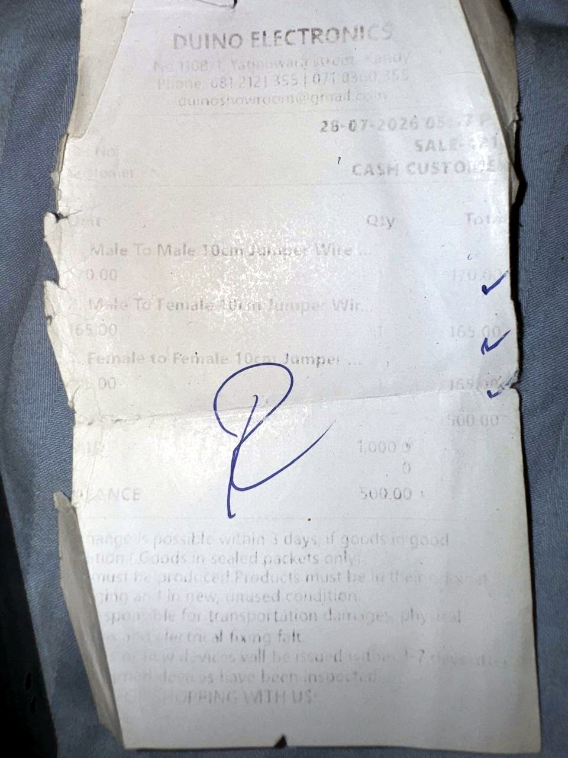
Bill Ref. B09
Lasertronics (Pvt) Ltd, Colombo 11 | Date: ____ (faded) | No: Inv. ____ (faded) | Amount: Rs. 750.00


