CO2060 Software Systems Design Project · Group e22
Testing Report
Debate Management System (VIVAATHI)
Final milestone · 25 September 2026
Git branch: Testing (based on main @ f344c79)

Measure | Result
Automated tests / API requests executed | 262
Backend line coverage (JaCoCo) | 86.9%
Frontend line coverage (Vitest, auth & routing modules) | 78.9%
Defects found by testing | 15 (3 high, 5 medium, 7 low)
Lighthouse performance score | 99–100

Contents
1. Summary 3
2. Test strategy 3
2.1 Scope 4
2.2 How results are judged 4
3. Tools and frameworks 4
4. Results by level 5
4.1 Backend unit tests (JUnit 5 + Mockito) 5
4.2 Backend integration and access-control tests 5
4.3 Frontend component tests (Vitest + React Testing Library) 6
4.4 API end-to-end tests (Postman / Newman) 6
4.5 Browser end-to-end tests (Playwright on Microsoft Edge) 6
4.6 Non-functional: Lighthouse audit (production build, desktop) 7
5. Code coverage 8
5.1 Backend (JaCoCo) 8
5.2 Frontend (Vitest, V8 coverage) 8
6. Test evidence 10
7. Defect log 13
7.1 Details and suggested fixes 13
7.2 Other observations 15
7.3 Bug resolution history 15
8. Manual testing 16
9. How to run the tests 16
10. Limitations and next steps 16

1. Summary
We tested the Debate Management System at four levels: backend unit tests, backend integration tests (including role-based access control), frontend component tests, and end-to-end tests through both the API (Postman) and a real browser (Playwright). We also ran a Lighthouse audit for performance and accessibility. Everything runs from the command line and produces a report file, listed in Section 9.
The tests check what the system should do, not what it currently does. When a test failed because of a real problem in the application, we kept the test as it was and recorded the problem as a defect. That is why some tests are shown as failing: each failure matches a defect in Section 7.
Level | Tool | Tests | Passed | Failed | Coverage
Backend unit | JUnit 5 + Mockito | 46 | 46 | 0 | 85.7% of service layer
Backend integration & RBAC | MockMvc + H2 | 70 | 55 | 15 | 86.9% overall (lines)
Frontend components | Vitest + RTL | 52 | 52 | 0 | 78.9% (lines)
API end-to-end | Postman / Newman | 69 requests / 197 checks | 181 | 16 | 44 of 67 endpoints
Browser end-to-end | Playwright (Edge) | 25 | 21 | 4 | Main user journeys

Main findings. Tournament creation, match scoring, results, leaderboards, statistics, connections, messaging and the multi-tab session handling all work end-to-end. Role checks do stop debaters and judges from performing organizer actions. Testing found 15 defects. The most important are: (1) users can edit other users' profiles and post comments under other people's names; (2) judges never see the organizer's custom score criteria, because the template endpoint fails; and (3) expired logins are never detected by the frontend, because the backend returns 403 instead of 401.

2. Test strategy
We followed the testing pyramid: many fast, isolated tests at the bottom and fewer, slower tests that exercise the whole system at the top.
Level | What it proves | Environment
Unit | Business rules in each service (scoring, winners, judge codes, connections, JWT) are correct in isolation | Mockito fakes, no database, ~2 s
Integration | Controllers, security filter, JPA and database work together; every organizer-only endpoint is protected | Full Spring Boot app, in-memory H2 (PostgreSQL mode)
Component | Login, sign-up, role selection, protected routes, session storage and API client behave correctly | jsdom, API mocked
API end-to-end | A realistic scenario across 44 of the 67 endpoints works against the real server and PostgreSQL | Backend jar on :8081, PostgreSQL database dms_test
Browser end-to-end | Real users can complete key journeys in the real UI | Vite frontend on :5174 + backend + dms_test, Microsoft Edge
Non-functional | Performance, accessibility, best practice, SEO | Production build, Lighthouse desktop preset

2.1 Scope
- In scope: authentication, roles (DEBATER, JUDGE, ORGANIZER), tournaments, matches, score sheets, results and statistics, connections, messages, diaries, calendar, news, notifications, search, newsletter.
- Test data: every run creates its own users with unique names, so results do not depend on leftover data. End-to-end runs use a separate PostgreSQL database (dms_test), never the development database.
- Out of scope: load testing, testing of the deployed Azure/Vercel environment, and real user-acceptance sessions. A manual test sheet for the team is provided instead (Section 8).

2.2 How results are judged
- Each test states the correct behavior, such as "a debater must get 403 Forbidden". A failing test becomes a defect entry. The test is not weakened to make it pass.
- Where the application blocks an action but answers with the wrong HTTP status code, the test records two things separately: whether the action is blocked (security) and whether the right status code is used (API correctness). This keeps working security separate from a cosmetic code problem.

3. Tools and frameworks
Tool | Used for | Why we chose it
JUnit 5 | Backend unit & integration test framework | Standard for Spring Boot; already included via spring-boot-starter-test
Mockito | Replaces repositories with fakes in unit tests | Tests business rules in isolation, in milliseconds
Spring MockMvc + spring-security-test | Calls real controllers through the real security filter chain | Verifies RBAC and HTTP status codes without starting a server
H2 (PostgreSQL mode) | In-memory database for integration tests | Fast, repeatable, never touches real data
JaCoCo | Backend code-coverage report | Shows which lines and branches the tests exercised
Vitest + React Testing Library | Frontend component & logic tests | Native to Vite; tests the UI the way a user sees it
@vitest/coverage-v8 | Frontend coverage report | Built into the Vitest toolchain
Postman + Newman | API end-to-end scenario, run from the command line | The collection can be opened in Postman for a live demo; Newman produces HTML/JUnit reports
Playwright (Microsoft Edge) | Browser end-to-end tests with screenshots and traces | Drives the real UI against the real backend and database
Google Lighthouse | Performance, accessibility, best-practice and SEO audit | Industry-standard non-functional quality scores
GitHub Actions | Runs the suites automatically on every push | Keeps tests running after the presentation

4. Results by level

4.1 Backend unit tests (JUnit 5 + Mockito)
Unit tests cover the business rules. All of them pass.
Test class | What is tested | Tests | Failed
JwtUtilTest | Token creation; rejection of expired, tampered, foreign-secret and garbage tokens | 5 | 0
AuthServiceTest | Sign-up per role (stats rows), duplicate username/e-mail, login by username/e-mail, wrong password, no user enumeration | 10 | 0
ScoreSheetServiceTest | Judge identity checks, double submission, winner by average score, tie rule, best-speaker vote, stats update, reopen | 8 | 0
TournamentAndMatchServiceTest | Tournament creation with schools/judges/template, duplicate debater, judge codes, match round numbers, next-round pairing | 10 | 0
SocialServicesTest | Connection states, blocking, diary likes/verify/delete permissions, leaderboard points | 13 | 0

4.2 Backend integration and access-control tests
These tests start the whole Spring Boot application with an in-memory database and call it over HTTP using real login tokens.
Test class | What is tested | Tests | Failed
AuthApiIntegrationTest | Sign-up/login API, /me, validation, newsletter | 8 | 1
RbacIntegrationTest | Organizer-only matrix, public vs private endpoints, forged and expired tokens, status codes | 47 | 5
TournamentWorkflowIntegrationTest | Full lifecycle: tournament → match → two judges score → winner, stats, leaderboard; social features; 404s | 7 | 2
OwnershipSecurityIntegrationTest | Acting on another user's profile, comments, notifications, tournament; e-mail exposure | 8 | 7

Role-based access control matrix. Each organizer-only endpoint was called by every role. All 28 combinations behave safely: only organizers get through. The footnotes mark where the status code is wrong (DEF-05, DEF-10).
Organizer-only endpoint | Organizer | Judge | Debater | No login
POST /api/tournaments | Allowed ✓ | Blocked ✓ ¹ | Blocked ✓ ¹ | Blocked ✓ ²
DELETE /api/tournaments/{id} | Allowed ✓ | Blocked ✓ ¹ | Blocked ✓ ¹ | Blocked ✓ ²
POST /api/tournaments/{id}/judges | Allowed ✓ | Blocked ✓ ¹ | Blocked ✓ ¹ | Blocked ✓ ²
POST /api/matches | Allowed ✓ | Blocked ✓ ¹ | Blocked ✓ ¹ | Blocked ✓ ²
POST /api/tournaments/{id}/generate-next-round | Allowed ✓ | Blocked ✓ ¹ | Blocked ✓ ¹ | Blocked ✓ ²
POST /api/score-templates | Allowed ✓ | Blocked ✓ ¹ | Blocked ✓ ¹ | Blocked ✓ ²
POST /api/score-sheets/{id}/reopen | Allowed ✓ | Blocked ✓ ¹ | Blocked ✓ ¹ | Blocked ✓ ²
¹ Returns 400 "Access Denied" instead of 403 (DEF-10). ² Returns 403 instead of 401 (DEF-05).

4.3 Frontend component tests (Vitest + React Testing Library)
Test file | What is tested | Tests | Failed
LoginPage.test.tsx | Empty form, server error message, redirect per role, password toggle | 7 | 0
SignupPage.test.tsx | Password mismatch/length, judge-only fields, successful sign-up, username taken, role selection | 8 | 0
App.test.tsx | Protected routes: 7 redirects for visitors, 5 wrong-role refusals, 5 allowed cases, unknown URLs | 18 | 0
AuthContext.test.tsx | Session restore, login/logout, corrupted storage, cross-tab user switch and logout warnings | 8 | 0
axios.test.ts | Bearer token attached; 401 clears session and redirects; 403 does not | 4 | 0
utils.test.tsx | Notification routing, avatar URLs, toast timeout | 7 | 0
All frontend tests pass. The project's only existing frontend test was broken (it looked for an old password placeholder after the UI redesign), so it was rewritten.

4.4 API end-to-end tests (Postman / Newman)
The collection runs 69 requests in order as one realistic scenario. The requests share state, such as tokens and ids, through environment variables. Every request also checks that it responds in under 2 seconds. The same collection can be opened in the Postman app for a live demo.
Folder | Requests | Checks | Failed checks
01 Health & public pages | 4 | 9 | 1
02 Authentication | 13 | 45 | 2
03 Role-based access control | 5 | 15 | 4
04 Tournament lifecycle | 21 | 65 | 4
05 Social features | 21 | 52 | 0
06 Ownership & privacy | 5 | 11 | 5
Result: 181 of 197 checks passed. All 16 failed checks correspond to defects already found by the backend tests, which confirms them against the real PostgreSQL database.

4.5 Browser end-to-end tests (Playwright on Microsoft Edge)
Spec | Test | Result
01-auth | organizer logs in through the UI and lands on their dashboard | Passed
01-auth | judge logs in through the UI and lands on their dashboard | Passed
01-auth | debaterA logs in through the UI and lands on their dashboard | Passed
01-auth | wrong password shows an error and stays on the login page | Passed
01-auth | new user can sign up and is taken to their dashboard | Passed
01-auth | logged-out visitor cannot open the organizer dashboard | Passed
01-auth | debater cannot open the create-tournament page | Passed
01-auth | user can log out from the navbar menu | Passed
02-session | logging in as another user in a second tab warns the first tab | Passed
02-session | logging out in a second tab tells the first tab the session ended | Passed
02-session | an expired token sends the user back to login | Failed
03-tournament | organizer creates a tournament with the 6-step wizard | Passed
03-tournament | a visitor can find the new tournament with search | Passed
03-tournament | judge opens the score sheet for an assigned match | Passed
03-tournament | judge submits the score sheet | Passed
03-tournament | match result appears on the tournament page | Passed
04-public | / loads without errors | Passed
04-public | /news loads without errors | Passed
04-public | /about loads without errors | Passed
04-public | /scoring loads without errors | Passed
04-public | search finds seeded debaters | Passed
04-public | home page loads live matches for visitors without API errors | Failed
04-public | layout works on a phone-sized screen | Passed
05-score-sheet | score sheet shows the organizer's custom criteria | Failed
05-score-sheet | after submitting, reopening the sheet shows "already submitted" | Failed
21 of 25 browser tests pass. The 4 failures show defects DEF-03, DEF-04, DEF-05 and DEF-11 from a real user's point of view. Screenshots and traces are saved for every test.

4.6 Non-functional: Lighthouse audit (production build, desktop)
Page | Performance | Accessibility | Best practices | SEO | LCP
Home / | 99 | 94 | 96 | 83 | 0.9 s
Login /login | 100 | 81 | 100 | 83 | 0.7 s
News /news | 99 | 94 | 100 | 83 | 0.9 s
Role select /role-select | 99 | 94 | 100 | 83 | 0.8 s
Performance is excellent on every page. The accessibility and SEO points lost are listed as DEF-15. The home page's best-practice deduction is the console error caused by DEF-11.

5. Code coverage

5.1 Backend (JaCoCo)
Package | Line coverage | Branch coverage
com.dms.service | 85.7% | 77.1%
com.dms.controller | 65.4% | 56.3%
com.dms.security | 100% | 70%
com.dms.dto | 99.4% | 73.3%
com.dms.entity | 100% | n/a
com.dms.exception | 72.7% | 60%
com.dms.config | 100% | n/a
Total | 86.9% | 74.2%
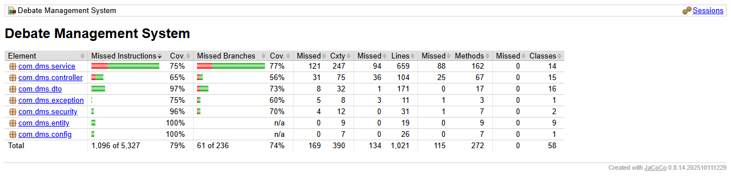
Figure 1. JaCoCo coverage report for the backend (reports/backend/jacoco/index.html)

5.2 Frontend (Vitest, V8 coverage)
Coverage was measured on the modules containing logic: the API client, the auth context, route protection, the auth pages, utilities, the toast and the session modal. Lines 78.9%, statements 76.11%, branches 74.37%, functions 73.97%. Page layouts and dashboards are covered by the Playwright tests instead.
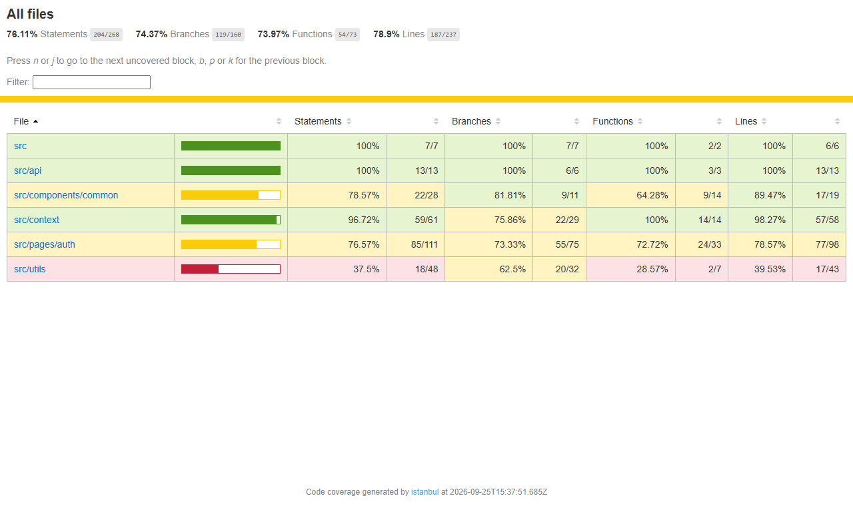
Figure 2. Frontend coverage report (reports/frontend/coverage/index.html)

6. Test evidence
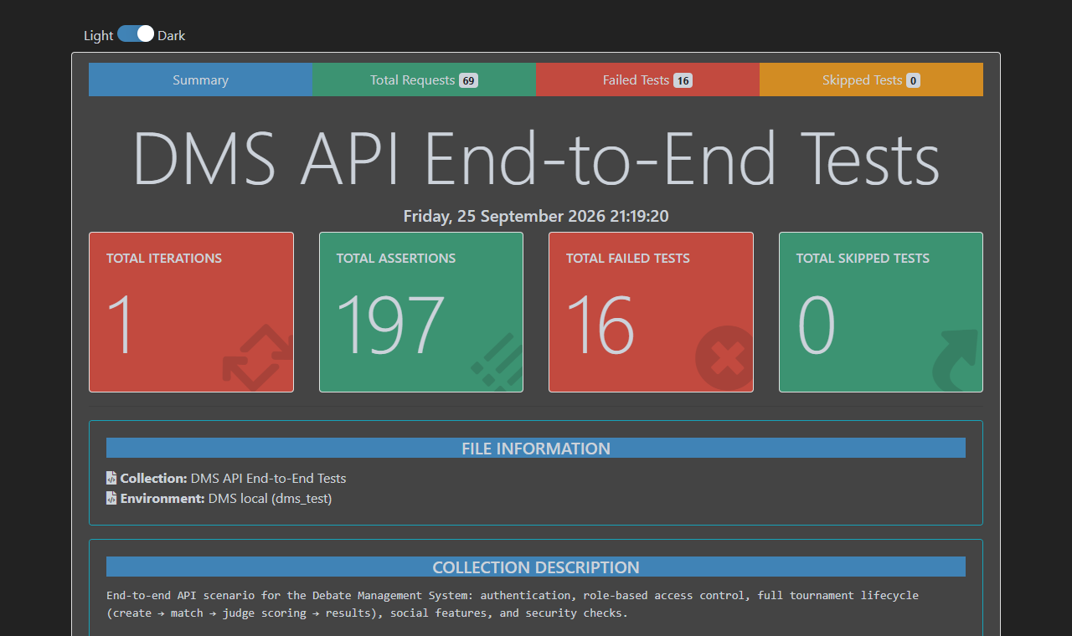
Figure 3. Newman HTML report for the Postman API run
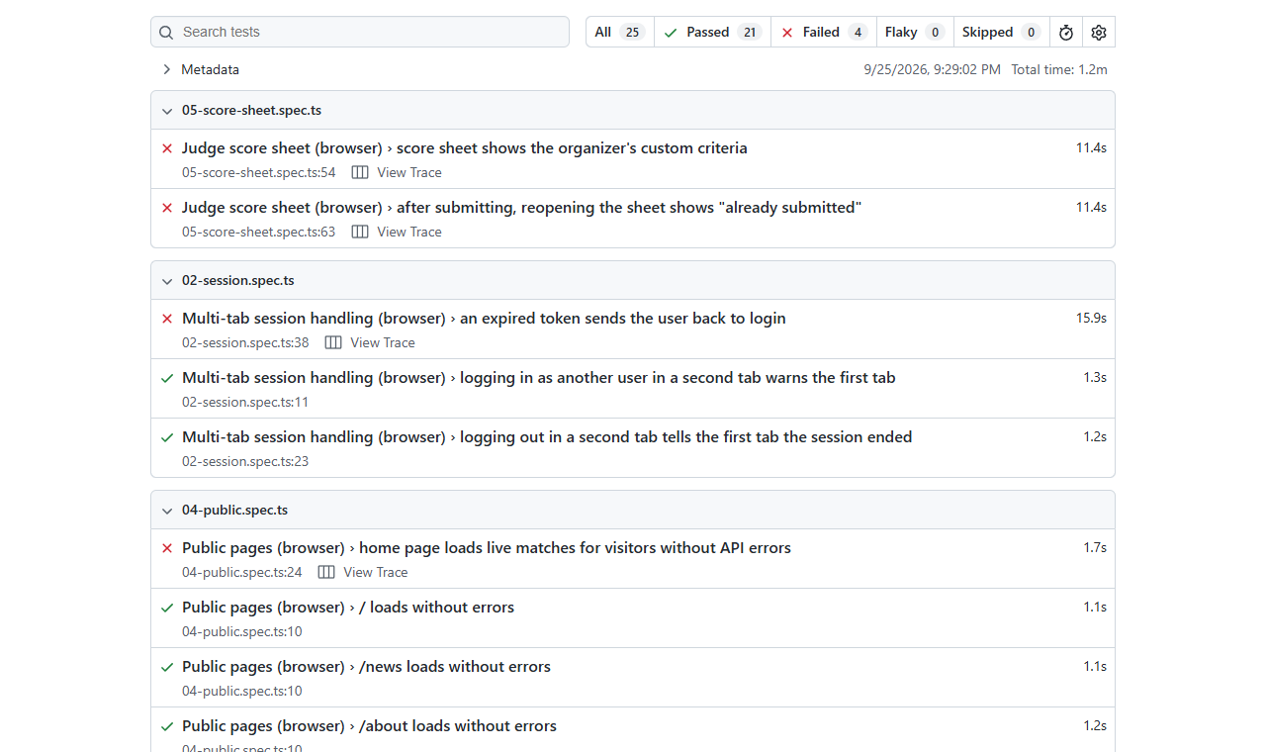
Figure 4. Playwright HTML report (failures listed first)
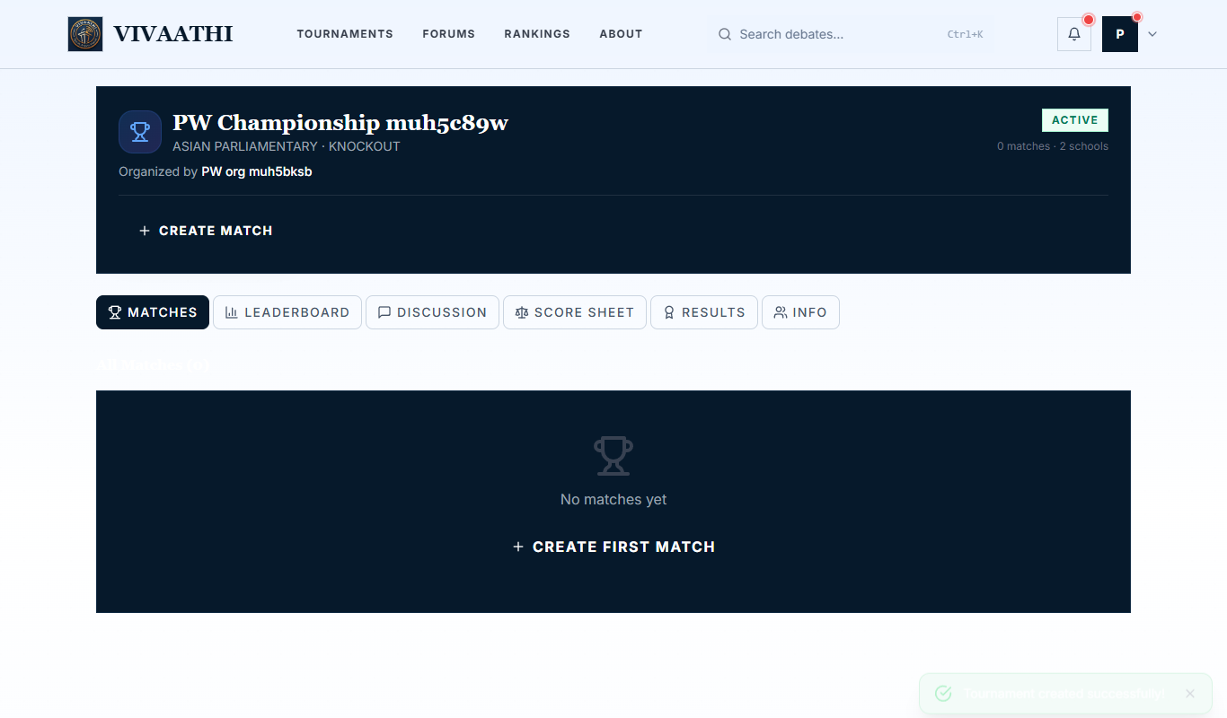
Figure 5. Playwright: tournament created through the 6-step wizard (passing test)
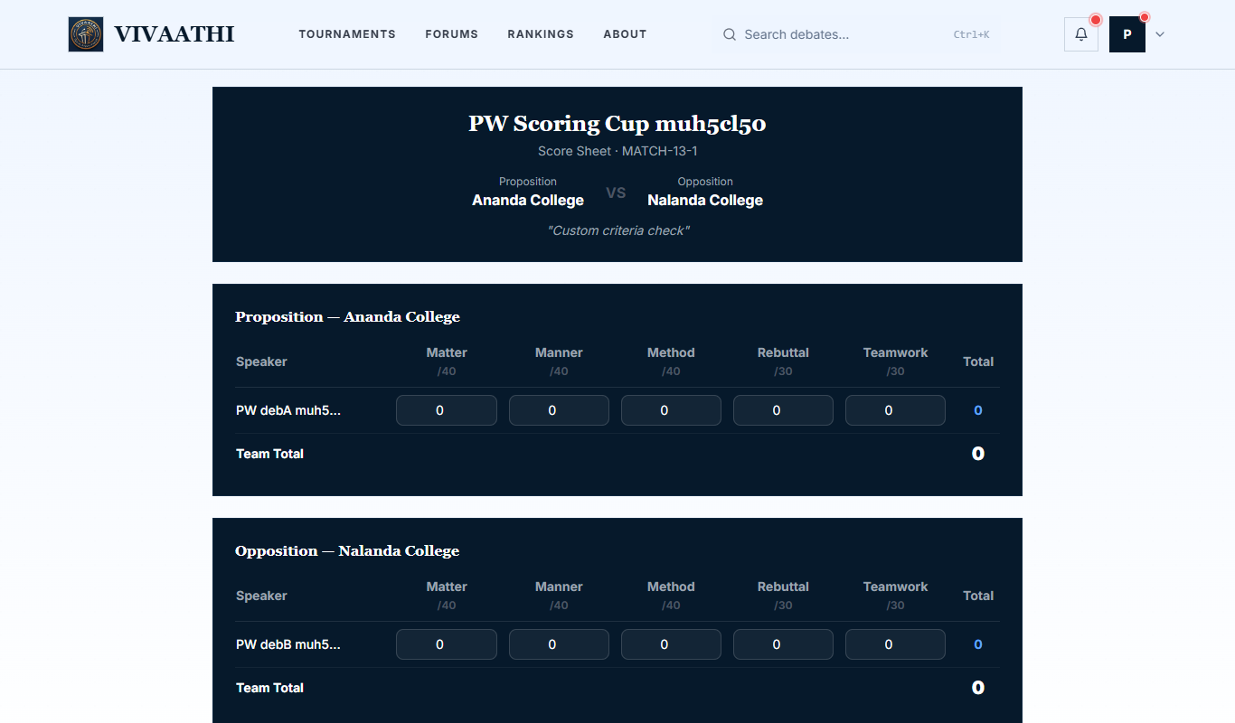
Figure 6. Playwright evidence for DEF-03: the organizer set "Persuasion" and "Evidence", but the judge sees the built-in criteria

Figure 7. Multi-tab conflict warning works (passing test). Its low-contrast styling is DEF-14
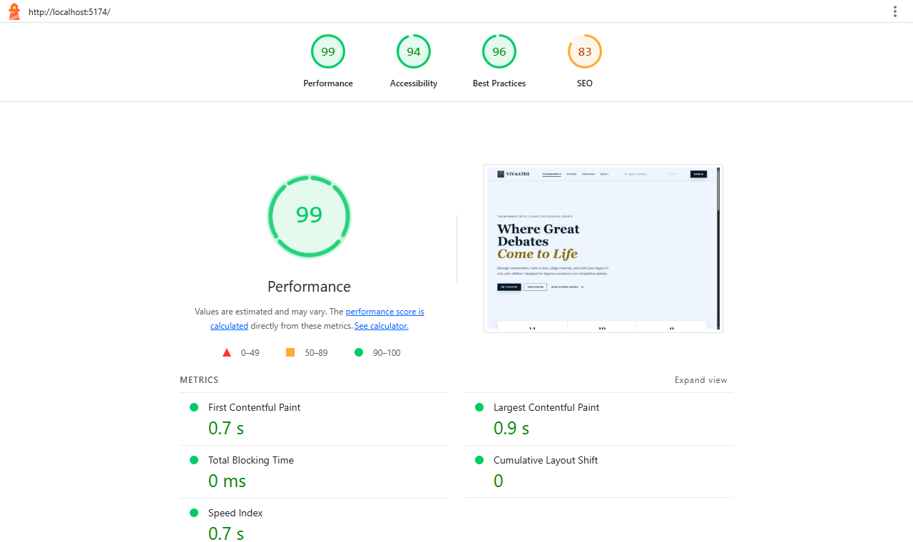
Figure 8. Lighthouse report for the home page

7. Defect log
Testing found 15 defects. None has been fixed yet, because this work only adds tests and does not change application code. Each entry says which test found it and suggests a fix. The same list is in the Excel workbook (sheet "Defect Log") with Status and Assigned-to columns for tracking.
ID | Sev. | Defect | Found by
DEF-01 | High | Any logged-in user can edit another user's profile | JUnit OwnershipSecurity · Postman 06
DEF-02 | High | Discussion comments can be posted under someone else's name | JUnit OwnershipSecurity · Postman 06
DEF-03 | High | Judge's score sheet ignores the organizer's custom criteria | JUnit Workflow · Postman 04 · Playwright 05
DEF-04 | Medium | "Already submitted" check on the score sheet never works | JUnit Workflow · Postman 04 · Playwright 05
DEF-05 | Medium | Expired or invalid login returns 403 instead of 401, so users are never logged out | JUnit RBAC · Postman 03 · Playwright 02
DEF-06 | Medium | An organizer can delete another organizer's tournament | JUnit OwnershipSecurity
DEF-07 | Medium | Any logged-in user can delete anyone's discussion comment | JUnit OwnershipSecurity · Postman 06
DEF-08 | Medium | Public user list exposes every e-mail address | JUnit OwnershipSecurity · Postman 06
DEF-09 | Low | Users can mark other users' notifications as read | JUnit OwnershipSecurity · Postman 06
DEF-10 | Low | Role-denied requests return 400 instead of 403 | JUnit RBAC · Postman 03/04
DEF-11 | Low | Home page always shows 0 live matches to visitors | JUnit RBAC · Postman 01 · Playwright 04 · Lighthouse
DEF-12 | Low | /api/auth/me without a token returns 400 (server error) instead of 401 | JUnit RBAC · Postman 02
DEF-13 | Low | Sign-up accepts invalid e-mail addresses | JUnit Auth · Postman 02
DEF-14 | Low | Session warning modal text is hard to read | Playwright screenshot review
DEF-15 | Low | Login page accessibility issues | Lighthouse

7.1 Details and suggested fixes
DEF-01 (High, Security): Any logged-in user can edit another user's profile
PUT /api/users/{id} updates whichever id is in the URL; there is no check that it belongs to the caller. Debater A changed Debater B's bio (the profile-picture upload endpoint follows the same pattern).
Suggested fix: Compare the id with the authenticated user (or allow organizers only) before updating.
DEF-02 (High, Security): Discussion comments can be posted under someone else's name
POST /api/discussion takes the author from the "userId" field in the request body instead of the login token.
Suggested fix: Ignore userId in the body; use the authenticated user.
DEF-03 (High, Functional): Judge's score sheet ignores the organizer's custom criteria
GET /api/score-templates/{id} fails with "Type definition error ... ByteBuddyInterceptor" (a raw JPA entity with a lazy proxy is returned). The page swallows the error and silently falls back to built-in criteria.
Suggested fix: Return a DTO (id, name, criteriaJson) instead of the entity.
DEF-04 (Medium, Functional): "Already submitted" check on the score sheet never works
GET /api/score-sheets/{match}/{judge} fails with the same serialization error, so a judge who already submitted sees an empty form again; re-submitting is then rejected by the server.
Suggested fix: Return a DTO for ScoreSheetSubmission.
DEF-05 (Medium, Security / UX): Expired or invalid login returns 403 instead of 401, so users are never logged out
Spring Security has no authentication entry point configured, so missing/expired tokens get 403. The frontend only logs out on 401, so an expired session leaves the user on a page where every request fails.
Suggested fix: Add .exceptionHandling(e -> e.authenticationEntryPoint(new HttpStatusEntryPoint(HttpStatus.UNAUTHORIZED))).
DEF-06 (Medium, Security): An organizer can delete another organizer's tournament
DELETE /api/tournaments/{id} checks the ORGANIZER role but not ownership.
Suggested fix: Allow delete only when tournament.organizer is the caller.
DEF-07 (Medium, Security): Any logged-in user can delete anyone's discussion comment
DELETE /api/discussion/{id} has no ownership check.
Suggested fix: Allow only the author (or the tournament organizer).
DEF-08 (Medium, Privacy): Public user list exposes every e-mail address
GET /api/users is public and returns each user's e-mail to anonymous visitors.
Suggested fix: Use a public profile DTO without e-mail, or require login.
DEF-09 (Low, Security): Users can mark other users' notifications as read
PUT /api/notifications/{id}/read receives the username but never checks it.
Suggested fix: Check notification.user == caller.
DEF-10 (Low, API): Role-denied requests return 400 instead of 403
GlobalExceptionHandler catches RuntimeException, which includes Spring's AccessDeniedException, and turns "Access Denied" into 400. Access is still correctly blocked.
Suggested fix: Add an @ExceptionHandler(AccessDeniedException.class) returning 403.
DEF-11 (Low, Functional): Home page always shows 0 live matches to visitors
The public home page calls GET /api/matches/live, which is not in the public list in SecurityConfig, so visitors get 403 (also logged as a console error by Lighthouse).
Suggested fix: Permit GET /api/matches/** for everyone.
DEF-12 (Low, API): /api/auth/me without a token returns 400 (server error) instead of 401
/api/auth/** is fully public, so the controller runs with no Authentication and throws a NullPointerException.
Suggested fix: Permit only /api/auth/login and /signup; require auth for /me.
DEF-13 (Low, Validation): Sign-up accepts invalid e-mail addresses
SignupRequest has no validation annotations, so "not-an-email" is stored.
Suggested fix: Add @Valid with @Email/@NotBlank/@Size on SignupRequest.
DEF-14 (Low, UI): Session warning modal text is hard to read
SessionChangedModal still uses the old dark-theme classes (glass-dark, text-white), so after the UI refresh the title and message are white on a light panel.
Suggested fix: Restyle the modal with the new theme colors.
DEF-15 (Low, Accessibility): Login page accessibility issues
The show/hide password button has no accessible name; some text fails color-contrast; pages have no <main> landmark or meta description.
Suggested fix: Add aria-label to icon buttons, a <main> element and a meta description.

7.2 Other observations
- The default JWT secret and a database password are committed in application.properties. Anyone who reads the repository could forge login tokens if production ever runs with the default secret. Set JWT_SECRET and DB_PASSWORD only as environment variables.
- The home page lists the first 6 tournaments (oldest first), so new tournaments disappear from it as the list grows.
- Generating the next knockout round silently drops a winner when there is an odd number of winners.
- The one existing frontend test (LoginPage.test.tsx) had been broken since the UI redesign changed the password placeholder. It was rewritten as part of this work.

7.3 Bug resolution history
Bugs fixed during development, taken from the project's git history. The last column shows which new test now protects each fix against regression.
Commit | Date | Author | Problem fixed | Now covered by
c045431 | 2026-09-21 | Pathi-02 | Multiple log-ins in one browser conflicted | Regression-tested: AuthContext.test.tsx and Playwright 02 (passing)
c0a3d93 | 2026-09-21 | Pathi-02 | No warning when session ended in another tab | Regression-tested: AuthContext.test.tsx and Playwright 02 (passing)
eebd145 | 2026-09-22 | Pathi-02 | Notification bugs | Notification flow covered by JUnit Workflow and Postman 04/05
dec7edb | 2026-07-10 | Jeyanth3 | Tournament creation issue | Wizard covered by Playwright 03 (passing)
b1a77ed | 2026-07-09 | Jeyanth3 | Submit button issue | Score submission covered by Playwright 03 (passing)
9d3ff79 | 2026-07-09 | Jeyanth3 | Profile issue | Profile update covered by JUnit OwnershipSecurity
e7c7f7e | 2026-05-02 | Jeyanth3 | Organizer and judge dashboard issue | Dashboard access covered by App.test.tsx and Playwright 01
980dcf4 | 2026-05-02 | Jeyanth3 | Viewer-side dashboard and notification access | Covered by App.test.tsx route rules
87645b6 | 2026-05-02 | Jeyanth3 | Debater search menu UI bug | Debater search used in Playwright 03 wizard (passing)
c655b0d | 2026-05-01 | Jeyanth3 | Login issue | Covered by LoginPage.test.tsx and Playwright 01 (passing)
e18de01 | 2026-06-13 | Jeyanth3 | TypeScript build errors for Vercel | Build check: vite build succeeds

8. Manual testing
The workbook DMS_Test_Workbook.xlsx contains 40 manual test cases covering every module. Each has preconditions, steps, the expected result, a Status dropdown (Pass / Fail / Blocked / Not run), tester and date columns, and a note on which automated test covers the same behavior. Team members should run these in the browser before the presentation and fill in the results; any failure goes in the Defect Log sheet.

9. How to run the tests
Suite | Command (from repository root) | Report
Backend unit + integration | cd backend && mvn test | backend/target/site/jacoco/index.html
Frontend | cd frontend && npx vitest run --coverage | frontend/test-results/coverage/index.html
API end-to-end | cd testing && npm run api (backend on :8081 with DB_NAME=dms_test) | testing/reports/newman/api-report.html
Browser end-to-end | cd testing && npx playwright test | testing/reports/playwright/html/index.html
Regenerate this report | cd testing && node report/collect.js && node report/build-docx.js | testing/reports/DMS_Testing_Report.docx
A GitHub Actions workflow (.github/workflows/tests.yml) runs the backend, frontend and Postman suites on every push. It will show red until the defects above are fixed, which is intended: the pipeline turns green as fixes land.

10. Limitations and next steps
- Fix the three high-severity defects first (DEF-01, DEF-02, DEF-03). Then re-run all suites; the matching tests will turn green.
- Coverage is lower in controllers (65%) because several read-only endpoints are exercised only by the Postman run, which JaCoCo does not measure.
- Load and stress testing (for example with k6 or JMeter) and testing against the deployed Azure/Vercel environment were not done.
- Real user-acceptance testing with debaters, judges and organizers is still recommended.

