
MPhil/PhD Lifecycle
Management System
USER GUIDE
Department of Computer Engineering
Faculty of Engineering
University of Peradeniya
Document version 1.0
Application version 0.1.0
25 September 2026

Organization: Department of Computer Engineering, Faculty of Engineering, University of Peradeniya
Document version: 1.0
Application version: 0.1.0
Publication date: 25 September 2026
Document status: Draft for operational verification
Intended audience: Applicants, Students, Supervisors, Examiners, the PG Coordinator, and the Head of Department

Document control
Item | Value
Document title | MPhil/PhD Lifecycle Management System User Guide
System | Postgraduate Student Management System (PGSMS)
Document version | 1.0
Application version | 0.1.0
Publication date | 25 September 2026
Document owner | Needs verification
Status | Draft for operational verification

Table of contents
Document control 1
1. About this guide 6
1.1 Purpose 6
1.2 Scope 6
1.3 Conventions 6
2. System overview 6
3. User roles and permissions 7
4. Prerequisites and access 8
4.1 Public applicants 8
4.2 Authenticated users 9
Part I - Tutorials 10
5. Follow the application-to-admission journey 10
5.1 Submit the public application 10
5.2 Complete Department review 10
5.3 Complete a requested revision 11
6. Learn the authenticated workspace 11
6.1 Sign in 11
6.2 Navigate the workspace 12
Part II - How-to guides 13
7. Complete public and common tasks 13
7.1 Submit an application 13
7.2 Sign in and sign out 13
7.3 Review notifications 14
8. Complete Student tasks 14
8.1 Submit or revise a research proposal 14
8.2 Submit an ethics declaration 14
8.3 Submit a progress milestone 15
8.4 Request thesis readiness 15
8.5 Submit a thesis 16
8.6 Submit ordered thesis corrections 16
8.7 Find and download a document 16
9. Complete Supervisor tasks 17
9.1 Record proposed-Supervisor consent 17
9.2 Review assigned Students 17
9.3 Evaluate an authenticated Student proposal 17
9.4 Recommend or return an ethics declaration 17
9.5 Approve or return a progress report 18
9.6 Certify or return thesis readiness 18
9.7 Certify or return corrections 18
10. Complete Examiner tasks 19
10.1 Review an assigned application proposal 19
10.2 Submit an independent thesis report 19
10.3 Submit a viva recommendation 19
10.4 Review required corrections 20
11. Complete PG Coordinator tasks 20
11.1 Start application review and assign an Examiner 20
11.2 Execute an approved admission 20
11.3 Manage user accounts 21
11.4 Record Department ethics status 21
11.5 Assign Supervisors and propose Examiners 21
11.6 Schedule or reschedule a viva 21
11.7 Monitor progress and reports 22
11.8 Execute completion, graduation, and archive 22
11.9 Review notification delivery and recover failures 22
12. Complete HOD tasks 23
12.1 Decide an application 23
12.2 Confirm, return, or reject ethics status 23
12.3 Approve or return thesis readiness 23
12.4 Confirm or decline an Examiner assignment 24
12.5 Record the final viva outcome 24
12.6 Issue and close corrections 24
12.7 Approve academic completion 25
Part III - Reference 26
13. Navigation reference 26
14. Application field reference 26
15. Programme and milestone reference 27
16. Status reference 27
16.1 Application and admission 27
16.2 Progress 28
16.3 Thesis readiness and thesis 28
16.4 Viva and corrections 28
16.5 Completion 28
17. Document and upload reference 28
18. Notifications and messages 29
Part IV - Explanations 30
19. Understand the lifecycle 30
20. Understand permissions and academic authority 30
21. Understand versions and evidence 30
22. Troubleshooting 30
22.1 Sign-in fails 30
22.2 A workspace or candidate is missing 31
22.3 An application cannot proceed to HOD decision 31
22.4 A file upload fails 31
22.5 Thesis submission is locked 31
22.6 A thesis is missing from Schedule Vivas 32
22.7 Viva recommendation is blocked 32
22.8 HOD outcome is locked 32
22.9 Completion is blocked 32
23. Frequently asked questions 32
Can an Administrator approve an application or viva outcome? 32
Can an Examiner open every Student record? 33
Can a Student change milestone dates? 33
Does submitting a revision delete the previous version? 33
Does an Examiner recommendation become the final viva outcome? 33
Is graduation the same as completion? 33
24. Security, privacy, and responsible use 33
25. Accessibility guidance 33
26. Glossary 34
27. Revision history 35

1. About this guide

1.1 Purpose
This guide explains how to use PGSMS across the Department-owned MPhil and PhD lifecycle. It covers public applications, admission, authenticated role workspaces, progress milestones, ethics, thesis examination, corrections, completion, graduation, and archive.

1.2 Scope
PGSMS supports MPhil and PhD programmes in full-time and part-time study modes. It does not manage fees, leave, extensions, programme transfers, withdrawals, readmission, registration renewal, annual review panels, Faculty Board, Senate, or multi-department processes.

1.3 Conventions
- Bold text identifies a visible interface label.
- Code-style text identifies a status or system value.
- A Note provides useful context.
- A Caution identifies an action that can cause a recoverable problem.
- A Warning identifies a privacy, security, data-loss, or irreversible decision risk.
- Screenshot placeholders identify authenticated screens that require capture in a protected demonstration environment.

2. System overview
PGSMS is a role-based academic workflow system. It keeps applications, submissions, assignments, decisions, documents, notifications, and lifecycle status in one auditable platform.
The public landing page provides access to applications and sign-in, as shown in Figure 1.
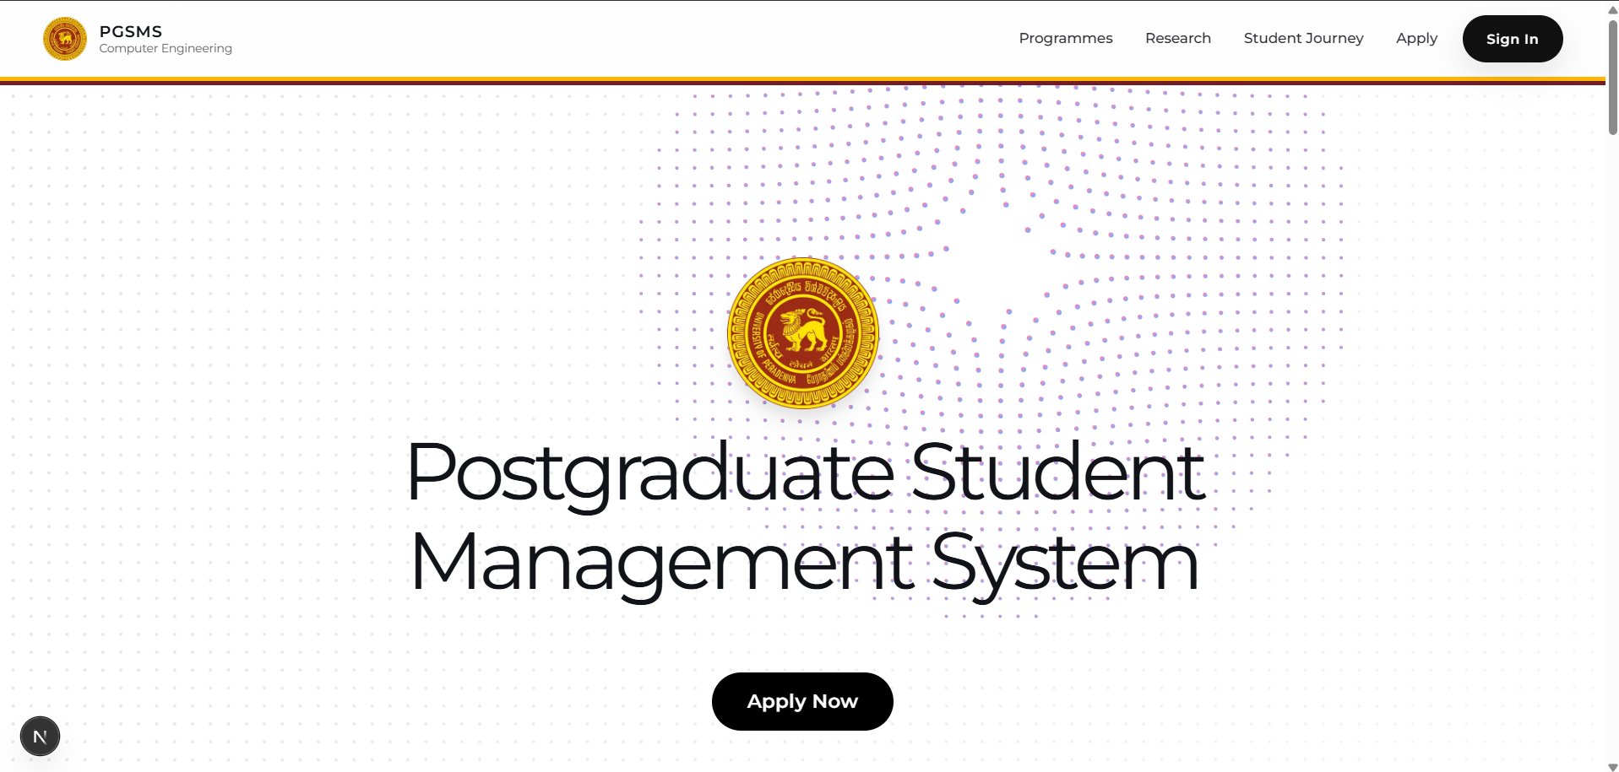
Figure 1: PGSMS public landing page
The implemented lifecycle is:
- A public applicant submits an application and proposal evidence.
- The PG Coordinator begins review.
- The proposed Supervisor records consent or decline.
- The PG Coordinator assigns at least one Examiner to the current proposal version.
- Every assigned Examiner completes an independent review.
- The HOD approves, requests revision, or rejects the application.
- The PG Coordinator executes an approved admission.
- The Student completes proposal, ethics, and fixed progress work.
- The Student requests thesis readiness; the primary Supervisor certifies it and the HOD approves examination readiness.
- The Student submits a verified thesis version.
- The PG Coordinator proposes Examiners and the HOD confirms assignments.
- Confirmed Examiners submit independent reports and viva recommendations.
- The PG Coordinator schedules the viva and the HOD records the final outcome.
- If corrections are required, the Student submits a new correction version for the required reviews and HOD closure.
- The HOD approves academic completion.
- The PG Coordinator executes completion, records externally confirmed graduation, and later archives the lifecycle record.

3. User roles and permissions
Table 1: User roles and principal responsibilities
Role | Principal responsibilities | Important restriction
Public applicant | Prepare and submit an application; respond to a protected revision request | Does not receive an authenticated Student workspace until admission is executed
Student | Submit proposals, ethics information, progress reports, a thesis, and ordered corrections; monitor released status | Cannot change programme, study mode, enrolment date, milestone labels, or milestone dates
Supervisor | Record proposed-Supervisor consent; monitor assigned Students; review ethics, progress, readiness, and corrections | Cannot access unassigned candidates
Examiner | Review an exactly assigned proposal or thesis version; submit independent evidence and recommendations | Role membership alone does not grant candidate access; one Examiner cannot see another Examiner's confidential draft
Administrator / PG Coordinator | Operate applications, accounts, assignments, schedules, records, reports, completion, notifications, and archive | Cannot manufacture HOD academic approval
Head of Department (HOD) | Make Department academic decisions for admission, ethics, examination, viva outcomes, corrections, and completion | Does not perform routine operational account or scheduling work

Warning: Decisions shown as HOD actions are academic decisions. Do not share an HOD account or ask the PG Coordinator to perform an HOD-only action.

4. Prerequisites and access

4.1 Public applicants
Prepare:
- A working email address and telephone number.
- The intended programme and study mode.
- A research area, proposal title, abstract, and statement of purpose.
- A proposed Supervisor selected from the available list.
- At least one supporting PDF or ZIP file.
Each public-application attachment must be 10 MB or smaller. A submission may contain up to 10 attachments.

4.2 Authenticated users
You need:
- An active institutional account provisioned in PGSMS.
- The email address associated with that account.
- Your account password.
- An active role matching the workspace you need.
- A modern browser with cookies and JavaScript enabled.
Note: Examiner and Supervisor access also depends on an active assignment. Having the role alone does not expose every candidate.

Part I - Tutorials

5. Follow the application-to-admission journey
What you will learn: How an application moves from public submission to an admitted Student record.
Participants: Applicant, proposed Supervisor, Examiner, PG Coordinator, and HOD.
Prerequisites: The PG Coordinator, proposed Supervisor, Examiner, and HOD must have active accounts.

5.1 Submit the public application
- Open the public landing page.
- Select Apply Now.
- Complete the four application steps: Applicant, Research, Documents, and Review.
- Confirm that the information is correct.
- Select Submit application.
- Wait for the success page before closing the browser.
The first application step is shown in Figure 2.
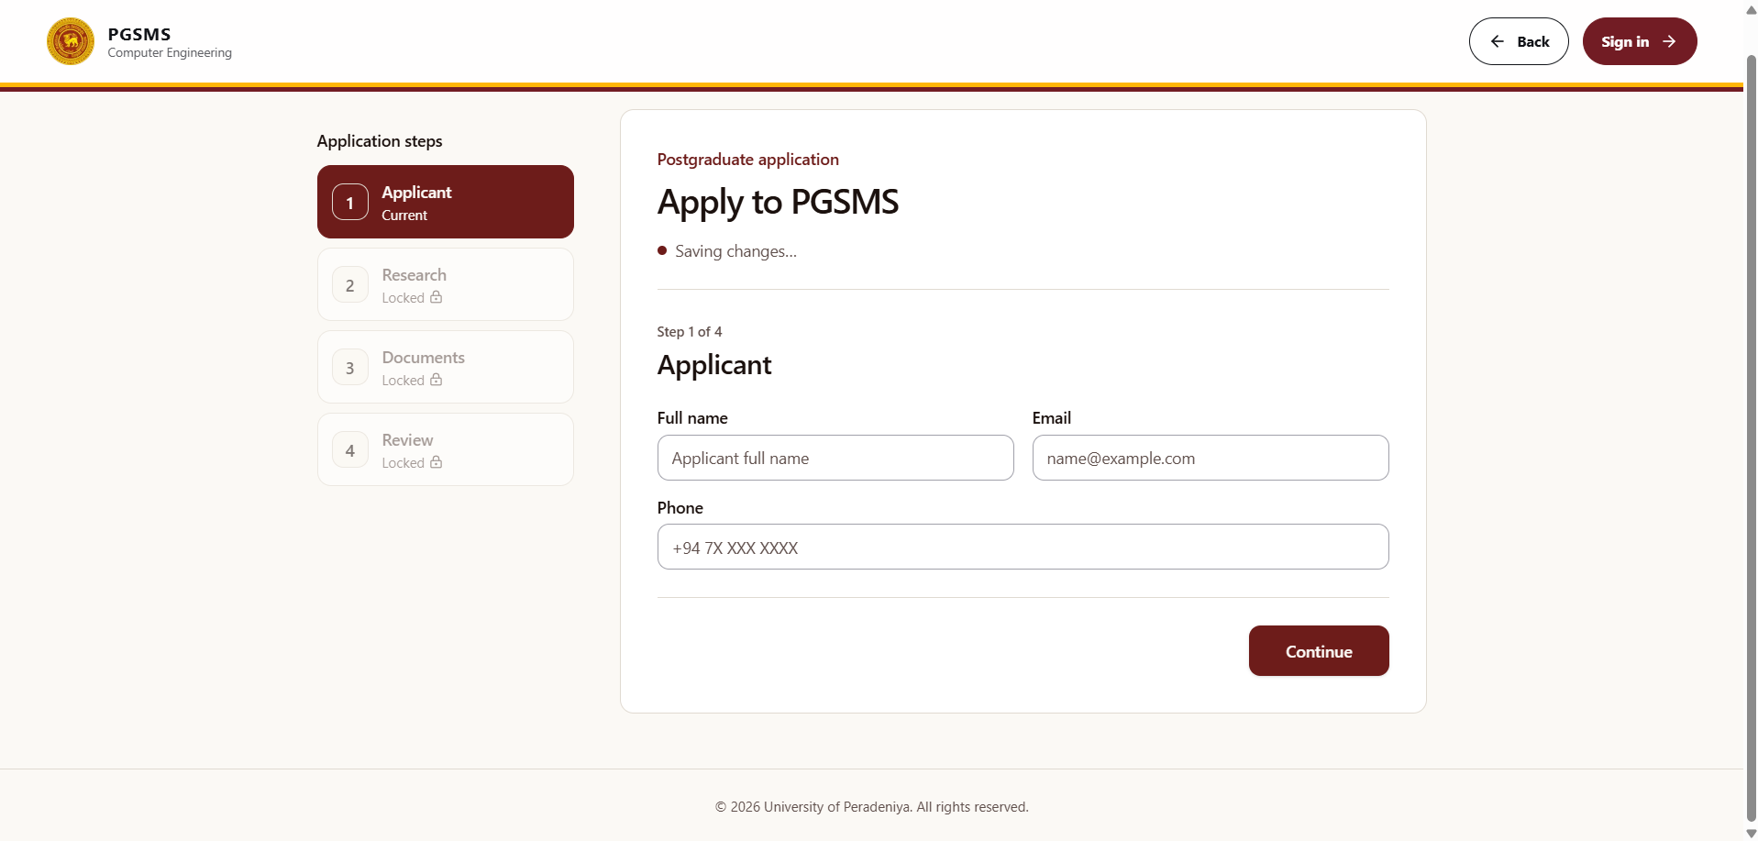
Figure 2: Public application form at the Applicant step

5.2 Complete Department review
- The PG Coordinator opens Applications and starts the review.
- The named proposed Supervisor opens Application Work and records Consent or Decline.
- After consent, the PG Coordinator assigns an active Examiner to the current proposal version.
- The assigned Examiner opens Assigned Proposals, selects a decision, enters independent comments, and selects Submit independent review.
- After all assigned current-version reviews are complete, the HOD opens Admission Decisions.
- The HOD records Approve, Request revision, or Reject, with a reason.
- If approved, the PG Coordinator executes admission.
Result: Admission creates the Student account, registration, fixed milestone schedule, Supervisor assignment, audit records, and notification intents.
Caution: The HOD decision remains unavailable until proposed-Supervisor consent and every required current-version Examiner review are complete.

5.3 Complete a requested revision
If the HOD requests a proposal revision, the applicant receives a protected, time-limited revision link.
- Open the protected link from the Department message.
- Confirm that the application and revision request are yours.
- Replace the requested proposal information and documents.
- Submit the new version.
- Wait for the Department to complete review of the new version.
Result: The new proposal becomes the current version, and review assignments are bound to that exact version.

6. Learn the authenticated workspace
What you will learn: How to sign in, use the dashboard shell, read notifications, and sign out.
Applicable roles: Student, Supervisor, Examiner, PG Coordinator, and HOD.
Prerequisite: An active account.

6.1 Sign in
- Open the PGSMS landing page.
- Select Sign In.
- Enter your institutional Email and Password.
- Select Sign in.
- Confirm that your role-specific Overview page opens.
The sign-in page is shown in Figure 3.
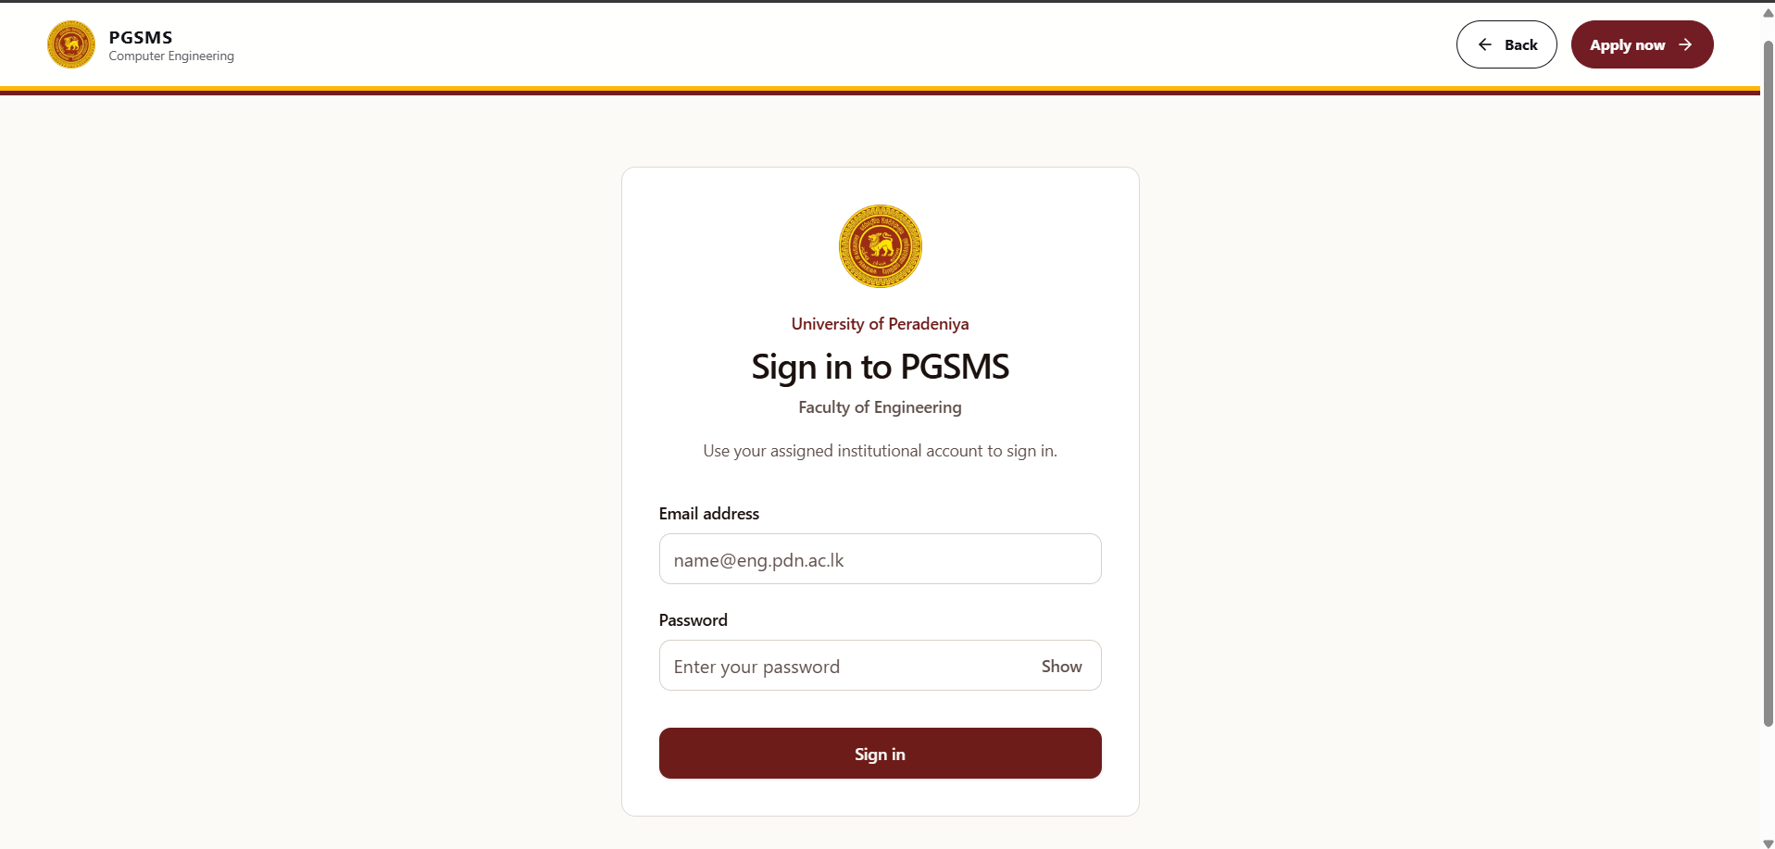
Figure 3: PGSMS sign-in page
Caution: If another person's workspace appears, select Sign Out immediately and notify the system administrator.

6.2 Navigate the workspace
- Use Overview to review status cards and quick actions.
- Use the Workspace navigation items to open role-specific functions.
- Select Notifications to review new workflow messages.
- Use the profile menu to review your displayed identity and role.
- Select Sign Out when you finish.
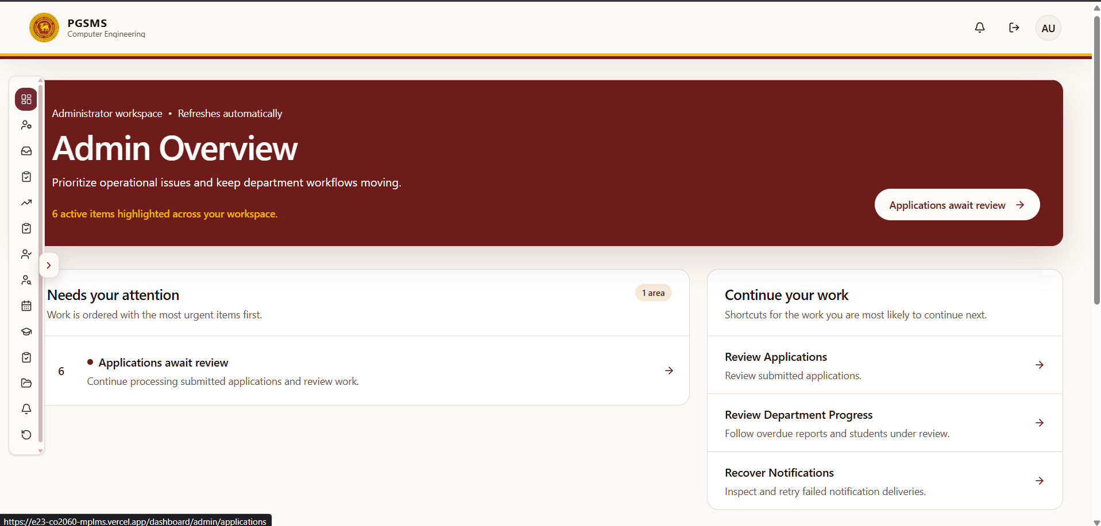
Figure 4: Admin dashboard

Part II - How-to guides

7. Complete public and common tasks

7.1 Submit an application
Role: Public applicant
Prerequisites: Application information and at least one PDF or ZIP supporting document.
- Select Apply Now on the public landing page.
- In Applicant, enter Full name, Email, and Phone.
- Select Continue.
- In Research, select Programme and Study mode.
- Enter Research area, select Proposed supervisor, and enter Proposal title, Proposal abstract, and Statement of purpose.
- Select Continue.
- In Documents, select the file input and upload 1 to 10 PDF or ZIP files. Ensure each file is 10 MB or smaller.
- Select Continue.
- In Review, verify every value and attached filename.
- Select the confirmation checkbox.
- Select Submit application.
Expected result: The application success page appears and the application enters SUBMITTED status.
*Common errors:*
- A name shorter than three characters is rejected.
- A telephone number must contain 7 to 15 digits and may use spaces, hyphens, parentheses, and a leading plus sign.
- The proposal title must contain at least five characters.
- The proposal abstract must contain at least 20 characters.
- A proposed Supervisor and at least one document are required.

7.2 Sign in and sign out
Role: Any authenticated role
Prerequisite: Active account credentials.
- Open Sign In from the landing page.
- Enter Email and Password.
- Select Sign in.
- Complete your work.
- Select Sign Out from the workspace navigation.
Expected result: Your authenticated session ends and protected pages are no longer available.

7.3 Review notifications
Role: Any authenticated role
- Select Notifications in the workspace sidebar.
- Read unread items and follow a permitted destination when an action link is available.
- Return to your workspace after reviewing the message.
Expected result: You understand the action or status change that requires attention.
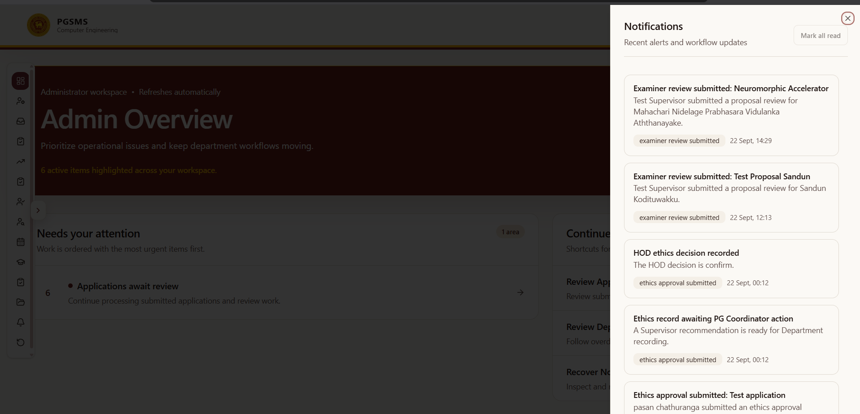
Figure 5: Notification panel

8. Complete Student tasks

8.1 Submit or revise a research proposal
Role: Student
Prerequisites: Active registration and a proposal submission state that permits a new version.
- Open Proposals.
- Enter Proposal Title and Abstract.
- Under Document Upload, choose 1 to 10 PDF or ZIP files.
- Wait for the upload to finish.
- Select Submit Proposal for the first version or Submit Revision for a permitted new version.
- Review History to confirm the version and download availability.
Expected result: The current proposal version appears with its status, while older versions remain available as history.
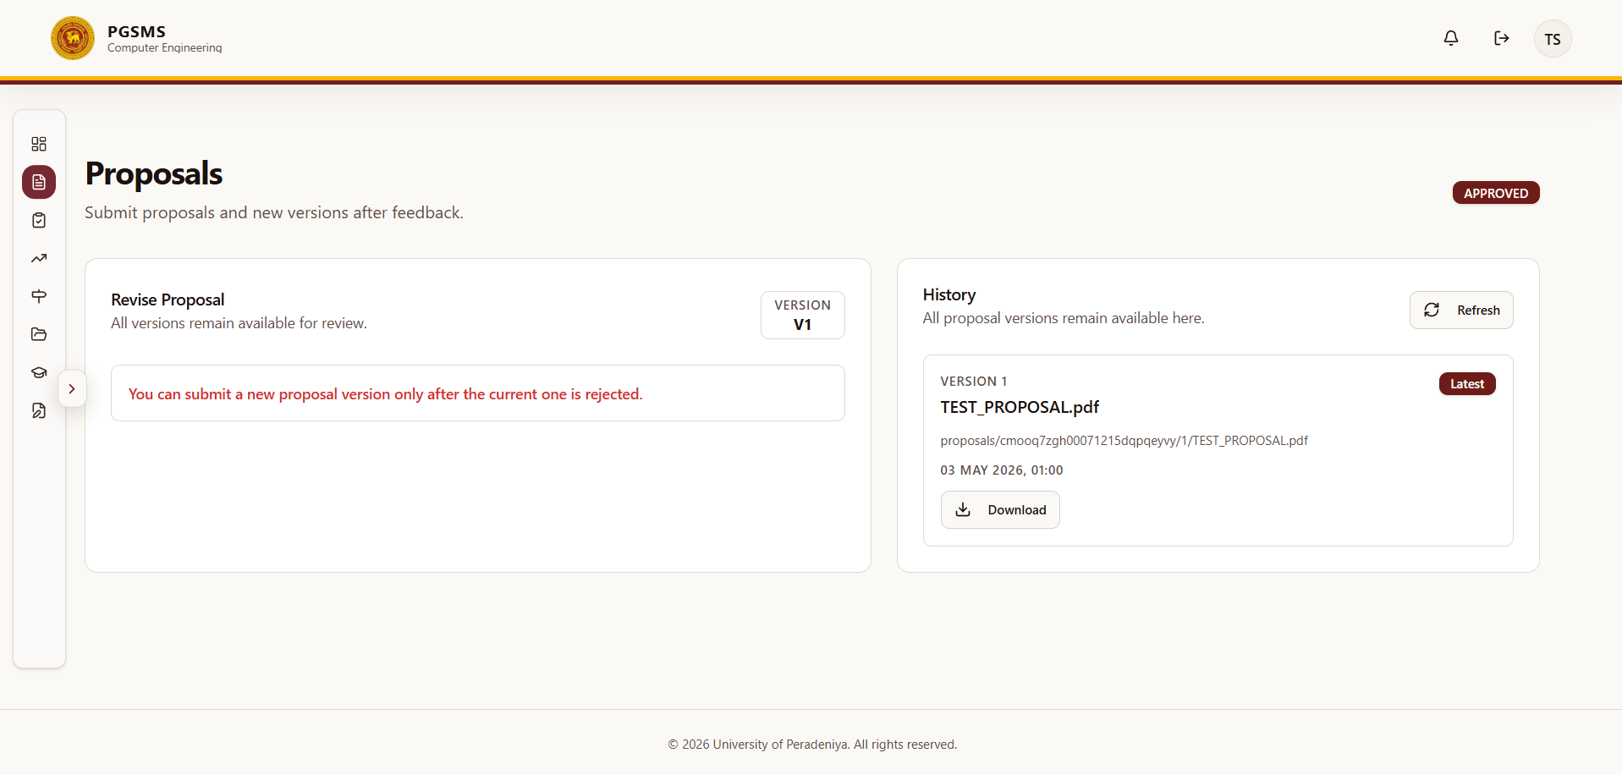
Figure 6: Proposals panel

8.2 Submit an ethics declaration
Role: Student
Prerequisites: Active registration and an approved proposal.
- Open Ethics Approval.
- In Ethics Declaration, choose Ethics approval required or Ethics approval not required.
- Enter Application title and Summary.
- If approval is required, upload the supporting PDF or ZIP evidence.
- Select Submit Declaration and Evidence or Submit Declaration, as displayed.
- Review Ethics History for the recorded revision and workflow status.
Expected result: The declaration moves to Supervisor review.

8.3 Submit a progress milestone
Role: Student
Prerequisites: Active registration and a milestone that is scheduled, due, overdue, or returned.
- Open Progress Reports.
- Locate the next available milestone.
- Enter a Progress narrative of at least 20 characters.
- If this is a returned version, complete What changed.
- Optionally add PDF or ZIP supporting evidence.
- Select the displayed submit or resubmit action.
- Confirm that the milestone version appears in its history.
Expected result: The milestone becomes submitted and waits for the active primary Supervisor.
Note: Milestone labels and due dates are generated by the programme schedule and cannot be edited by the Student.

8.4 Request thesis readiness
Role: Student
Prerequisites: Approved proposal, all required milestones complete, and the Department ethics gate satisfied.
- Open Thesis Submission.
- Review the criteria in Thesis readiness.
- Enter an optional Message to primary Supervisor.
- Select Request Thesis Readiness.
- Wait for primary-Supervisor certification and HOD approval.
Expected result: The request becomes available to the primary Supervisor. Thesis submission remains locked until the HOD approves examination readiness.

8.5 Submit a thesis
Role: Student
Prerequisite: Readiness status HOD_APPROVED.
- Open Thesis Submission.
- Enter Thesis title and Abstract.
- Under Thesis Document, choose 1 to 10 PDF or ZIP files.
- Select Submit thesis.
- Review Thesis record to confirm the current version.
Expected result: A verified thesis version is created with status SUBMITTED.

8.6 Submit ordered thesis corrections
Role: Student
Prerequisite: An HOD correction order in ORDERED or RETURNED status.
- Open Corrections.
- Review the correction Type, Examiner-review requirement, due date, and requirements.
- In Response to requirements, explain how every correction was addressed. Enter at least 20 characters.
- Under Corrected thesis and response package, choose the corrected PDF or ZIP files.
- Select Submit corrected package or Resubmit corrected package.
- Review Version and review history.
Expected result: The exact correction version moves to primary-Supervisor certification.

8.7 Find and download a document
Role: Student
- Open Documents.
- Search by filename, title, summary, or period.
- Optionally filter by category, tag, or date.
- Select the relevant download action.
Expected result: PGSMS authorizes the request and provides a short-lived download link when you have access.

9. Complete Supervisor tasks

9.1 Record proposed-Supervisor consent
Role: Supervisor
Prerequisite: The application names you as the proposed Supervisor.
- Open Application Work.
- Review the applicant and current proposal information.
- Select Consent to accept or Decline to refuse.
Expected result: The decision is recorded once. A consented application can proceed to Examiner reviewer assignment.

9.2 Review assigned Students
Role: Supervisor
Prerequisite: Active Supervisor assignment.
- Open Student Roster.
- Filter by Program Type or Registration Status when needed.
- Open a Student record to review registration, milestones, proposal, and related work.
Expected result: Only Students within your active assignment scope are shown.

9.3 Evaluate an authenticated Student proposal
Role: Supervisor
Prerequisite: The proposal belongs to an assigned Student and is available for evaluation.
- Open Monitor Proposals.
- Select the proposal.
- Review the current proposal version and documents.
- Enter evaluation feedback of at least 10 characters.
- Select the available evaluation decision and submit it.
Expected result: The evaluation is recorded against the proposal version.
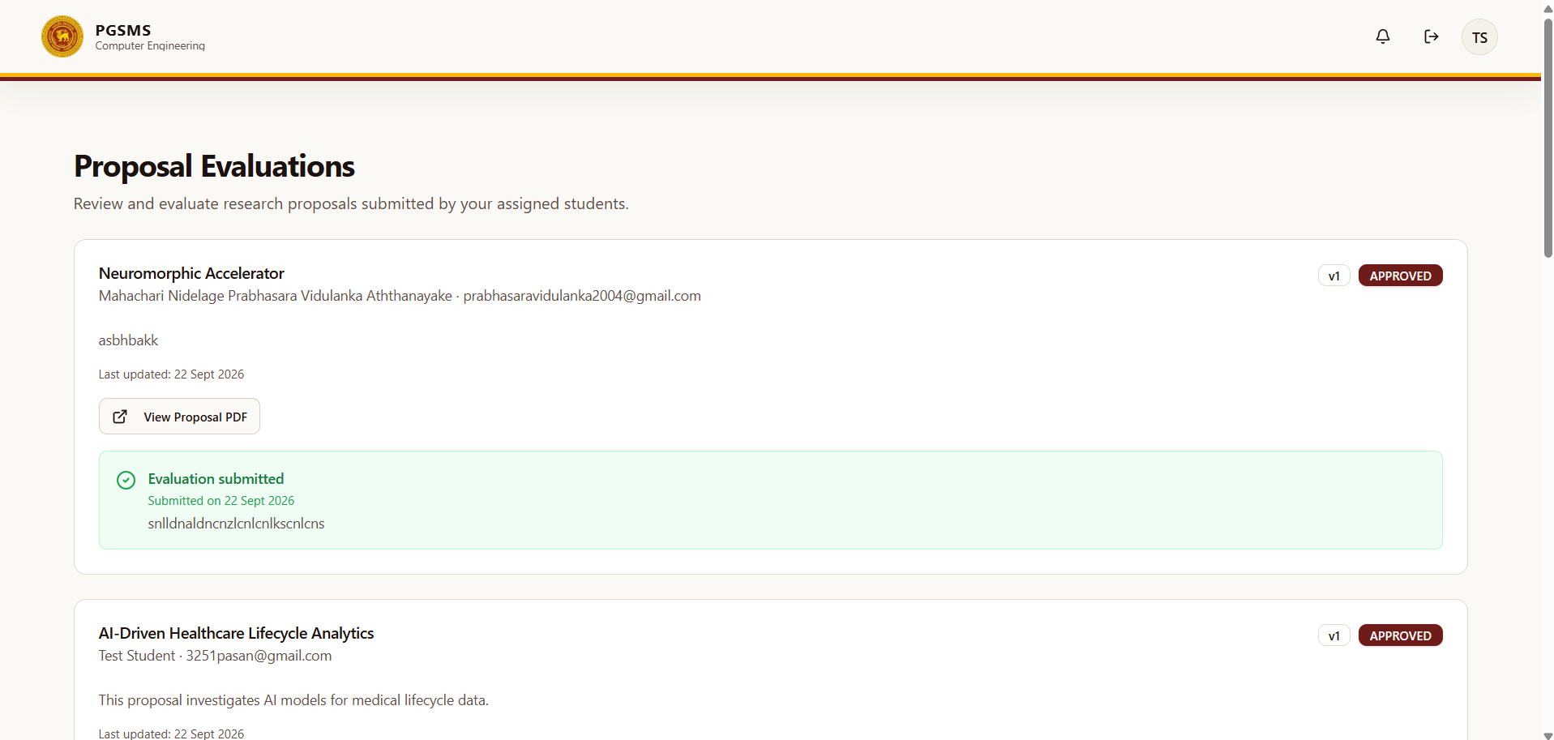
Figure 7: Proposals evaluation panel for the supervisor

9.4 Recommend or return an ethics declaration
Role: Assigned Supervisor
- Open Ethics Recommendations.
- Review the Student's applicability, summary, and evidence.
- Enter Decision notes.
- Select Recommend or Return to Student.
Expected result: A recommended declaration moves to PG Coordinator recording; a returned declaration can be revised by the Student.

9.5 Approve or return a progress report
Role: Active primary Supervisor
- Open Monitor Reports.
- Review the submitted milestone narrative and evidence.
- Enter feedback.
- Select the approval action to complete the milestone, or select the return action to request a new version.
Expected result: Approval completes the milestone; return preserves the reviewed version and reopens submission.

9.6 Certify or return thesis readiness
Role: Active primary Supervisor
- Open Thesis Readiness.
- Locate the Student request.
- Verify the displayed checklist: approved proposal, completed fixed milestones, satisfied ethics gate, and examination copy readiness.
- Enter Supervisor notes.
- Select the certification action or return the request.
Expected result: Certification makes the request available for HOD examination-readiness approval.

9.7 Certify or return corrections
Role: Active primary Supervisor
- Open Correction Reviews.
- Review the correction order, Student response, and exact submitted documents.
- Enter review notes.
- Certify the version or return it with a reason.
Expected result: A certified minor-correction version advances to the next required decision. When Examiner review is required, it advances to the assigned Examiner.

10. Complete Examiner tasks

10.1 Review an assigned application proposal
Role: Assigned Examiner
Prerequisite: An active assignment to the current application proposal version.
- Open Assigned Proposals.
- Review the applicant, proposal version, abstract, and permitted documents.
- Select Approved, Revision required, or Rejected.
- Enter independent review comments of at least 10 characters.
- Select Submit independent review.
Expected result: The assignment becomes complete. The HOD can decide only after every required current-version assignment is complete.
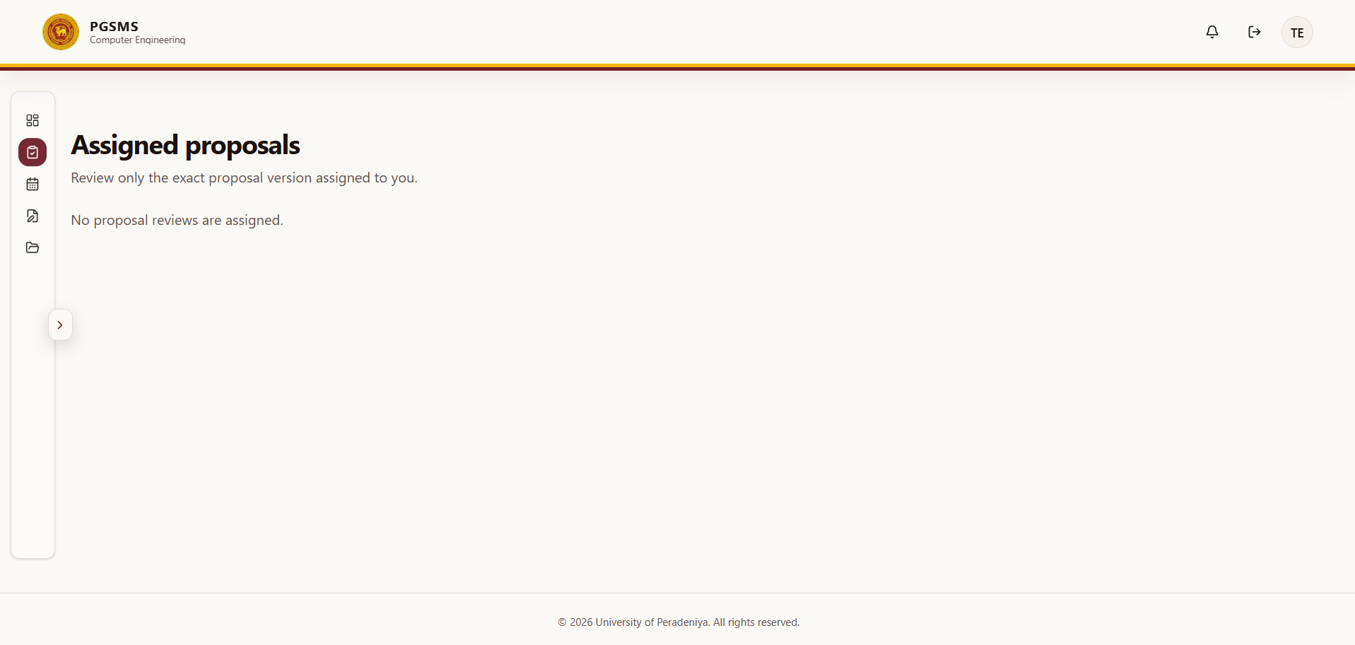
Figure 7: Assigned proposals for the examiners

10.2 Submit an independent thesis report
Role: Confirmed, exact-version Examiner
Prerequisites: Confirmed thesis assignment and access to the assigned viva workspace.
- Open Assigned Vivas.
- Review the candidate, thesis version, and viva information.
- Download the thesis using the available document action.
- Under Independent thesis report, select a report recommendation.
- Enter a Report of at least 20 characters.
- Attach exactly one Formal report PDF.
- Submit the report.
Expected result: The independent report, recommendation, and formal PDF are recorded against your exact assignment.

10.3 Submit a viva recommendation
Role: Confirmed Examiner
Prerequisite: Your independent thesis report and formal report PDF are complete.
- Remain in Assigned Vivas.
- Select Recommendation.
- Enter a Rationale of at least 20 characters.
- Select the submit action.
- Review the confirmation dialog and confirm.
Expected result: Your recommendation is recorded independently. It does not itself set the final viva outcome.

10.4 Review required corrections
Role: Assigned thesis Examiner
Prerequisites: Examiner review is required and the primary Supervisor has certified the current correction version.
- Open Correction Reviews.
- Review the HOD order, Student response, revised thesis, and compliance documents.
- Enter review notes.
- Approve the version or return it with a reason.
Expected result: An approved version advances to HOD correction closure; a returned version reopens Student submission.
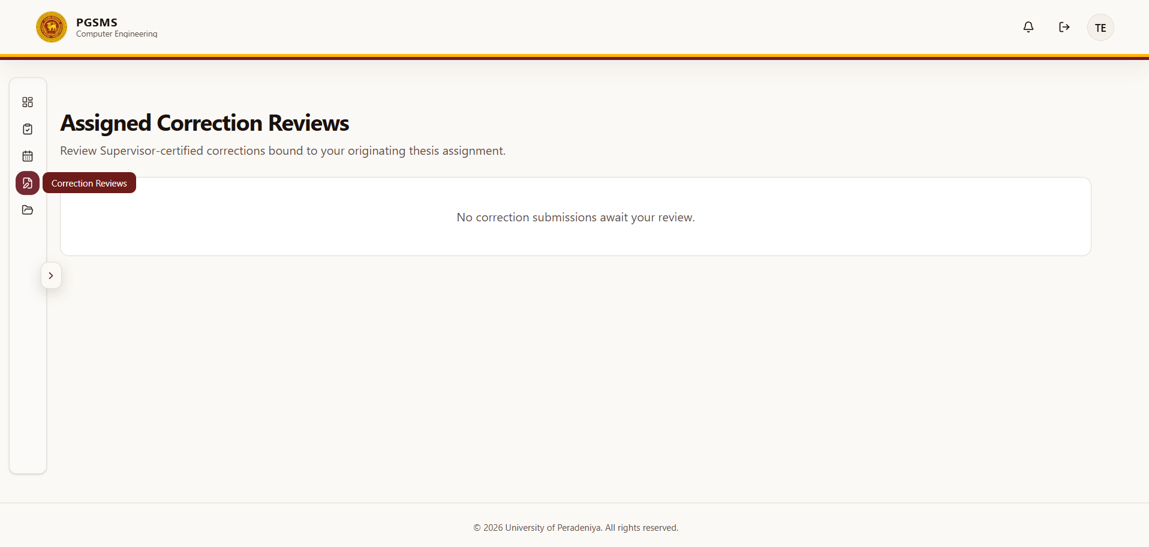
Figure 8: Correction review panel

11. Complete PG Coordinator tasks

11.1 Start application review and assign an Examiner
Role: Administrator / PG Coordinator
- Open Applications.
- Select the submitted application and start its completeness review.
- Confirm that the proposed Supervisor has recorded consent.
- Assign an active Examiner to the current proposal version.
- Monitor assignment completion.
Expected result: The application becomes ready for an HOD decision only after all required current-version reviews are complete.

11.2 Execute an approved admission
Role: Administrator / PG Coordinator
Prerequisite: HOD decision APPROVED.
- Open the approved application in Applications.
- Review the decision and admission prerequisites.
- Select the admission-execution action.
- Confirm the newly created Student and registration records.
Expected result: PGSMS creates one active registration, fixed milestones, role relationships, audit events, and notification intents.

11.3 Manage user accounts
Role: Administrator / PG Coordinator
- Open Manage Users.
- Filter by role when needed.
- Use Create User only for an authorized operational need.
- Use Deactivate when access must be removed without deleting audit history.
Warning: Deactivation affects access. Verify the selected person and role before confirming.

11.4 Record Department ethics status
Role: Administrator / PG Coordinator
Prerequisite: Supervisor recommendation complete.
- Open Ethics Documents.
- Review the declaration, evidence, and decision history.
- Choose Approved, Rejected, or Exempt as permitted.
- Enter Approval reference when the status is Approved.
- Enter Decision notes.
- Select Record for HOD or Return.
Expected result: The proposed Department status moves to HOD confirmation or returns for correction.

11.5 Assign Supervisors and propose Examiners
Role: Administrator / PG Coordinator
- Use Supervisor Assignments to create or maintain authorized Student-Supervisor relationships.
- Use Examiner Assignments after a verified thesis is submitted.
- Bind each proposed Examiner to the exact current thesis version.
- Wait for HOD confirmation before treating the assignment as active.

11.6 Schedule or reschedule a viva
Role: Administrator / PG Coordinator
Prerequisite: Thesis status UNDER_EXAMINATION.
- Open Schedule Vivas.
- Select the thesis.
- Enter Defense Date, time, and Venue/Link.
- Select Schedule Viva.
Expected result: The viva schedule is recorded and notification intents are created.

11.7 Monitor progress and reports
Role: Administrator / PG Coordinator
- Open Department Progress.
- Filter or review the Department-wide progress tables.
- Export the permitted CSV when an operational report is required.
- Follow up on overdue or incomplete milestones without changing Student-controlled schedule fields.

11.8 Execute completion, graduation, and archive
Role: Administrator / PG Coordinator
Prerequisites: HOD completion approval and all displayed gates satisfied.
- Open Completion Records.
- Execute approved programme completion.
- After receiving external confirmation, record the graduation date and reference.
- Archive the lifecycle record only after graduation is recorded.
- Enter an archive reason when requested.
Expected result: Completion updates the Student, registration, thesis, audit, and notification records atomically. Graduation and archive remain separate later actions.

11.9 Review notification delivery and recover failures
Role: Administrator / PG Coordinator
- Open Notification Log to review delivery records.
- Open Notification Recovery to inspect failed or dead-letter items.
- Verify that the underlying cause has been corrected.
- Use the retry action only for an authorized recoverable delivery.
Caution: Retrying can send a message again. Confirm the recipient, event, and current workflow state first.

12. Complete HOD tasks

12.1 Decide an application
Role: HOD
Prerequisites: Proposed-Supervisor consent and all required current-version Examiner reviews complete.
- Open Admission Decisions.
- Review the application, consent, proposal version, and independent reviews.
- Select Approve, Request revision, or Reject.
- Enter the decision reason.
- Review and confirm the academic decision.
Expected result: Approval permits PG Coordinator admission execution; revision creates a protected applicant revision path; rejection is terminal.

12.2 Confirm, return, or reject ethics status
Role: HOD
Prerequisite: PG Coordinator record complete.
- Open Ethics Confirmations.
- Review the declaration, evidence, Supervisor recommendation, Coordinator record, and history.
- Enter Decision notes.
- Select Confirm, Return to Coordinator, or Reject.
Expected result: Only confirmed Approved or Exempt status satisfies the thesis ethics gate.

12.3 Approve or return thesis readiness
Role: HOD
Prerequisite: Primary-Supervisor certification.
- Open Examination Decisions.
- Under Examination readiness, review the request and certification evidence.
- Enter HOD notes.
- Approve the request or return it.
Expected result: Approval unlocks Student thesis submission.

12.4 Confirm or decline an Examiner assignment
Role: HOD
Prerequisite: PG Coordinator proposed assignment to the exact current thesis version.
- Open Examination Decisions.
- Under Examiner confirmations, review the candidate, Examiner, thesis version, and assignment information.
- Select Confirm or Decline.
Expected result: A confirmed Examiner receives exact-version access. The first accepted assignment changes the thesis to UNDER_EXAMINATION.

12.5 Record the final viva outcome
Role: HOD
Prerequisites: At least two confirmed Examiners and complete independent report, formal report PDF, and viva recommendation evidence for every confirmed Examiner.
- Open Examination Decisions.
- Under Viva outcomes, review all independent evidence.
- Select Pass, Minor corrections, Major corrections, or Fail.
- Enter an outcome rationale of at least 10 characters.
- Review the decision and record the final outcome.
Expected result: The HOD outcome becomes the authoritative Department viva outcome.

12.6 Issue and close corrections
Role: HOD
- For a minor- or major-corrections outcome, open the correction-order action.
- Enter correction requirements of at least 20 characters.
- Set whether assigned-Examiner review is required. Major corrections require Examiner review.
- Issue the order.
- After required reviews are complete, review the exact current correction version.
- Approve correction completion or return the version.
Expected result: Approval changes the thesis to CORRECTIONS_APPROVED; return preserves history and opens a new Student version.

12.7 Approve academic completion
Role: HOD
Prerequisites: All milestones complete, ethics gate confirmed, current thesis evidence verified, viva passed or corrections closed, and no unresolved correction order.
- Open Completion Decisions.
- Review the completion dossier and every displayed gate.
- Confirm that the approval is bound to the exact current thesis version.
- Select the completion-approval action.
Expected result: Completion status becomes HOD_APPROVED, allowing PG Coordinator execution.

Part III - Reference

13. Navigation reference
Table 2: Role workspace navigation
Role | Workspace items
Student | Overview; Proposals; Ethics Approval; Progress Reports; Milestones; Documents; Thesis Submission; Corrections
Supervisor | Overview; Student Roster; Application Work; Monitor Proposals; Ethics Recommendations; Monitor Reports; Thesis Readiness; Correction Reviews; Documents
Administrator / PG Coordinator | Overview; Manage Users; Applications; Proposal Approvals; Department Progress; Ethics Documents; Supervisor Assignments; Examiner Assignments; Schedule Vivas; Finalize Theses; Completion Records; Documents; Notification Log; Notification Recovery
Examiner | Overview; Assigned Proposals; Assigned Vivas; Correction Reviews; Documents
HOD | Overview; Admission Decisions; Department Progress; Ethics Confirmations; Examination Decisions; Completion Decisions

Every authenticated workspace also provides Notifications, a profile control, and Sign Out.

14. Application field reference
Table 3: Public application fields and validation
Step | Field | Requirement
Applicant | Full name | Required; at least 3 characters
Applicant | Email | Required; valid email address
Applicant | Phone | Required; 7 to 15 digits; spaces, hyphens, parentheses, and a leading plus sign are permitted
Research | Programme | Required; MPhil or PhD
Research | Study mode | Required; Full-time or Part-time
Research | Research area | Required; at least 2 characters
Research | Proposed supervisor | Required; selected from the available active list
Research | Proposal title | Required; at least 5 characters
Research | Proposal abstract | Required; at least 20 characters
Research | Statement of purpose | Required
Documents | Supporting documents | 1 to 10 PDF or ZIP files; maximum 10 MB each
Review | Confirmation | Required before Submit application becomes available

15. Programme and milestone reference
Table 4: Programme duration and generated milestones
Programme | Study mode | Expected duration | Fixed milestones
MPhil | Full-time | 24 calendar months | M1-M4
MPhil | Part-time | 36 calendar months | M1-M6
PhD | Full-time | 36 calendar months | M1-M6
PhD | Part-time | 54 calendar months | M1-M9

Milestones are created during admission at six-calendar-month offsets from the enrolment timestamp. The Student cannot edit these labels or dates.

16. Status reference

16.1 Application and admission
- SUBMITTED: The public application has been finalized.
- UNDER_REVIEW: Department review is active.
- ADMITTED: The PG Coordinator executed an HOD-approved admission.
- REJECTED: The application will not proceed.
- Supervisor consent: PENDING, CONSENTED, DECLINED, or WITHDRAWN.
- Department decision: PENDING, APPROVED, REVISION_REQUIRED, or REJECTED.

16.2 Progress
- SCHEDULED: The milestone exists but is not yet the active due item.
- DUE: Submission is available.
- SUBMITTED: A version waits for primary-Supervisor review.
- RETURNED: The Student must submit a new version.
- APPROVED: The milestone is complete.
- OVERDUE: The due date has passed without completion.
- WAIVED: The milestone does not require completion.

16.3 Thesis readiness and thesis
- Readiness: PENDING, REQUESTED, CERTIFIED, HOD_APPROVED, RETURNED, or REVOKED.
- Thesis: SUBMITTED, UNDER_EXAMINATION, CORRECTIONS_REQUIRED, CORRECTIONS_APPROVED, COMPLETED, ARCHIVED, or CLOSED.

16.4 Viva and corrections
- Viva outcome: PASS, MINOR_CORRECTIONS, MAJOR_CORRECTIONS, or FAIL.
- Correction order: ORDERED, SUBMITTED, RETURNED, SUPERVISOR_CERTIFIED, EXAMINER_APPROVED, or COMPLETION_APPROVED.

16.5 Completion
- Completion: PENDING, HOD_APPROVED, or COMPLETED.
- Academic status: ACTIVE, UNDER_REVIEW, COMPLETED, GRADUATED, ARCHIVED, or FAILED.
- Registration: ACTIVE, COMPLETED, or ARCHIVED.

17. Document and upload reference
PGSMS accepts PDF and ZIP document types for general staged uploads. Public-application attachments are limited to 10 MB each. Authenticated staged uploads are limited to 50 MB each and to 10 files per version unless a stricter screen-specific rule applies.
The independent Examiner report requires exactly one PDF file.
Document categories include application attachments, proposals, ethics approvals, progress reports, theses, corrections, and review attachments.
Caution: Do not rename a file to .pdf or .zip without converting it to the correct format. PGSMS verifies the document type and may reject an invalid file.

18. Notifications and messages
PGSMS can create in-app notifications and email delivery intents after important committed workflow events. A notification may include a permitted dashboard destination.
Messages do not replace the authoritative status displayed in the relevant workspace. If an email and the dashboard disagree, stop and ask the PG Coordinator to verify the record.

Part IV - Explanations

19. Understand the lifecycle
The lifecycle separates academic decisions from operational execution. For example, the HOD approves admission, but the PG Coordinator creates the Student account and registration. The HOD records the viva outcome, but the PG Coordinator schedules the viva. The HOD approves completion, but the PG Coordinator executes completion and later records graduation and archive.
This separation protects academic authority while ensuring that operational work remains traceable.

20. Understand permissions and academic authority
PGSMS checks both role and relationship. A Supervisor sees assigned Students. An Examiner sees only candidates attached to an explicit proposal or thesis assignment. A Student sees their own released information. The PG Coordinator has Department-wide operational scope, while the HOD has Department academic decision scope.
Archived records remain available for authorized review but expose no new lifecycle mutations.

21. Understand versions and evidence
Submissions are versioned so that a review stays attached to the exact evidence that was reviewed. A returned progress report, proposal, thesis, or correction package does not overwrite the reviewed version. Instead, the Student submits a new version.
Examiner assignments are bound to an exact thesis version and document manifest. Completion approval is also bound to the exact verified current thesis version. This prevents a later file replacement from silently changing the evidence behind an academic decision.

22. Troubleshooting

22.1 Sign-in fails
Symptom: The sign-in page reports an authentication or access error.
Likely cause: Incorrect credentials, inactive local account, mismatched role, or unavailable authentication service.
Resolution: Re-enter the assigned email and password. If the error continues, contact the PG Coordinator and provide your email address, role, time of the attempt, and the displayed error. Never send your password.

22.2 A workspace or candidate is missing
Symptom: A Supervisor or Examiner cannot see an expected candidate.
Likely cause: No active assignment, assignment bound to another version, or the preceding decision is incomplete.
Resolution: Ask the PG Coordinator to verify the assignment and current version. Do not request broad candidate access.

22.3 An application cannot proceed to HOD decision
Symptom: The HOD decision action is unavailable.
Likely cause: Proposed-Supervisor consent is incomplete, no Examiner is assigned, or at least one current-version review is incomplete.
Resolution: Complete each prerequisite in order and refresh Admission Decisions.

22.4 A file upload fails
Symptom: PGSMS rejects or cannot finish an upload.
Likely cause: Unsupported type, excessive size, too many files, interrupted upload, or verification failure.
Resolution: Use PDF or ZIP, remain within the displayed limits, upload again, and wait for completion before submitting the form.

22.5 Thesis submission is locked
Symptom: Thesis fields or the submit action are unavailable.
Likely cause: Readiness has not reached HOD_APPROVED.
Resolution: Check Thesis readiness. Complete Student request, primary-Supervisor certification, and HOD approval in that order.

22.6 A thesis is missing from Schedule Vivas
Symptom: The PG Coordinator cannot select a submitted thesis.
Likely cause: The thesis has not reached UNDER_EXAMINATION.
Resolution: Propose an Examiner assignment and have the HOD confirm it, then refresh Schedule Vivas.

22.7 Viva recommendation is blocked
Symptom: An Examiner cannot submit a viva recommendation.
Likely cause: The independent thesis report or formal report PDF is incomplete.
Resolution: Submit the independent report and exactly one formal PDF first, refresh if necessary, and then submit the viva recommendation.

22.8 HOD outcome is locked
Symptom: The HOD cannot record the final viva outcome.
Likely cause: Fewer than two confirmed Examiners have complete evidence, or a confirmed Examiner is missing a report, PDF, or recommendation.
Resolution: Review the missing-evidence list and ask each named Examiner to complete the required item.

22.9 Completion is blocked
Symptom: Completion approval or execution is unavailable.
Likely cause: An incomplete milestone, unconfirmed ethics gate, missing verified current thesis, incomplete viva/corrections outcome, or unresolved correction order.
Resolution: Review every displayed completion gate and resolve the missing evidence without bypassing the workflow.

23. Frequently asked questions

Can an Administrator approve an application or viva outcome?
No. The HOD records the academic decision. The PG Coordinator performs the permitted operational action after that decision.

Can an Examiner open every Student record?
No. Examiner access requires an explicit assignment to an exact proposal or thesis version.

Can a Student change milestone dates?
No. Milestones are generated from programme and study mode during admission.

Does submitting a revision delete the previous version?
No. Previous versions remain in history so that reviews and decisions retain their evidence.

Does an Examiner recommendation become the final viva outcome?
No. Examiner recommendations are independent evidence. The HOD records the final Department outcome.

Is graduation the same as completion?
No. HOD approval and PG Coordinator completion occur first. Graduation is recorded later from external confirmation, and archive is a separate final operation.

24. Security, privacy, and responsible use
- Use only your assigned account.
- Do not share passwords or session access.
- Confirm the candidate and version before submitting a decision.
- Upload only documents required for the academic workflow.
- Do not include unnecessary personal or sensitive data in free-text fields.
- Do not forward signed document links; they are short-lived and authorization-scoped.
- Sign out on shared devices.
- Report unexpected access, incorrect role information, or another person's record immediately.
- Do not use browser Back or repeated submission to try to override a completed decision.

25. Accessibility guidance
- Use the keyboard to move through links, fields, menus, and buttons.
- Use the Skip to dashboard content link when it appears during keyboard navigation.
- Zoom browser content when larger text is required.
- Refer to controls by their visible label rather than position or colour.
- Keep uploaded documents accessible, with selectable text, useful headings, and meaningful filenames where possible.
- If a workflow cannot be completed with assistive technology, report the page, role, control label, and observed problem to the PG Coordinator.

26. Glossary
Academic status: The Student's overall lifecycle state, such as Active, Completed, Graduated, or Archived.
Active primary Supervisor: The Supervisor relationship authorized to perform final progress, readiness, and correction certification actions.
Archive: A non-destructive final state that retains documents, decisions, and audit history while preventing new lifecycle changes.
Current version: The latest authoritative version of a proposal, thesis, progress report, or correction package.
Department decision: An academic decision made by the HOD within the system's Department scope.
Examiner: A user who receives candidate access through an explicit proposal or thesis assignment.
HOD: Head of Department.
Manifest: The recorded set of files and identifying evidence associated with one exact submission version.
Milestone: A fixed six-month progress checkpoint generated from programme and study mode.
PG Coordinator: The Administrator role responsible for Department operational commands.
PGSMS: Postgraduate Student Management System.
Readiness: The gated process that must be completed before thesis submission for examination.
Released information: Workflow information that the system permits the Student or another role to view.
Signed URL: A short-lived document access link issued after authorization.
Version-bound review: A review attached to one exact submission version rather than to a changeable general record.

27. Revision history
Version | Date | Description of changes | Author
1.0 | 25 September 2026 | Initial release | Documentation Team
1.1 | 10 October 2026 | Updated sign-in instructions and screenshots | Documentation Team

