OrthoFlow User Manual
  - CO2060 Milestone 4
Project team E23G20 | Version 1.0 | 25 September 2026
This manual explains how clinic staff register patients, record orthodontic findings, manage appointments and follow treatment in OrthoFlow. Students and administrators should use only functions available to their own account.

1 Getting started
Open the clinic-provided address. For the local demonstration, use http://localhost:5173 after both services have been started. Sign in with your assigned username and password. Keep credentials private and sign out after using a shared computer.
Account | Main use
Staff or clinician | Patient registration, clinical records, appointments, media and student access.
Student | Read assigned patient records. Ask staff to grant access.
Administrator | Manage accounts and personal settings. The administrator interface is not the staff clinical workspace.

Patient records are not user accounts. This version has no dedicated patient-login role. Patients receive emails at the address in their patient record. Do not create a student account as a substitute for a patient portal.

Contents
Section | Page
Register and edit a patient | 2
Clinical examination and treatment | 3
Book and manage appointments | 4
Reminders and notifications | 5
Media access and account settings | 6
Troubleshooting and safe use | 7

Clinicians remain responsible for findings, diagnosis, treatment decisions and consent. Screens shown here contain fictional test data.

2 Register and edit a patient

Register a new patient
1. Open Patients and select New Patient. Check that you are not duplicating an existing record.
2. In Personal, enter the name, date of birth and available contact details. Complete guardian information where relevant. Confirm the email with the patient or guardian.
3. Review the suggested registration number, for example ORT-2026-0001. It combines the year and a sequence and is not the database UUID.
4. In History, record the complaint, medical and dental history, allergies and relevant notes. Do not replace unknown information with a guessed normal result.
5. In Examination, select the relevant findings. Use numeric inputs for measurements and text fields for observations not covered by choices.
6. In Media, select relevant clinical images if available. Only attach files belonging to this patient.
7. Open Review, verify the summary and select Create Patient once. Wait for confirmation, then reopen the record to confirm the saved information and attachments.

Move between stages
Use Continue, Back or the numbered stage buttons. Values remain when moving between stages in the current form. Validation can return you to a stage needing correction. There is no persistent draft guarantee after refreshing, closing the browser or leaving the form.

Correct an existing record
1. Search for and open the patient. Confirm name and registration number.
2. Select Edit Patient, correct the relevant fields and select Save Changes.
3. Reopen the record and review History where available. Treatment entries use their own revision workflow, not the demographic edit form.
Avoid repeated Save clicks while the network is slow. After an uncertain response, check the patient list before attempting another registration.

3 Clinical examination and treatment

Navigate the patient record
The patient page contains Overview, Examination, Treatment, Visits and Media. Staff also have History and Access. Overview contains identity and background details; Examination displays the structured clinical findings.

Record examination findings
Seven numbered topics cover history and examination; facial and skeletal relationships; soft tissues and mandibular closure; dentoalveolar examination; occlusal relationships; assessment and referral; and consultation use only.
Use checkboxes for multiple findings and radio buttons for mutually exclusive choices. Some choices reveal dependent fields; changing the parent choice may clear answers that no longer apply. Review measurements and units. Where overjet sign is selected separately, enter a non-negative magnitude and choose the appropriate sign.

Treatment and follow up
1. Open Treatment and choose treatment plans, consent, retention or discharge.
2. Select the Add action, complete required fields and select Save record.
3. Review a treatment proposal before using Approve plan. Only act when clinically authorized. STAFF is the clinician role; the system does not enforce a separate consultant-only role.
4. Use Revise to correct an entry. This creates a linked version and retains the original. Review which version is current.
5. Open Visits to record a visit date, findings, procedures and next planned action.

Consent and completion
Granted consent requires a signed PDF, PNG or JPEG up to 10 MB. For a minor, record the parent or guardian and relationship. Record different scopes separately. A revised grant requires newly attached evidence.
Retention and discharge entries update patient status. Verify the saved entry and status. Do not record a discharge merely to hide a patient from the active list.

Print a summary
Select Print case summary / PDF from the clinical workspace. Review the browser preview and choose a printer or Save as PDF. Store patient exports only in approved locations.

4 Book and manage appointments

Create a booking
1. Open Appointments and select New Appointment.
2. Select the clinician and patient. Confirm patient identity.
3. Enter date, time, type and duration.
4. Select Schedule Appointment. If a conflict appears, choose another time or clinician.
5. Check the saved booking and verify the patient email.
Overlapping active appointments for the same patient or clinician are rejected. Dates and times depend on the backend computer timezone; operators must keep it consistent with the clinic location.

Find and change a booking
Use Calendar to move between months and select a day. Select an event to show its day agenda. Use List for upcoming and past bookings. Search by patient details and filter by clinician or status.
1. Select Reschedule for the correct booking.
2. Change the date, time or clinician and save.
3. Review the updated booking. Rescheduling resets reminder delivery state.
4. Use the status selector for Confirmed, Completed, Missed or Cancelled as appropriate. Do not record attendance outcomes before the appointment.

Archive instead of deleting
Archive patient preserves records and cancels active appointments. Use the archived-patient list to find and restore a record. Restoration does not reactivate cancelled bookings. Use appointment cancellation, not patient archiving, when only a single booking needs to change.
Automatic reminders exclude cancelled, completed and missed appointments and archived patients. Check status when investigating missing delivery.

5 Reminders and notifications
Reminders use email only. Telephone numbers are contact information; the system does not send SMS.

Automatic delivery
By default the backend checks at startup and every five minutes for eligible upcoming bookings within 24 hours. Keep the backend and internet connection available. Delivery is not guaranteed at the exact second of the 24-hour threshold.
Book more than 24 hours in advance when a full day of notice is needed. Later bookings can still be processed while upcoming and inside the window, but cannot provide 24 hours of notice. Confirm short-notice bookings directly.

Understand the result
Sent indicates a successful send attempt, not that the patient read the email. Pending awaits processing; Failed needs investigation; Skipped can mean a missing address; Mock means no real email was delivered. A panel notification alone does not prove email delivery.
Remind is a manual action and can resend a previously sent message. Use it deliberately, not repeatedly while waiting for an inbox update.
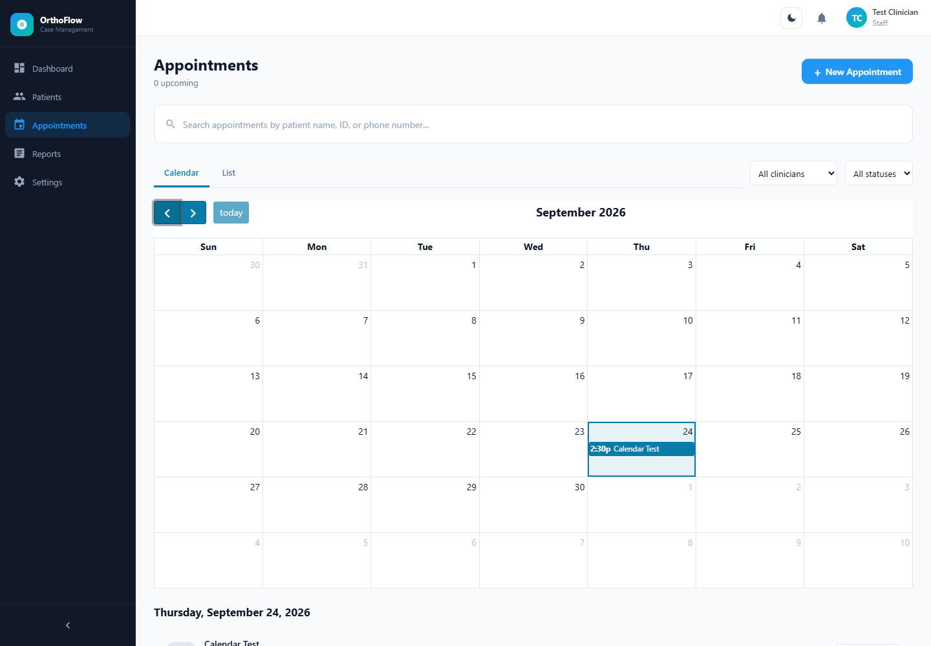
Figure 1 Calendar with fictional data. Select a day to see its bookings.
The bell shows notifications associated with the signed-in account. Patient-targeted records exist, but a dedicated patient portal is not provided in this release.

6 Media access and account settings

Attach and review clinical media
1. Open the correct patient and select Media.
2. Choose the upload action for case-history images or radiographs.
3. Select a JPEG, PNG or WebP image up to 15 MB and wait for the result.
4. Open the image to confirm its patient association and readability. Check orientation and labels before clinical use.
Radiographs are image files with database metadata. This is not a DICOM workstation or automated diagnostic tool. Signed consent documents belong in the consent workflow. Never upload unrelated patient information.

Give a student access
A staff member opens Access on the patient, selects the intended student and grants access. Verify account identity and revoke access when the assignment ends. A student who cannot see a patient should contact staff, not borrow another login.

History and reports
History shows recorded activity for a patient. Reports & History provides summaries and activity information for staff. Review underlying records before using figures in an audit. These features do not establish complete medico-legal audit certification.

Manage your account
1. Open Settings and select Edit Profile.
2. Update your name and email where required. Clinician email must be accurate for reminders.
3. Fill New Password only when changing it; leave it blank to retain the current password.
4. Select Save Changes and check the confirmation.
Use the top-bar theme control or Appearance in Settings to switch Light and Dark. Both controls should reflect the same theme.

Administrator workflow
Administrators use user management to create appropriate accounts. Grant the minimum required role and verify email. Do not delete a clinician account with associated records as a routine suspension method; involve the maintainer.

7 Troubleshooting and safe use
Problem | Action
Cannot sign in | Check credentials and ask the administrator to verify the account. Never include passwords in screenshots.
Patient is missing | Check search and archived filters. Students need explicit access. Confirm the signed-in account.
Changes disappeared | Only saved records persist. Reopen before repeating an uncertain save. Report the steps and time.
Upload fails | Check patient, permitted type, size and connection. Do not rename a different file type to bypass validation.
Booking conflicts | Check clinician and patient schedules, including the complete duration. Choose a non-conflicting slot.
No email arrives | Verify address, future date, active status and reminder window. Check spam. Ask the maintainer to inspect SMTP, backend uptime and delivery state.
Email says Mock | Real SMTP delivery is not configured. Do not rely on this reminder until the maintainer corrects it.
Page fails to load | Confirm frontend and backend are running. Use Retry where shown. Preserve unsaved information before refreshing.

Before leaving the workstation
1. Confirm changes saved to the correct patient.
2. Close exports and collect printouts from shared printers.
3. Sign out and lock the workstation.

Report a problem
Provide the page, action, time, error and a non-identifying example. Redact patient details and credentials. For urgent appointments or clinical concerns, use established clinic communication instead of relying only on the application.
Use fictional data for demonstrations. Clinical deployment requires institutional approval, security review, backup arrangements and staff training.

