Iditarod: MTU Degree Auditor

User Manual

# Purpose

Iditarod was created to help Michigan Tech students, specifically computer science students, understand their degree requirements and plan for future courses.

# Getting Started

To log in to the site all you need is your Michigan Tech email ending in @mtu.edu. When you first visit the site you will be on the ‘Dashboard’ page, this will have a login button. After logging in, you will see various information, which will update once you have entered courses. 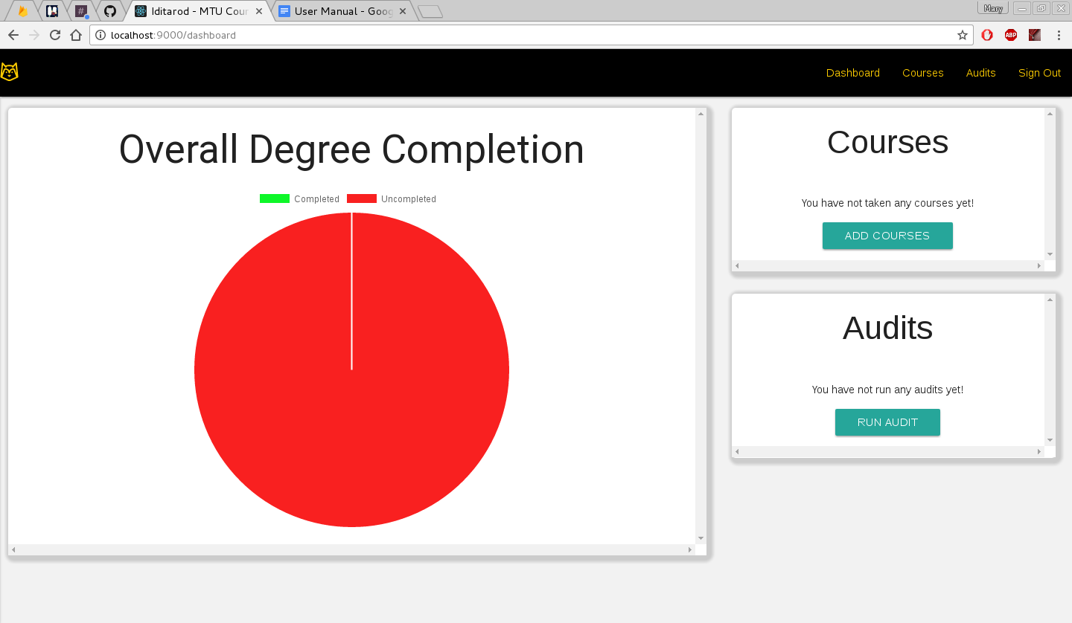

To enter the courses you have taken, or are taking. Click on the add courses button. This will display two lists, on the left is all courses Michigan Tech offers, and on the right is all the courses you have added. Simply search by department for a course and click the add button to indicate you have taken the course, this will make the course appear in the right list, and remove it from the general course list.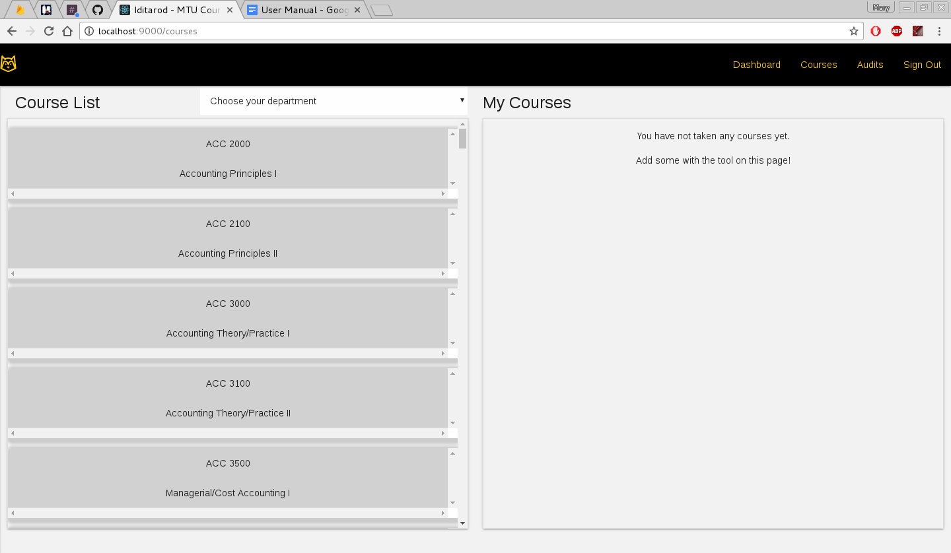

After you have added all the courses you have taken, you are ready to run an audit. Navigate to the Dashboard page and select the run audit button. This will take you to another page while it calculates your degree audit.