1. **功能頁面背景資料**

|  |  |  |
| --- | --- | --- |
| 功能頁面名稱 | 實際進度計算 | |
| 頁面檔名 | ProgressA.aspx | |
| 隸屬模組 | 進度管理模組 | |
| 原頁面 | 進度管理 | ProgressMode_new3.aspx |

1. **使用者介面(UI)及操作流程說明**
   1. **PageLoad**

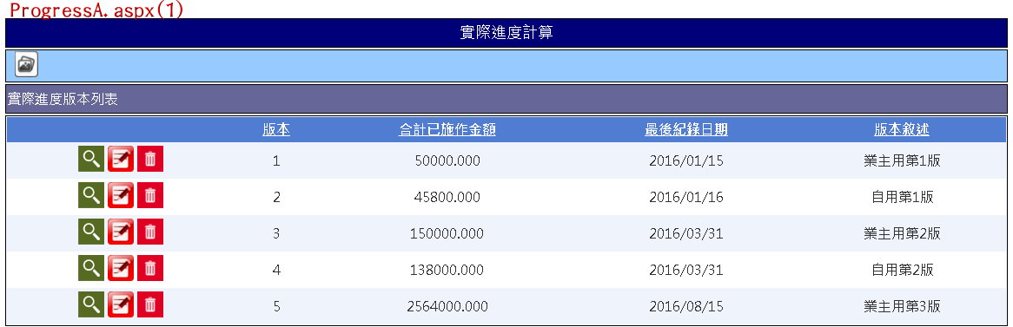

1. 如圖(1)，載入下方版本列表Table資訊，Select From Progress_ RVersion Where PID= Session("PID")
   1. 版本：Progress_RVersion.Version
   2. 合計已施作金額：Progress_RVersion.TotalPrice
   3. 最後記錄日期：Progress_RVersion.LastDate
   4. 版本敘述：Progress_RVersion.Note
2. 版本列表Table各列前方有三個按鈕
   1. ****(查看內容)：詳2.2
   2. ****(編輯版次資訊)：點擊可編輯版次資訊，可直接使用GridView功能(Update Progress_ RVersion )
   3. ****(刪除版次)：點擊可刪除版次，須先與使用者確認，可直接使用GridView功能(Delete From Progress_ RVersion)，但須加上Delete From Progress_Real Where Version=所選版次
   4. **版本列表-(查看內容).Click**

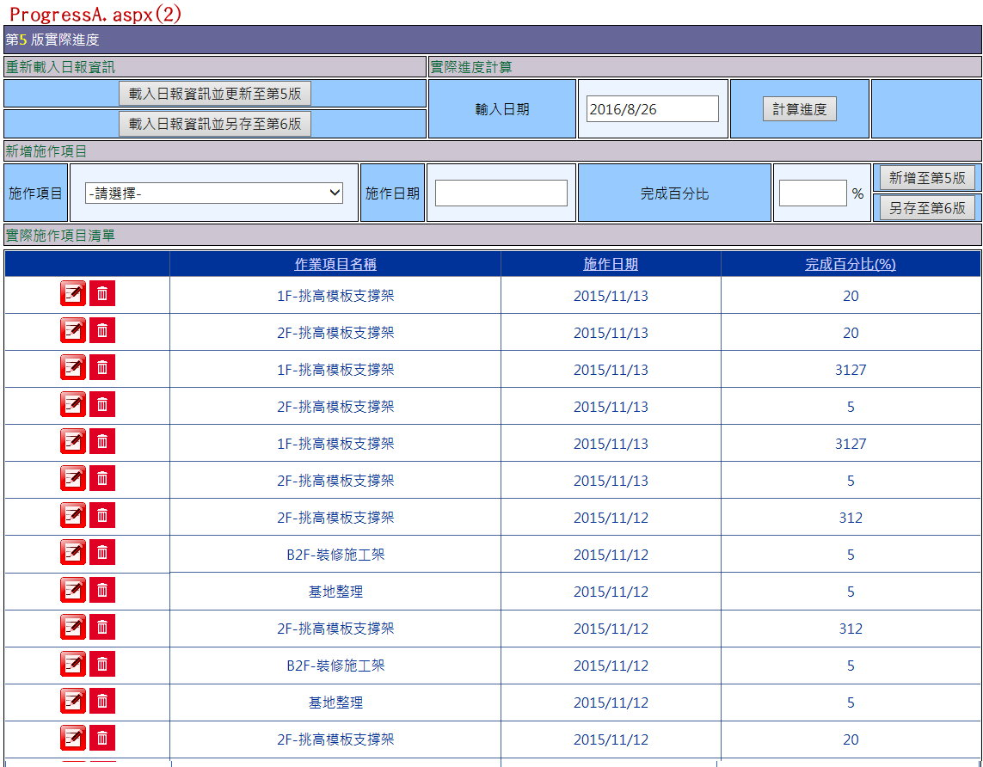

1. 顯示如圖(2)，Session("Version")=所選版次，Session("MaxVersion") =Select Max Version From Progress_RVersion Where ProjectID= Session ("PID")
2. Pnl_Main.Visable=True
3. 標題「第X版實際進度」，其中X(LB_Version)= Session("Version")
4. 載入日報資訊並更新至第X版(Btn_DailyReload)，其中X= Session ("Version")，詳細功能詳2.3
5. 載入日報資訊並另存至第X版(Btn_DailyReloadNew)，其中X= Session("MaxVersion")+1，詳細功能詳2.4
6. 新增至第X版(Btn_Insert)，其中X= Session("Version")，詳細功能詳2.6
7. 另存至第X版(Btn_InsertNew)，其中X= Session("MaxVersion") +1，詳細功能詳2.7
8. 輸入日期(TB_Date).Text預設代入今天日期
9. 施作項目▼(DDL_Activity).SelectedItem.Text/.SelecedValue=Select WIName/WIID From Progress_WIINF Where ProjectID= Session ("PID")
10. 載入實際施作項目清單之Table，Select From Progress_Real INNER JOIN Progress_WIINF ON Progress_Real.ProgressID = Progress_WIINF.ProgressID Where Progress_Real.ProjectID= Session("PID") And Progress_Real.Version= Session("Version")
    1. 作業項目名稱：Progress_WIINF.WIName
    2. 施作日期：Progress_Real.WorkDate
    3. 完成百分比：Progress_Real.CompleteAmount
11. 實際施作項目清單之Table各列前方有三個按鈕
    1. (編輯施作項目)：點擊可編輯施作項目，可直接使用GridView功能(Update Progress_ Real)
    2. (刪除施作項目)：點擊可刪除施作項目，須先與使用者確認，可直接使用GridView功能(Delete From Progress_ Real)
    3. **載入日報資訊並更新至第X版(Btn_DailyReload).Click**
12. 與使用者再次確認重新載入將會清除目前所有實際施作項目
13. Delete From Progress_Real Where ProjectID= Session("PID") And Version= Session("Version")
14. Select Progress_WIINF.Amount, EBudget_WBS.LastENumber, EBudget_WBS.EPrice, Daily_Main.Date, Daily_Activity.WIID, Daily_Activity.DailyNumber From Daily_Activity INNER JOIN Daily_Main ON Daily_Activity.DailyID = Daily_Main.DailyID INNER JOIN EBudget_WBS ON Daily_Activity.EWID = EBudget_WBS.EWID INNER JOIN Progress_WIINF ON Daily_Activity.WIID = Progress_WIINF.WIID Where Daily_Main.PID= Session("PID")
15. CompleteAmount= Daily_Activity.DailyNumber/ (EBudget_WBS. LastENumber* (Progress_WIINF.Amount/100)) *100
16. Insert Into Progress_Real(ProjectID, ProgressID, WorkDate, CompleteAmount, Version) Values(Session("PID"), Daily_Activity.WIID, Daily_Main.Date, 前計算之CompleteAmount, Session("Version"))
17. TotalPrice=SUM(EBudget_WBS.EPrice* EBudget_WBS. LastENumber*(Progress_WIINF.Amount/100)*(前計算之CompleteAmount/100))
18. LastDate=Max(Daily_Main.Date)
19. Update Progress_RVersion Set TotalPrice=前計算之TotalPrice, LastDate=前計算之LastDate Where PID=Session("PID") And Version=Session("Version")
20. 重新載入版本列表Table及實際施作項目清單之Table
21. 此功能部分等同原ProgressMode_new3.aspx中載入日報資訊之功能，可參考引用
    1. **載入日報資訊並另存至第X版(Btn_DailyReloadNew).Click**
22. 與使用者再次確認要另存新版本至第X版
23. Select Progress_WIINF.Amount, EBudget_WBS.LastENumber, EBudget_WBS.EPrice, Daily_Main.Date, Daily_Activity.WIID, Daily_Activity.DailyNumber From Daily_Activity INNER JOIN Daily_Main ON Daily_Activity.DailyID = Daily_Main.DailyID INNER JOIN EBudget_WBS ON Daily_Activity.EWID = EBudget_WBS.EWID INNER JOIN Progress_WIINF ON Daily_Activity.WIID = Progress_WIINF.WIID Where Daily_Main.PID= Session("PID")
24. CompleteAmount= Daily_Activity.DailyNumber/ (EBudget_WBS. LastENumber* (Progress_WIINF.Amount/100)) *100
25. Insert Into Progress_Real(ProjectID, ProgressID, WorkDate, CompleteAmount, Version) Values(Session("PID"), Daily_Activity.WIID, Daily_Main.Date, 前計算之CompleteAmount, Session("MaxVersion")+1)
26. TotalPrice=SUM(EBudget_WBS.EPrice* EBudget_WBS. LastENumber*(Progress_WIINF.Amount/100)*(前計算之CompleteAmount/100))
27. LastDate=Max(Daily_Main.Date)
28. Insert Into Progress_RVersion(PID, Version, TotalPrice, LastDate) Values(Session("PID"), Session("MaxVersion")+1, 前計算之TotalPrice, 前計算之LastDate)
29. Session("Version")= Session("MaxVersion")+1
30. Session("MaxVersion")= Session("MaxVersion")+1
31. 重新執行2.2之內容
32. 重新載入版本列表Table
33. 此功能部分等同原ProgressMode_new3.aspx中載入日報資訊之功能，可參考引用
    1. **計算進度(Btn_Cal).Click**

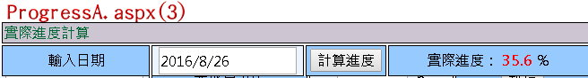

1. Select Progress_Real.CompleteAmount, Progress_Real.WorkDate, Progress_WIINF.Amount, EBudget_WBS.LastENumber, EBudget_WBS.EPrice From Progress_Real INNER JOIN Progress_WIINF ON Progress_Real.ProgressID = Progress_WIINF.ProgressID INNER JOIN EBudget_WBS ON Progress_WIINF.WBSID = EBudget_WBS.EWID Where Progress_Real.ProjectID=Session("PID") And Progress_Real. WorkDate <=輸入日期.Text And Progress_Real.Version= Session("Version")
2. DonePrice=SUM(EBudget_WBS.EPrice* EBudget_WBS. LastENumber*(Progress_WIINF.Amount/100)*( Progress_Real.CompleteAmount/100))
3. EBudgetPrice=SUM(Select LastENumber, EPrice From EBudget_WBS Where PID= Session("PID"))
4. LB_CalAns.Text=前計算之DonePrice/前計算之EBudgetPrice*100(計算至小數點後兩位)
5. LB_Cal01.Visable=True; LB_Cal02.Visable=True; LB_CalAns.Visable=True
   1. **新增至第X版(Btn_Insert).Click**

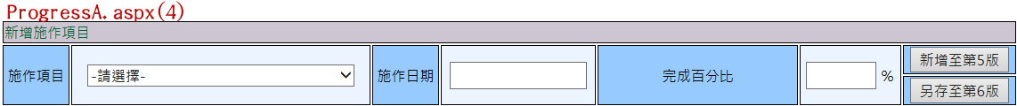

1. 確認施作項目▼、施作日期、完成百分比皆已輸入，其中完成百分比僅可輸入<=100之數字
2. Insert Into Progress_Real(ProjectID, ProgressID, WorkDate, CompleteAmount, Version) Values(Session("PID"),施作項目▼. SelectedValue, 施作日期.Text, 完成百分比.Text, Session("Version"))
3. Select TotalPrice, LastDate From Progress_RVersion Where PID= Session("PID") And Version=Session("Version")
4. 原TotalPrice=前Select之TotalPrice
5. 原LastDate=前Select之LastDate
6. Select EBudget_WBS.LastENumber, EBudget_WBS.EPrice, Progress_WIINF.Amount From Progress_WIINF INNER JOIN EBudget_WBS ON Progress_WIINF.ProgressID= EBudget_WBS.EWID Where Progress_WIINF.ProgressID =施作項目▼.SelectedValue
7. 增加TotalPrice=EBudget_WBS.EPrice* EBudget_WBS. LastENumber*(Progress_WIINF.Amount/100)*(完成百分比.Text /100)
8. Update Progress_RVersion Set TotalPrice=(原TotalPrice+增加TotalPrice), LastDate=(Max(原LastDate, 施作日期.Text)) Where PID=Session("PID") And Version=Session("Version")
9. 重新載入版本列表Table及實際施作項目清單之Table
   1. **另存至第X版(Btn_InsertNew).Click**



1. 確認施作項目▼、施作日期、完成百分比皆已輸入，其中完成百分比僅可輸入<=100之數字
2. 將Progress_Real中Version=Session("Version")之所有資料複製Insert IntoProgress_Real(Version=Session("MaxVersion")+1)
3. Insert Into Progress_Real(ProjectID, ProgressID, WorkDate, CompleteAmount, Version) Values(Session("PID"),施作項目▼. SelectedValue, 施作日期.Text, 完成百分比.Text, Session ("MaxVersion")+1)
4. Select TotalPrice, LastDate From Progress_RVersion Where PID= Session("PID") And Version=Session("Version")
5. 原TotalPrice=前Select之TotalPrice
6. 原LastDate=前Select之LastDate
7. Select EBudget_WBS.LastENumber, EBudget_WBS.EPrice, Progress_WIINF.Amount From Progress_WIINF INNER JOIN EBudget_WBS ON Progress_WIINF.ProgressID= EBudget_WBS.EWID Where Progress_WIINF.ProgressID =施作項目▼.SelectedValue
8. 增加TotalPrice=EBudget_WBS.EPrice* EBudget_WBS. LastENumber*(Progress_WIINF.Amount/100)*(完成百分比.Text /100)
9. Insert Into Progress_RVersion(PID, Version, TotalPrice, LastDate) Values(Session("PID"), (Session ("MaxVersion")+1), (原TotalPrice+增加TotalPrice), (Max(原LastDate, 施作日期.Text))
10. Session("Version")= Session("MaxVersion")+1
11. Session("MaxVersion")= Session("MaxVersion")+1
12. 重新執行2.2之內容
13. 重新載入版本列表Table
    1. **(IBtn_Draw).Click**

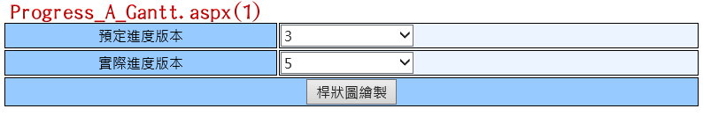

1. 點擊後開啟Progress_A_Gantt.aspx(開新視窗)，開啟後Pageload畫面如上圖(1)
2. 預定進度版本▼.SelectedItem.Text/.SelectedValue= Select Distinct Version From Progress_WIINF Order By Version DESC，預設Max (Progress_WIINF.Version).Selected=True
3. 實際進度版本▼.SelectedItem.Text/.SelectedValue= Select Distinct Version From Progress_RVersion Order By Version DESC，預設Max (Progress_WIINF.Version).Selected=True

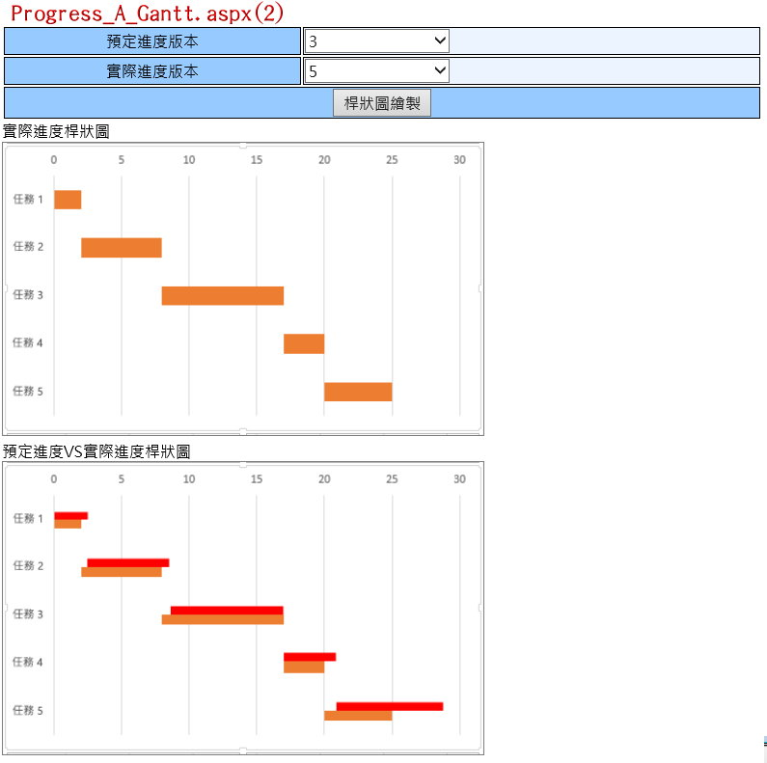

1. 桿狀圖繪製.Click則依據使用者所選預定進度版本▼及實際進度版本▼繪製桿狀圖，如上圖(2)，桿狀圖繪製功能可參考原Progress_new3.aspx之 Function drawchar2()，以及Progress_new3.aspx.cs之Function LString()、make_header_row()、make_date_row()、make_compare_ header_row()、make_compare_row()、Line_string()