8位元雙向電壓電平轉換器  
  
描述：如果你曾经试图将3.3V设备连接到5V系统，你知道什么是一个挑战。双向逻辑电平转换器是一种小型器件，可以将5V信号安全地降低到3.3V，同时将3.3V升压到5V。此电平转换器也适用于2.8V和1.8V器件。这个逻辑电平转换器与我们之前的版本的区别在于，您可以成功地设置高低电压，并在同一通道上安全地升降它们。每个电平转换器具有将高侧上的4个引脚转换为低侧上的4个引脚的能力，其中为每侧提供两个输入和两个输出

电平转换器非常容易使用。电路板需要由系统使用的两个电压源（高电压和低电压）供电。高电压（例如5V）到“HV”引脚，低电压（例如3.3V）到“LV”，接地从系统到“GND”引脚

兼容5-3V系统

VIN连接5V系统电源

5A连接5V系统

5B连接5V系统

GND连接5V系统GND

3V3连接3V系统电源

3A连接3V系统

3B连接3V系统

GND连接3V系统GND

尺寸：28×19mm / 1.1×0.74英寸

数量：1pc

套餐包括：

1 x 8通道IIC I2C逻辑电平转换器模块

Logic Level Converter 8-Ch Bi-Directional Module

<https://protosupplies.com/product/logic-level-converter-8-ch-bi-directional-module/>

## Description

The Logic Level Converter 8-Ch Bi-Directional Module allows you to connect almost any 2 different voltage logic circuits together like 3.3V and 5V.

**PACKAGE INCLUDES:**

* Logic Level Converter 8-Ch Bi-Directional Module
* Qty 2 – 10-pin male header strip

**KEY FEATURES OF LOGIC LEVEL CONVERTER 8-CH BI-DIRECTIONAL MODULE:**

* 8 channels can convert up to 8 logic signals
* Can convert between 1.8V, 2.8V, 3.3V and 5V logic circuits
* Bi-directional so can work with bi-directional buses such as I2C
* Utilizes N-Ch MOSFET transistors for level translation
* Headers on 0.45″ centers (see our Module Assembly notes down below)

This module is typically used to connect 3.3V and 5V logic signals together, but it is compatible with many different logic voltages including 1.8V and 2.8V as found in some of the newer devices.  It will also work with most oddball voltages if you have some special conversion requirement

There are 8 bi-directional channels which is especially useful for buses such as I2C that pass data in both directions or bi-directional data buses.  It can also be used for unidirectional signals like SPI or TTL serial communications as well as standard logic signals.

The circuit makes clever use of N-Channel MOSFET transistors and some pull-up resistors to take care of the voltage translation.

**Module Operation**

To use the module, you hook up the two voltages that you want to convert between to the **LV** (low Voltage) and **HV** (High Voltage) inputs.  The higher voltage is always connected to the HV side.

If using with an Arduino, you would typically connect the 3.3V output of the Arduino to the Low Voltage (LV) input and the 5V output of the Arduino to the High Voltage (HV) input.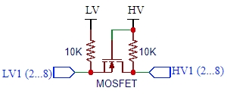

There are two grounds on the board as well.  These aren’t used by the circuit on the board, but can be used to pass a ground connection along with the data between the systems if it is needed.

You then hook-up the lower voltage logic signals to the **LV1-LV8** pins and the higher voltage logic signals to the corresponding **HV1-HV8** pins (LV1 connects to HV1, etc) and you are set to go.  There is no direction control required for the bi-directional functionality.

**Module Assembly**

The module comes with 2 strips of male headers.  These can be soldered on either side of the board or you can attach wires directly to the board depending on what your application requires.

**An important note:**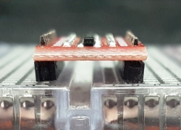

The two rows of headers are on about 0.45″ centers rather than being on a standard 0.4″ or 0.5″ spacing.  It can be made to work with breadboards or perf boards, but the headers will need to be soldered into the module at a slight angle.

This is most easily accomplished by putting the headers into a solderless breadboard and then pressing on the module before soldering.  The picture shows the angle you end up with on the headers.

**Module Connections**

**The board has the following I/O connections:**

* **HV** = High voltage.  Must be higher voltage than LV.  Typically tied to 5V
* **LV** = Low voltage.  Must be lower voltage than HV.  Typically tied to 3.3V
* **GND** = Ground (x2).  Can be used to pass a ground between the two different voltage circuits
* **HV1 / LV1**  =  Channel 1
* **HV2 / LV2**  = Channel 2
* **HV3 / LV3**  = Channel 3
* **HV4 / LV4**  = Channel 4
* **HV5 / LV5**  = Channel 5
* **HV6 / LV6**  = Channel 6
* **HV7 / LV7**  =  Channel 7
* **HV8 / LV8**  = Channel 8

**OUR EVALUATION RESULTS:**

These modules are an easy and low cost way to implement level shifting.   You can convert between pretty much any two logic voltage levels that you will find in electronics like 5V and 2.8V.

The 10K pull-up resistors tend to be the limiting factor for the maximum switching speed that can be obtained with these modules depending on the capacitive load.  400KHz operation is usually possible.  If you are trying to push the speed boundaries and are seeing data glitches, lower value pull-up resistors can be used to speed up rise-times.

**BEFORE THEY ARE SHIPPED, THESE MODULES ARE:**

* Sample tested per incoming shipment

*Notes:*

1. *None*

**Technical Specifications**

|  |  |  |
| --- | --- | --- |
| **Dimensions** | L x W (PCB) | 28 x 14mm (1.1 x 0.55″) |
|  | Footprint | DIP-20 |
| **Datasheet** | N-Channel MOSFET Transistor | [**BSS138**](http://www.onsemi.com/pub/Collateral/BSS138-D.PDF) |

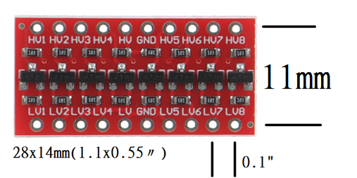

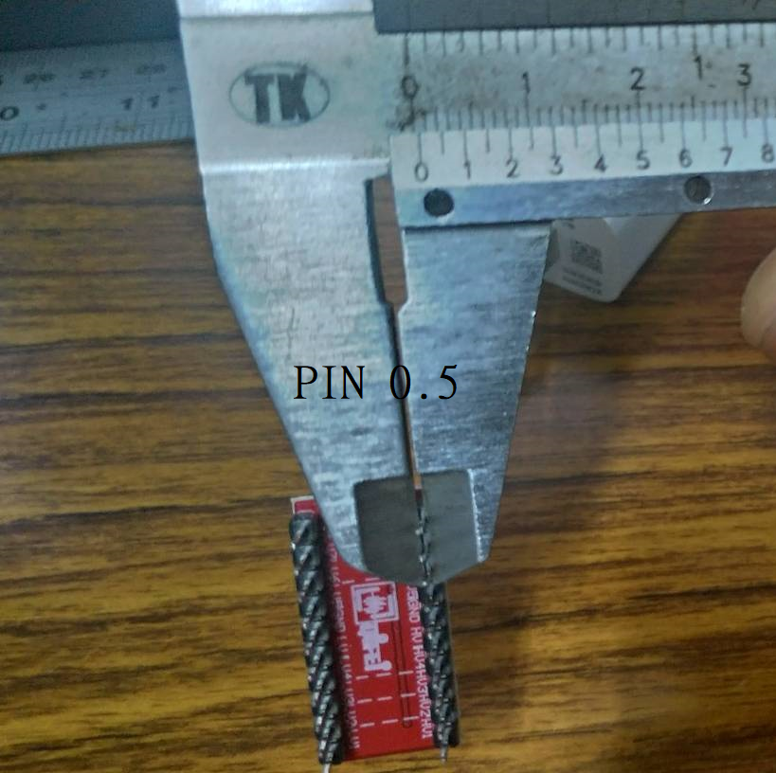

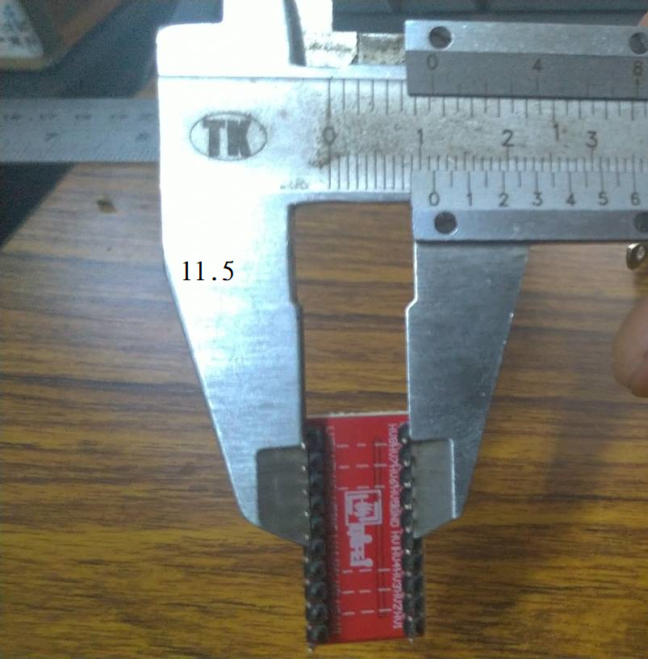

購買  
<https://www.ruten.com.tw/item/show?21906774988528>  
<https://item.taobao.com/item.htm?spm=a230r.1.14.33.c76521bdccpMeC&id=569839308392&ns=1&abbucket=15#detail>

<https://protosupplies.com/product/logic-level-converter-8-ch-bi-directional-module/>

一板7x5=35個

