








ADAPTATION AND INTEGRATION COURSE
The Course is mandatory for selected groups of foreigners who have newly arrived in the Czech Republic and obtained long-term or permanent residency (the biometric card) after 1. 1. 2021. You must take the course at latest within 1 year from the date when you received the card. In case you fail to fulfil this obligation, you risk being subject to a fine of up to CZK 10,000.
Take a quiz and find out if you have this obligation →Turn the page!
WHAT? | HOW? | WHERE?  You can only fulfil this  obligation at an official  course at a Centre for  Support of Integration of  Foreign Nationals  In Prague the course is  provided by the Integration  Centre Prague (ICP).  Does the  obligation  to take the  course apply to you?
The Adaptation and Inte- | You need to register for the
gration Course is a four- | course via the MOI portal:
-hour educational seminar
about the Czech Republic, | The CZK 1,500 fee is paid
which will help you get ori- | in advance during regis-
ented in the new country | tration. You can find the
as soon as possible and get | registration guide
acquainted with your basic | at
rights and obligations.
We will answer your questions or assist you with registration at ICP free of charge
+420 253 253 984
Consultations in person: Thursday (9:00-12:00, 13:00-16:00)
a 1

Aktivita probíhá v rámci projektu AIK ICP 25 zaměřeného na integraci cizinců a financovaného MV ČR.










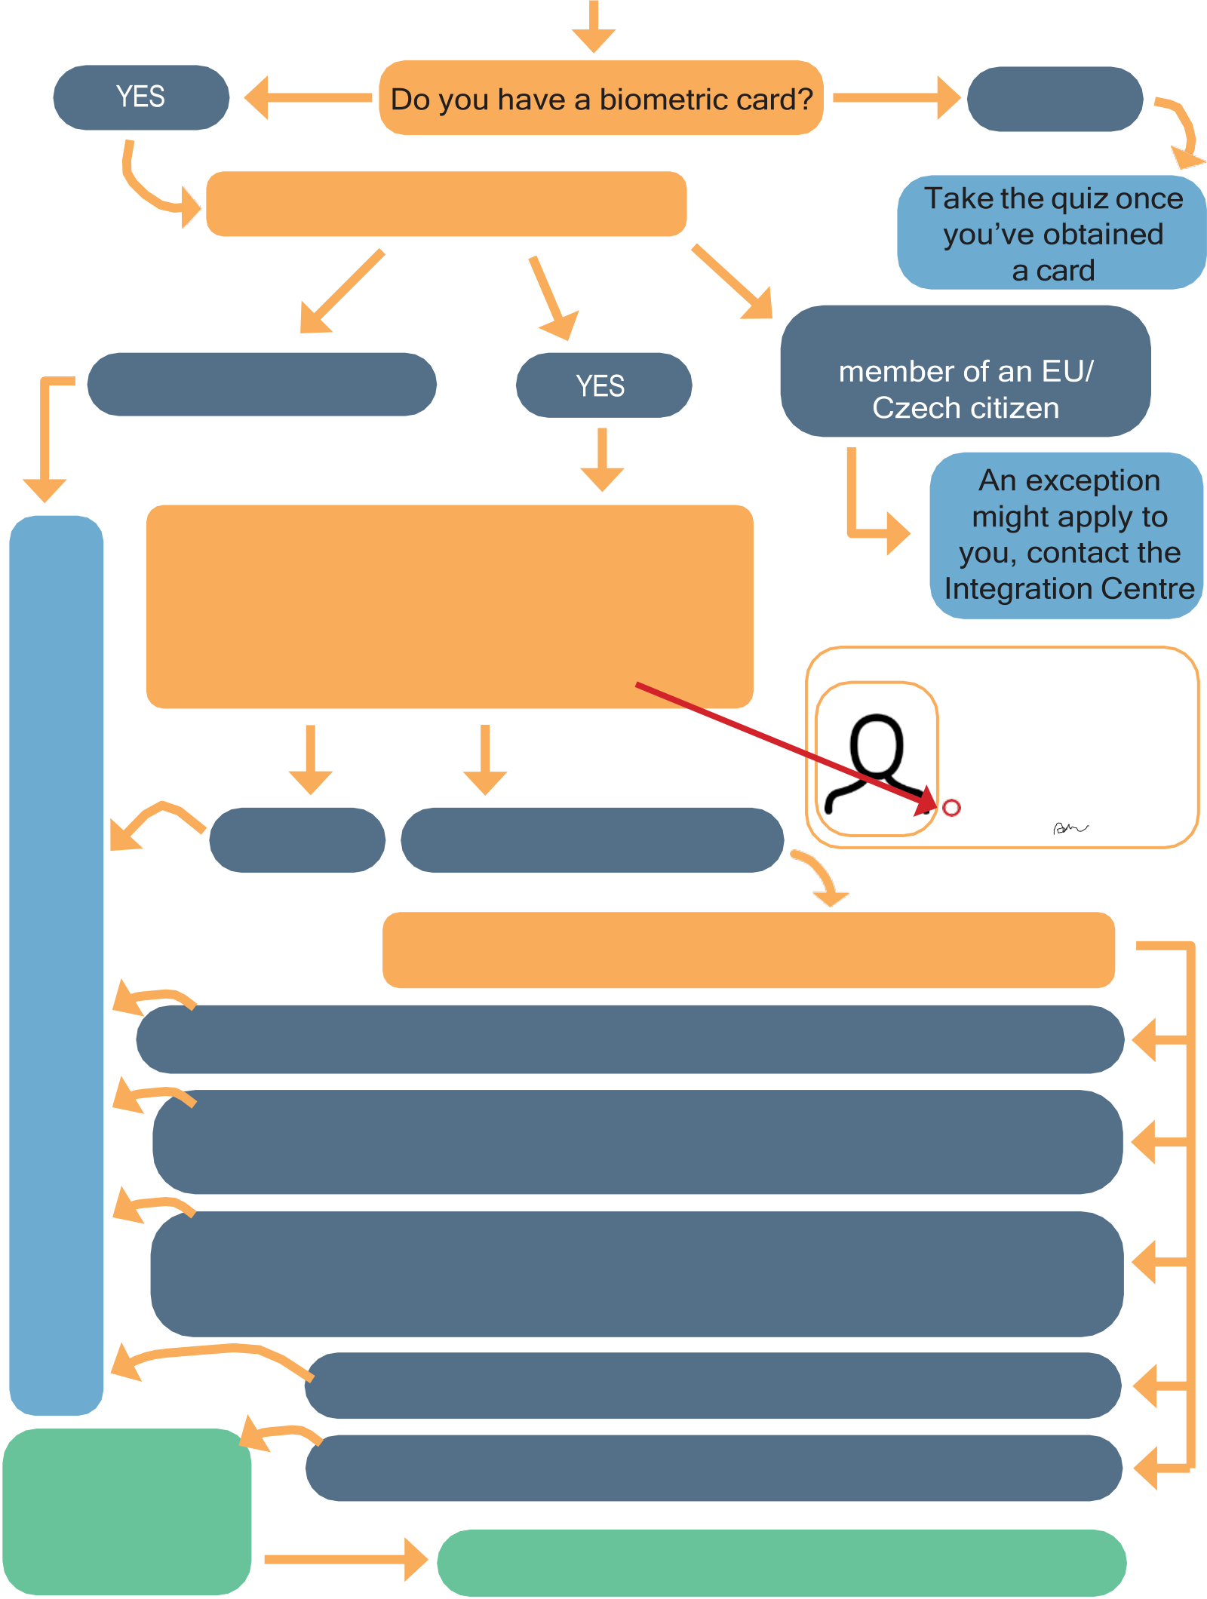
Does the obligation to take the Adaptation and Integration Course apply to you? Take a quiz and find out!
NO
Are you a non-EU citizen?
YES, but I’m a family
NO, I’m an EU citizen
Does your biometric card have one of
TheCourseisnotmandatoryforyou | these codes on it? (You will find the code on the biometric card, see picture) - 21,
 | 22, 23, 30, 41, 42, 43, 47, 60, 67, 78, 79, |  | CZE Povolení k pobytu |  | 999004402
 | 80, 89?
 |  |  | PŘÍJMENÍ,jména
 |  |  | SPECIMEN
 | Luka Lukaschevich
 | POHLAVÍ |  |  | STÁTNÍ PŘÍSLUŠNOST |  | DATUM NAROZENÍ
 | M |  |  | AIA | 15 11 1997
 | DRUHPOVOLENÍ |  |  |  | PLATNOSTDO
 | DLOUHODOBÝ POBYT |  |  |  | 30 06 2024
POZNÁMKY
23 Volný přístup na trh práce - ANO
 | YES | NO, I have another code | student
 |  |  | 981115/0571
Did you receive the biometric card after 1. 1. 2021?
NO, I received the card before 1. 1. 2021, and it was valid on this date
YES, but I had valid long-term residence before 1. 1. 2021, and after this date I changed the purpose of my stay/extended my residence
YES, I was issued an employee card or a blue card based on the “Highly Qualified Employee” or “Key and Scientific Staff” government program
YES, but I’m under 15 or over 61 years old
The Course is mandatory  for you | YES, and none of the options above applies to me  Registerhere:www.frs.gov.cz/kurzy An exception might apply to you, contact the IntegrationCentre

