**Exercise 1**

Proposed architecture:

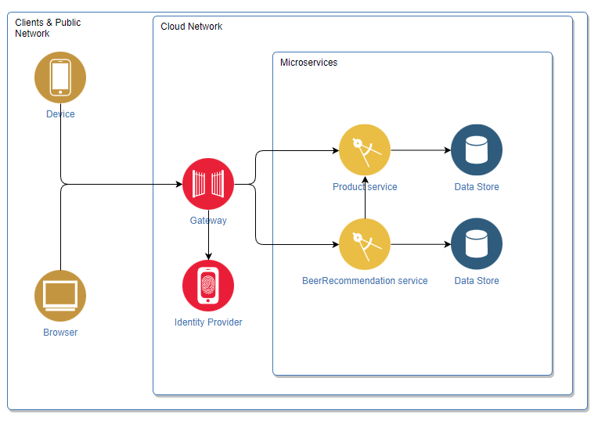

**Exercise 2**

<https://github.com/cepon/BeerPirates>

**Excercise 3**

**Answers**

1.) API gateway is a proxy between client and microservices. We do not need to expose microservices to the client. API gateway is point of entry.

2.) Serverless architecture is design for developers to write and deploy functions instead of applications.

3.) Idempotency is duplication of requests. Clients send the same request multiple times. It is useful when there is timeout.

4.) CI/CD is automatization of building and deploying. CI means continuous integration which is building and testing new code on a regular basis. CD means continuous delivery which is automatic release of new code and ready to be deployed.

5.) Blue-green deployment is a model that creates the same container of microservice and updates a new container with a new version of microservice. With load balancer we redirect from the old microservice to the new one. When all traffic is redirected, old microservice can be shut down or be in stand by for rollback.

Rolling deployment is usually used in distributed applications. It replaces application one by one.

6.)

* GET - used to get data from server
* POST - used to create data on server
* PUT - used to modify data on server
* DELETE - used to delete data on server

7.) OpenAPI specification is a format that describes, produces and visualizes RESTful API. I would use swagger for REST API.

8.) CORS is Cross-Origin Resource Sharing. It is a header that is allowing resources from other servers. If there is no CORS header, it restricts clients to access shared resource.